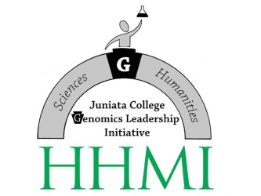
CERTIFICATE IN GENOMICS, ETHICS & SOCIETY
Student's Name:
POE Title:
Program Advisor:
General Advisor:
Class: FR SO JR SR
Degree Date:
Career Aspiration:
Took Assessment Pre-test: Yes / No
 | Dept | Cat# |  | Course Title | #Credits | Semester/YR
1
2
3
4
5
6
7
8
9
10
Co-curricular leadership experiences (e.g. club officer, tutor or TA, captain, other):
My motivation for completing the certificate program:
Briefly list your research experience(s) or any plans for independent research beyond classes in the certificate, including the name of your mentor:

Certificate Advisor: |  |  | ________________________________________________
Program Advisor: |  |  | ________________________________________________
General Advisor: |  |  | ________________________________________________
Student's Signature  and Date |  |  | ________________________________________________

