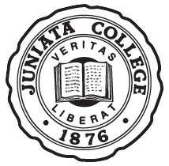**ECEC News**

**Theme**

Birds



**For Week of 4-27-2015**

**Upcoming Events:**

* **JIF Babysitting Night – TONIGHT, April 24 @ 6:00pm – 10:00pm**
  + Bring you children to the ECEC on **Friday April 24 at 6:00pm** for a night of fun with other children and the Juniata Instructors of the Future (JIF).
  + There is no cost for this night; however JIF will be accepting donations to the Standing Stone Elementary Backpack Program. They accept non-perishable food items, as well as monetary donations.
  + Dinner will be served (chicken nuggets and pasta), and there will be fun activities like a scavenger hunt, outdoor activities, and a spring craft.
  + There will be an option for the children to watch a G-rated movie at the end of the evening if there is time remaining.
  + Email Kortney Showers ([showekj11@juniata.edu](mailto:showekj11@juniata.edu)) to sign up, or if you have any questions or concerns. Please include children’s ages when calling.
* **May Program**
  + The May Program starts in less than 2 weeks, on Wednesday, May 6, 2015. If you would like to enrolled your child in the program, please fill out the sign-up sheet on top of the cubbies and complete the enrollment form. We look forward to a fun May!
* **May Program DelGrosso’s Field Trip**
  + On May 21st, we will have an optional field trip to DelGrosso’s Amusement Park. If you have signed up your child for the May Program, check their cubbies this next week for more information and a permission slip.

**Center Community News**

* There will be **no school for the T.I.U**. on Thursday, April 30, 2015
* Our End-of-the-Year Family night was a huge success and fun was had by all. Thanks to all those who attended, brought food, and helped to make it such a success. A special thanks goes out to the *Families and Teachers* class for organizing and facilitating the entire event. They did an amazing job!!
* **The last day of school for the Juniata ECEC Program will be Tuesday, May 5, 2015.** There’s still time to enroll your child in the **May Program** which begins on May 6.
* Enrollment forms for Juniata ECEC children returning this fall are available on the cubbies by the parent sign-in sheet. Please return as soon as possible.

Family and Community Involvement



* You will find **Family Surveys** in your child’s cubby. Please take the time to complete these. We truly value your input which, in turn, helps us to set our goals for next year. It’s one way to be included in our Annual Program Evaluation.
* Please continue to bring in your Terracycle items. Our Earth with thank you!

|  |
| --- |
|  |

PA Learning Standards for Early Childhood

Below are just **some** of the PA Learning Standards we’ll target this week…

* Approaches to Learning Through Play
  + AL.3 PK.C – Use materials and objects to represent new concepts
* Language and Literacy Development
  + 1.2 PK.L – With prompting and support, actively engage in group reading activities.
  + 1.3 PK.G – Describe pictures in books using detail
* Mathematical Thinking and Expression
  + 2.1 PK.A.2 – Count and tell the number of objects
* Scientific Thinking and Technology
  + 4.3 PK.A – Identify how the environment provides for the needs of the people
* Social Studies Thinking
  + 7.1 PK.A – Explain how a map is a representation of places
* Social and Emotional Development
  + 16.3 PK.B – Recognize there are socially acceptable ways to behave in different places

See Photos on Next Page

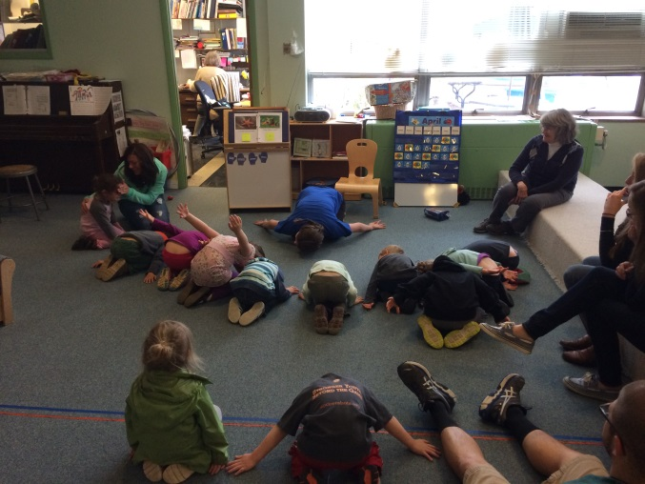 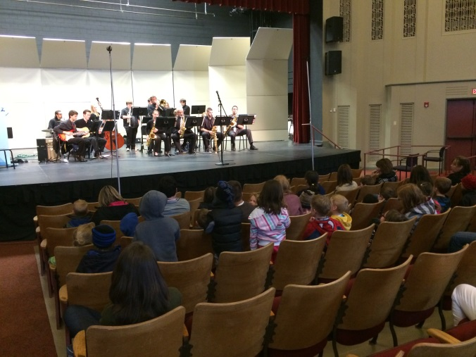

College student, Katey, did yoga with the children this week.

We took the children to hear a jazz ensemble for Juniata’s Liberal Arts Symposium.

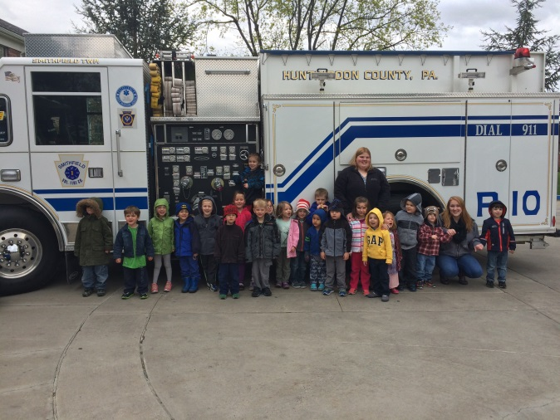 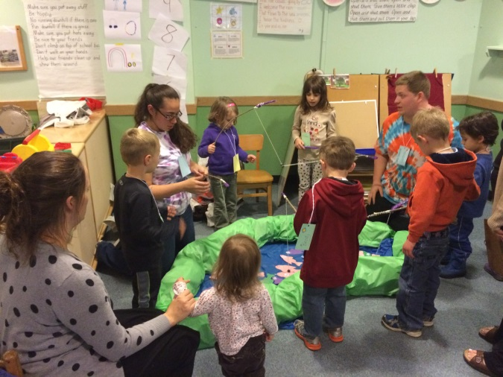

The fishing pond was a huge hit at our Family Night.

College student, Amber, organized a fire truck to come to the center.

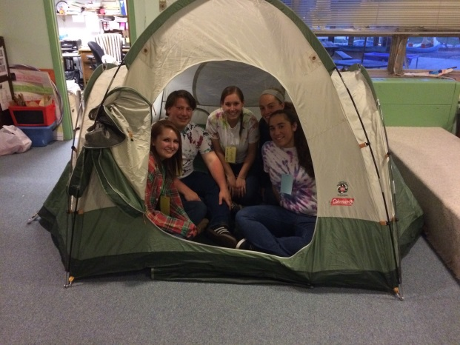

The college students (not all pictured here) did a great job organizing our Family Night this year. They seemed to have a great time working together and with the families, and I know that the rest of us had a fantastic time! Kudos to the Families and Teachers class!!!