Date | Circle Time Books or Activities | Small Group  Birds | Art | Snack | Other Learning Areas
Monday  4/27/15 | Sycamores AM: The Best Nest  PM: Please Say Please | AM: Bird Songs  PM: Manners | AM: Bird Nest Collage  PM: Tube Penguins | Cereal & Milk  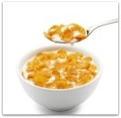 | Bird Seed in the Sensory Table  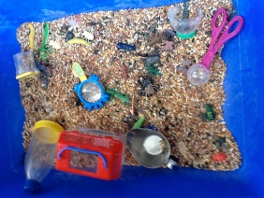
 | Willows AM: Animal Homes  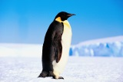  PM: The Best Nest | AM: Rhyming Game  PM: Geo Boards | AM: Build a Nest  PM: Painting with Feathers
 | Dogwoods  Birds | Bird Feeders | Finger Paint
Tuesday  4/28/15 | Sycamores AM: Grumpy Bird  PM: There is a Bird on Your Head | AM: Eagle Web Cam  PM: Problem Solving | AM: Grumpy Birds  PM: Nests on Elephant | Raisins & Sunflower Seeds  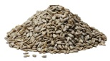
 | Willows AM: Robins and Chicks  PM: Owl Babies | AM: Missing Objects  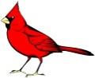  PM: Bird Feeders | AM: Stamp Art  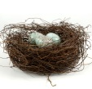  PM: Pine Cone Birds
 | Dogwoods  There is a Bird on Your Head | Finding Birds | Bird Nests
Wednesday  4/29/15 | Sycamores AM: Owl Babies  PM: Dr. Duck | AM: Science  PM: Counting Feathers | AM: Pinecone Owls  PM: Ducks | Birds in a Nest  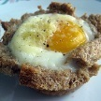
 | Willows AM: Three Little Chicks  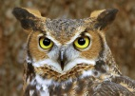  PM: Grumpy Bird | AM: Science  PM: Feelings | AM: Puppets  PM: Modeling Clay
 | Dogwoods  Biddle Bird | Making Feathers | Bird Nests
Thursday  4/30/15 | Sycamores AM: I’m Not Ready  PM: Silly Little Goose | AM: Sorting Bird Seed  PM: Why Different Beaks? | AM: Bird Seed Art  PM: Farm Hats | Apples & Peanut Butter  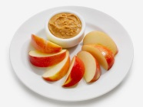
 | Willows AM: Have you Seen My Duckling?  PM: There is a Bird on Your Head | AM: Counting Objects  PM: Nest Observation | AM: Painting Ducks  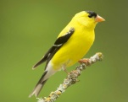  PM: Nests
 | Dogwoods | NO I.U. Today
Friday  5/1/15 | Sycamores: A Home for Bird | Field Guide to Birds | Feather Art | Hummus & Pita Chips  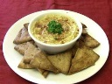
 | Willows Minerva Louise | Grouping Objects | Mixed Up Painting
 | Dogwoods  Grumpy Bird | Mr. Mark | Emotion Birds

