

Juniata College INTERNATIONAL HANDBOOK

Center for International Education Oller Center
USEFUL INFORMATION
Emergency Numbers

Public Safety – +1-814-641-3163 (non-emergency) Public Safety – +1-814-641-3636 (emergency)
Director, International Student and Scholar Services: Shya Erdman
Office: 814.641.5331 l Cell: 814.599.1372
Dean of International Programs: Jamie Weaver
Office: 814.641.3182

Campus Numbers
(814.641.ext)
Bursar’s Office ext.3302
Bookstore…………………………………………………………………… ext.3381 Campus Activities ……………………………………………………… ext.3331 Campus Ministry………………………………………………………… ext.3361 Career Services ………………………………………………………… ext.3354 Food Services …………………………………………………………… ext.3335 Health Center …………………………………………………………… ext.3410 Help Desk (Technology Problems) …………………………… ext.3619 International Office …………………………………………………… ext.3180 Library ……………………………………………………………………… ext.3450 Post Office ………………………………………………………………… ext.3370
Residential Life…………………………………………………………… ext.3324

Important Juniata Websites
International Student Information – http://www.juniata.edu/academics/departments/international/interna tional-students/
The Arch – http://arch.juniata.edu Webmail – http://webmail.juniata.edu Moodle – http://moodle.juniata.edu

TABLE OF CONTENTS
Welcome to Juniata College | 5
Center for International Education | 6
Center for International Education Staff List | 7
Juniata College Information | 8
History & Facts | 9
Traditions | 10
Campus Life at Juniata | 11
Residential Life | 12
Residence Halls | 12
Keys | 12
Meal Plans | 12
Identification Cards | 13
Public Safety | 13
Living with a Roommate | 13
Residence Life Staff Directory | 14
Campus Services | 15
Campus Map | 16
Campus Alcohol Policies | 17
Banking in Huntingdon | 20
United States Currency | 20
Dining & Shopping in Huntingdon | 21
Huntingdon Map | 23
Cultural Life | 24
Friendship Family Program | 24
Language in Motion | 25
Student Clubs | 26
Culture Shock | 28
Adapting to New Surroundings | 28
Academic Information and Records | 29
Academic Requirements | 30
Grades | 32
Academic Services on Campus | 33
International Student Policies | 34
Immigration Information Forms & Documents | 35
Maintenance of Status | 36
Health Forms & Immunizations | 37
Types of International Students | 38
Replacing Lost & Stolen Documents | 39
Employment | 40
On & Off Campus Employment | 41
Social Security Process | 42
Travel & Holiday | 44
Residence Hall Closings | 45
American Holidays | 46
Personal Safety | 47
Academic Calendar 2023-2024 | 48
Frequently Asked Questions | 49
Academic | 50
Transportation/Travel | 52
Campus Life | 52
Food | 53
Mail | 53
Address, Phone, and email for Center for International Education | 55

Welcome to Juniata College!

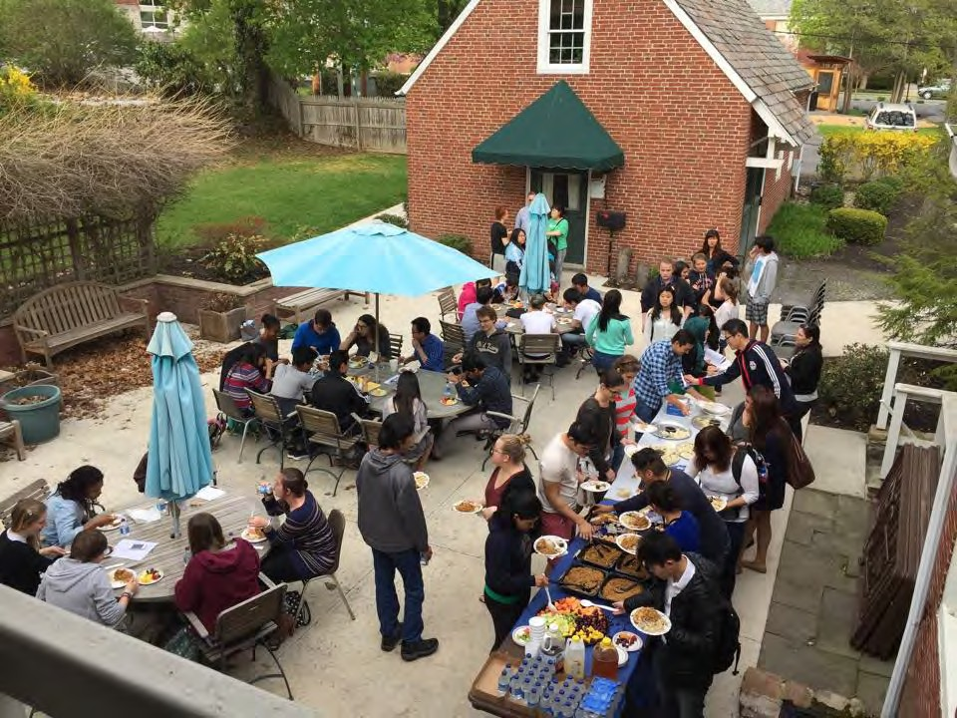
Congratulations on your acceptance to Juniata College! As a new student, we welcome you to campus and hope that you feel at home. You will find that the campus community is friendly and active. We hope you will return home – as have many international students before you – with wonderful new friends and memories from your experience at Juniata.

This handbook answers some of the questions you might have. Of course, if you have any questions, talk with the Center for International Education staff.

We look forward to inviting you into our Juniata family!

The Center for International Education Staff
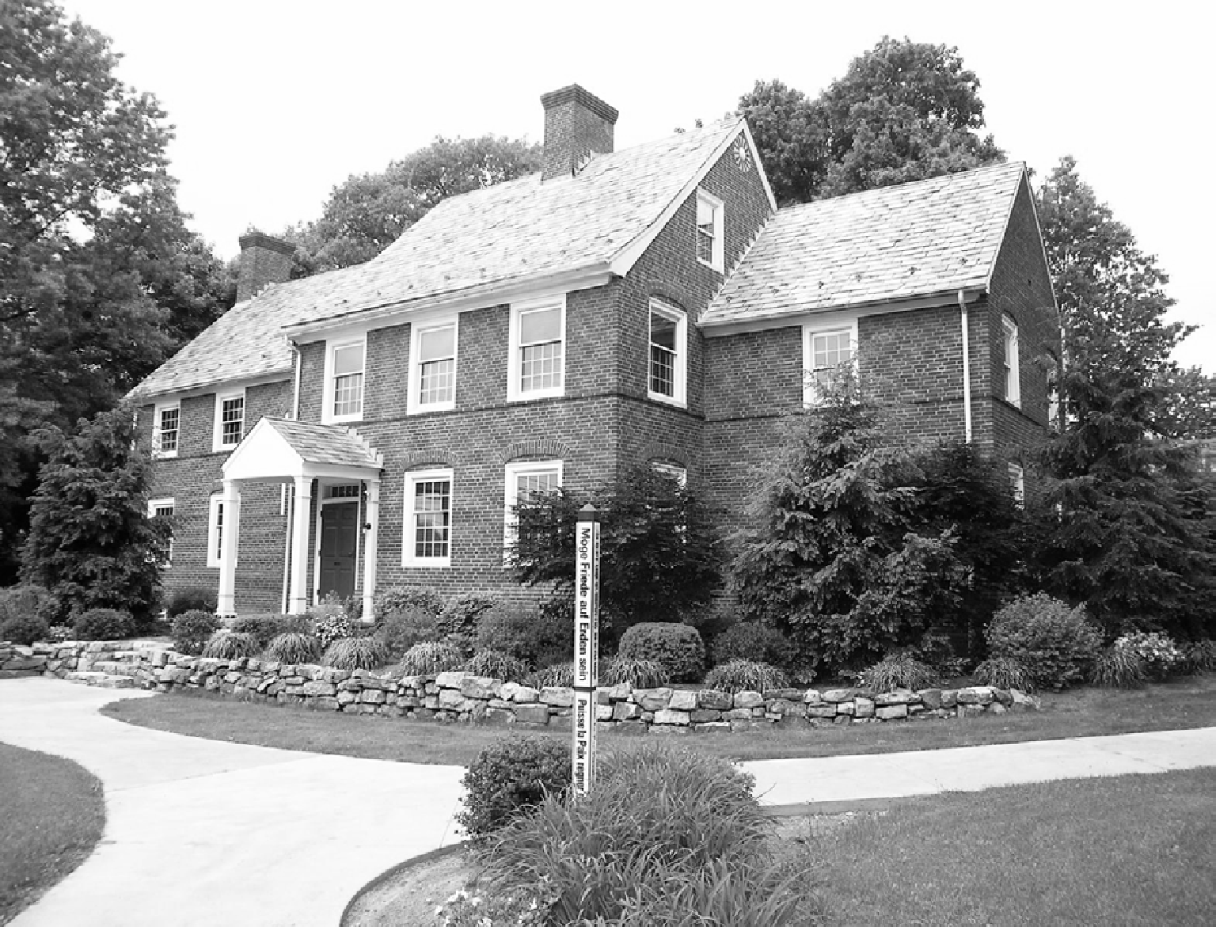

Center for International Education

- The Staff
- Location
- Hours of Operation
5 |
Center for International Education
The Staff

International Student Services  The staff of the Center for International Education (CIE) provides support to students with visa issues, pre-arrival planning, orientation, academic advising, and adjustment to studying and living in the U.S.  Director, International Student and Scholar Services:  Shya Erdman  Email: sme100@juiniata.edu Phone: 814.641.3183  Cell: 814.599.1372 | International Office  The CIE works closely with faculty members and their departments, both to integrate study abroad into each student’s course of study and to support the academic performance of international students.  Dean of International Programs:  Jamie Weaver  Email: weaverj@juniata.edu Office: 814.641.3182  CIE Office Assistant:  Kelsey Lane  Email: klt100@juniata.edu  Office: 814-641-3180
English for Academic Purpose Program  The English for Academic Purpose Program offers English language classes and intercultural learning for Juniata students who are studying for a degree, are on exchange, or are studying solely in the EAPP.  Instructor:  Elliot Hirshon  Email: hirshoe@juniata.edu Phone: 814-641-3169 | Address Juniata College 1700 Moore St  Huntingdon, PA 16652  Fax: 814.641.3185  Hours  Academic Year  Monday - Friday: 8:30 AM-5:00 PM (08:30 to 17:00)  Meetings can be made by appointment.  Summer (May to August)  Monday - Friday: 8:00 AM-4:00 PM (08:00 to 16:00)


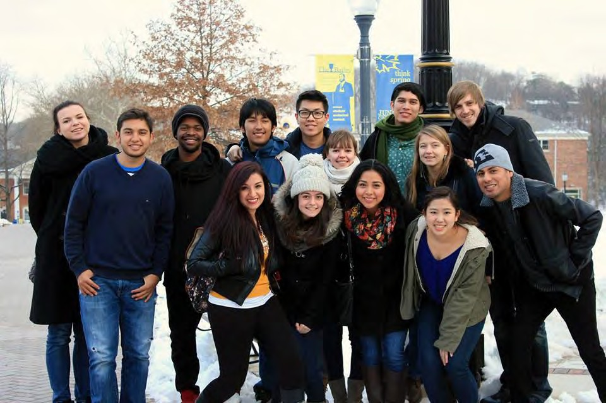

Juniata College Information

History


Juniata was founded in 1876 by Henry, John, and Andrew Brumbaugh. April 17, 1878, was the first day of classes and Juniata’s first class had three students. That year, a smallpox epidemic in Huntingdon forced the College to close from January 13 to February 25. The three Juniata students from Ohio - William Beery, Benjamin Bowser, and Levi Stoner - feared that going home meant they would never return. Instead, they decided to stay in an old rickety house until the quarantine was lifted. The smallpox exile of the three students led to one of the great traditions
of Juniata- an event known now as "Mountain
Day."

The College has a longstanding connection to the Church of the Brethren that started at its roots. Though Juniata is not officially affiliated with any religion, many Brethren values still remain on campus. The Brethren faith is a division of Christianity that promotes living as Jesus would have: peacefully, simply, and together.
Jacob Zuck, first president of Juniata
College.

Facts

Motto: Veritas Liberat, Truth sets Free
Number of Students: 1226 (1179 undergraduates; 47 graduate)
Average Class Size: 29 Women: 56%; Men: 44% Student to Faculty Ratio: 11:1
Students Designing Their Own Program: 29%
Countries Represented: 30
States Represented: 35
Students with an International Experience: 48%
International Students: 11%

Traditions

Mountain Day is held on a beautiful fall day when classes are canceled and everyone flocks to one of the state parks in the area for a day of outdoor fun including a picnic lunch, nature walks, music, crafts, games and more!
LobsterFest is held at the end of the first week of classes to welcome the students back to campus after summer break. It is a picnic that features whole Maine lobster as the main course and live music as the entertainment. During the festivities, many of the student organizations and clubs set up display tables so that the new students have the opportunity to see the many activities available to them.
Storming the Arch is when first-year students from across campus gather on the campus quad with the intention of charging the Cloister Arch and making it through to the other side. This mission is complicated by the group of upper-class students who serve as “defenders” of the Arch. The new students discuss their strategy and charge the Arch in attempts to make it through until they are knocked down or someone gets through the challenge. Video of the 2019 storm: https://www.youtube.com/watch?v=piIUbpfQqE8
Madrigal takes place on the last Saturday of the fall semester. This holiday tradition starts with a first-class meal served by the faculty and staff. After dinner, guests are entertained with performances by members of the campus community and entertainment groups. The evening concludes with a sing-along to “The Twelve Days of Christmas,” with various sections of the dining hall acting out the different parts of the song.


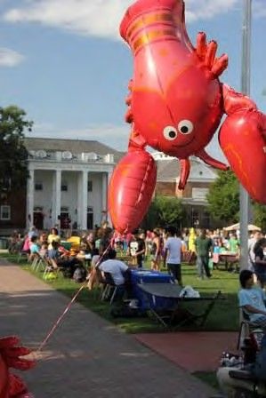



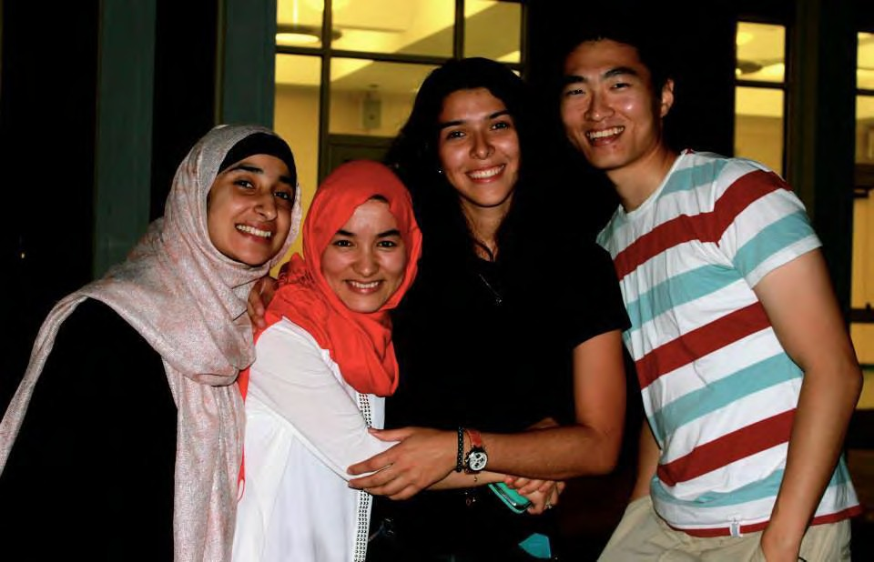
Campus Life at Juniata

- Residential Life
- Campus Services
- Campus Map
- Campus Policy about Alcohol
- PA Law Regarding Alcohol
- Living with a Roommate
- Banking in Huntingdon
- Dining and Shopping In Huntingdon
- Cultural Life
  - Friendship Family Program
  - Language in Motion Program
- Student Clubs
Residential Life

Residence Halls
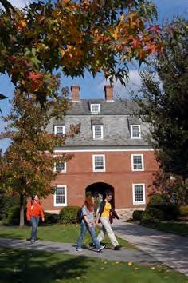
Residence halls house from 100 to 200 students and include recreation rooms, lounges, and utility rooms for washing and ironing clothes. Some halls have kitchens for students to use. Rooms are designed for two students and include two beds, two bureaus, two desks, two chairs, and closet space. Most residence halls have shared lavatories.
All international students are expected to obey the rules and regulations of Juniata College. All of these regulations are published in the Juniata College “Pathfinder” which is available online at: https://www.juniata.edu/offices/dean-of- students/pathfinder/
If a student violates the rules listed in the Pathfinder,
Juniata College has the right to take disciplinary action against the student.

Keys
It is very important to know where the key to your room is at all times. You should lock your room and take the key with you every time you leave. If you lose a key, the replacement cost is $100. Mailbox key replacement is
$5.

Meal Plan
Meals are provided through the College Dining Services at Baker Refectory. Students can choose from the following meal plans:

- Blue plan: $3,169 per semester, All Access to Baker Refectory +
$150 Declining Cash Balance
*Required for incoming students, sophomores and juniors; default plan for residential students.
- Gold plan: $2,932 per semester, with a lock of 185 Baker meals
+ $75 DCB or Block of 125 Baker meals + $300 DCB

*Alternate option for seniors.
- Off Campus / Commuter plan: $2,014 per semester, All Access to Baker Refectory Monday- Friday + $100 DCB

*Available to residents of campus apartments/houses with in- unit kitchens.
With an ever-present focus on craftsmanship, our daily offerings will always be made-from-scratch. You’ll enjoy fresh, consciously sourced food with a focus on seasonal items, a wide variety of delicious and healthy meals, build-your-own meal concepts, and special options for every diet. We’re here to nourish, comfort, and excite through our food offerings every single day. The declining balance dollars (DCB dollars) allow purchases in Baker Refectory, Jitters, On the Go! Café, Beeghly Library 365 Market and Parkhurst Dining catering. Moneys from the DCB account may also be used by students to pay for any guests they bring to the dining hall. All declining
cash balances (DCBs) associated with meal plans that are not used by the end of each academic year will be forfeited. Additional DCB Dollars may be purchased throughout the semester. Any remaining DCB will transfer from Fall semester to Spring semester but will not transfer from Spring semester to the following school year.
Identification (ID) Cards
Every student at Juniata must have a Student Identification card (Gold Card). This is needed for entry to the resident halls, the dining hall, and to check out books from the library. If you lose it, replacement cards are
$25.00 each in the Public Safety Office. There is a $10 fee to replace a damaged ID card, the damaged card must be returned to Public Safety. Photographs for your identification card can be uploaded prior to your arrival.

Public Safety
Security Personnel are on campus 24 hours a day, seven days a week.
The officers have a variety of training and experience ranging from criminal investigation procedures to self-defense techniques. They have an excellent working relationship with the local and state police. They are located in the basement of Ellis.

Living with a Roommate

At Juniata, all new students are assigned a roommate. Sharing a room might be a new experience for both you and your roommate. The adjustment is a challenge, but we encourage you to keep an open mind as you begin a relationship with your roommate. Learn to talk about things that bother you right from the start before they become a problem. If you do develop problems, the first step after you talk to your roommate is to talk to your Resident Assistant (RA), who is trained for this purpose.
Many misjudgments and misunderstandings can arise from interactions between people who have different communication styles. Here are some examples:
- Foreign visitors in the U.S. might hear “small talk” among people and conclude that they are not intellectually capable of anything more than simple talk.
- Responding to people who customarily speak little and who rely heavily on ritual conversation, students in the U.S. might use the labels “shy,” “formal,” or “too polite.”
- Vigorous arguing (with raised voices and much use of hands/arms, perhaps more than one person talking at a time) is ordinary for some cultures but may alarm students in the U.S. who fear that violence or long-lasting anger may follow arguments.
- What U.S. culture might regard as “keeping cool” – that is, not being drawn into an argument, not raising the voice – might be seen as coldness or lack of interest. In the U.S., those who do not “keep cool” are likely to be seen as too emotional.

- Embarrassment or unease almost always results when someone raises a discussion topic that the other person thinks is inappropriate for the particular setting or relationship.
These are but a few of the many challenges that arise between U.S. people and people from other countries. Talking about differences in communication, when such a difference seems to be causing problems, is usually a good way to reduce the negative effects of the differences.
For more tips visit: http://collegelife.about.com/od/beforeyouarrive/qt/roommatetips.htm

Campus Life Staff Directory 2020-2021

Assistant Dean of Students-Campus Life | Erin Paschal | Founders Hall
Associate Director of Residential Life | Penny Hooper-Conway | Ellis Hall
Assistant Director of Residential Life | Taylor Rigatti | Ellis Hall
Assistant Director of Student Engagement | Dani Erdley | Ellis Hall
Residential Life Coordinator | Isabella Klug | Ellis Hall
Residential Life Coordinator | Rylee Walers | Ellis Hall

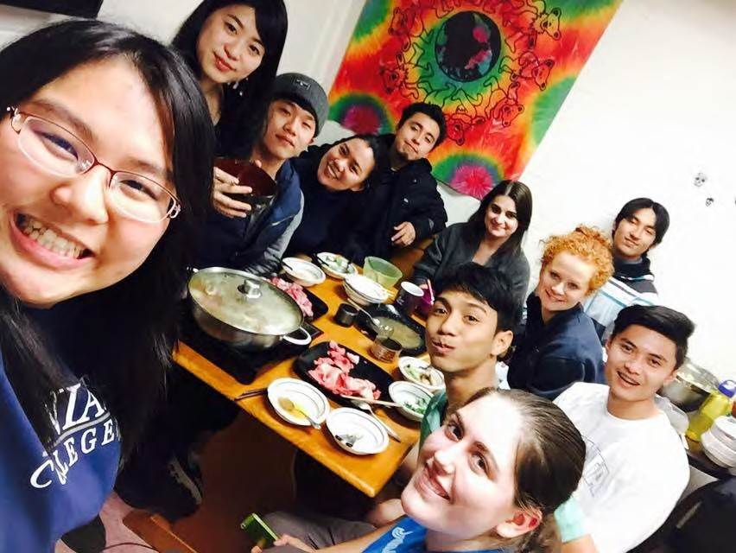

Campus Services

Technology Services Center (TSC)  - Located Brumbaugh in Room C107  - Phone: 814.641.3169  - The TSC provides some computer support along with training sessions regarding different software packages  - A place where students can reserve cameras, iPods and laptops | Kennedy Sports & Recreation Center  - Located between Ellis, Lesher and Cloister  - Includes a swimming pool, fitness center, and handball/racquetball courts  - Free for all students
The Writing Center  - Located in the basement of the library  - Provides assistance to students writing reports, papers and other academic assignments | Beeghly Library  - Phone: 814.641.3450  - Librarians are available to help you search the available books and databases that the library offers
Sports  - The College has a large number of men’s and  women’s teams that compete across the country in a variety of sports  - Intramural Sports are available  - Visit https://www.juniatasports.net/landing/ index to see the Varsity Sports offered at Juniata    Visit https://www.juniata.edu/campus-life/activities/clubs.php for a listing of Intercollegiate and Collegiate Club Sports. Contact OSA for more information 814.641.3330 | Religion and Spirituality  - There are several churches within walking distance of the College  - Catholic mass is held on Sunday evenings in Tussey/Terrace Lounge  - Protestant fellowship is held on Wednesday evenings, and there are Bible studies throughout the week  - Jewish services and holiday observances are conducted through arrangements with community contacts  - Muslim holidays may be observed by students, with arrangements made in advance for Food Service to provide special dietary provisions during this time  - A meditation room is available in the Unity House  - Center for International Education can help you make arrangements for religious needs
Health and Wellness Center  - Located on Moore Street between 16th and 17th Street, across from Stone Church.  - Registered physician and nurse available  - Free counseling is available | *For Hours of Operation across campus, please refer to the Arch at  http://arch.juniata.edu/today-at-juniata
Career Services  - Located in the QUEST Office in Founders Hall  - There are resources and staff there to provide students with information about job opportunities and ways for looking for a job | Tutoring  - By talking to your professor, you can request a tutor  - Tutors are students who have taken the course before and are  knowledgeable in that area of study
Post Office  - Located on the Ground floor level of Ellis Hall  - Open Monday through Friday from 10 am to 4 pm. Closed on Holidays  - You will have a mailbox that you will share with another student | Computer Labs  - Various locations on campus  - Each student is issued a personal user name  - All official communication happens through your Juniata email address

Campus Map

For a larger view of the campus map, click on the link below: http://www.juniata.edu/about/_images/juniata-college-campus-map.pdf
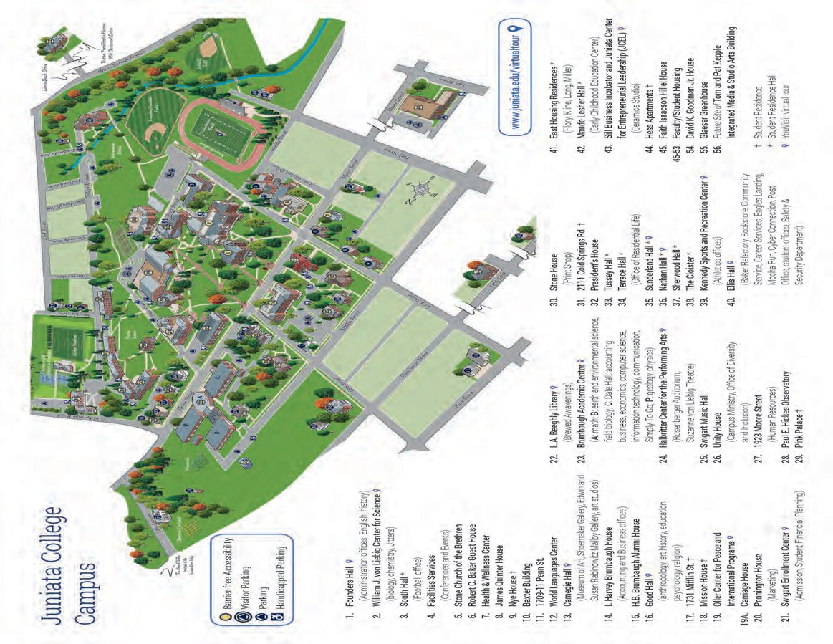

Campus Policy About Alcohol

In Pennsylvania, it is illegal for persons less than 21 years of age to purchase, consume, possess, or transport alcoholic beverages.

Student Rooms
- Room parties should not disturb other people’s rights. The college tries to keep an atmosphere that is good for studying. (We want to keep things clean and secure.) Each student has the right to a quiet residence hall, even on weekends. Any student who disrupts the residence hall or disturbs other people’s rights to study or sleep will be subject to disciplinary action.
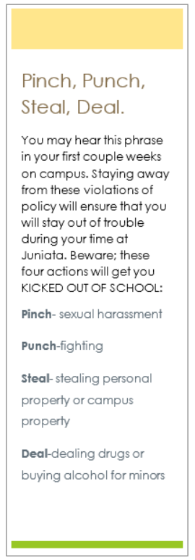

- Room parties must be self-contained. Parties cannot be in hallways, study lounges, or bathrooms.
- Hosts must not “supply, provide to, or allow a person under 21 to possess alcohol on premises or property owned or controlled by the person charged."
- All residents in the room must be 21 to have alcohol.

- Kegs, beer bongs, and similar products (even when empty) are not allowed in student rooms, apartments, or residence hall lounges.
- Being in a room or area where a keg, beer ball, or similar product is present is a violation of the campus alcohol policy. This applies to students under 21 as well as students 21 and older.
- The College prohibits alcoholic beverages in public areas, which include: academic buildings, Ellis College Center, the Sports Recreation Center, residence hall corridors, the stairwells and bathrooms, athletic fields, and all outdoor areas.
- Because of the potential dangers to health, the possession of excessively potent forms of ethyl alcohol for drinking purposes is prohibited.

Lounges
- The Office of Campus Activities located in the Ellis College Center must approve all social functions in advance.
- Any function that is intended to include alcoholic beverages must be approved 48 hours in advance and follow the procedures outlined on the Social Function Request Form.
- Chartered student groups may register residence hall lounges for social functions.
- Lounge parties sponsored by chartered student organizations are open to all students. However, only students 21 and older may possess or consume alcoholic beverages at lounge parties. Each student must show proper ID when requested by College personnel.
- Weeknight social functions need to comply with residence hall policies.
- Only college-recognized student organizations may charge admission for professional or live entertainment.
- Alcoholic beverages CANNOT be furnished by a chartered organization under any circumstances.
- Number and types of social functions held and the persons who may accept responsibility for them may be restricted based upon the following criteria: the frequency of social functions, number of functions scheduled by the same group, cleanup of previous social functions, scheduled use of rooms, and student behavior at previous functions.
- Non-alcoholic beverages and refreshments must be provided as prescribed in the Social Function Request Form.
- There may be no reference to alcohol in advertising social functions.
- Funds held in student organization accounts may not be used for the purchase of alcoholic beverages.
- Only Juniata College students, staff, and their guests may attend registered social functions.
- All off-campus guests attending social functions must be registered with the party sponsor by their student’s host. Students are responsible for the behavior of their guest(s).
- If a scheduled social function is canceled, notification should be given to the Programming Office as soon as possible so that an alternative activity may be scheduled in that area.
Penalties
- Purchase/consumption/possession/transportation of alcohol by persons under 21: FIRST OFFENSE is $500 fine, suspension of driver’s license for 90 days, and notification of parents by police. SECOND OFFENSE is the same but the license is suspended for a year. THIRD OFFENSE the fine remains the same with the suspension for two years.
- Misrepresentation of age to secure intoxicating beverages: FIRST OFFENSE is a summary offense. SUBSEQUENT VIOLATIONS are misdemeanors. A $500 fine and court costs up to $500 will be assessed for each violation in addition to the driver’s license suspension outlined under #1.
- Selling or furnishing intoxicating beverages to minor(s): FIRST OFFENSE
carries a $1000 fine. SUBSEQUENT VIOLATIONS carry $2500 fine for each.

Requesting or inducing minor to purchase intoxication beverages:
Misdemeanor offense and a $300 fine.
- Manufacture or sale of false identification cards: FIRST OFFENSE second- degree misdemeanor with a $1000 fine. SUBSEQUENT OFFENSES $2500 fine.
- Carrying a false identification card: FIRST OFFENSE is a summary offense with a loss of driver’s license as outlined in #1 as well as a $500 fine, and court costs up to $500 would be imposed. SUBSEQUENT VIOLATIONS is a misdemeanor as well as the fines remaining the same.
If convicted under number 1, 2, or 6 above, the additional requirements of being evaluated for the extent of involvement with alcohol may be required by the court. All costs associated with this evaluation and subsequent counseling, if deemed appropriate, will be the responsibility of the person upon whom the requirement is placed.

If you are convicted of one of these crimes, you will be sent home. You may also lose your visa.
Further information regarding the use of alcoholic beverages is often published and distributed to each student in The Pathfinder’s supplement, “The Student Services Newsletter.”

Policy Reminder
All international students are required to adhere to policies as listed in The Pathfinder. The Pathfinder is written and issued by the Dean of Students Office and is designed to provide students with information about the policies, procedures, and services of Juniata College. All Juniata students are expected to be thoroughly familiar with the information presented in The Pathfinder: https://www.juniata.edu/offices/dean-of-students/pathfinder/
Unless otherwise noted, exceptions to any of the above policies must be requested in writing and submitted to the Dean of International Programs, with supporting letters from student advisors. Decisions will be made in consultation with the Dean and the International Education Committee.

Banking in Huntingdon

Opening a Bank Account


Representatives from First National Bank will be available to assist students with opening a US bank account.

You must provide a copy of your passport, your Juniata mailing address, and an email address.
There is are FNB ATM machines located close to campus and downtown
Huntingdon.

United States Currency
- The basic unit of currency in the U.S. is the dollar
- There are 100 cents in each dollar
- American coins come in two colors and various sizes.
- Smaller-sized coins are not always lower in value than larger coins.

Coins


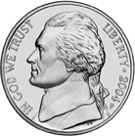





Penny | Nickel | Dime | Quarter
- Worth 1 cent  - copper color | - Worth 5 cents  - dull silver color  - larger than penny | - Worth 10 cents  - bright silver color  - smallest U.S. coin | - Worth 25 cents  - bright silver color  - larger than nickel

Paper Money
All U.S. paper money is the same size and same base color. Denominations include
$1 (commonly called a “buck”), $5, $10, $20, $50, and $100.
As is generally true everywhere in the world, it is not a good idea to carry or keep large amounts of cash in your room. Learn early to estimate how much money you will need for the next few days or the week. Keep the remainder of your money safely in a bank or in the form of traveler’s checks.

Tipping
  - Tipping is a common United States practice.
  - A tip is a service charge that is not included in the bill, but which is expected.
  - Remember to leave or give a tip to someone who gives you service like taxi drivers or restaurant servers.
To not tip in the U.S. makes the customer appear “cheap” or as though they are
unhappy with the service. Fifteen to twenty percent (15% to 20%) is considered minimal for a formal restaurant meal. Do not neglect your server or taxi driver by forgetting the tip. He/she depends on it to make a living. If you are uncertain whether the person will expect a tip, you can ask the employee or other customers if it is appropriate to tip.

Dining and Shopping Huntingdon

Sit Down Food
→ Boxer’s Café: 410 Penn St. (Huntingdon) 814.643.5013
→ Muddy Run Tavern:708 Washington St. (Huntingdon) 814.506.9914
→ Donna’s Family Restaurant: next to Hoss’s on Rt. 22 (Huntingdon)
→ Hoss’s Steak and Sea House: Rt. 22 (Huntingdon) 814.643.0665
→ Jumbo China Buffet: 6716 Towne Center Blvd. by Wal-Mart 814.643.3328
→ Memories Sports Bar & Grill: 221 13th St. (Huntingdon) 814.643.0353
→ O.I.P.: 628 Washington St. (Huntingdon) 814.643.0665
→ Standing Stone Coffee Company: 1229 Mifflin St (Huntingdon) 814.643.4545
→ Stone Town Gallery & Café: 511 Washington St. (Huntingdon) 814.251.2075
→ Domino’s Pizza: 614 Washington St (Huntingdon) 814.644.7444
→ All American Pizza and Subs: 612 Washington St (Huntingdon) 814.643.0222
→ The Wildflower Café: 516 Washington St (Huntingdon) 814.643. 6206
→ Kelly's Korner: 1430 Pennsylvania Avenue (Huntingdon) 814.643.4900
→ Woody’s BBQ Grill & Bar: 7620 Lake Raystown Shopping Center Rt. 22 814.641.7429
→ Milk & Honey: 406 Seventh St. (Huntingdon) 814.500.8917
→ Pizza Hut: 9003 William Penn Highway (Huntingdon) 814.643.6727
→ O.I.P. Route 22: 9599 William Penn Highway (Huntingdon) 814.643.5520

Take Out Only
→ Great Dragon Chinese Restaurant: 7545 Huntingdon Plaza 814.643.1166
→ Downtown Joe: 500 Penn St. 814.506.9759

Fast Food (Most Located on Rt. 22)
→ Burger King (Located near Walmart; 6779 Towne Center Blvd.)
→ McDonald’s
→ Taco Bell
→ Subway (2 locations- Rt. 22 and inside Walmart)
→ Arby's
→ Sheetz (3 locations – Rt. 22, Moore St. & 14th St., Rt. 26 near Walmart)
→ Wendy’s

Deliver to Campus

→ Domino’s | 814.644.7444
→ Pizza Hut | 814.643.6727
→ All American Pizza | 814.641.9498
→ OIP on Rt. 22 | 814.641.9498
→ Great Dragon Chinese 814.643.1166

Some restaurants may not be open on Sunday or Monday. Call the restaurant.

Shopping Options
→ Dollar General: food and general supplies store on Moore St
→ Giant: food store on Rt. 22
→ Rite Aid: pharmacy on Rt. 22
→ The Shoe Department: shoe store in Wal-Mart Plaza
→ Wal-Mart: everything from food to hunting supplies
→ Weis: food store on 15th St behind the football field

→ Bealls: 7505 Huntingdon Plaza (Huntingdon) 814.907.7778 (clothing/home goods)
→ Love It: 850 Ice Plant Rd (Huntingdon) 814.506.9140 (Thrift/Consignment items)
→ Twice Upon a Time: 708 Washington St (Huntingdon) 814.641.7211 (Thrift/Consignment items)

Other Options
→ Holiday Bowl: league and casual bowling on Rt. 22 East
→ Clifton 5: movie theater at 717 Washington St.
→ Lincoln Caverns: Caves on Rt. 22 West of campus about 2 miles
→ Enterprise Rentals: rental car service on Fairgrounds Road 814.643.5778
→ A Thousand Steps: a man-made outdoor staircase about 2 miles from campus

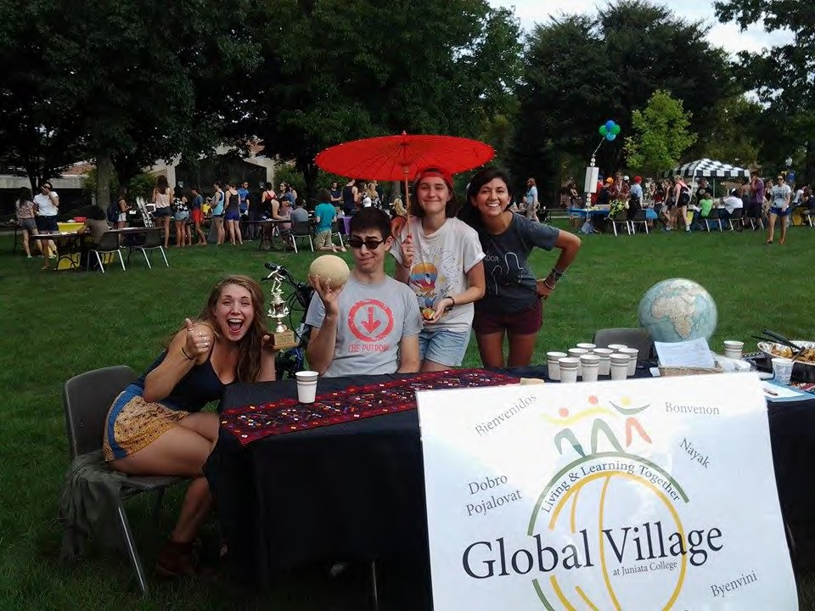

Huntingdon Map
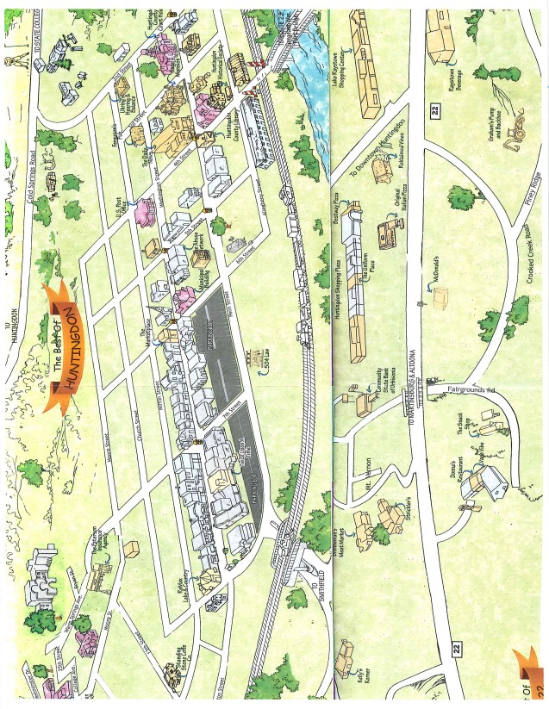

Cultural Life


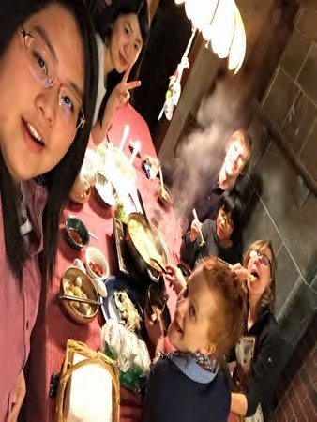
Friendship Family Program
The Friendship Family Program is the best opportunity to learn about life for Americans. These families are residents in Huntingdon who have expressed an interest in welcoming an international student into some part of their daily lives.
Perhaps this would mean someone you could call on to find out where to shop, to get a ride to the train station, to celebrate U.S. holidays or to stay with during a short holiday. A Friendship Family might also invite you to an occasional dinner at their home or include you in some of their family outings.
In turn, you will have an opportunity to tell them about your country and to do a bit of international public relations. The friendship you decide to develop or not to develop depends on you.
International students fill out a questionnaire, and a similar questionnaire is sent to each of the prospective host families. We highly recommend the benefits of having a friendship family locally to enable you to get to know people of the U.S. other than those you will meet at Juniata. We will provide you with an application and a chance to meet the families during the orientation period.

Family Activities
→ Potluck Dinners – shared dinner to celebrate cultures
→ American Holiday Dinners
→ Shopping Trips
→ Sporting Events

Family Participation
→ To invite the student to dinner or other family outings
→ To provide an atmosphere that is friendly and supportive to the students
→ To become aware of the student’s plans for holidays and break

Student Participation
→ To become a member of the family, not a guest
→ To honor commitments made to the family and be willing to share your time
→ To share your own culture

Contact
Jessica Martin, Friendship Family Coordinator
martinj@juniata.edu

Language in Motion
Language in Motion is an innovative, cooperative outreach program using international students, study abroad returnees, and upper-level language students to aid rural K-12 language teachers. Students create projects about language and culture.

Goals
→ Establish and maintain vigorous K-16 partnerships
→ Enrich teachers’ and students’ knowledge of language and culture
→ Provide all participants with opportunities for additional language practice
→ Provide the ability to look at culture from different perspectives
→ Increase interest in studying languages and cultures, at home and abroad

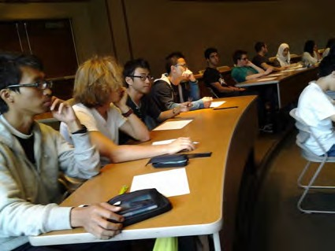
→ Provide college and study abroad role models to young people
→ Increase visibility for the college

Benefits
→ Opportunities for language practice and a new look at own culture
→ Chances to meet and work with new people
→ Respect for yourself and the language and culture presented
→ A better sense of the American educational system and school students

Sharing the World with K-12 Students
International students, upper-level language students, and study-abroad returnees regularly present in high school, middle school, and elementary classrooms to enrich language and cultural learning and to share their understanding of the country and culture. The teacher and presenter agree early in the semester on the level and amount of language to be used. In language classes and classes ranging from Social Studies, English, Biology, Art, Music, and Physical Education as well as Arabic, Cantonese, Mandarin, Dari, French, German, Greek, Japanese, Korean, Portuguese, Russian, Spanish, Urdu, Australian, and British English.

Contact
Jessica Martin, Language in Motion Coordinator
martinj@juniata.edu lim@juniata.edu Phone: 814.641.3493
Fax: 814.641.3185

Student Clubs

Advocacy  American Association of University Women  Colleges Against Cancer Environmental Coalition  Omicron Delta Kappa (The National Leadership Honor Society)  PAX-O (Peace Studies Club) Plexus  PRISM  Women in Physics | Arts  Dance Ensemble  Juniata College Knitting Club Mud Junkies  Social Dance
Club Sports  JC Divers  Men’s Rugby- Intercollegiate  Quidditch Club- Collegiate Ultimate Frisbee- Intercollegiate Women’s Rugby- Intercollegiate | Communications  92.3 WKVR  Communication and Media Club  Juniata Activities Board (JAB)
Cultural Chinese Club French Club German Club  Japanese Club  Juniata College Russian Club Korean Club  South Asian Student Alliance Spanish Club  Vietnamese Club | Entertainment & Gaming  JC Pokémon League  Ministry of Games
Outdoors  Archery  Juniata College Equestrian Club  Laughing Bush  The Wild Hunters of Juniata | Science  American Society for Microbiology (ASM)  Apiary Club (Bee Team)  Chemistry Club  Epidemiology Club  Health Occupations Students of America (HOSA)  Juniata College Student Chapter of Wildlife Society  Null Set  Pre-Veterinary Medicine & Animal Science  The Society of Phyics Students  Tri-Beta

Service  Big Brothers Big Sister (BBBS) Campus Girl Scouts  Caring for Kids with Cancer (CFKC)  Eco House  Habitat for Humanity  JC Emergency Medical Services (JCEMS)  Juniata Instructors of the Future (JIF) Mini-Thon  National Society of Leadership and Success (NSLS)  Pet and Animal Welfare Society (PAWS)  Social Work Club | Spiritual Catholic Council Hillel  Juniata Christian Fellowship (JCF) Unitarian Universalist Union (UUU)

For more information related to Juniata clubs and organizations can be found here: https://www.juniata.edu/campus-life/activities/clubs.php.

Culture Shock
No matter how prepared you think you are for your year abroad, you will experience culture shock. Climate, food, landscapes, people, and their habits will be different from what you are used to. The process of acclimatization is culture shock. Every person experiences this feeling to some degree. As you become adjusted to the culture, learn your way around, and make friends, it will become easier.
Common symptoms of culture shock include isolation and frustration; sleeping a lot; nervousness; homesickness; frequent crying; hostility towards the United States; and feelings of self-doubt.
To cope with culture shock, remember that it is a natural process that most people go through when traveling or living in a new country. Try to determine if your expectations of the situation were reasonable and how you can adjust your expectations to the reality. Keep an open mind and get involved in the community. You do not have to accept and adapt to the culture and the values of your new surroundings, but you will be able to cope better and enjoy the experience more if you can try to understand people and culture.

Adapting to New Surroundings
It is normal to have some ups and downs during the period of transition to a new culture. Culture shock does not happen all at once. It builds up gradually. Everyone experiences culture shock. Looking back on the experience, many say it was a source of insight and personal growth. Culture shock is not quite as shocking or as sudden as most people expect. It is part of the process of learning a new culture that is called cultural adaptation.

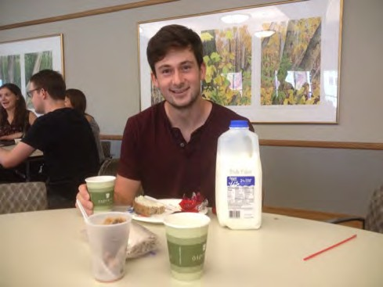
You might experience some discomfort before you are able to function well in a new setting. This discomfort is the culture shock stage of the adaptation process. The main thing to remember is that this is a very normal process that nearly everyone goes through. Just as you will bring clothes and other personal items with you to the US, you will also carry invisible cultural baggage when you travel. That baggage is not as obvious as the items in your
suitcases, but it will play a major role in your adaptation abroad. Cultural baggage contains the values that are important to you and the patterns of behavior that are customary in your culture. The more you know about your personal values and how they are derived from your culture, the better prepared you will be to see and understand the cultural differences you will encounter abroad.
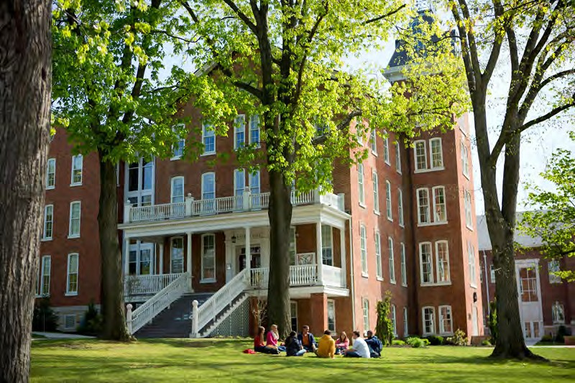

Academic Information
and Records

- Academic Requirements
- Course Level
- Grades
- Academic Services on Campus
- Academic Terms
Academic Requirements
Juniata College students design their education and focus their curiosity to connect ideas, develop skills to engage with people and issues, and learn to discern meaning, relevance, and value. Our Curriculum strengthens every student’s ability to solve problems, empathize with others, act with grace in the face of complexity, and understand that to get better answers, one must ask better questions.

The Intellectual Foundations of the Juniata College Curriculum

Three core themes are central to the Curriculum:
Connect: Students will be challenged to consider issues for which no single discipline has sole ownership.
Engage: A requirement of the Curriculum is embarking on projects that foster engagement between students and the surrounding town of Huntingdon.
Discern: Students will strengthen their ability to consider the world from different vantage points.

Ultimately, the Juniata College Curriculum aims to help graduates become intellectually agile and expansive enough to pursue any endeavor with a powerful and open mind. The Curriculum will provide an intellectual context for every student’s Program of Emphasis. And it provides a powerful way of finding one’s place in the world, challenging authority, and questioning assumptions.

Components of the Juniata College Curriculum
The Curriculum will help students seek answers to fundamental questions: How will I choose to live my life?
How and with what tools at my disposal will I understand the world? How will I choose to act in the world?

How will I choose to live my life?

Students reflect on values, beliefs, their knowledge, and their experiences.

First-Year-Experience courses (8 credits) support students as they transition to college life and scholarly expectations. Seminars in topics such as “Mars,” “Water Wars,” “The Good Life,” and “Leadership in the Contemporary Age” challenge students to consider issues for which no single discipline has sole ownership. Such study is informed by ethics, professionalism, epistemological skill, and more.

First-Year-Experience courses focus on developing and strengthening communication skills, strategies for navigating college life and the exploratory and practical demands of such work and engendering the resiliency necessary for success.

Through such work, students consider perspectives and develop reflective habits needed to decide what their “life of meaning” will look like. Students continue this work throughout their entire experience at the College.

How and with what tools at my disposal will I understand the world?

In our interconnected world, problem-solving requires a willingness to consider other perspectives—personal, cultural, professional, ethical, and more. The ability to understand other perspectives provides advantages in people’s ability to contribute in their communities and places of work.

Ways of Knowing courses (12-15 credits) help students strengthen their ability to consider the world from different vantage points—that of a historian, a scientist, an artist, a sociologist, or an educator, for example—and to experience how their own approach to a given issue gains dimension and clarity when considered through an interdisciplinary prism. In Ways of Knowing courses, students critique distinct disciplinary styles of inquiry, learn to connect ways of knowing, and confront the complexities in our urge to organize, synthesize, and impose meaning.

In a Connections course (3 credits), students consider a common topic through two ways of knowing that are quite different from one another. While Ways of Knowing courses focus on traditions of related vantage points (say, chemists and physicists), Connections courses are designed specifically to be team-taught by two faculty from disciplines intellectually distant from one another: chemistry and art, politics and geology, finance and literature, for example.

How will I choose to act in the world?

An important aim of the Curriculum is to help students develop a wide base of reference for sophisticated ethical questions that benefit from strong self-awareness and awareness of the complexity of others.

In Self and the World courses (10-17), students enhance interpersonal skills, gain experience understanding people with different histories, and consider diversity, culture, and ethics through varied experiences. Collectively, these courses help students decide for themselves how best to live a life of meaning. All students put this learning to use as they participate in both local and global community engagement work, a signature element of the Curriculum.

All students work on a Senior Capstone, a project that draws upon their total learning at Juniata. The capstone may involve global or local engagement, research, internships, extra-curricular or co-curricular experiences and more as part of student’s complete reflection on their education. Through the capstone project, students act on a project and complete both critical and personal reflections on the sum of their work.

The Enduring Value of the Juniata College Curriculum

The Juniata College Curriculum is designed to ensure that every student earns an education that is greater than the sum of courses taken. The Curriculum aims to enable students to connect disciplines, engage problems, and discern meaning. It sharpens students’ focus in the Program of Emphasis while expanding their ability to learn and adapt to new experiences and ideas outside their area of specific emphasis.

Juniata College works with its students as they earn the most useful and powerful kind of education—an education grounded in how to learn, how to communicate, and how to grow awareness and understanding of themselves and the world. A student’s successful completion of the Curriculum compels them to reflect on their individual learning journey and the ways their stories will apply to employment, to graduate school, to service opportunities, and other pursuits after graduation.

Grades
Grades are awarded according to the following scale:
→ A indicates work of the highest excellence, showing a superior grasp of content as well as independent and creative thinking in the subject
→ B signifies unusual achievement wherein the student reveals exceptional insight and ability
→ C is given for satisfactory achievement of the college level where the work in the course has been conscientious and shows no considerable deficiency in either quality or quantity
→ D indicates that the work in the course is below the quality normally expected for college work, but is only marginally so
→ F signifies work which is distinctly unsatisfactory at the college level
The above grades may be qualified by the use of a plus (+) or a minus (-). For the permanent record, a grade point average (GPA) is compiled and the GPA appears on the transcript. The following equivalents should be used for calculating the GPA.

A | 4.00 | C | 2.00
A- | 3.67 | C | 1.67
B+ | 3.33 | D+ | 1.33
B | 2.67 | D | 1.00
B- | 2.67 | D- | 0.67
C- | 2.33 | F | 0.00

Performance in a few courses is graded S (satisfactory) or U (unsatisfactory). But in the majority of courses, the grades listed about are given. Only grades of A (-), B (+, -), C (+, -), D (+, -) and S are given credit towards a degree.
In addition to the regular grade designations, the following irregular grades are used on occasion:

→ AU (audit). Students who register for audit classes will get this grade
→ I (incomplete). At the discretion of the faculty member involved, a grade of incomplete may be submitted. This option is to be used sparingly, however, and only when the student has given a satisfactory explanation (such as extended illness or accident) for failure to complete a required piece of work.
Otherwise, a student receives an F for a course which is not completed. Simple preference on the part of the student for an extension of time is not regarded as sufficient cause for granting an incomplete. Upon the granting of an incomplete, the students must complete the work within three weeks of the
beginning of the next semester of the academic year or an F automatically will be recorded. Both the instructor and the Registrar must approve any exceptions to this policy in writing.
→ WF and WP (withdrawal). Withdrawals from a course will be permitted up to the scheduled date (usually near the midterm date of the semester, or as stated on the course syllabus) with permission of the student’s faculty instructor and advisor. A withdrawal grade of WF or WP is recorded when a student drops a course after the official drop/add period. WP signifies that at the time of the withdrawal the student was passing the course, while an EF signifies that at the time of the withdrawal the student was failing the course; WP and WF grades are not calculated into the GPA. Unofficial withdrawals from all courses are recorded, as F. Withdrawals from class are considered unofficial if the student fails to make satisfactory arrangements at the office of the Registrar.
If students withdraw from all classes/the College, they must apply to the Student Academic Development Committee through the Registrar to be readmitted.

Academic Services on Campus

The Writing Center is located in the basement of the library and is a great place to go to have students proofread your papers for you. They will not fix your papers. They will show you some of your mistakes. They will expect you to take that knowledge and apply it to the rest of your paper. This is a free service.
If you need a tutor in an English for Academic Purpose class, see Elliot Hirshon in the Center for International Education. This is a free service.
If you need a tutor in course that is not in English for Academic Purpose Program, go to the Learning Services Office. Tutoring is free and you can have a tutor in any course you would like. Many students have tutors and they are a great resource if you need help in a class.

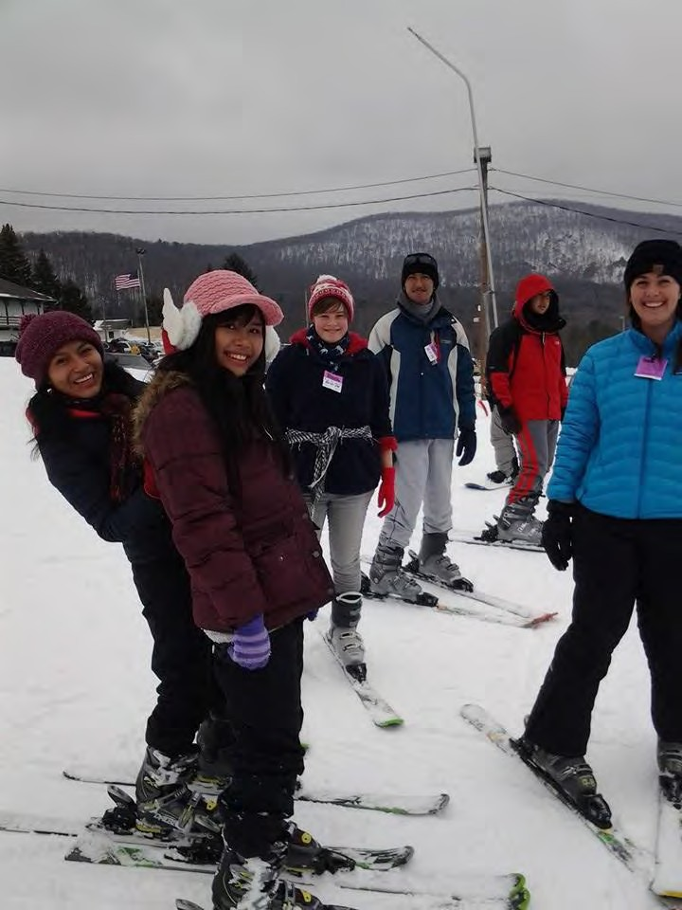

International Student Policies

- Immigration Information, Forms, & Documents
- Obtaining a Visa
- Important Note about Immigration
- Maintenance of Status
- Health Forms and Immunizations
- Deposit
- Types of International Students
- Reminder About Juniata’s Policies
33 |
- Replacing Lost or Stolen Documents
The International Student Services staff in the Center will answer all questions concerning your nonimmigrant status as a student in the United States for International Education.

Immigration Information, Forms, and Documents

The U.S. Department of Homeland Security’s (DHS) Student Exchange Visitor Program is responsible for the Student and Exchange Visitor Information System (SEVIS). SEVIS is a database system used to track and monitor schools and programs, students, exchange visitors, and their dependents throughout the duration of approved participation within the U.S. education system.

Passport  - Passports must be valid for six months beyond the day you will enter the United States and should be kept valid during your time in the U.S.  - Please make a copy of the first page of your passport and keep it in a safe place. | Visa  - Stamp entered on one of the pages of your passport obtained from the U.S. Department of State at an U.S. embassy or consulate.  - The visa gives the student permission to apply at port of entry for admission to the U.S.
I-20 – F-1 Visa  Certificate of Eligibility for Nonimmigrant F-1 student  - This form allows a student to obtain an F-1 student visa from an U.S. consulate or embassy.  - The I-20 document has information like what you will study and how long you can stay in the U.S.  - Bring the I-20 document with you when you travel to the United States for the U.S. Customs and Border Protection Official to look at when you arrive at the port of entry. | I-94 Departure Record  - The electronic record identifies your place and time of entry and departure with a specific number and your alien registration number.  - Students can print their I-94 at https://i94.cbp.dhs.gov/I94/consent.html
DS-2019 - J-1 Visa  Certificate of Eligibility for Exchange Visitor J-1 Status  - This form allows a student to obtain a  J-1 student visa from an U.S. consulate or embassy.  - The DS-2019 document has information like what you will study and how long you can stay in the U.S.  - Bring the DS-2019 document with you when you travel to the United States for the U.S. Customs and Border Protection Official to look at when you arrive at the port of entry. | **Important**  The Department of Homeland Security requires Juniata to keep records of the student passport, visa, I-20 or DS-2019, and I-94 documents. During the orientation period, the Center for International Education will ask you to bring these items to the office.  You should also keep records of all these documents and keep all versions of the original I-20 or DS-2019 documents.

Obtaining a Visa
Please visit our Visa Information site at:
http://www.juniata.edu/academics/departments/international/international-students/visa.php

Important Note about Immigration
Immigration rules and regulations are very complex and specific. You should always speak with a staff person in the Center for International Education about immigration and visa issues.

Maintenance of Status

Maintaining Status for F-1 and J-1 visa students
- Keep a valid passport.  - Attend classes where you are authorized to attend and maintain full-time academic status (minimum of 12 credits).  - Refrain from off-campus employment without authorization and limit on-campus employment to no more than 20 hours per week while school is in session.  - Report any change in address to the Center for International within 10 days of the address change. You may email international@juniata.edu | - Obtain signatures on immigration documents from the Center for International Education before traveling outside of the United States. You may need a new visa to re- enter the U.S. Please check with the Center for International Education.  - Apply for an extension on the  I-20 or DS-2019 at least 30-45 days before the completion date.  - Keep all immigration documents in a secure place. Keep all original copies of the I- 20 and DS-2019.
Maintaining Status Regulations for F-1 Students
“Undergraduate study at a college or university, certified by a school official to consist of at least twelve semester or quarter hours of instruction per academic term in those institutions using standard semester, trimester, or quarter hour systems, where all undergraduate students who are enrolled for a minimum of twelve semester or quarter hours are charged full-time tuition or are considered full-time for other administrative purposes, or its equivalent (as determined by the district director in the school approval process), except when the student needs a lesser course load to complete the course of study during the current term…” [8 CFR 214.2(f)(6)(i)(B)].
“Current name and address. A student must inform the DSO and the Service of any legal changes to his or her name or of any change of address, within 10 days of the change, in a manner prescribed by the school. A student enrolled at a SEVIS school can satisfy the requirement in 8 CFR 256.1 of notifying the Service by providing a notice of a change of address within 10 days to the DSO, who in turn shall enter the information
in SEVIS within 21 days of notification by the student” [8 CFR 214.2(f)(17)].

Medical Insurance
Students will enroll in the Juniata College insurance policy in order to maintain compliance regarding government regulations related to insurance requirements.
→ Unlike many other countries, in the U.S., the government does not pay for medical costs.
→ Medical costs are the responsibility of the person receiving treatment.

If you have an accident (such as breaking your arm while skiing) or are treated for any medical illness, it is imperative that the college is notified of this occurrence as soon as possible, even though the treatment may have been received in another location.

Students are encouraged to visit our on-campus Health & Wellness Center. If there is a medical need outside of their office, the local hospital JC Blair Memorial Hospital is located very close to campus.

Additional local care centers:
Penn Highlands QCare Walk-In Clinic: Lake Raystown Shopping Center, Huntingdon. 814.643.8750. Monday through Friday 8am-7:00pm, Saturday-Sunday 9am-4pm
Broad Top Walk-In Medical Care: Walmart Shopping Plaza, Huntingdon. 814.643.1232. 7 days a week 9am-9pm

Health Forms and Immunizations
Prior to your arrival, the Center for International Education will send you student health forms; a medical doctor or health care provider must complete these documents. You must return the forms prior to your arrival to campus. All students are required to have specific immunizations as required by law in Pennsylvania. For the Health Forms please visit:
https://www.juniata.edu/orientation/2023updatehealthform.pdf

Deposit
You must pay a deposit to the college prior to your arrival. This fee insures that any library fines, damages to your room, etc., will be paid for. If you have no fines or cause no damage, this money will be returned to you in cash before you depart at the end of your stay at Juniata.
It is your responsibility to complete the checkout process. Juniata will not release your grades (to you or your home institution) until after the checkout process is completed in its entirety. The checkout process has four steps. All must be completed in order to receive your deposit back and/or have your transcript released.
After you have completed all four steps your transcript will be released and you will be able to receive your deposit back.
- Exit Survey: After completion, print out the completion page and return to the CIE. You will need to show the completion page to receive your Contingency Deposit Form.
- Reentry Workshop: The workshop is to get you to think about your time at Juniata and

how you’ve changed since arriving. We will talk about changes that might affect you when you return home and how to deal with reverse culture shock. This will take place at the end of the semester and dinner will be provided. This is a mandatory event.
4. Contingency Deposit Form: This is the official form to check out of Juniata. You will receive this form from the CIE after you’ve completed steps 1-3. Several offices have to sign off on the form to make sure that you do not owe the college money. Once it is complete, return it to the CIE for Shya to sign off on BEFORE you take it to the Bursar’s Office where they will issue you your deposit in cash.

As part of the Contingency Form you need to check out of your room with someone in the Residential Life Office and return your housing key. You should make an appointment with the RA/CA/RCL one or two days before you are leaving. It is your responsibility to work with your RA/CA/RCL, because this check has to be done as close to your checkout as possible.
NOTE: It is your responsibility to make sure you pay any outstanding balances, including any hospital bills, and return all items borrowed. Failure to do so will result in a hold placed on your account.
If you have anything useful that you cannot take with you, you can bring it to the CIE for future international students.
For more information: http://www.juniata.edu/academics/departments/international/international- students/check-out-procedure.php

Types of International Students

Type | Description
Degree | Students that will be accepted to Juniata through the admissions process. They will complete the program in four or fewer years. The student might transfer credits  from a previous university.
Exchange | Students that are here for one or two semesters to learn about American culture while studying academic content which results in transferring credits to their home  institution.
English for Academic Purpose | Students that will be accepted to Juniata through the admissions process. Students may be enrolled in the EAPP Program for one or two semesters, studying primarily in the English for Academic Purpose Program.
Non-degree | Students who are here to enroll in language courses or complete home university requirements – a combination  of course work and research.
Pathway | Students that will be accepted to Juniata through the admissions process. Students may be enrolled in the Pathway Program for one or two semesters. Student are enrolled in a combination of courses within the English for Academic Purpose Program and degree seeking courses.

Reminder about Juniata’s Policies
All international students are required to adhere to policies as listed in The Pathfinder. The Pathfinder is written and issued by the Dean of Students Office and is designed to provide students with information about the policies, procedures, and services of Juniata College. All Juniata students are expected to be thoroughly familiar with the information presented in the Pathfinder: https://www.juniata.edu/offices/dean-of-students/pathfinder/

Replacing Lost or Stolen Documents
File a police report for lost or stolen passport then follow these instructions in order to replace lost or stolen documents:

Passport
Contact or review website information for your country’s embassy or consulate in the U.S. to find out how to obtain a new passport and to notify your embassy of your missing passport.
→ Contact information for foreign embassies in the U.S. can be found at: http://www.state.gov/s/cpr/rls/fco/
→ Web site addresses for foreign embassies in the U.S. can be found at: http://www.embassy.org/embassies/. Links to consulate offices (the closest is usually in NYC) are usually available from the embassy homepages.
→ If you have lost all of your photo identification, contact your country’s embassy or consulate to find out what alternate documents you might need.
Generally, in the case of the loss of official documents, you have to file a report with the police in the area where your documents were lost or stolen as soon as the incident occurs. The Center for International Education can assist you with this.

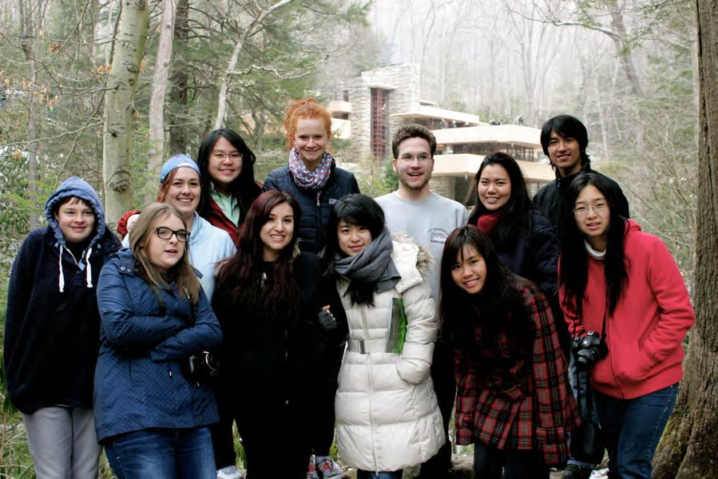

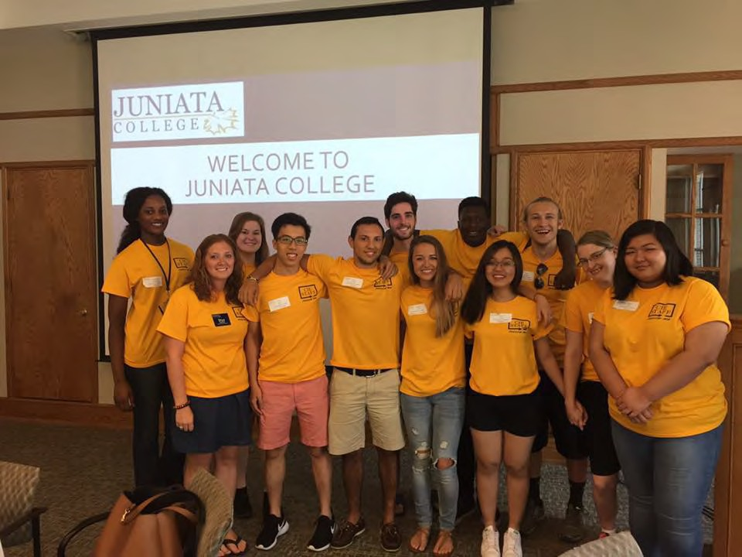

Employment

- Campus Guidelines
- On-Campus Employment
- Off-Campus Employment
- J-1 Student Academic Training
- Social Security Process
Employment Guidelines
When a student has student visa status (F-1 or J-1) to study in the United States, he or she must maintain that status at all times to be eligible for employment. All students must obtain a social security card to be employed and must complete the necessary paperwork in the Office of Human Resources.

On- Campus Employment

  - Students

On-campus employment is permitted as long as the student is registered as a full-time student and the following is provided:

→ You are maintaining F-1 status and are in good academic standing
→ You do not work more than part-time
    - 17.5 hours per week at Juniata
→ No special authorization is required with the Student Exchange Visitor Information System (SEVIS)
  - Students
On-campus employment is permitted as long as the student is registered as a full-time student and the following is provided:
→ You are maintaining J-1 and are in good academic standing
→ You do not work more than part-time
    - 17.5 hours per week at Juniata
→ J-1 students must provide specific information to the Center for International Education about the on-campus employment. The information should include: employer name; employer address; number of hours per week; employment beginning and end dates.
→ The Center for International Education staff will report the on-campus employment in the Student Exchange Visitor Information System (SEVIS)

Off- Campus Employment
Curricular Practical Training (CPT) is available if the employment is an integral part of an established curriculum. F-1 students must be in-status for nine- months before qualifying for CPT. CPT is defined to be alternate work/study programs, internships, cooperative education programs, or any other type of required internship or practicum which is offered by sponsoring employers through cooperative agreements with the school. The training must be a required part of the major for all students in the major for all students and a requirement for degree completion.

Eligible CPT POE’s/Courses:
Art History & Museum Studies - AH 490 or AH 001
Education - ED 419 and ED 450
Exercise Science & Kinesiology - ESK 498
History & Museum Studies - HS 490 or HS 00
Information Technology - Noted that all students must complete an internship.
Social Work - SW 330 and SW 490
More information on Curricular Practical Training.

Optional Practical Training (OPT) is defined as “temporary employment for practical training directly related to the student’s major area of study” for a maximum of twelve months before qualifying for OPT. The Center for International Education will hold workshops every year to help students with the OPT employment authorization process.

The Center for International will hold workshops every year to help students with the Optional Practical Training employment authorization process.

More information on Optional Practical Training.

STEM OPT extension is a 24-month period of temporary training that directly relates to an F-1 student's program of study in an approved STEM field.

More information on applying for STEM OPT Extension can be found here.

Additional information regarding STEM OPT Extension Overview can be found on the Study in the States website.

J-1 Student Academic Training
Academic training is employment or training that is authorized for a specific period of time in order for students in J-1 visa status to gain practical experience in their field of study. Academic training must complement a student’s academic activities and supplement the stated program objectives.
What are the Eligibility Requirements?
→ You may work no more than 17.5 hours per week while school is in session and 40 hours per week during summer and vacations
→ Your primary purpose must be to study rather than to engage in academic training only. You must be enrolled in at least 12 credits at Juniata
→ You must be in good academic standing
→ The proposed academic training must be directly related to your field of study as listed on your DS-2019 form
→ If the academic training is after the completion of your studies, you must begin the training no more than 30 days after the completion of studies
More information on the Academic Training Program.

Social Security Process

A Social Security Number is a unique identifying number assigned by the national government to all United States Residents. The number is used for employment purposes in the United States in order to report wages to the government.
Generally, only non-U.S. citizens who have permission to work from Department of Homeland Security (DHS) can apply for a Social Security Number. To apply for a Social Security Number:
→ Meet with the Center for International Education Staff.
→ Complete the Application for a Social Security Card (Form SS-5)
→ Show original documents proving immigration status, work eligibility, age, and identity. These include: Passport, visa, I-94, and I-20 or DS-2019.
→ Take completed application and original documents to the local Social Security Office.
Immigration Status: To prove your immigration status, students must present the current immigration document, I-94, Arrival/Departure Record and your visa page in your passport. If you are an F-1 student, you must also provide your I-20, Certificate of Eligibility for Nonimmigrant Student Status. If you are a J-1 student, you must show your DS-2019, Certificate of Eligibility for Exchange Visitor Status.
You must also show the visa page in your passport and the I-94 card.

Work Eligibility F-1: As an F-1 student, you must present a letter from the designated school official (staff in the Center for International Education) and your employer.
- The letter from the Designated School Official (the visa officer in the Center for International Education) should indicate you are in good academic standing and have valid F-1 status.

- The letter from your employer must be in official letterhead and should include the following information:
  - Identity of employee
  - Nature of job the student is, or will be, engaged in
  - Anticipated or actual employment start date
  - Number of hours the student is expected to work
  - Employer Identification Number (EIN)
  - Employer contact information, including the telephone number and the name of the F-1 student’s immediate supervisor
  - Original signature and signatory’s title
  - Date

Work Eligibility J-1: As a J-1 student, you must present a letter from the responsible or alternate responsible officer (the visa officer, Shya Erdman, in the Center for International Education) on the exchange program letterhead. The letter from the responsible or alternate responsible officer should indicate you are in good academic standing, have valid J-1 status, and have employment.




Travel and Holidays

    - Residence Hall Closing
    - Travel Plans
    - American Holidays
    - Personal Safety
    - Academic Calendar
Residence Hall Closings
→ College residence halls may close during Thanksgiving Recess, Spring Recess, and between semesters from mid-December through mid-January.
→ No food is provided by the cafeteria during these times.
→ Students can sign up for break housing and pay a small fee.
For specific closing times: http://www.juniata.edu/academics/departments/international/international- students/pre-arrival-planning/travel.php

IMPORTANT NOTE: Students must plan to stay through the end of their scheduled exams. Exams cannot be rescheduled due to travel plans.
During the semester break from mid-December to mid-January, the campus is closed. Students needing to stay on campus must sign up for break housing and pay break housing fees.

Planning Your Travel
International students usually want to see as much of the United States as possible. Fortunately, the school academic calendar permits time for this. The Center for International Education has a variety of materials and resources to help you if you need suggestions for planning vacation trips, but the Center and its staff are not a travel agency.
We ask you to notify us in a timely manner of your travel plans, and we will help with transportation to and from local points of departure and arrival. The CIE does not provide transportation. Harrisburg, New York, Philadelphia, or Washington, D.C., State College, Altoona, and Huntingdon are appropriate arrival and departure points.
International Education and other campus groups will provide announcements regarding the cost and details for those trips through the campus email system.
Possible travel during a three-day weekend:

New York 280 miles

Washington, D.C. Philadelphia Pittsburgh Boston
155 miles
172 miles
117 miles
484 miles

American Holidays
Legal and Business Holidays
- New Year’s Day (January 1): Celebration of New Year’s Day usually occurs the night before (New Year’s Eve) when it is common for groups of people to have a party to celebrate the coming of the New Year. It is customary at midnight, when the New Year officially begins, to make loud noises, toss confetti, and embrace or kiss others.

- Memorial Day (May 30, or closest Monday): Homage is paid to U.S. soldiers who have died in wars.
- Independence Day (4th of July): Parades, family or social picnics, and fireworks celebrate the U.S. public declaration of independence from Great Britain.
- Labor Day (1st Monday in September): Notes the importance of labor and labor organizations.
- Thanksgiving Day (4th Thursday in November): A celebration of the harvests of the first settlers (Pilgrims) in the U.S. Families gather and have a large traditional meal that includes turkey and pumpkin pie.
- Christmas (December 25): Began as a Christian holiday marking the birthday of Jesus Christ, it is now widely accepted as a day of friendship and gift giving. Preparations include decoration of homes and public places, visits by the mythical character “Santa Claus,” shopping and the wrapping of gifts to exchange on Christmas Eve or Morning.
Informal (but very important) Holidays
- St. Valentine’s Day (February 14): A day for lovers to exchange cards and/or gifts. Children in primary school usually exchange small valentine’s cards with classmates. Businesses do not close for this holiday because there is a tremendous sale of flowers, candy, cards, gifts, etc.
- St. Patrick’s Day (March 17): Day dedicated to the patron saint of Ireland. Traditionally, green is worn on St. Patrick’s Day.
- Mother’s Day (2nd Sunday in May): Gifts and cards and/or special attention are given to mothers and grandmothers.
- Father’s Day (3rd Sunday in June): Gifts, cards and/or special attention are given to fathers and grandfathers.
- Halloween (October 31): A children’s holiday, associated with carving faces on pumpkins (called Jack-O-Lanterns) and decorating with images of ghosts, witches, and cats. Children dress in costume to attend parties or go “trick or treating,” by going door to door in their neighborhood and being given a piece of candy (the “treat”).
- Election Day (Tuesday after the 1st Monday in November): People may leave their workplace long enough to vote in municipal, county, state or national elections.
Other holidays such as Kwanza, Ramadan, Diwali, and Chinese New Year are commemorated on campus by activities sponsored by student groups.

Personal Safety
It is very important that you watch your belongings at all times while you are in large cities, train stations, airports and other public places in the U.S. The bustling, transient nature of these places is a perfect climate for would-be thieves, ready to take advantage of a weary traveler or worker who is not protecting their things. It is advisable to carry only small amounts of cash ($20.00-$50.00 at the most) General safety tips to protect you and your valuables:
→ Do not leave your bags unattended in public places, even if you are only walking away from them for a few minutes.
→ Do not carry your passport everywhere, except for the first few weeks of your stay at Juniata – you will need it.
→ Make photocopies of your important documents and carry them with you.
→ Put your cash in several different locations on your body – sock, pocket, bag, etc.
→ Be aware of your surroundings.
→ If a stranger does try to steal your bag, do not fight them. A few belongings are not worth risking serious injury.

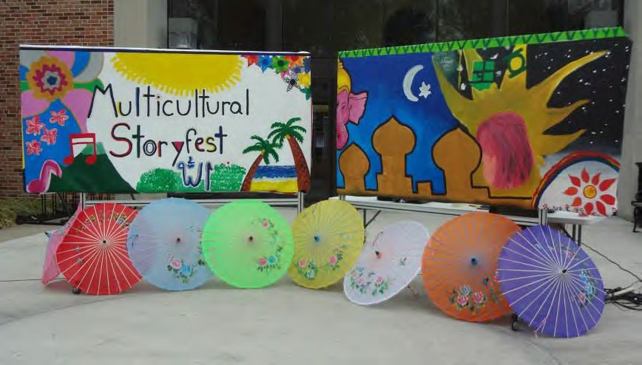

Academic Calendar 2023-2024
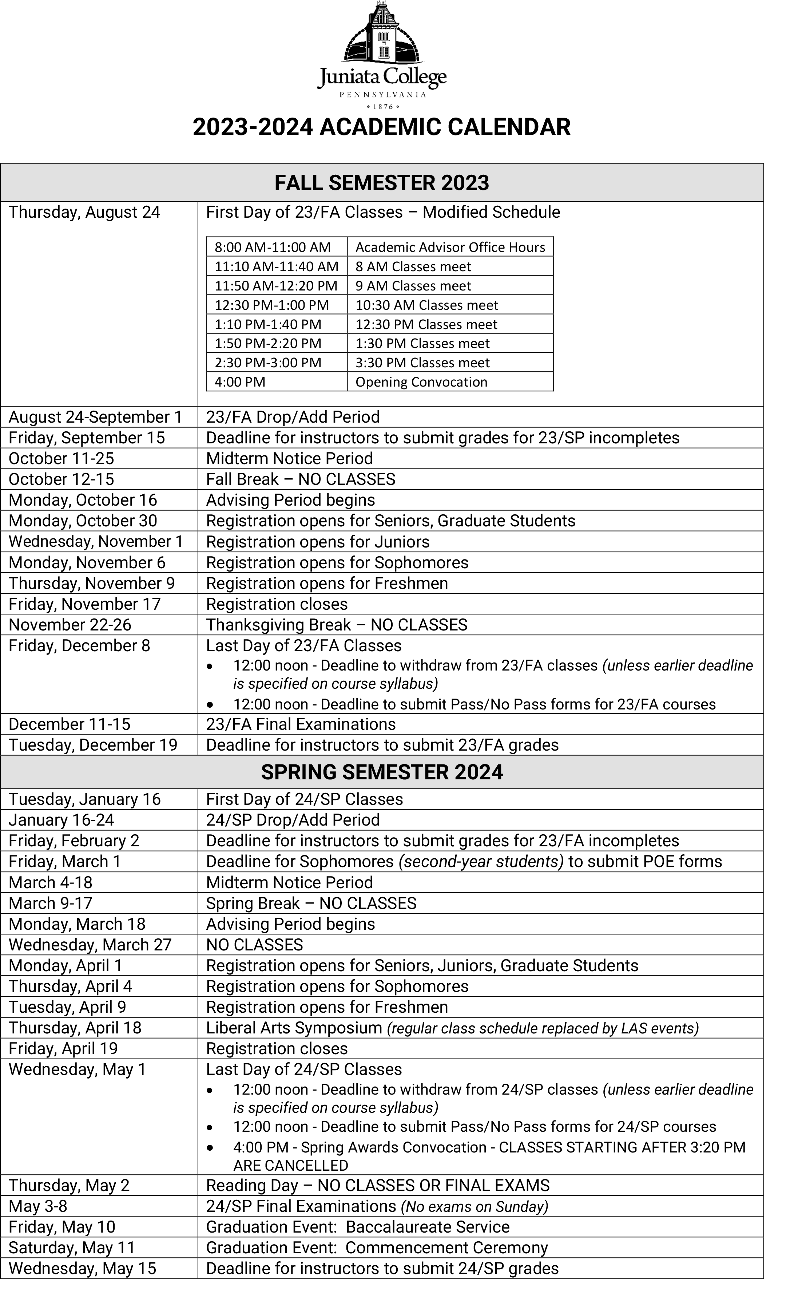

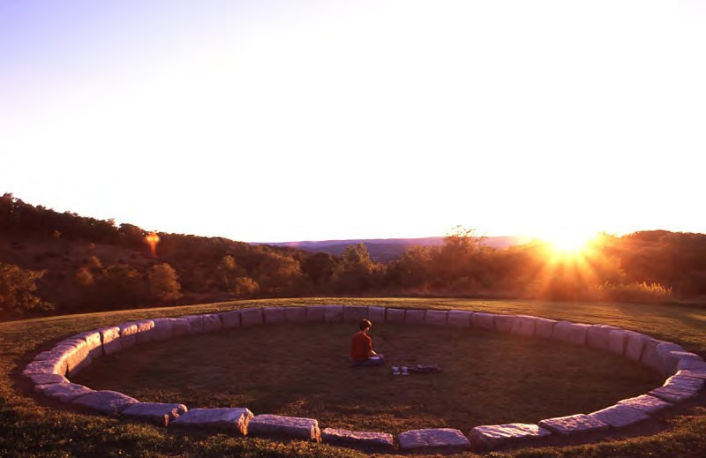

Frequently Asked Questions
Academics

Do the Professors assign a lot of assignments and homework?
This depends on the professor and course that you are taking. There are a variety of classes at this college. You might have classes that require homework for every class; some classes recommend material to look at but do not require you to do it; and some do not have any homework because they are lecture classes that you are recommended to follow the readings that go with the lecture.

What happens if I fail an exam?
If you fail an exam, it is not the end of the world. You should talk to the professor and see if there is anything that you can do to bring up that grade. You also have the option of asking your professor to recommend you for tutoring through Academic Support Services. Tutoring for any of your classes is free.

How do you know what assignments you have? What percent of your total grade is each assignment?
The assignments may be either given to you during class or at the beginning of the semester in the syllabus. Some professors use Moodle (an online system) to show what assignments are due each week. Read the syllabus at the beginning of the semester to find out how much each assignment is worth. If you are confused about an assignment, you should talk to that professor; each professor has a different way of grading that is usually provided to you in the syllabus.

When are the final exams?
Final exams are at the end of the semester and the schedule is sent out through email from the Registrar’s Office around the 3rd or 4th week of school.

What happens if I am late to class?
Depending on the class, there are different consequences. Some professors require you to be on time or you might get points off on your next assignment. Other professors will allow two to three absences and might tolerate students coming late to class. This information should be in the syllabus; if not, you should talk to the professor. Also remember that classes at Juniata are typically small; therefore, if you arrive late, you will cause a disturbance.

What’s the average mark to pass? What grade is a pass?
A grade of a C is the average to pass a course. Some professors have different grading scales, but the one used by the school can be found at: https://www.juniata.edu/catalog/planning.php. You can also talk to the Center for International Education about how your grades will transfer.

What English proficiency level do students need for lecture?
In terms of English proficiency, students should be comfortable with the language and should talk to classmates and the professor about material that is covered in the course that you might not have understood. A TOEFL score of 80 iBT (550 PBT) or better is required for unconditional admission to Juniata. Results from other English proficiency tests such as IELTS, Pearson Academic PTE, and Duolingo DET will also be accepted.

Applicants with TOEFL scores under 80 iBT (550 PBT) may be admitted conditionally. Juniata administers an online placement exam during the orientation when students first come to campus, plus an oral interview and a writing assessment. Most students who test below 80 iBT are required to take some ESL courses in the English for Academic Purpose Program. Often students with scores above those levels choose to take ESL courses in the EAP Program because they want to be sure to have a strong foundation in English.
Do Professors take into account that you are an International Student? Most of the professors will try to take into account your international background. Some professors might even use your knowledge of a different culture as a way of examining other aspects of their course. Some professors might not be aware of your struggle, so you might need to talk to them about any issues that you are having.

When the professors assign books and material to buy and read, how extensively should we go through this material?
It is important to understand the material because some professors give quizzes on reading assignments, where other professors will have discussion on the readings.

How do the professors grade?
Each professor has a different way of grading, and this will be communicated to you through the syllabus that is handed out the first day of classes. If you have any questions about the grading, feel free to talk to that professor.

How does Moodle work?
Moodle is a Learning Management System that is used by the school and some of the professors to help organize courses, get information to the students, and centralize grading. Some professors use this system more than others. Moodle is found on the Internet through moodle.juniata.edu. It is recommended that you ask the professor any questions you have about Moodle so that you are familiar with the program.

What do I do if I struggle with a class? Where should I go? Who should I talk to?
If you are struggling with a course, you should talk to the professor to see what you can do to bring up your grade or understand the material better. You can also talk with the staff of the Center for International Education or your advisor regarding classes that you are struggling with to get their input on the situation. You can also talk to Learning Services to request a tutor who will help you understand the information in the class.

Would there be room to change a class if I was really struggling?
As a last resort, if you are struggling with a class and have talked to the professor, advisor, and the International Office, then you might be able to drop the class.
However, there is a point during the semester when you are no longer able to drop classes. Once the Drop/Add period is over, then you are only able to withdraw from a class. Withdrawing means that you did not finish the course, a W will be recorded on your transcript if you drop the class after the drop/add deadline. You must maintain the minimum of 12 credits each semester.

How many hours are we supposed to study per day?
As a full-time student, you are required to be enrolled in at least 12 credits. It is recommended that you spend two hours studying for each one-hour lecture.

What will be on the exams?
If the syllabus lists readings as required, you should plan for it to be on the exams and quizzes (even if it is never discussed in class.) If the reading is listed as optional, reading the material will make you more informed and possibly allow you to obtain a better grade when you include that material in your discussion and papers. Read the assignments before the class session.

Who do I talk to about making sure that all my immunizations have been received?
You can refer to the Health and Wellness website for more information about Juniata’s Immunization Policy at: https://www.juniata.edu/offices/health/immunization-policy.php.

Who can I go to for help in managing my stress?
You can go to Glaeser Counseling Services and request an appointment with one of the counselors. They will be able to help you relieve your stress. You can also talk to the Center for International Education about any concerns you have.

How do I address my professors?
Americans tend to be very informal except in academics. The majority of professors at Juniata have a Ph.D and are entitled to be called “Dr. Last Name.” You can also use “Professor Last name.” Do not use Mr. or Ms. unless you know that the professor does not have a Ph.D. Do not use Mrs. when addressing a female professor; always use Ms. You might be invited by a professor to address that her/him by a first name. Once you are invited to call a professor by their first name, please feel free to do so. If you are unsure of how to address your professors, just ask them.
Transportation/travel

Is there any public transportation?
There is an Amtrak station in the town. The trains go to both Pittsburgh and Philadelphia once a day. If you change trains, you can go to New York City, Washington D.C., Chicago and other cities. GoDezi provides local transportation. Please make reservations in advance. Do not assume they will always be available. More information regarding transportation can be found here: https://www.juniata.edu/academics/departments/international/international- students/pre-arrival-planning/travel.php

How can I get to the airport?
Juniata offers transportation to the airport in State College before each break. You will get announcements about the costs and dates via e-mail during the semester.

Do you organize any trips?
Yes. Announcements regarding the cost and details for these trips are sent via the campus e-mail system. In the past, there were trips to New York City, Philadelphia, and Washington D.C.

Can you help me arrange travel plans if I decide to go somewhere during the semester or for the break?
We have resources to help you if you need suggestions for planning vacation trips. Please note that the Center for International Education and its staff are not a travel agency.

CampusLife

What if I have a problem with roommate/roommates?
It might be a new experience for you to share a room with someone. Sometimes, the adjustment process can be challenging. But try to be open and talk to your roommate about any issues that you are having before they become huge issues. If you have problems, you can talk to your RA. You can also talk to us.

Is it possible that I will get an international roommate? Can I choose not to have an international roommate?
Usually, you will get an American roommate who is interested in having an international roommate. There are some exceptions.

What if I become homesick? Is there anyone I can talk to?
Feeling homesick in another country is common to many people. There are ways to cope with it. You should bring things from your country, such as music, pictures, and books. Calling home and friends can be helpful. You can also talk to other international students at Juniata since they might be feeling the same way as you. You can talk to the staff of the office.
What should I do when I get sick? Is there a doctor/nurse on campus? Yes. Juniata has the Health and Wellness Center. There is a nurse during weekdays and a doctor is in twice a week. You should bring your medicines and prescriptions with you.

What can I do on the weekend?
There are various activities on campus such as games and cultural events. During a three-day weekend, it is possible to go to New York City, Washington, D.C., Philadelphia, and Pittsburgh. Remember, you will be studying a lot.
Food

Is the Dining Hall open all the time throughout the academic year?
It will be closed on special occasions; however, you will be notified beforehand. There are other places on campus that you can get meals such as Jitters, Eagles Landing, and Café A La Carte.

Can I buy imported international food in the town?
We have some imported international food sold in supermarkets in the town. If you go to State College or Altoona, it is possible to find more.

Can I cook in a residence hall?
There is a kitchen in most of the residence halls. Pots, pans, and other cooking materials are sometimes available. Ask your RA for help in scheduling kitchen use. Please note that you will be sharing a kitchen including a refrigerator and a microwave with others. These kitchens are not intended for making all of your meals, but just every once in a while.

Mail

To Receive Your Package Mail:
When a package arrives for you, you will receive an email and a white paper will be
placed in your mailbox. Present the paper at the window when the post office is open
to receive you package.

There is no mail pick up or delivery on Federal and Juniata administration
holidays.

Can I buy USPS boxes from the post office?
Yes, we even have a few UPS and FedEx items to help you (free of charge). If we don’t
have it, we might be able to get it for you. Just ask.

Can I pay with my Juniata gold card or a debit/credit card at the post office?
No, Juniata’s post office does not accept debit/credit cards nor DCBs from your Juniata
gold card. You can pay by cash or check.

What happens to my mail over fall/spring and summer break?
Your mail is held at Juniata’s post office over the fall/spring break periods. During summer
break, mail is forwarded to your home address, unless you ask the post office to hold your
mail. If you are living on campus during summer break, let the post office know so you can continue to get your mail.
THE COST OF A REPLACEMENT KEY TO THE MAILBOX: $25.00

YOUR NEW ADDRESS: To receive your mail as quickly as possible, always use your box number. Here are two examples:
Your Name
Juniata College
Box Number
1700 Moore Street
Huntingdon, PA 16652
Your Name/box number
Juniata College
1700 Moore Street
Huntingdon, PA 16652

JUNIATA’S POST OFFICE HOURS
Fall and Spring Semesters:
Monday-Friday 10:00 am—4:00 pm.
Summer:
Monday-Friday 10:00 am- 3:30 pm.
CLOSED all Federal and Juniata holidays

Lori Hughes, postmaster - (814) 641-3370 - jcpostoffice@juniata.edu - www.juniata.edu/services/post

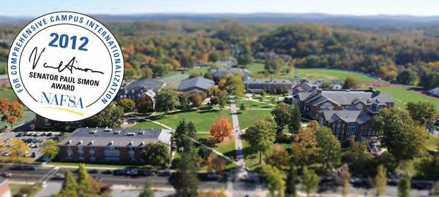

Center for International Education
1700 Moore Street
Huntingdon, Pennsylvania 16652

Phone: 814.641.5331
Email: international@juniata.edu

