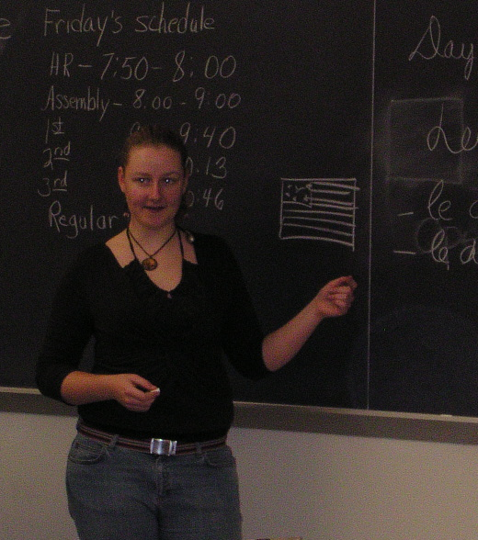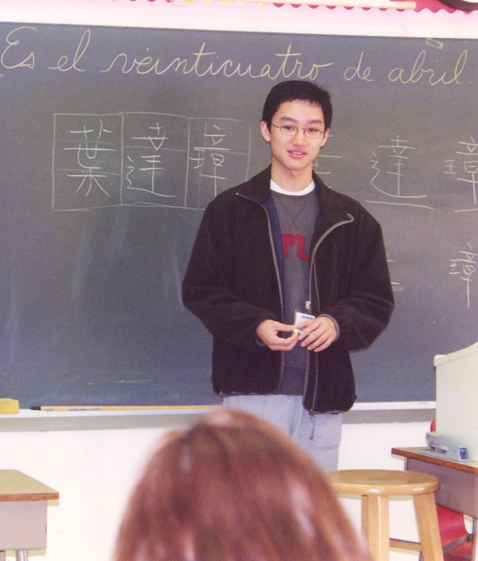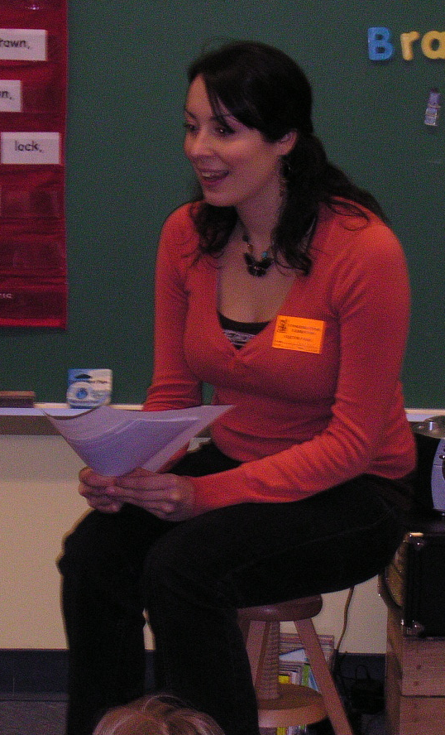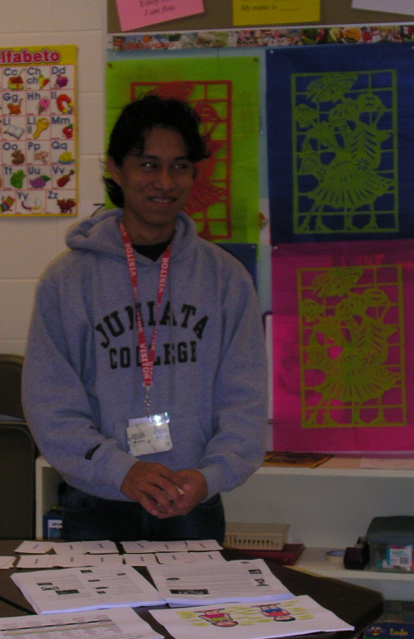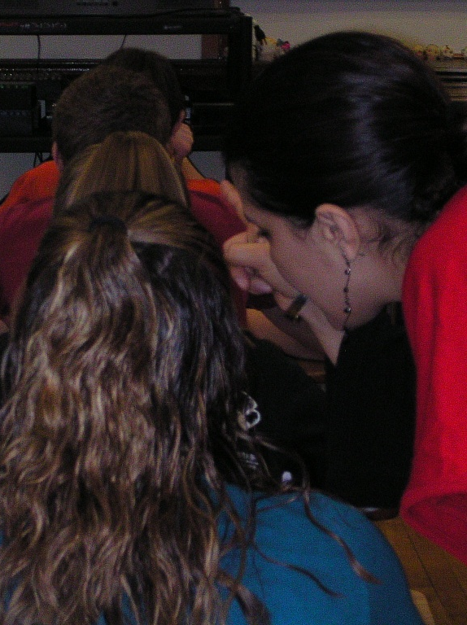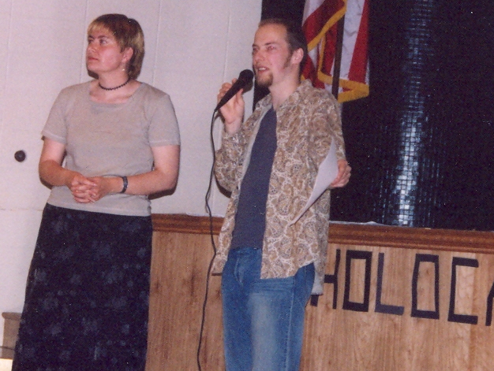

Language in Motion

Enjoying your international experiences?
Enthusiastic about language learning?
Interested in sharing your cultural & language adventures?

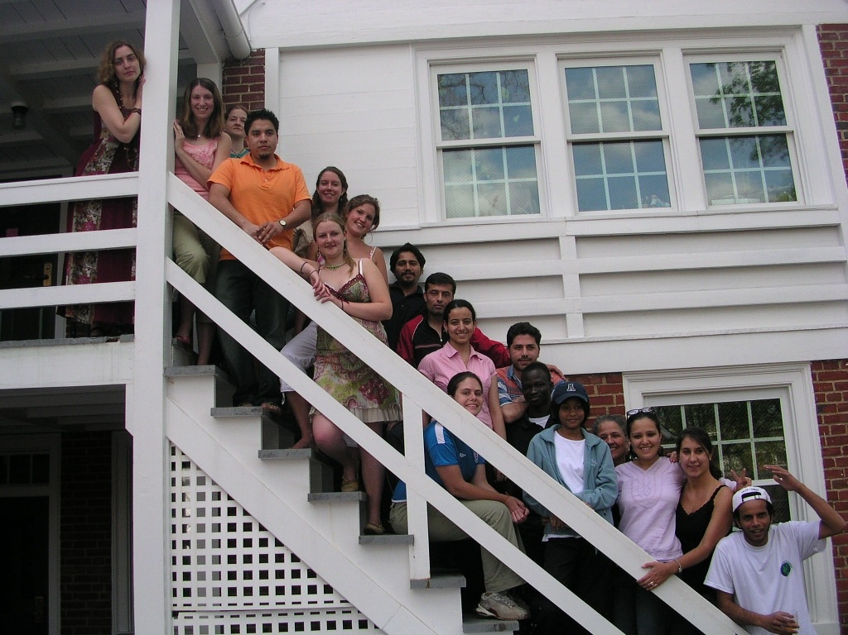

- Elementary, middle, and high school students await you
- No teaching experience needed
- All POEs welcome
- Earn one credit (WL 201) or volunteer

Come and discover Language in Motion!!

Contact us at lim@juniata.edu
Phone: 814-641-3493 or Fax: 814-641-3155
For more information, contact us or see our website: http://www.juniata.edu/departments/international/lim/students.html

