Fall 2008 CIE Faculty/ Staff Workshop: International Student Advising
Sill Boardroom, Tuesday, October 14, 4-5pm
Presenters: Kati Csoman, Jen Cushman, Prudence Ingerman, Song Gao, Gretchen Ketner
Participants: Judith Benz, Henry Escuadro, Nick Felice, Holly Hayer, Kim Roth, Dan Welliver
Agenda
4:00 Welcome & Introductions
4:05 International Student Advising
4:15 English as a Second Language
4:25 Academic Culture Awareness
4:30 Culture Focus: China
4:45 Advising scenarios & questions

Fall 2008 International Student Enrollment
Degree Seeking
FOUR YEAR: 45 PARTNER DEGREE : 5
Nondegree
INTENSIVE ENGLISH PROGRAM IEP: 17
BRETHREN COLLEGES ABROAD BCA: 3 EXCHANGE: 20
OTHER (Nondegree, Visiting Language Instructors): 9
TOTAL INTERNATIONAL: 99 MALE: 36 FEMALE: 63
Fall 08 29 Countries Represented
AFGHANISTAN | FRANCE | MONACO
ARGENTINA | GERMANY | NETHERLANDS
AUSTRALIA | GUINEA | NICARAGUA
BRAZIL | HONDURAS | PANAMA
BULGARIA | INDIA | PHILIPPINES
CHINA | IRAN | RUSSIA
CZECH REPUBLIC | JAMAICA | SPAIN
DOMINICAN REPUBLIC | JAPAN | TURKEY
ECUADOR | KOREA | UNITED KINGDOM
 | MEXICO | VIETNAM
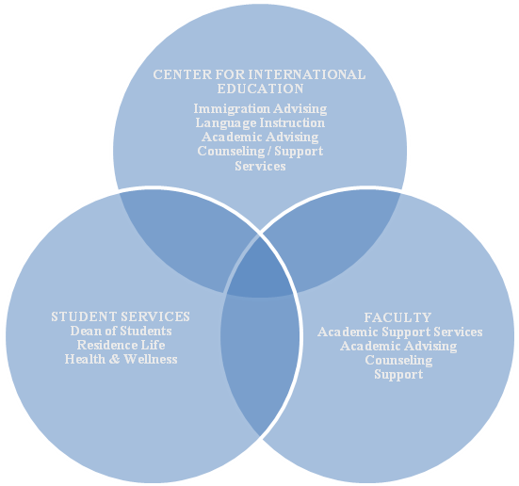

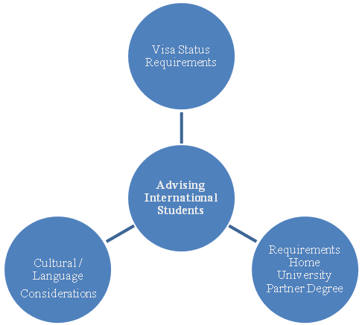

International Student Advising Scenarios
- One of your first year international advisees is registered for 15 credits of ESL (intermediate/high intermediate level) in the fall semester. She is very eager to sign up for at least 2 classes in her POE for the spring. What will you advise?
- One of your first-year international advisees wishes to drop a 4-credit IC, because he is failing the course. The drop/ add deadline is tomorrow, and he is currently registered for 15 credits. What might you advise?
- Yunio is a non-degree student studying in the Intensive English Program and taking one course in her area of study at her home university. She has consistently been unprepared for Spanish class and does not participate very often. In week four of classes, one day when called upon to participate, Yunio could not answer and started to cry with her head down. The professor needed to move onto someone else. Yunio sat with her head down for the rest of the class.
International Students Advising Workshop Fall 2008
ACADEMIC CULTURE
Problems that an international student may face in an American university
- Language barriers
- Should be number one priority and don’t feel being offended if she (he) uses inappropriate words or expressions. (i.e. “ROC’s get-out incident”)
- May not understand classroom instructions even though they think they do. (i.e. “Song’s normal distribution table incident”)

- Cultural shocks
- Realize her (his) unique social backgrounds. (focus on Chinese students)
- Most of our Chinese students are from “One Child” families. To a great extent, their personality and social skills have been shaped by this policy.
- Chinese society is more conventional and homogeneous. They may not know how to deal with racial issues or other “unconventional” social phenomena.
- Living in a foreign country may make them more sensitive or resistant to critics of their home country.
- Their intentions may be easily misunderstood because of different styles of communication in U.S., i.e. do not ask professors critical questions or do not directly tell professors what they feel.
- Encourage and help her (him) learn American cultures.
- It is much more comfortable to stay with your friends from the same culture. It is harder than other people think.

- Academic challenges
  - The design of the higher education system is different. i.e. “make your own decisions” v.s. “you will be taken care of”
  - Learning and teaching styles are very different, i.e. “overwhelmed by examinations, readings, and assignments”.
  - Some academic skills need years to be developed for foreign students, i.e. writing.
What a faculty can do to help
- Recognize difficulties and challenges that an international student may face
- Identify her (his) problems by encouraging her (him) to speak out and by communicating with her (him) patiently
- Don’t rush to your solution or conclusion without listening to him (her)
- Help him (her) solve the problem and yet don’t let him (her) feel being treated differently
- Don’t stereotype a group of international students with your previous positive (or negative) experiences with one of them.

