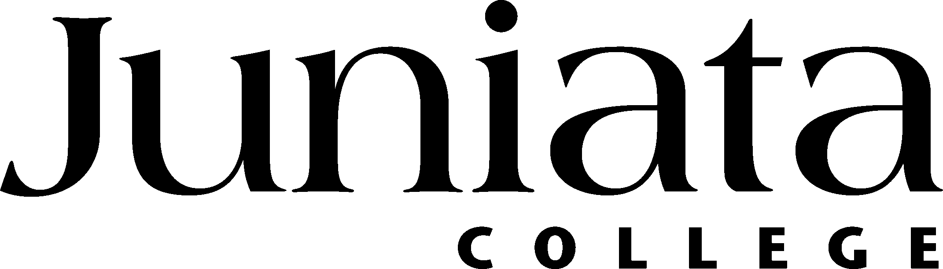

Name |  |  |  |  |  |  | Social Security #
I hereby authorize the direct deposit of my pay, in the amounts set forth below, by my employer into the account(s) and financial institution(s) indicated below. Such direct deposit will be made on each succeeding payday, unless I choose to terminate or change this agreement in writing to my employer. If this is a change to a previous Authorization, I give my permission to my employer to follow this Authorization by adding or changing my account information. Any such notification to my employer shall become effective following receipt, after a reasonable opportunity to act on it. In the event that my employer deposits funds erroneously into my account, I authorize my employer to debit my account for an amount not to exceed the original amount of the credit.
Initial Authorization □ |  |  |  | New Account (Close Previous Account) □ |  |  |  |  |  | Add Additional Account □
Name and Address of Financial Institution |  |  |  |  | Transit Routing Number |  | Account Number |  | Type of Account |  |  |  | Deposit Amount
 |  |  |  |  |  |  |  |  | Checking □  Savings □ |  |  |  | Net Check □  Set Amount $
 |  |  |  |  |  |  |  |  | Checking □  Savings □ |  |  |  | Net Check □  Set Amount $
 |  |  |  |  |  |  |  |  | Checking □  Savings □ |  |  |  | Net Check □  Set Amount $
Please attach a voided check for checking account or deposit slip for savings account to this form.
Signature |  |  |  |  |  |  |  |  |  |  | Date

Please cut on line above and keep bottom portion for instructions on how to view your pay advices (statements). PLEASE NOTE: New accounts are verified with the bank before becoming active for deposits. Therefore it is likely that your first pay may be in the form of a check instead of direct deposit. Checks are distributed to students via their campus mailbox.
- Log on to the Juniata campus portal, the Arch. If you are on a campus computer, enter “Arch” in your browser. If you are off campus, use may use this link https://arch.juniata.edu/render.userLayoutRootNode.uP
- Click on the Administrative tab, and then look under the Finance and Operations area. If you don’t already have it, instructions to add it are available at: http://services.juniata.edu/cts/wiki/index.php/Customizing_the_ARCH.
- Click on the link that says “Your Payroll.” This will open up a window for the initial WebAdvisor screen.
  - Please note that under the Your Payroll link are instructions for Webadvisor that provide screen shots for the rest of the process http://services.juniata.edu/webdev/channels/webadvisor/WAfinanceinstructions.pdf If you do not need screen shots you may proceed by following the steps below.
- Click on the LOG IN tab to get started and enter your EagleNet login ID and password, then click Submit.
- Once you have logged in, you will see sections at the right, representing your possible roles within the college. To view your pay advices, click on the Employees area.
- Now click on the Pay Advices link.
- Under Current Year, you will see a list of pay dates for which you have pay advices available. Click on the date of the advice you would like to view, and a new window will open with the advice. You do not need to click Submit. In the future, when the available online pay advices span multiple years, you will be able to use the Select Other Year drop down to list and view advices in past years.
- If you want to print a copy of your pay advice, click the printer icon on your browser.
- When you have finished with this advice, close the window and you will return to the Pay Advices screen.
- Now you can view another advice, or click on the Employees Menu or Main Menu tabs to work in other parts of WebAdvisor. If you have any questions or problems, click the Contact Us tab for information on getting assistance.
- When you have finished using WebAdvisor, click the Log Out tab.
  - When you click the Log Out tab, you will get warnings about closing your browser as a security measure. If you are working on a publicly accessible computer, closing the browser by clicking OK and then Yes is a very good idea to protect your privacy.

