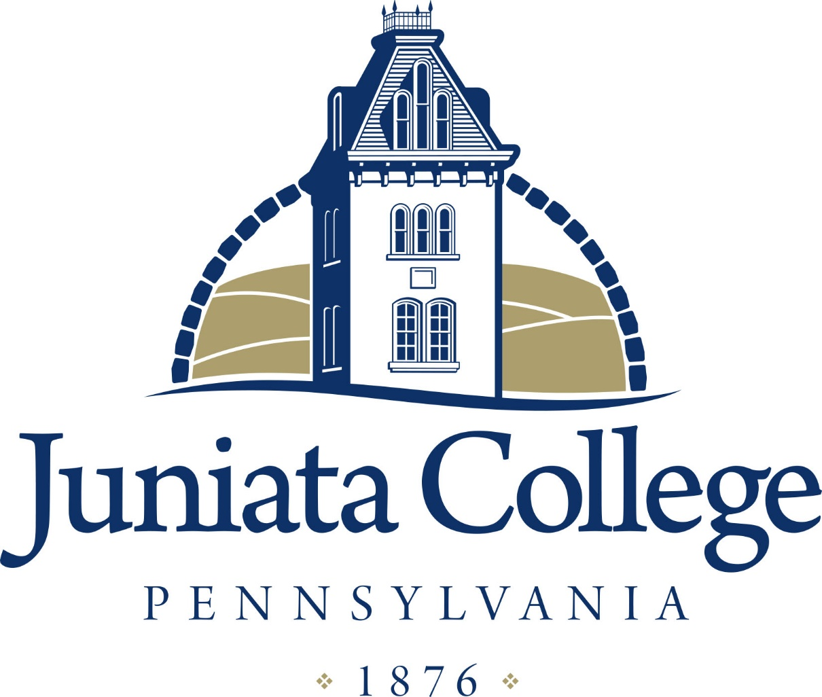
ANNUAL PERFORMANCE FEEDBACK AND DEVELOPMENT PLAN
Name: Position:
Department: Supervisor:
Date:
This document, as part of the College Performance Management and Development Program, can be used as a tool to:
Enhance COMMUNICATION through:  - Giving and receiving feedback  - Benefit of your thoughts and impressions about yourself and your job. | Consider in HUMAN RESOURCES DECISIONS:  - Transfer and promotion opportunities | Identify DEVELOPMENT needs:  - Training and professional goals  - Performance improvement program  - Introspective self-assessment

Due to Human Resources by June 30, 2018
USE FOR ALL STAFF
Please provide a brief narrative or examples for the following questions regarding your job.

- Over the last 12 months, of what job related accomplishments are you most proud?
  - Include status or achievement on FY18 goals.

- Name at least three of your greatest strengths and/or skills.

- Name at least two opportunities/challenges that you could have done differently for greater impact. What do you see as areas of improvement in your job performance?

- How have you contributed to Juniata’s work towards achieving a culture of respect, diversity & inclusion?

- How can I help you achieve success in your job and accomplish your goals? What resources do you need?

- Professional and/or personal development:
  - What professional or personal development or training opportunities did you attend that you felt were beneficial?

  - What opportunities would you like to attend or wish we had more of?

- Goals- list at least 2 in each category:

  - Contributes to achievement of strategic plan and/or mission.

  - Department

- Supervisor comments:

___________________________________________ __________________________________________
Employee Supervisor

___________________________________________
Vice President

