Juniata College
Search Committee Guidelines for Diversity Employment
Approved by President Jim Troha, January 2015
Issued by Dr. Grace Fala
Office of Diversity & Inclusion, in conjunction with Human Resources
Prepared by the Diversity Committee & the Stewards of Diversity
Established in fall 2011, approved by President Tom Kepple 2011 / Updated, June 2017/ Nov 2017/March 2018
TABLE OF CONTENTS:
Background 1
Goals 3
Membership 4-5
Procedure 5
EEO/Job Statements 6
Guidelines for Stewards 6-9

BACKGROUND:

Over the last twenty-five years Juniata College has been slowly and steadily diversifying its student population. We have grown from 4% domestic minorities in 1992 to 12% African, Latino, Asian and Native American (ALANA) students in 2014. We have also increased our international student population from 6% to 10%. Juniata College has successfully changed its composition and complexion, especially with regard to the cultural and racial backgrounds of 22% of our 1600+ students.

There were understandable reasons why ALANA students did not attend Juniata in the past but through the efforts of an evolving community, we challenged those barriers and, in spite of them, we continue all-the-more, to diversify.

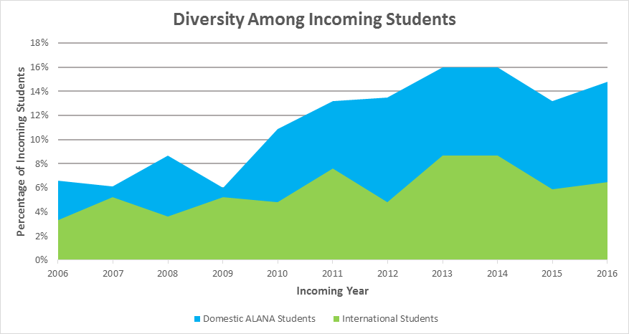

Unfortunately, we have not yet witnessed similar results with regard to diversity employment.
We have made some improvements, however, at a more gradual growth with: 8% for faculty (8.82%), 2% (2.17%) for staff, and 4% (6.43%) for administration. Our overall average for diversity employment is currently at 5% (6.26%) of 438 employees. We are mandated by the EEOC to report employment of domestic minorities to the Integrated Postsecondary Education Data System (IPEDS). When individuals are hired, we ask them to self-identify as first, whether Hispanic or non- Hispanic and then, as American/Alaskan Native, Asian, Black or African American, Hawaiian/Pacific Islander, White, International and Multiracial individuals. With regard to employment, the term “domestic minority” is applied to all populations other than white and international. We also ask individuals to self-identify as Vietnam veteran, veteran with disability, or individual with disability. (Updated Data from 2014)
Of our 151 (166) full and part time members of the faculty, ten have a domestic minority identity and three (four) have an international identity. Of the 127 (136) members of our staff and facilities, one (three) has a domestic minority identity and one has an international identity. Of the 176 members of our administration, seven (eleven) have a domestic minority identity and one has an international identity.

GOALS:

Over the next decade, we hope to reap results similar to our present student population, and more. With at least a dozen or more retirements expected in the next three years alone, the present is the best time to rekindle our community-based efforts and commitments to diversify our staff, faculty and administration. In doing so, we further support Juniata College’s mission to “develop the skills, knowledge and values that lead to a fulfilling life of service and ethical leadership in the global community.”

Research shows the values gained and correlations made between diversity and learning. By diversifying our employee population, we hope to inspire and enhance Juniata’s quality of living and learning through: the cultivation of social skills; the awakening/sustenance of global citizenry and rhetorical civility; the nourishing of values intrinsic to human relationships; the broadening of scholarly activity and community service; the networking potentials for student career and advance degree options; deepening our moral and/or spiritual sensibilities; and the emboldening of our creativity.

Diversity employment is now an institutional initiative approved by President Kepple and authorized by President Troha; it was implemented campus-wide in November 2011.

Many of us rely on the traditions and procedures of the past when recruiting new candidates for employment. Most of these traditions will remain intact. The guidelines herein are aimed to strengthen, improve and modernize what we already do.

MEMBERSHIP:

All members of the Juniata community need to become a part of the shared effort, consciousness, creativity and commitment to our campus-wide initiative: To work together toward increasing diversity employment (and, eventually, diversity retention) at Juniata. How?

Here are some suggestions:

- When attending conferences/workshops, consider talking about job openings (or future job openings) to qualified candidates, especially those among ALANA populations.
- If you meet ALANA students in advanced degree programs, discuss potential employment opportunities at Juniata.
- Address some of the real drawbacks to living in the area but also highlight reasons why you live here and why you decided to stay.
- Imagine and discuss diversity employment to be a real possibility for Juniata College. (Until we think/speak it, we won’t be able to live it.)
- Be creative, inclusive and welcoming in your job announcements and flyers (For example see page 6)
- Please compose a selection committee that is as diverse as possible, and encourage an open tone of inquiry in the deliberations.
- Work collaboratively and openly with the Stewards. (Please refer to the Procedure section on page 5)

Some members of the Juniata community, known as Stewards, have been trained specifically to help. Stewards are Juniata employees who have undergone training in diversity employment. When the Stewards formed in the spring semester of 2012, there were twenty-two members. Three years later, in January of 2015, we had almost doubled in size. Now, we have almost tripled our size; there are now fifty-four Stewards in all.

At least one Steward of Diversity will sit on each selection committee that forms. Stewards aim to assist other members of the committee in their search, selection, and retention of qualified candidates, especially those from ALANA/international populations. In addition to helping to create a more diverse pool of applicants, the Steward serves as a full, voting member of the search committee.

As we implement our “Training the Trainers” program at Juniata the fall of 2017, we have equipped each of our four Co-Chairs (Kati Csoman; Cindy Gibboney; Kathy Jones; and Dan Welliver) with a copy of two relevant & current resources to share:

Diversifying the Faculty: A Guidebook for Search Committees
ISBN-13: 978-0911696905
ISBN-10: 0911696903

Searching for Excellence and Diversity: A Guide for Search Committees
- ISBN-10: 0615711782
- ISBN-13: 978-0615711782

PROCEDURE:

- Before the search begins, a Steward is selected. The Office of Human Resources will contact an available Steward and once confirmed an email is sent to the steward and program chair. That Steward will then meet with the Chair/Program Director of the search committee to discuss procedural options.
- In collaboration with Human Resources, the Steward will assist in the review of the job description and offer advice on relevant classified sites before placing the ad.
- Stewards will meet with the search committee to facilitate a preliminary discussion of institutional goals and inquiries regarding diversity employment.
- Stewards will participate in the review, selection and voting process of candidates for the specified position. Stewards will also be involved in the interview processes. Note: the stewards is a full voting member of the committee.
- Stewards will make relevant connections with volunteers on campus who are willing to invest time to make the candidate’s site visit and interview more welcoming and meaningful.
- Stewards will collaborate with the rest of the committee and the candidate for relevant & useful feedback.
- Mindful of confidentiality, the Steward will then share his/her observations with the other Stewards.
- In an effort to assess the strength of this initiative, Stewards of Diversity who participated in search committees in any given academic year will give a report to the College, through Human Resources and the Office of Diversity and Inclusion (ODI), detailing the search committee’s successes in enhancing the diversity of the hiring process. (The timing for this report will be decided by the ODI and Human Resources)
- Diversity Employment training will continue and evolve as we learn from one another so that more emphasis can be placed on Diversity Retention.
- If your department seeks additional information/training regarding diversity employment, please feel free to request it through Human Resources and the ODI.

Stewards are volunteers with a shared vision, working toward a common goal. We welcome your heartfelt insights and helpful suggestions. Thank you for your efforts.

EEO/JOB STATEMENTS:

Juniata College’s current EEO statement, job announcement, and non-discrimination policy state:
Juniata College, a highly ranked, national liberal arts college of 1,600 students located in the scenic Allegheny Mountains of central Pennsylvania…
Juniata College will take positive steps to enhance the ethnic and gender diversity on its campus. The College commits to this policy not only because of legal obligations, but because it believes that such practices are basic to human dignity. AA/EEO
Our College is committed to maintaining a work environment that is free of discrimination … based on an individual's race, color, religion, gender, national origin, age, disability, ancestry, genetic information, ethnic origin, marital and parental status, veteran status, citizenship status, sexual orientation, gender identity or expression, or because of any other protected status of an individual or that individual's associates or relatives.
Collaboratively discussed, debated and drafted by the ODI, HR, members of the Diversity Committee and the Stewards in 2011, Juniata College’s job announcement aims to attract a diverse range of qualified applicants:
Juniata College takes positive steps to enhance diversity in both its community and its curriculum. The College commits to this policy not because of legal obligations but because it fully believes that such practices are basic to human dignity. AA/EEO

GUIDELINES FOR STEWARDS:

Stewards are encouraged to:

- Model what we seek from other members of the Juniata community with regard to diversity employment
- Follow the steps outlined in these Guidelines.
- Assist the selection committee with choosing the job announcement option. Use this process to prompt a discussion of our shared goals.
- Seek assistance from the co-chairs, other Stewards when doubtful or confused.
- Report back to the ODI
- Be willing to share relevant (and non-confidential) information with other members of the campus community
- Consider using questions like these as guideposts when working with search committees: *

- Why do people want to come to Juniata? (By focusing on why they don’t want to come, we lose sight of our mission)
- What makes Juniata College exciting to people?
- Why did you come to Juniata?
- What makes you want to stay here?
- What do you value about this geographic area?
- What do we mean by that notion of “fit”?
- What do we mean by “experience?”
- What do we value in terms of “research?” Why?
- What does “quality” mean in terms of hiring the most qualified candidate?
- What is your experience working with diversity? Working with ALANA communities? Give an example. (While this question is not only useful to ask the job candidates, it might also be useful to ask the search committee)

*What, as an institution, can we do more of?
- Actively find a more diverse applicant pool
  - Targeted advertising and outreach (e.g. HBCUs, career services of peer schools, conferences, personal contacts)
- Explaining the Steward’s role so the entire search committee is informed
- Entire search committee should be involved with the search process from start to finish
- Begin to ask questions about diversity at the beginning of the search process
- Support the people that are already engaging in “diversity work”
- Greater transparency about resources
  - Assistance with temporary housing
  - Childcare
  - Life management
- Focus more on relational, tangible skills than names of institutions
- Selling the positives of the Huntingdon community
  - Improving Huntingdon community relations
  - JC presence at Mayfest, Hartslog (craft or ethnic foods booth)
  - Educating committee on what is available in Huntingdon
- Student involvement on search committees
  - Training for students by Stewards members
- Formal mentoring for new administrators
- Steward follow-up with new hires
What, as an institution, can we do less of?
- Apologizing for location
  - Making assumptions (certain people won’t want to come here)
- Having a pre-defined candidate
  - Looking for someone who will “fit”
- Resistance to the process
- Reluctance to do the “hard work” (acknowledging and confronting our own bias)
- Inferiority complex and privileged credentials (for some positions)

*Adapted from the research of Dr. Tiffenia Archie, Temple University, who consulted with Stewards of Diversity at Juniata in both the fall of 2011, spring 0f 2012 and again in the fall of 2016.
At the interactive workshops on diversity employment facilitated by Dr. Tiffenia Archie from Temple University, Stewards shared insights and concerns about interview processes. Much of what emerged is highlighted in this outline.

Key Ideas and Strategies to Assist Stewards
All members of the Juniata community are pivotal at this exciting time in the College’s history. We can also expect to be busier and hopefully, more engaged the next couple of years. The Stewards are a resource to the College as it undergoes change and advances its mission. By being more attentive to our own “Unconscious Bias,” we can perhaps awaken it elsewhere. All Stewards should be prepared to address questions and comments:
- “Why bother?”
  - Diversity Employment has become an institutional imperative. The College has become more diversified with regard to student population. We aim to continue to hire employees who relate directly to students with regard to race, ethnicity, gender, religion and so forth. Students often seek mentors who share common backgrounds and understandings. In fact, all of us gain and grow. Research shows repeatedly the correlation between diversity and quality of education. (References available soon on the shared drive)
- “What if the candidate doesn’t want to come to Huntingdon?”
  - Ask, “Why are you here? What brought you here? Why did you stay?” Consider letting the candidate decide for him or herself.
- When developing the profile for the position, relevant questions can include: (a) Who are we excluding; (b) What do we mean by skill set? Research? Years of experience? Why?
- When the focus of attention shifts to “fit” or “match,” remind committee that Juniata is an evolving community and that change can help us become more competitive and creative.
- A key question also to ask is, “How do we want this person to change us?”
- What don’t I understand about this candidate based on my own background?
- What kinds of considerations are we giving to nonverbal behaviors? Are we reading into behaviors? For example, if a woman is outspoken, do we regard her as “dominant” while a similar quality in men might be regarded as a sign of “strong leadership?”
- Do we share an appreciation for diverse communication styles or is a particular communication style being sought? Expected?
- In what ways are we looking for someone who looks like, thinks like (etcetera) me/us? In what ways do we feel more comfortable because the individual is similar to us? Diversity often asks us to feel uncomfortable. How might the tension be helpful? (Acknowledge fears & hopes)
- When interviewing candidates, ask for specifics: What have you done to promote diversity in your department? What have you done to recruit women and minority faculty? Can you give an example of when you mentored a person of color or another person of minority status?
- Consider the educational contributions and values that diversity brings to our shared mission.

“Key Ideas” prepared by Grace Fala, Ph.D. / February 8, 2012, intro modified by co-chairs Jan 2018.

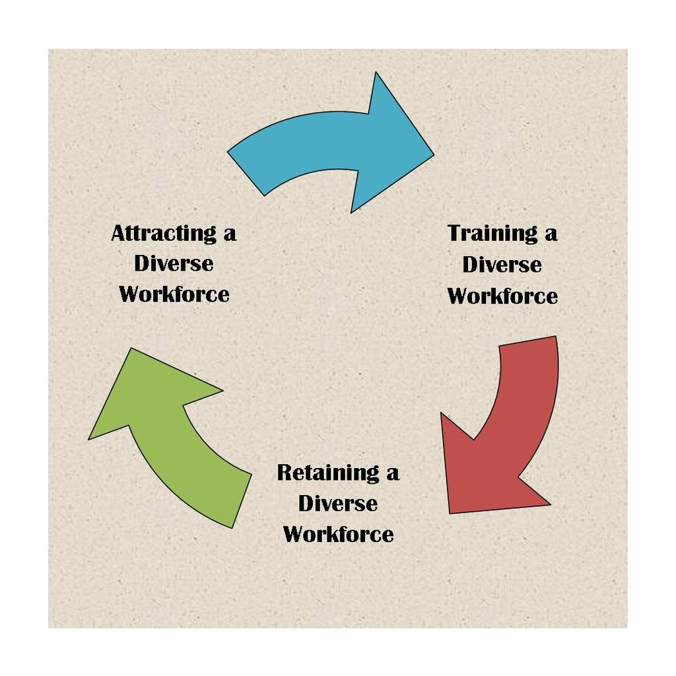
The Office of the President, the Office of Diversity and Inclusion, Human Resources, the Diversity Committee and the Stewards of Diversity are grateful for your investment of time and for your commitment to our shared vision. Please contact the ODI and/or Human Resources with questions, concerns or insights. Thank you.
These Guidelines were reviewed and updated in June, 2017 by former Chairperson, Grace Fala, and Director of Human Resources, Gail Ulrich.
Co-Chairs for the 2017-2018 academic year are:
Kati Csoman; Cindy Gibboney; Kathy Jones and Daniel Welliver

Additional Resources for the Recruitment and Retention of ALANA Faculty/Staff
Aguirre, A. (2000). Women and minority faculty in the academic workplace: recruitment, retention, and academic culture. San Francisco, CA: Jossey-Bass.

Aguirre Jr., A., R. Martinez, & A. Hernandez. (1993). Majority and minority faculty perceptions in academe. Research in Higher Education. 34(3), 371-384.

Alger, J.R. (2007). How to recruit and promote minority faculty: Start by playing fair. American Association of University Professors. Retrieved from http://www.aaup.org/issues/diversity-affirmative-action/resources-diversity-and-affirmative-action/how-recruit-and-promote-minority-faculty-start-playing-fair
Anderson, J.A. (2007). Eight crucial steps to increase diversity. Section: Diversity in academe The Chronicle of Higher Education, Vol. 54(5), B-36.
Antonio, A.L, (September/October 2002), Faculty of color reconsidered: Reassessing contributions to scholarship. The Journal of Higher Education, Vol. 73(5), pp. 582-602.
Antonio, A.L. Faculty of Color and Scholarship Transformed: New Arguments for Diversifying Faculty. Diversity Digest. Retrieved from http://www.diversityweb.org/digest/W99/diversifying.html
Astin, H. S., & Milem, J. F. (1997). The status of academic couples in U.S. institutions. In M. A. Ferber & J. W. Loeb (Eds.), Academic Couples: Problems and Promises (pp. 128-155). Urbana: University of Illinois Press.
Bertrand, M.A., & Mullianathan, S. (2003)Are Emily and Greg More Employable than Lakisha and Jamal? A Field Experiment on Labor Market Discrimination. Poverty Action Lab Paper #3.
http://www.chicago-united.org/elibrary/bertrand_mullainathan.pdf
Delton, J. (2007, September 28). Why diversity for diversity’s sake won’t work Section: Diversity in academe. The Chronicle of Higher Education, Vol. 54(5), B32. Retrieved from http://chronicle.com/article/Why-Diversity-for-Diversity-s/7121
Fleig-Palmer, M., Murrin, J., Palmer, D.K., Rathert, C., (2003), Meeting the needs of dual-career couples in academia. The Dual Career Conference at the University of Iowa on April 25, 2003. Retrieved 11/20/07. URL:http://www.uiowa.edu/~provost/dcn/survey.pdf
Gose, B. (2007, September 28). The professoriate is increasingly diverse, but that didn’t happen by accident. The Chronicle of Higher Education, Vol. 54(5), B1. Retrieved from http://chronicle.com/article/The-Professoriate-Is/1782
Hamilton, K. (2004).= Faculty science positions continue to elude women of color: Oklahoma professor’s study finds hiring, tenure remain stumbling blocks. Black Issues in Higher EducationVol. 21(3), pg. 38-40.
Hu-DeHart, E. (Sep/Oct 2000). The diversity project: Institutionalizing multiculturalism or managing differences? Academe, Vol.86(5), pg. 38-43.
Hune, S. (1998). Asian Pacific American Women in Higher Education: Claiming Visibility & Voice. A Report written for The Association of American Colleges and Universities Program on the Status and Education of Women. Washington, D.C.: Association of American Colleges and Universities.
Klein, S. S. (2007). The Handbook for Achieving Gender Equity through Education. 2nd ed. Mahwah, N.J.: Lawrence Erlbaum Associates.
Moody, J. (2000). Tenure and diversity: some different voices. Academe, 86(3), 30-33.
Perkins, L. S., (1997). For the good of the race: Married African-American academics – a historical perspective. In M. A. Ferber & J. W. Loeb (Eds.),Academic Couples: Problems and Promises (pp. 80-105). Urbana: University of Illinois Press.
Rai, K. B., & Critzer, J. W. (2000). Affirmative Action and the University: Race, Ethnicity, and Gender in Higher Education Employment. Lincoln, NE: University of Nebraska Press.
Readings, B. (1996). Introduction. In The university in ruins. Cambridge, MA and London, England: Harvard University Press, pp. 20-43.
Readings, B. (1996). The Idea of Excellence. In The University in Ruins. Cambridge: Harvard University Press, pp. 1-20.
Slaughter, S. and Leslie, L.L. (1997). Academic capitalism. In Academic Capitalism: Politics, Policies, and the Entrepreneurial University. Baltimore: Johns Hopkins University Press, pp. 1-13.
Smith, D.G. (Sep/Oct 2000). How to diversify the faculty. Academe, Vol 86 (5), pg. 48-52. Retrieved from http://codac.uoregon.edu/files/2011/01/How-to-Diversify-the-Faculty-by-Daryl-G-Smith.pdf
Smith, D. G., Turner, C., Osei-Kofi, N., and Richards, S. (2004). Interrupting the usual: Successful strategies for hiring diverse faculty. The Journal of Higher Education, 75(2), 133-160. Retrieved from http://www.jstor.org/stable/pdfplus/3838827.pdf?acceptTC=true
Steinpreis, R., Anders, K., & Ritzke, D. 1999. The Impact of Gender on the Review of the Curriculum Vitae of Job Applicants and Tenure Candidate: A National Empirical Study. Sex Roles, 41(7/8), 509-528).
Retrieved from: http://www.cos.gatech.edu/facultyres/Diversity_Studies/Steinpreis_Impact%20of%20gender%20on%20review.pdf
Tapia, R. A. (2007, September 28). True diversity doesn’t come from abroad. Section: Diversity in academe. The Chronicle of Higher Education, Vol. 54(5), B34. Retrieved from http://chronicle.com/article/True-Diversity-Doesn-t-Come/20812
Trowe, C.A. and Chait, R.P. (March-April, 2002). Faculty diversity: Too little for too long. Harvard Magazine. Retrieved 9/6/2007 from: http://www.harvard-magazine.com/on-line/030218.html
Trix, Frances & Psenka, C. (2003) Exploring the color of glass: letters of recommendation for male and female medical faculty. Discourse and Society, Sage Publications.
http://www.cos.gatech.edu/facultyres/Diversity_Studies/Trix%20&%20Psenka.pdf
Turner, C. S. (2003). Incorporation and marginalization in the academy: From border toward center for faculty of color? Journal of Black Studies, 34(1), 112-125.
Turner, C.S.V, (January/February 2002). Women of color in academe: Living with multiple marginality. The Journal of Higher Education, Vol. 73(1), pp. 74-91. Retrieved from http://www.jstor.org/stable/pdfplus/1558448.pdf?acceptTC=true
Turner, C.S., & S.L. Myers, Jr. (2000). Faculty of color in academe: Bittersweet success. Needham Heights, MA: Allyn and Bacon.
Turner, C.S., S.L. Myers, Jr., & J.W. Creswell. (1999). Exploring underrepresentation: The case of faculty of color in the Midwest. The Journal of Higher Education. 70(1), 27-59.
Turner, C.S. V. (2002). Diversifying the faculty: A guidebook for Search Committees. Washington, DC: Association of American Colleges and Universities.

University of California Affirmative Action Guidelines for Recruitment and Retention of Faculty. Office of the President, January 2, 2002.
http://www.ucop.edu/academic-personnel/_files/documents/affirmative.pdf
Williams, Damon A. (2013). Strategic Diversity Leadership. VA: Stylus Publishing.
Wilson, R. (2007). Black women seek a role in philosophy. Section: Diversity in academe. The Chronicle of Higher Education, Vol. 54(5), B-4.
Wolf-Wendel. L.E., Twombly. S., Rice S. (May – Jun., 2000). Dual-Career Couples: Keeping Them Together.The Journal of Higher Education, Vol. 71 (3), pp. 291-321.
Wolf-Wendel. L.E., Twombly. S., Rice S., (2003). The two-body problem: Dual-career-couple hiring policies in higher education. Baltimore and London: The Johns Hopkins University Press

