Juniata College

Search Committee Guidelines for Diversity Employment

DIVERSITY STATEMENT:

Juniata College’s current EEO statement, job announcement, and non-discrimination policy state:
Juniata College believes in and embraces the liberal arts and as such, we encourage and seek mutual benefit through diversity of thought and approach which enriches our academic community, as well as the lives of our students and colleagues.

Juniata College is committed to creating a welcoming community supported by relationships based on collaboration and mutual respect. We endeavor to create an inclusive learning environment where members with different perspectives and backgrounds can learn, contribute, and thrive. Please join us…

GOALS:
Strategic Priority #2: Juniata College will grow, nurture and support an inclusive, engaged, and vibrant community.

We support Juniata College’s mission to “develop the skills, knowledge and values that lead to a fulfilling life of service and ethical leadership in the global community.”

Research shows the values gained and correlations made between diversity and learning. By diversifying our employee population, we hope to inspire and enhance Juniata’s quality of living and learning through: the cultivation of social skills; the awakening/sustenance of global citizenry and rhetorical civility; the nourishing of values intrinsic to human relationships; the broadening of scholarly activity and community service; the networking potentials for student career and advance degree options; deepening our moral and/or spiritual sensibilities; and the emboldening of our creativity.

Many of us rely on the traditions and procedures of the past when recruiting new candidates for employment. Most of these traditions will remain intact. The guidelines herein are aimed to strengthen, improve and modernize what we already do.

MEMBERSHIP:

All members of the Juniata community need to become a part of the shared effort, consciousness, creativity and commitment to our campus-wide initiative: To work together toward increasing diversity employment (and, eventually, diversity retention) at Juniata. How?

Here are some suggestions:

- When attending conferences/workshops, talking about job openings (or future job openings) to qualified candidates, especially those among ALANA populations.
- If you meet ALANA students in advanced degree programs, discuss potential employment opportunities at Juniata.
- Address some of the real drawbacks to living in the area but also highlight reasons why you live here and why you decided to stay.
- Imagine and discuss diversity employment to be a real possibility for Juniata College. (Until we think/speak it, we won’t be able to live it.)
- Be creative, inclusive and welcoming in your job announcements and flyers
- Compose a candidate pool that is as diverse as possible, and encourage an open tone of inquiry in the deliberations of the search committee.
- Refer to the Additional Resources for the Recruitment and Retention of ALANA Faculty/Staff on pages 6-8

Some members of the Juniata community, known as Stewards, have been trained specifically to help. Stewards are Juniata employees who have undergone training in diversity employment.

At least one Steward of Diversity will sit on each selection committee that forms. Stewards aim to assist other members of the committee in their search, selection, and retention of qualified candidates, especially those from ALANA/international populations. In addition to helping to create a more diverse pool of applicants, the Steward serves as a full, voting member of the search committee.

PROCEDURE:

- Before the search begins, a Steward is selected. The Office of Human Resources will contact an available Steward and once confirmed an email is sent to the steward and search chair. That Steward will then meet with the Chair/Program Director of the search committee to discuss procedural options.
- In collaboration with Human Resources, the Steward will assist in the review of the job description and offer advice on relevant classified sites before placing the recruitment advertising.
- Stewards will meet with the search committee to facilitate a preliminary discussion of institutional goals and inquiries regarding diversity employment.
- Stewards will participate in the review, selection and voting process of candidates for the specified position.
- Stewards will also be involved in the interview processes. Note: the steward is a full voting member of the committee.
- Stewards will make relevant connections with volunteers on campus who are willing to invest time to make the candidate’s site visit and interview more welcoming and meaningful.
- Stewards will collaborate with the rest of the committee and the candidate for relevant & useful feedback.
- For accountability and to assess the strength of this initiative, Stewards of Diversity who participated in search committees in any given academic year will give a report to the College, through the Office of Diversity and Inclusion (ODI), detailing the search committee’s successes in enhancing the diversity of the hiring process within two weeks of final decisions.
- Diversity Employment training will continue and evolve as we learn from one another so that more emphasis can be placed on Diversity Retention.
- If your department seeks additional information/training regarding diversity employment, please feel free to request it through Human Resources and the ODI.

GUIDELINES FOR STEWARDS:

Stewards are encouraged to:
- Model what we seek from other members of the Juniata community with regard to diversity employment.
- Follow the steps outlined in these Guidelines.
- Assist the selection committee with choosing the job announcement option. Use this process to prompt a discussion of our shared goals.
- Seek assistance from HR, ODI, or other Stewards when in doubt or need clarification.
- Report back to the ODI.
- Consider using questions like these as guideposts when working with search committees: *
- Why do people want to come to Juniata? (By focusing on why they don’t want to come, we lose sight of our mission)
- What makes Juniata College exciting to people?
- Why did you come to Juniata?
- What makes you want to stay here?
- What do you value about this geographic area?
- What do we mean by that notion of “fit”?
- What do we mean by “experience?”
- What do we value in terms of “research?” Why?
- What does “quality” mean in terms of hiring the most qualified candidate?
- What is your experience working with diversity? Working with ALANA communities? Give an example. (While this question is not only useful to ask the job candidates, it might also be useful to ask the search committee)
*What, as an institution, can we do more of?
- Actively find a more diverse applicant pool
  - Targeted advertising and outreach (e.g. HBCUs, career services of peer schools, conferences, personal contacts)
- Explaining the Steward’s role so the entire search committee is informed
- Entire search committee should be involved with the search process from start to finish
- Begin to ask questions about diversity at the beginning of the search process
- Support the people that are already engaging in “diversity work”
- Greater transparency about resources
  - Assistance with temporary housing
  - Childcare
  - Life management
- Focus more on relational, tangible skills than names of institutions
- Selling the positives of the Huntingdon community
  - Improving Huntingdon community relations
  - JC presence at Mayfest, Hartslog (craft or ethnic foods booth)
  - Educating committee on what is available in Huntingdon
- Student involvement on search committees
  - Training for students by Stewards members
- Formal mentoring for new administrators
- Steward follow-up with new hires
What, as an institution, can we do less of?
- Apologizing for location
  - Making assumptions (certain people won’t want to come here)
- Having a pre-defined candidate
  - Looking for someone who will “fit”
- Resistance to the process
- Reluctance to do the “hard work” (acknowledging and confronting our own bias)
- Inferiority complex and privileged credentials (for some positions)

*Adapted from the research of Dr. Tiffenia Archie, Temple University, who consulted with Stewards of Diversity at Juniata in both the fall of 2011, spring 0f 2012 and again in the fall of 2016.

Key Ideas and Strategies to Assist Stewards
All members of the Juniata community are pivotal at this exciting time in the College’s history. We can also expect to be busier and hopefully, more engaged the next couple of years. The Stewards are a resource to the College as it undergoes change and advances its mission. By being more attentive to our own “Unconscious Bias,” we can perhaps awaken it elsewhere. All Stewards should be prepared to address questions and comments:
- “Why bother?”
  - Diversity Employment has become an institutional imperative. The College has become more diversified with regard to student population. We aim to continue to hire employees who relate directly to students with regard to race, ethnicity, gender, religion and so forth. Students often seek mentors who share common backgrounds and understandings. In fact, all of us gain and grow. Research shows repeatedly the correlation between diversity and quality of education. (References available soon on the shared drive)
- “What if the candidate doesn’t want to come to Huntingdon?”
  - Ask, “Why are you here? What brought you here? Why did you stay?” Consider letting the candidate decide for him or herself.
- When developing the profile for the position, relevant questions can include: (a) Who are we excluding; (b) What do we mean by skill set? Research? Years of experience? Why?
- When the focus of attention shifts to “fit” or “match,” remind committee that Juniata is an evolving community and that change can help us become more competitive and creative.
- A key question also to ask is, “How do we want this person to change us?”
- What don’t I understand about this candidate based on my own background?
- What kinds of considerations are we giving to nonverbal behaviors? Are we reading into behaviors? For example, if a woman is outspoken, do we regard her as “dominant” while a similar quality in men might be regarded as a sign of “strong leadership?”
- Do we share an appreciation for diverse communication styles or is a particular communication style being sought? Expected?
- In what ways are we looking for someone who looks like, thinks like (etcetera) me/us? In what ways do we feel more comfortable because the individual is similar to us? Diversity often asks us to feel uncomfortable. How might the tension be helpful? (Acknowledge fears & hopes)
- When interviewing candidates, ask for specifics: What have you done to promote diversity in your department? What have you done to recruit women and minority faculty? Can you give an example of when you mentored a person of color or another person of minority status?
- Consider the educational contributions and values that diversity brings to our shared mission.

“Key Ideas” prepared by Grace Fala, Ph.D. / February 8, 2012, intro modified by co-chairs Jan 2018.

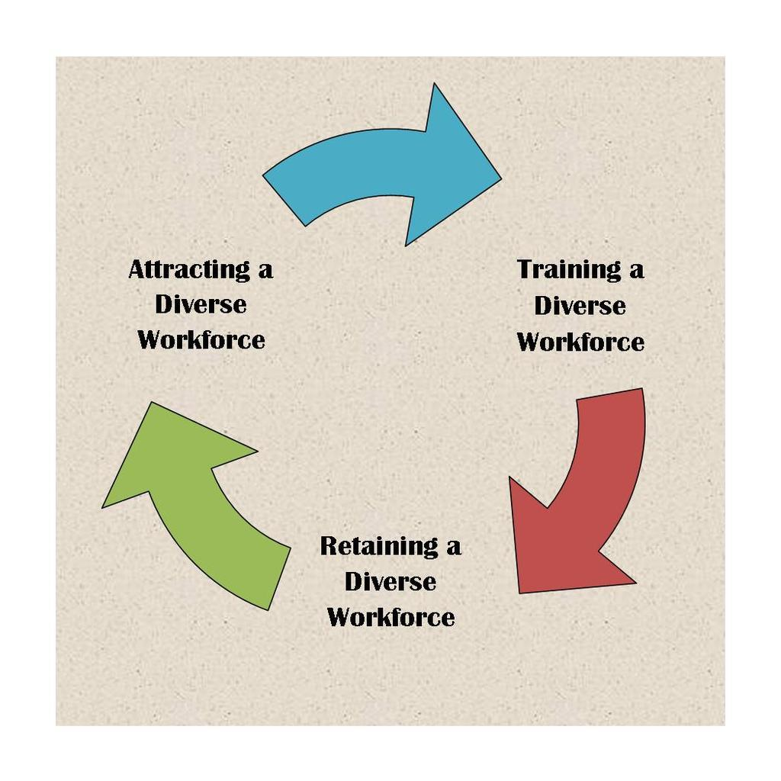

Stewards are volunteers with a shared vision, working toward a common goal. We welcome your heartfelt insights and helpful suggestions. The Office of the President, the Office of Diversity and Inclusion, Human Resources, the Diversity Committee and the Stewards of Diversity are grateful for your investment of time and for your commitment to our shared vision. Please contact the ODI and/or Human Resources with questions, concerns or insights.

Additional Resources for the Recruitment and Retention of ALANA Faculty/Staff
- Diversifying the Faculty: A Guidebook for Search Committees
- ISBN-13: 978-0911696905
- ISBN-10: 0911696903

- Searching for Excellence and Diversity: A Guide for Search Committees
- ISBN-10: 0615711782
- ISBN-13: 978-0615711782

- Aguirre, A. (2000). Women and minority faculty in the academic workplace: recruitment, retention, and academic culture. San Francisco, CA: Jossey-Bass.

- Aguirre Jr., A., R. Martinez, & A. Hernandez. (1993). Majority and minority faculty perceptions in academe. Research in Higher Education. 34(3), 371-384.

- Alger, J.R. (2007). How to recruit and promote minority faculty: Start by playing fair. American Association of University Professors. Retrieved from http://www.aaup.org/issues/diversity-affirmative-action/resources-diversity-and-affirmative-action/how-recruit-and-promote-minority-faculty-start-playing-fair

- Anderson, J.A. (2007). Eight crucial steps to increase diversity. Section: Diversity in academe The Chronicle of Higher Education, Vol. 54(5), B-36.

- Antonio, A.L, (September/October 2002), Faculty of color reconsidered: Reassessing contributions to scholarship. The Journal of Higher Education, Vol. 73(5), pp. 582-602.

- Antonio, A.L. Faculty of Color and Scholarship Transformed: New Arguments for Diversifying Faculty. Diversity Digest. Retrieved from http://www.diversityweb.org/digest/W99/diversifying.html

- Astin, H. S., & Milem, J. F. (1997). The status of academic couples in U.S. institutions. In M. A. Ferber & J. W. Loeb (Eds.), Academic Couples: Problems and Promises (pp. 128-155). Urbana: University of Illinois Press.

- Bertrand, M.A., & Mullianathan, S. (2003)Are Emily and Greg More Employable than Lakisha and Jamal? A Field Experiment on Labor Market Discrimination. Poverty Action Lab Paper #3.
- http://www.chicago-united.org/elibrary/bertrand_mullainathan.pdf

- Delton, J. (2007, September 28). Why diversity for diversity’s sake won’t work Section: Diversity in academe. The Chronicle of Higher Education, Vol. 54(5), B32. Retrieved from http://chronicle.com/article/Why-Diversity-for-Diversity-s/7121

- Fleig-Palmer, M., Murrin, J., Palmer, D.K., Rathert, C., (2003), Meeting the needs of dual-career couples in academia. The Dual Career Conference at the University of Iowa on April 25, 2003. Retrieved 11/20/07. URL:http://www.uiowa.edu/~provost/dcn/survey.pdf

- Gose, B. (2007, September 28). The professoriate is increasingly diverse, but that didn’t happen by accident. The Chronicle of Higher Education, Vol. 54(5), B1. Retrieved from http://chronicle.com/article/The-Professoriate-Is/1782

- Hamilton, K. (2004).= Faculty science positions continue to elude women of color: Oklahoma professor’s study finds hiring, tenure remain stumbling blocks. Black Issues in Higher EducationVol. 21(3), pg. 38-40.

- Hu-DeHart, E. (Sep/Oct 2000). The diversity project: Institutionalizing multiculturalism or managing differences? Academe, Vol.86(5), pg. 38-43.

- Hune, S. (1998). Asian Pacific American Women in Higher Education: Claiming Visibility & Voice. A Report written for The Association of American Colleges and Universities Program on the Status and Education of Women. Washington, D.C.: Association of American Colleges and Universities.

- Klein, S. S. (2007). The Handbook for Achieving Gender Equity through Education. 2nd ed. Mahwah, N.J.: Lawrence Erlbaum Associates.

- Moody, J. (2000). Tenure and diversity: some different voices. Academe, 86(3), 30-33.

- Perkins, L. S., (1997). For the good of the race: Married African-American academics – a historical perspective. In M. A. Ferber & J. W. Loeb (Eds.),Academic Couples: Problems and Promises (pp. 80-105). Urbana: University of Illinois Press.

- Rai, K. B., & Critzer, J. W. (2000). Affirmative Action and the University: Race, Ethnicity, and Gender in Higher Education Employment. Lincoln, NE: University of Nebraska Press.

- Readings, B. (1996). Introduction. In The university in ruins. Cambridge, MA and London, England: Harvard University Press, pp. 20-43.

- Readings, B. (1996). The Idea of Excellence. In The University in Ruins. Cambridge: Harvard University Press, pp. 1-20.

- Slaughter, S. and Leslie, L.L. (1997). Academic capitalism. In Academic Capitalism: Politics, Policies, and the Entrepreneurial University. Baltimore: Johns Hopkins University Press, pp. 1-13.

- Smith, D.G. (Sep/Oct 2000). How to diversify the faculty. Academe, Vol 86 (5), pg. 48-52. Retrieved from http://codac.uoregon.edu/files/2011/01/How-to-Diversify-the-Faculty-by-Daryl-G-Smith.pdf

- Smith, D. G., Turner, C., Osei-Kofi, N., and Richards, S. (2004). Interrupting the usual: Successful strategies for hiring diverse faculty. The Journal of Higher Education, 75(2), 133-160. Retrieved from http://www.jstor.org/stable/pdfplus/3838827.pdf?acceptTC=true

- Steinpreis, R., Anders, K., & Ritzke, D. 1999. The Impact of Gender on the Review of the Curriculum Vitae of Job Applicants and Tenure Candidate: A National Empirical Study. Sex Roles, 41(7/8), 509-528).
- Retrieved from: http://www.cos.gatech.edu/facultyres/Diversity_Studies/Steinpreis_Impact%20of%20gender%20on%20review.pdf

- Tapia, R. A. (2007, September 28). True diversity doesn’t come from abroad. Section: Diversity in academe. The Chronicle of Higher Education, Vol. 54(5), B34. Retrieved from http://chronicle.com/article/True-Diversity-Doesn-t-Come/20812

- Trowe, C.A. and Chait, R.P. (March-April, 2002). Faculty diversity: Too little for too long. Harvard Magazine. Retrieved 9/6/2007 from: http://www.harvard-magazine.com/on-line/030218.html

- Trix, Frances & Psenka, C. (2003) Exploring the color of glass: letters of recommendation for male and female medical faculty. Discourse and Society, Sage Publications.
- http://www.cos.gatech.edu/facultyres/Diversity_Studies/Trix%20&%20Psenka.pdf

- Turner, C. S. (2003). Incorporation and marginalization in the academy: From border toward center for faculty of color? Journal of Black Studies, 34(1), 112-125.

- Turner, C.S.V, (January/February 2002). Women of color in academe: Living with multiple marginality. The Journal of Higher Education, Vol. 73(1), pp. 74-91. Retrieved from http://www.jstor.org/stable/pdfplus/1558448.pdf?acceptTC=true

- Turner, C.S., & S.L. Myers, Jr. (2000). Faculty of color in academe: Bittersweet success. Needham Heights, MA: Allyn and Bacon.

- Turner, C.S., S.L. Myers, Jr., & J.W. Creswell. (1999). Exploring underrepresentation: The case of faculty of color in the Midwest. The Journal of Higher Education. 70(1), 27-59.

- Turner, C.S. V. (2002). Diversifying the faculty: A guidebook for Search Committees. Washington, DC: Association of American Colleges and Universities.

- University of California Affirmative Action Guidelines for Recruitment and Retention of Faculty. Office of the President, January 2, 2002.
- http://www.ucop.edu/academic-personnel/_files/documents/affirmative.pdf

- Williams, Damon A. (2013). Strategic Diversity Leadership. VA: Stylus Publishing.

- Wilson, R. (2007). Black women seek a role in philosophy. Section: Diversity in academe. The Chronicle of Higher Education, Vol. 54(5), B-4.

- Wolf-Wendel. L.E., Twombly. S., Rice S. (May – Jun., 2000). Dual-Career Couples: Keeping Them Together.The Journal of Higher Education, Vol. 71 (3), pp. 291-321.

- Wolf-Wendel. L.E., Twombly. S., Rice S., (2003). The two-body problem: Dual-career-couple hiring policies in higher education. Baltimore and London: The Johns Hopkins University Press

