Juniata College
Search Committee Guidelines for Diversity Employment
Approved by President Jim Troha, January 2015
Issued by Dr. Grace Fala
Office of Diversity & Inclusion, in conjunction with Human Resources
Prepared by the Diversity Committee & the Stewards of Diversity
Established in fall 2011, approved by President Tom Kepple 2011 / Updated, January 2015
TABLE OF CONTENTS:
Background 1
Goals 2
Membership 3-4
Procedure 5
EEO/Job Statements 6
Guidelines for Stewards 6-8
Follow-up Report 9
What to say and what not to say at an Interview……………………………………………………………………….…10

BACKGROUND:

Over the last twenty years Juniata College has been slowly and steadily diversifying its student population. We have grown from 4% domestic minorities in 1992 to 12% African, Latino, Asian and Native American (ALANA) students in 2012. We have also increased our international student population from 6% to 10%. Juniata College has successfully changed its composition and complexion, especially with regard to the cultural and racial backgrounds of 22% of our 1600+ students.

There were understandable reasons why ALANA students did not attend Juniata in the past but through the efforts of an evolving community, we challenged those barriers and, in spite of them, we continue all-the-more, to diversify.

Unfortunately, we have not yet witnessed similar results with regard to diversity employment.
We have made some improvements, however, at a more gradual growth with: 8% for faculty (8.82%), 2% (2.17%) for staff, and 4% (6.43%) for administration. Our overall average for diversity employment is currently at 5% (6.26%) of 438 employees. We are mandated by the EEOC to report employment of domestic minorities to the Integrated Postsecondary Education Data System (IPEDS). When individuals are hired, we ask them to self-identify as first, whether Hispanic or non- Hispanic and then, as American/Alaskan Native, Asian, Black or African American, Hawaiian/Pacific Islander, White, International and Multiracial individuals. With regard to employment, the term “domestic minority” is applied to all populations other than white and international. We also ask individuals to self-identify as Vietnam veteran, veteran with disability, or individual with disability. (Updated Data from 2014)
Of our 151 (166) full and part time members of the faculty, ten have a domestic minority identity and three (four) have an international identity. Of the 127 (136) members of our staff and facilities, one (three) has a domestic minority identity and one has an international identity. Of the 176 members of our administration, seven (eleven) have a domestic minority identity and one has an international identity.
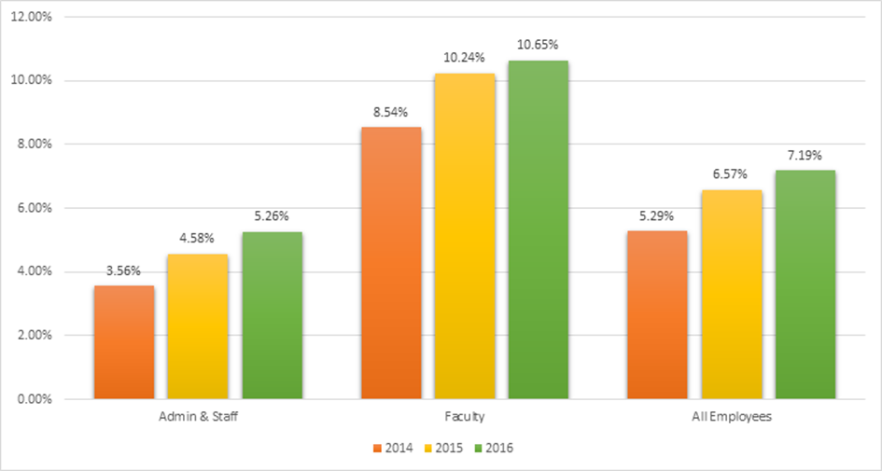

GOALS:

Over the next decade, we hope to reap results similar to our present student population, and more. With at least a dozen or more retirements expected in the next three years alone, the present is the best time to rekindle our community-based efforts and commitments to diversify our staff, faculty and administration. In doing so, we further support Juniata College’s mission to “develop the skills, knowledge and values that lead to a fulfilling life of service and ethical leadership in the global community.”

Research shows the values gained and correlations made between diversity and learning. By diversifying our employee population, we hope to inspire and enhance Juniata’s quality of living and learning through: the cultivation of social skills; the awakening/sustenance of global citizenry and rhetorical civility; the nourishing of values intrinsic to human relationships; the broadening of scholarly activity and community service; the networking potentials for student career and advance degree options; deepening our moral and/or spiritual sensibilities; and the emboldening of our creativity.

Diversity employment is now an institutional initiative approved by President Kepple, to be implemented campus-wide beginning November 2011.

Many of us rely on the traditions and procedures of the past when recruiting new candidates for employment. Most of these traditions will remain intact. The guidelines herein are aimed to strengthen, improve and modernize what we already do.

MEMBERSHIP:

All members of the Juniata community need to become a part of the shared effort, consciousness, creativity and commitment to our campus-wide initiative: To work together toward increasing diversity employment (and, eventually, diversity retention) at Juniata. How?

Here are some suggestions:

- When attending conferences/workshops, consider talking about job openings (or future job openings) to qualified candidates, especially those among ALANA populations.
- If you meet ALANA students in advanced degree programs, discuss potential employment opportunities at Juniata.
- Address some of the real drawbacks to living in the area but also highlight reasons why you live here and why you decided to stay.
- Imagine and discuss diversity employment to be a real possibility for Juniata College. (Until we think/speak it, we won’t be able to live it.)
- Be creative, inclusive and welcoming in your job announcements and flyers (For example see page 6)
- Please compose a selection committee that is as diverse as possible, and encourage an open tone of inquiry in the deliberations.
- Work collaboratively and openly with the Stewards. (Please refer to the Procedure section on page 5)

Some members of the Juniata community, known as Stewards, have been trained specifically to help. Stewards are Juniata employees who have undergone training in diversity employment. When the Stewards formed in the spring semester of 2012, there were twenty-two members. Three years later, in January of 2015, we have almost doubled in size. There are now forty-three Stewards in all.

Presently, the forty-three Stewards of Diversity are:

Michelle Bartol
Brett Basom
Michael Beamer
Beth Bleil
James Borgardt
Lauren Bowen
Katron Broomfield
Celia Cook-Huffman
Kati Csoman
Greg Curley
Cynthia Merriwether deVries
Maria Engels
Grace Fala, Chair
Athena Frederick
Cindy Gibboney
Caroline Gillich
Fiona Grugan
Chad Herzog
Kathleen Jones
Genna Kasun
Cady Kyle
Ryan Navarro
David Meadows
Christina Miller
Lindsay Monihen
Valerie Park
Susan Prill
Matt Powell
Susan Radis
Rosalie Rodriguez
Deborah Roney
Paul Schettler
Amanda Siglin
Jim Troha
Stephanie Turner
Belle Tuten
Gail Ulrich
Neal Utterback
Donna Weimer
Daniel Welliver
Kathy Westcott
David Witkovsky
Rob Yelnosky

At least one Steward of Diversity will sit on each selection committee that forms. Stewards aim to assist other members of the committee in their search, selection, and retention of qualified candidates, especially those from ALANA/international populations. In addition to helping to create a more diverse pool of applicants, the Steward serves as a full, voting member of the search committee.

PROCEDURE:

- Before the search begins, a Steward is selected. The Office of Human Resources will contact an available Steward. That Steward will then meet with the Chair/Program Director of the search committee to discuss procedural options.
- In collaboration with Human Resources, the Steward might also assist in the review of the job description and offer advice on relevant classified sites before placing the ad.
- Stewards will meet with the search committee to facilitate a preliminary discussion of institutional goals and inquiries regarding diversity employment.
- Stewards will participate in the review, selection and voting process of candidates for the specified position. Stewards will also be involved in the interview processes.
- Stewards will make relevant connections with volunteers on campus who are willing to invest time to make the candidate’s site visit and interview more welcoming and meaningful.
- Stewards will collaborate with the rest of the committee and the candidate for relevant & useful feedback.
- Mindful of confidentiality, the Steward will then share his/her observations with the other Stewards.
- In an effort to assess the strength of this initiative, Stewards of Diversity who participated in search committees in any given academic year will give a report to the College, through Human Resources and the Office of Diversity and Inclusion (ODI), detailing the search committee’s successes in enhancing the diversity of the hiring process. (The timing for this report will be decided by the ODI and Human Resources)
- Diversity Employment training will continue and evolve as we learn from one another so that more emphasis can be placed on Diversity Retention.
- If your department seeks additional information/training regarding diversity employment, please feel free to request it through Human Resources and the ODI.

Stewards are volunteers with a shared vision, working toward a common goal. We welcome your heartfelt insights and helpful suggestions. We are fully aware of the many challenges we might face. Thank you, ahead of time, for not reminding us of how difficult this might be and for, instead, forging ahead with us in our evolution.

EEO/JOB STATEMENTS:

Juniata College’s current EEO statement, job announcement, and non-discrimination policy state:
Juniata College, a highly ranked, national liberal arts college of 1,600 students located in the scenic Allegheny Mountains of central Pennsylvania…
Juniata College will take positive steps to enhance the ethnic and gender diversity on its campus. The College commits to this policy not only because of legal obligations, but because it believes that such practices are basic to human dignity. AA/EEO
Our College is committed to maintaining a work environment that is free of discrimination … based on an individual's race, color, religion, gender, national origin, age, disability, ancestry, marital status, veteran status, citizenship status, sexual orientation, or any other protected status of an individual or that individual's associates or relatives.
Collaboratively discussed, debated and drafted by the ODI, HR, members of the Diversity Committee and the Stewards in 2011, Juniata College’s job announcement aims to attract a diverse range of qualified applicants:
Juniata College takes positive steps to enhance diversity in both its community and its curriculum. The College commits to this policy not because of legal obligations but because it fully believes that such practices are basic to human dignity. AA/EEO

GUIDELINES FOR STEWARDS:

Stewards are encouraged to:

- Model what we seek from other members of the Juniata community with regard to diversity employment
- Follow the steps outlined in these Guidelines.
- Assist the selection committee with choosing the job announcement option. Use this process to prompt a discussion of our shared goals.
- Seek assistance from other Stewards when doubtful or confused.
- Report back to the ODI
- Be willing to share relevant (and non-confidential) information with other members of the campus community
- Consider using questions like these as guideposts when working with search committees: *

- Why do people want to come to Juniata? (By focusing on why they don’t want to come, we lose sight of our mission)
- What makes Juniata College exciting to people?
- Why did you come to Juniata?
- What makes you want to stay here?
- What do you value about this geographic area?
- What do we mean by that notion of “fit”?
- What do we mean by “experience?”
- What do we value in terms of “research?” Why?
- What does “quality” mean in terms of hiring the most qualified candidate?
- What is your experience working with diversity? Working with ALANA communities? Give an example. (While this question is not only useful to ask the job candidates, it might also be useful to ask the search committee)

*Adapted from the research of Dr. Tiffenia Archie, Temple University, who consulted with Stewards of Diversity at Juniata in both the fall of 2011 and again, in the spring of 2012
At the interactive workshops on diversity employment facilitated by Dr. Tiffenia Archie from Temple University, Stewards shared insights and concerns about interview processes. Much of what emerged is highlighted in this outline.

Key Ideas and Strategies to Assist Stewards
All members of the Juniata community are pivotal at this exciting time in the College’s history. We can also expect to be busier and hopefully, more engaged the next couple of years.) The Stewards are a resource to the College as it undergoes change and advances its mission. By being more attentive to our own “Unconscious Bias,” we can perhaps awaken it elsewhere. Suggestions include:
- “Why bother?”
  - Diversity Employment has become an institutional imperative. The College has become more diversified with regard to student population. We aim to continue to hire employees who relate directly to students with regard to race, ethnicity, gender, religion and so forth. Students often seek mentors who share common backgrounds and understandings. In fact, all of us gain and grow. Research shows repeatedly the correlation between diversity and quality of education. (References available soon on the shared drive)
- “What if the candidate doesn’t want to come to Huntingdon?”
  - Ask, “Why are you here? What brought you here? Why did you stay?” Consider letting the candidate decide for him or herself.
- When developing the profile for the position, relevant questions can include: (a) Who are we excluding; (b) What do we mean by skill set? Research? Years of experience? Why?
- When the focus of attention shifts to “fit” or “match,” remind committee that Juniata is an evolving community and that change can help us become more competitive and creative.
- A key question also to ask is, “How do we want this person to change us?”
- What don’t I understand about this candidate based on my own background?
- What kinds of considerations are we giving to nonverbal behaviors? Are we reading into behaviors? For example, if a woman is outspoken, do we regard her as “dominant” while a similar quality in men might be regarded as a sign of “strong leadership?”
- Do we share an appreciation for diverse communication styles or is a particular communication style being sought? Expected?
- In what ways are we looking for someone who looks like, thinks like (etcetera) me/us? In what ways do we feel more comfortable because the individual is similar to us? Diversity often asks us to feel uncomfortable. How might the tension be helpful? (Acknowledge fears & hopes)
- When interviewing candidates, ask for specifics: What have you done to promote diversity in your department? What have you done to recruit women and minority faculty? Can you give an example of when you mentored a person of color or another person of minority status?
- Consider the educational contributions and values that diversity brings to our shared mission.

Prepared by Grace Fala, Ph.D. / February 8, 2012, Juniata College in the fall, 2011.

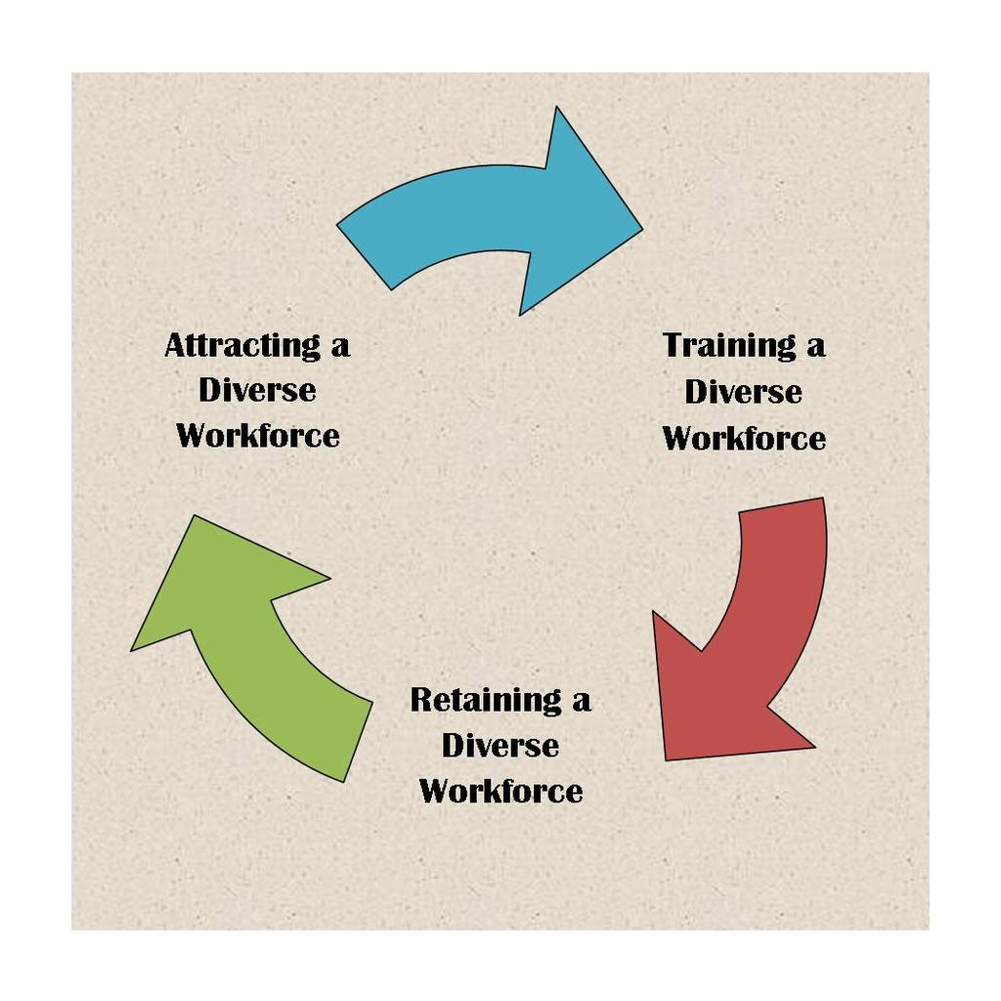
Follow-Up Report from Steward

Your Name:
Selection Committee you served on:
General Dates of Services:

- When you were invited to participate as Steward on a selection committee, were you given reasonable time with the notification? If not, please explain:

- Did you meet with the Chair of the Committee in advance of deliberations?

- Were you invited to participate in discussions related to the selection process?

- Did you feel included in the conversations and interviewing process?

- Were you and did you feel included in the decision-making process?

- On a scale of 1-5, how would you rate your overall experience? Please feel free to elaborate.

- Based on your experience, what suggestions do you have to strengthen our mission as Stewards?

- What did you gain? What might you change?

Please submit this report to Gail Ulrich and Grace Fala within two weeks of final decisions.
Thank you for your service to our growing and evolving community.

What to say and what not to say at an Interview:
“It's important to note that discriminatory practices can occur in any aspect of employment. It is illegal for an employer to make assumptions based on race, sex, gender, or age-related stereotypes, and it's also unlawful for an employer to assume that an employee may be incapable because he or she is disabled.
Additionally, companies are prohibited from withholding employment opportunities from an employee because of his or her relationship with someone of a certain race, sex, gender, religion, or ethnicity. Unlawful discrimination also includes harassment based on legally protected personal traits, including (but not limited to) race, sex, gender, age, and religion.”
(http://jobsearch.about.com/od/hiringdiscrimination/qt/Examples-Of-Employment-Discrimination.htm)
- Please avoid asking any question that directly or indirectly focuses on:
  - Race
  - Color
  - Sex
  - Gender
  - Religion
  - National Origin
  - Birthplace
  - Age
  - Disability
  - Marital/family status
Costly mishaps can occur during any stage of an interview process. Questions that cannot be asked are listed below and, when necessary, alternatives are provided.

Nationality
Certainly, you want to be sure that a candidate can legally work for you, but it's important to be careful how you ask. These questions address citizenship, language and other touchy subjects.
- What you can't ask: Are you a U.S. citizen?
Although this seems like the simplest and most direct way to find out if an interviewee is legally able to work for your company, it's hands-off. Rather than inquiring about citizenship, question whether or not the candidate is authorized for work.
What to ask instead: Are you authorized to work in the U.S.?
- What you can't ask: What is your native tongue?
Finding out about a candidate's native language may seem like a good way to find out about their fluency, but you may offend applicants that are sensitive to common assumptions about their language. Additionally, as an employer, it's not your concern how the applicant attained fluency in a language — just that they are fluent.
What to ask instead: What languages do you read, speak or write fluently?
- What you can't ask: How long have you lived here?
Familiarity with local culture may be important to the position, but it's important not to ask about a candidate's residency in the country or region directly. Rather, ask about their current situation, and they may volunteer information about their past along the way.
What to ask instead: What is your current address and phone number? Do you have any alternative locations where you can be reached?
Religion
Religion is a subject that should be treaded upon lightly at the office, and even more so in interviews. Protect yourself from overstepping the boundaries but still get the information you need with these questions.
- What you can't ask: What religion do you practice?
You may want to know about religious practices to find out about weekend work schedules, but it's imperative that you refrain from asking directly about a candidate's beliefs. Instead, just ask directly when they're able to work, and there will be no confusion.
What to ask instead: What days are you available to work?
- What you can't ask: Which religious holidays do you observe?
Again, scheduling is important, but don't risk stepping on toes to find out what you need to know. Simply confirm that your interviewee can work when you need them to.
What to ask instead: Are you able to work with our required schedule?
- What you can't ask: Do you belong to a club or social organization?
This question is too revealing of political and religious affiliations that candidates are not required to share such information with potential employers. Additionally, this question has little to no relation to a candidate's ability to do a job. For this question, it's important that the wording focuses on work.
What to ask instead: Are you a member of a professional or trade group that is relevant to our industry?
Age
Maturity is essential for most positions, but it's important that you don't make assumptions about a candidate's maturity based on age. Alternately, you have to be careful about discrimination towards applicants nearing retirement. These questions will keep you in the clear.
- What you can't ask: How old are you?
While it seems like a simple question, it's in fact quite loaded. Knowledge of an applicant's age can set you up for discrimination troubles down the road. To be safe, just ensure that the candidate is legally old enough to work for your firm.
What to ask instead: Are you over the age of 18?
- What you can't ask: How much longer do you plan to work before you retire?
Again, asking this question opens up discrimination troubles. While you may not want to hire an older worker who will retire in a few years, you can't dismiss an applicant for this reason. Instead, see what the candidate's plans are for the future; they may plan to work for a number of years.
What to ask instead: What are your long-term career goals?
Marital and Family Status
These questions primarily concern women with children, but they're applicable to everyone. Ensure that you don't make assumptions, and avoid embarrassing candidates by using the following questions.
- What you can't ask: Is this your maiden name?
This question, like many others, may seem innocent and simple, but it's off-limits. A woman's marital status isn't something that's required to be shared with employers. Instead, verify whether or not she's gained experience using any other names.
What to ask instead: Have you worked or earned a degree under another name?
- What you can't ask: Do you have or plan to have children?
Clearly, the concern here is that family obligations will get in the way of work hours. Instead of asking about or making assumptions on family situations, get to the root of the issue by asking directly about the candidate's availability.
What to ask instead: Are you available to work overtime on occasion? Can you travel?
- What you can't ask: Can you get a babysitter on short notice for overtime or travel?
Don't make the mistake of assuming that a candidate has children or that they don't already have proper child care plans. As with many other questions, the key here is to ask directly about availability.
What to ask instead: You'll be required to travel or work overtime on short notice. Is this a problem for you?
- What you can't ask: Do you have kids?
This one is for positions in which the candidate may work with children. The added experience of children at home may be a bonus for you, but it's not an employer's place to ask about this. Rather, inquire about the candidate's experience, and they may volunteer this information to you anyway.
What to ask instead: What is your experience with "x" age group?
- What you can't ask: Who is your closest relative to notify in case of an emergency?
Although not especially offensive, this question makes assumptions about the candidate's personal life. They may not be close to relatives and instead prefer to list a friend or caretaker.
What to ask instead: In case of emergency, who should we notify?
- What you can't ask: What do your parents do for a living?
Asking a candidate about their parents can reveal a lot, but it's not directly related to their future performance in a position. However, if you are trying to find out if your candidate's family has traditionally worked in your industry, this question is a good way to find out.
What to ask instead: Tell me how you became interested in the "x" industry.
- What you can't ask: If you get pregnant, will you continue to work, and will you come back after maternity leave?
Ultimately, you want to invest your time in a candidate that will stick around, but you can't ask a woman to share her pregnancy plans, or lack thereof, with you. Discuss her general plans for the future to gauge her commitment level, baby or not.
What to ask instead: What are your long-term career goals?
Gender
Once you've reached the interview stage, a candidate's gender is almost always clear. It is important, however, to ensure that you don't make assumptions about a person's abilities based on this information.
- What you can't ask: We've always had a man/woman do this job. How do you think you will stack up?
Leave gender out of this question, and you should be fine. Inquire about th applicant's ability to handle the job, but don't ask directly about how being a man or woman could affect it.
What to ask instead: What do you have to offer our company?
- What you can't ask: How do you feel about supervising men/women?
This question, although it may seem like a valid concern, is not acceptable. The candidate may not have any issues working with the opposite or same sex, and you'll seem crass for even bringing it up.
What to ask instead: Tell me about you previous experience managing teams.
- What you can't ask: What do you think of interoffice dating?
The practice of interoffice dating can be distracting, break up teams and cause a number of other problems in the workplace. But asking this question makes assumptions about the candidate's marital status and may even be interpreted as a come-on.
What to ask instead: Have you ever been disciplined for your behavior at work?
Health and Physical Abilities
Your employees' health and abilities may be essential to getting the job done, but it's important to avoid assumptions and discrimination. Stick to these questions in order to avoid embarrassment and legal troubles.
- What you can't ask: Do you smoke or drink?
As an employer, you probably want to avoid someone who has a drinking problem or will take multiple smoke breaks throughout the day. It's even a concern for insurance. Instead of asking about this directly, find out if they've had trouble with health policies in the past.
What to ask instead: In the past, have you been disciplined for violating company policies forbidding the use of alcohol or tobacco products?
- What you can't ask: Do you take drugs?
This question is just a simple confusion of terms. Your interviewee may think you're asking about prescription drugs, which is off-limits. Make sure you specify that you want to know about illegal drug use instead.
What to ask instead: Do you use illegal drugs?
- What you can't ask: How tall are you?
In a labor environment, height may be essential to the job, but this question is too personal. As with many of these questions, it's best just to ask directly about the candidate's ability to do what's required of them.
What to ask instead: Are you able to reach items on a shelf that's five feet tall?
- What you can't ask: How much do you weigh?
This highly personal question is embarrassing for most and is not necessarily relevant to a candidate's ability to do even a physical-labor job. Avoid making assumptions, and ask about abilities directly.
What to ask instead: Are you able to lift boxes weighing up to 50 pounds?
- What you can't ask: How many sick days did you take last year?
No one wants a flaky employee, but even the most dedicated workers get sick every now and then. Take a look at missed days as a whole to measure the candidate's commitment.
What to ask instead: How many days of work did you miss last year?
- What you can't ask: Do you have any disabilities?
Disabilities, whether they're physical or mental, may affect a candidate's ability to do the job, but it's critical that you avoid asking about them. Rather, find out if the applicant can handle doing what's required.
What to ask instead: Are you able to perform the specific duties of this position?
- What you can't ask: Have you had any recent or past illnesses or operations?
Again, gauging commitment is important, but illness isn't something that most people can help.The answer here is to make sure that the candidate can perform the job while avoiding questions about his or her physical abilities.
What to ask instead: Are you able to perform the essential functions of this job with or without reasonable accommodations?
Miscellaneous
Avoid interviewing gaffes by sidestepping these questions about residence, legal troubles and military service.
- What you can't ask: How far is your commute?
Although hiring employees who live close by may be convenient, you can't choose candidates based on their location. Find out about their availability instead.
What to ask instead: Are you able to start work at 8 a.m.?
- What you can't ask: Do you live nearby?
If your candidate lives outside of the city your company is hiring in, it may be necessary to have them move to your area. But again, you can't discriminate based on location. Rather, find out if the applicant is willing to move closer to the office.
What to ask instead: Are you willing to relocate?
- What you can't ask: Have you ever been arrested?
In sensitive positions, like those that deal with money, you may want to find out about your candidate's legal fortitude. But ensure that you ask only directly about crimes that relate to your concern.
What to ask instead: Have you ever been convicted of "x" (fraud, theft and so on)?
- What you can't ask: Were you honorably discharged from the military?
A bad military record can be illuminating, but you can't ask about it. Instead, ask about the candidate's experience, and they may volunteer this information on their own.
What to ask instead: Tell me how your experience in the military can benefit the company.
- What you can't ask: Are you a member of the National Guard or Reserves?
Losing an employee to military service can be disrupting, but it's critical that you don't discriminate based on assumptions of a candidate's upcoming military commitments. Find out what their plans are for the short term instead.
What to ask instead: Do you have any upcoming events that would require extensive time away from work?
http://www.comparebusinessproducts.com/fyi/30-interview-questions-you-cant-ask-and-30-sneaky-legal-get

The Office of the President, the Office of Diversity and Inclusion, Human Resources, the Diversity Committee and the Stewards of Diversity are grateful for your investment of time and for your commitment to our shared vision. Please contact the ODI and/or Dr. Grace Fala with questions, concerns or insights. Thank you.

These Guidelines were reviewed and updated in January of 2015 by Chairperson, Grace Fala, and Director of Human Resources, Gail Ulrich, and approved by President Troha on January 14, 2015
The Recruitment and Retention of ALANA Faculty
Aguirre, A. (2000). Women and minority faculty in the academic workplace: recruitment, retention, and academic culture. San Francisco, CA: Jossey-Bass.

Aguirre Jr., A., R. Martinez, & A. Hernandez. (1993). Majority and minority faculty perceptions in academe. Research in Higher Education. 34(3), 371-384.

Alger, J.R. (2007). How to recruit and promote minority faculty: Start by playing fair. American Association of University Professors. Retrieved from http://www.aaup.org/issues/diversity-affirmative-action/resources-diversity-and-affirmative-action/how-recruit-and-promote-minority-faculty-start-playing-fair
Anderson, J.A. (2007). Eight crucial steps to increase diversity. Section: Diversity in academe The Chronicle of Higher Education, Vol. 54(5), B-36.
Antonio, A.L, (September/October 2002), Faculty of color reconsidered: Reassessing contributions to scholarship. The Journal of Higher Education, Vol. 73(5), pp. 582-602.
Antonio, A.L. Faculty of Color and Scholarship Transformed: New Arguments for Diversifying Faculty. Diversity Digest. Retrieved from http://www.diversityweb.org/digest/W99/diversifying.html
Astin, H. S., & Milem, J. F. (1997). The status of academic couples in U.S. institutions. In M. A. Ferber & J. W. Loeb (Eds.), Academic Couples: Problems and Promises (pp. 128-155). Urbana: University of Illinois Press.
Bertrand, M.A., & Mullianathan, S. (2003)Are Emily and Greg More Employable than Lakisha and Jamal? A Field Experiment on Labor Market Discrimination. Poverty Action Lab Paper #3.
http://www.chicago-united.org/elibrary/bertrand_mullainathan.pdf
Delton, J. (2007, September 28). Why diversity for diversity’s sake won’t work Section: Diversity in academe. The Chronicle of Higher Education, Vol. 54(5), B32. Retrieved from http://chronicle.com/article/Why-Diversity-for-Diversity-s/7121
Fleig-Palmer, M., Murrin, J., Palmer, D.K., Rathert, C., (2003), Meeting the needs of dual-career couples in academia. The Dual Career Conference at the University of Iowa on April 25, 2003. Retrieved 11/20/07. URL:http://www.uiowa.edu/~provost/dcn/survey.pdf
Gose, B. (2007, September 28). The professoriate is increasingly diverse, but that didn’t happen by accident. The Chronicle of Higher Education, Vol. 54(5), B1. Retrieved from http://chronicle.com/article/The-Professoriate-Is/1782
Hamilton, K. (2004).= Faculty science positions continue to elude women of color: Oklahoma professor’s study finds hiring, tenure remain stumbling blocks. Black Issues in Higher EducationVol. 21(3), pg. 38-40.
Hu-DeHart, E. (Sep/Oct 2000). The diversity project: Institutionalizing multiculturalism or managing differences? Academe, Vol.86(5), pg. 38-43.
Hune, S. (1998). Asian Pacific American Women in Higher Education: Claiming Visibility & Voice. A Report written for The Association of American Colleges and Universities Program on the Status and Education of Women. Washington, D.C.: Association of American Colleges and Universities.
Klein, S. S. (2007). The Handbook for Achieving Gender Equity through Education. 2nd ed. Mahwah, N.J.: Lawrence Erlbaum Associates.
Moody, J. (2000). Tenure and diversity: some different voices. Academe, 86(3), 30-33.
Perkins, L. S., (1997). For the good of the race: Married African-American academics – a historical perspective. In M. A. Ferber & J. W. Loeb (Eds.),Academic Couples: Problems and Promises (pp. 80-105). Urbana: University of Illinois Press.
Rai, K. B., & Critzer, J. W. (2000). Affirmative Action and the University: Race, Ethnicity, and Gender in Higher Education Employment. Lincoln, NE: University of Nebraska Press.
Readings, B. (1996). Introduction. In The university in ruins. Cambridge, MA and London, England: Harvard University Press, pp. 20-43.
Readings, B. (1996). The Idea of Excellence. In The University in Ruins. Cambridge: Harvard University Press, pp. 1-20.
Slaughter, S. and Leslie, L.L. (1997). Academic capitalism. In Academic Capitalism: Politics, Policies, and the Entrepreneurial University. Baltimore: Johns Hopkins University Press, pp. 1-13.
Smith, D.G. (Sep/Oct 2000). How to diversify the faculty. Academe, Vol 86 (5), pg. 48-52. Retrieved from http://codac.uoregon.edu/files/2011/01/How-to-Diversify-the-Faculty-by-Daryl-G-Smith.pdf
Smith, D. G., Turner, C., Osei-Kofi, N., and Richards, S. (2004). Interrupting the usual: Successful strategies for hiring diverse faculty. The Journal of Higher Education, 75(2), 133-160. Retrieved from http://www.jstor.org/stable/pdfplus/3838827.pdf?acceptTC=true
Steinpreis, R., Anders, K., & Ritzke, D. 1999. The Impact of Gender on the Review of the Curriculum Vitae of Job Applicants and Tenure Candidate: A National Empirical Study. Sex Roles, 41(7/8), 509-528).
Retrieved from: http://www.cos.gatech.edu/facultyres/Diversity_Studies/Steinpreis_Impact%20of%20gender%20on%20review.pdf
Tapia, R. A. (2007, September 28). True diversity doesn’t come from abroad. Section: Diversity in academe. The Chronicle of Higher Education, Vol. 54(5), B34. Retrieved from http://chronicle.com/article/True-Diversity-Doesn-t-Come/20812
Trowe, C.A. and Chait, R.P. (March-April, 2002). Faculty diversity: Too little for too long. Harvard Magazine. Retrieved 9/6/2007 from: http://www.harvard-magazine.com/on-line/030218.html
Trix, Frances & Psenka, C. (2003) Exploring the color of glass: letters of recommendation for male and female medical faculty. Discourse and Society, Sage Publications.
http://www.cos.gatech.edu/facultyres/Diversity_Studies/Trix%20&%20Psenka.pdf
Turner, C. S. (2003). Incorporation and marginalization in the academy: From border toward center for faculty of color? Journal of Black Studies, 34(1), 112-125.
Turner, C.S.V, (January/February 2002). Women of color in academe: Living with multiple marginality. The Journal of Higher Education, Vol. 73(1), pp. 74-91. Retrieved from http://www.jstor.org/stable/pdfplus/1558448.pdf?acceptTC=true
Turner, C.S., & S.L. Myers, Jr. (2000). Faculty of color in academe: Bittersweet success. Needham Heights, MA: Allyn and Bacon.
Turner, C.S., S.L. Myers, Jr., & J.W. Creswell. (1999). Exploring underrepresentation: The case of faculty of color in the Midwest. The Journal of Higher Education. 70(1), 27-59.
Turner, C.S. V. (2002). Diversifying the faculty: A guidebook for Search Committees. Washington, DC: Association of American Colleges and Universities.

University of California Affirmative Action Guidelines for Recruitment and Retention of Faculty. Office of the President, January 2, 2002.
http://www.ucop.edu/academic-personnel/_files/documents/affirmative.pdf
Williams, Damon A. (2013). Strategic Diversity Leadership. VA: Stylus Publishing.
Wilson, R. (2007). Black women seek a role in philosophy. Section: Diversity in academe. The Chronicle of Higher Education, Vol. 54(5), B-4.
Wolf-Wendel. L.E., Twombly. S., Rice S. (May – Jun., 2000). Dual-Career Couples: Keeping Them Together.The Journal of Higher Education, Vol. 71 (3), pp. 291-321.
Wolf-Wendel. L.E., Twombly. S., Rice S., (2003). The two-body problem: Dual-career-couple hiring policies in higher education. Baltimore and London: The Johns Hopkins University Press

