Bad Lessons: How Student Loan Debt Promotes Participatory Inequality

**Erin O’Brien**

*Calvert Ellis Distinguished Lecture, April 6, 2021*

Erin O’Brien is Associate Professor of Political Science at the University of Massachusetts Boston.

T

his project, “Bad Lessons: How Student Loan Debt Promotes Participatory Inequality,” is part of a bigger project that I am working on with Travis Johnston, my colleague in political science at the University of Massachusetts Boston, so it is a collective effort. As you all know, student loan debt is in the news, and, for many or even most of you, if you are like I was as a student, it’s personal.

There are at least four policy proposals when it comes to student loan debt forgiveness. These are broad contours, but they help root our conversation. The first, as I am sure a lot of you know, comes out of the 2016 Bernie Sanders campaign, as well as from Alexandria Ocasio-Cortez, in terms of really being on the national agenda. It is overall student loan forgiveness.[1] The idea is that if you forgive student loan debts, people are not indebted, so they can spend money, they can pursue homeownership, they can help small businesses, etc. It is an economic engine to have their dollars not be spent on loans but to be present in the economy. The first idea, then, is to get rid of student loan debt through total forgiveness.

The second proposal comes from Senate Majority Leader Chuck Schumer and Senator Elizabeth Warren. Their idea is to cancel $50,000 in federal student loan debt per person, arguing that it will help close the racial wealth gap and that it will benefit the 40% of borrowers who do not have a college degree as well as stimulate the economy.[2]

The Bernie Sanders approach is one pole in the Democratic Party, the Schumer/Warren approach is the median position, and the least progressive position in the Democratic Party is personified by the current President, Joe Biden. While campaigning for the presidency, he stated that he was prepared to write off $10,000, but not $50,000, in debt, in part because he does not believe it is in the purview of the president to do so; however, he is also willing to keep interest from accruing on those loans.[3] Those are the three Democratic positions, broadly construed.

I pulled the following quotation from Senator Bill Cassidy (R-LA) because I think he does a really good job of simplifying the whole of the Republican position: “Rather than jumping straight to student debt forgiveness, which creates a moral hazard for current and future student borrowers and is poorly targeted, Congress and the administration should do a better job of informing borrowers about what options exist to make affordable payments, while simplifying options to remove confusion.”[4] It’s not just that we should not do student loan forgiveness. It’s that if we forgive those loans, it encourages people to make bad bets, taking out loans that they should not have. These are the four policy positions that very much drove the 2020 presidential contest.

We know now that there is a good reason that student loan debt is on the national agenda: because the amount of student loan debt in the United States is staggering and is rapidly worsening. This is not symbolic policy; this is policy that matters. In 2020, there was $1.56 trillion dollars of student loan debt owed by forty-five million Americans; one in five adults over age eighteen has student loan debt.[5] The average obligation for those who currently owe is over $36,000, with an average monthly payment of $393.[6]

Student loan debt is second only to mortgage debt in terms of the total amount.[7] If you came of age in the 1990s, you will remember that we used to talk about credit card debt and the staggering negative effects of credit card debt all the time. Student loan debt was like, “Hold my beer, credit cards, I’m coming.” Student loan debt has really taken over, and it is an intergenerational problem. Three out of five parents expect to help their kids pay back student loans after they graduate from college.[8] In addition, 14% of parents have taken out a loan to help the student while the student is still in college, and the average amount of that loan is $37,200.[9] This is—to use a very precise term—a ton of money.

We know from psychologists, sociologists, and economists that the implications of all this debt include effects on physical and mental health: feelings of anxiety, extreme stress, insomnia, weight gain, and heart issues. We know that homeownership and having kids are delayed because of such substantial student loan debt. Higher debt levels also mean that individuals are less likely to pursue public interest jobs, and those public interest jobs benefit all of us.

We think the story is even worse. As political scientists, we suspect that political engagement—whether you vote, whether you contact public officials, whether you feel your government is responsive to you—is negatively affected by student loan debt. In particular, we are examining whether student loan debt heightens participatory inequality, the idea that the more economically advantaged—the richer—you are, the more likely you are to participate. In the United States, the more affluent you are, the more likely you are to be white. That is participatory inequality, and it defines American politics. We think student loan debt is making that problem even worse.

Now some of you might be sitting there thinking, “My parents took out loans, and no one spoke of participatory inequality” or “Student loans have been taken out for a considerable amount of time,” and that’s true. What is different is that, since the 1970s, the amount of student loan debt carried by borrowers has really been dramatically heightened in real dollars. As Sara Goldrick-Rab noted in her book *Paying the Price*, “Just as Americans decided that college was essential, states began spending less on public higher education and the price of college rose.”[10] The average grant award, which you do not have to pay back, covered 80% of college costs in the 1970s; in 2012, it covered only 31%.[11] Between 1988 and 2018—just a thirty-year span, there was a 129% increase in tuition at private four-year institutions.[12] Additionally, from 1990 to 2010, state funding to public colleges and universities was cut 26%.[13] It remains the case that 73% of individuals who go to college go to a state university where they reside and, according to the Center on Budget and Policy Priorities, another $6.6 billion in state funding was cut from 2008 to 2018.[14] These are dramatic cutbacks, further saddling borrowers. In addition, we know that over half of the states have cut funding for public higher education in response to the budget pressures created by COVID.[15]

All of this has dire consequences. Seventy percent of those who begin college take out a loan, so the majority of your classmates, and probably you yourself, have taken out a loan to complete your degree.[16] This is where our project adds something to our understanding of politics and policy because this does not get talked about nearly as much: forty percent of those who take on loans never finish the degree, so they are indebted with student loan debt but do not experience the economic gains from having a degree.[17]

Importantly, whether or not you finish your degree, the debt stays with you. There is a fancy word for this: non-dischargeable. A “non-dischargeable” debt cannot be gotten rid of even if you declare bankruptcy. Since 2005, student loan debt has been considered non-dischargeable, so you are usually saddled with it for the rest of your life. We know that those who are in default on their loans are not equally distributed among degree status. Figure 1 below, which groups delinquency status by how many days the loans are delinquent as well as by whether or not the borrower ever completed school, shows that the majority of those who are paying back their loans completed their degree. Of borrowers actively repaying their loans, 68.4% completed a degree; however, only 31.6% of those who never completed a degree are paying back their loans, a two-to-one ratio. Those who completed their degree and are paying it back, you will notice, took out considerably more money. In contrast, those who did not finish but are still paying back (“stop-outs”) took out considerably less in loan dollar amount.

When we started this project, debt for higher education was not an area we had done work in before. Rather, I am a scholar of public policy and democratic engagement, and Travis is a Congressionalist who was a middle school special education teacher prior to graduate school. Initially, we thought that the amount of loan debt would be determinative—higher debt, more depressive effects for political participation. Once we got into the literature, though, we realized, “Oh, we had better distinguish between those who dropped out and those who finished.” In terms of the majority of those who are delinquent, meaning they are not paying back their loan, we see the inverse pattern; the majority of those delinquent never completed their degree: 54% versus 46% (see Figure 1 below). Almost 60% of those

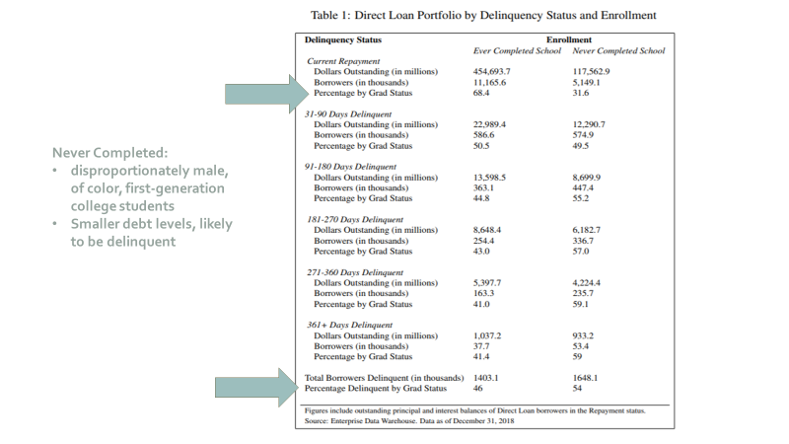

Figure 1. Delinquency status for graduates vs. non-graduates.[18]

who have been delinquent for over a year never completed their degree (pre-COVID). They took out less money, yes, but they never completed a degree. They may not have huge loans, but they are apt to have a much harder time paying them back.

Keep in mind that those people who never completed a degree are disproportionately male, are disproportionately of color, and are disproportionately first-generation college students, meaning that they are the first in their family to go to college. When we look at participatory inequality in the United States, lower-income individuals are less likely to vote, people of color are less likely to vote, and men are less likely to vote, so there is a pretty strong demographic correlation between who those who “stop out” and are delinquent and those who, on average, participate less in politics. And, again, driving home the point: smaller absolute debt levels are more crippling for those who do not finish the degree as delinquency rates are much higher. The effect of loans is conditioned less by amount than by whether or not one finished the degree.

This is the hook of this project. We think that that difference matters for participatory inequality, and there is strong theoretical grounding to expect that this is the case. The policy feedback literature is intuitive: when you have a good experience with the government, you want to participate more.[19] You think the government listens to people like you, so you go away with good feelings, and those good feelings lead to participation. If you have a bad experience with government, you are less likely to participate and to believe government wants to hear from you. Perhaps a number of you got $1400, or some amount, in the mail as a COVID stimulus check. You were loving the government, at least that day. You were walking tall. You were rich that day! In contrast, think about when you go to the Department of Motor Vehicles (DMV). Nobody has left the DMV happy—except maybe when you got your license when you were sixteen. Otherwise, nobody has enjoyed the experience of being at the DMV. That is a more negative experience and leaves people feeling less inclined toward political participation.

We are simply using this explanatory framework to suggest that student loan debt should affect people’s feelings about their role in the polity—whether they want to participate, whether they think it is worth contacting a government official, whether they even feel confident in doing so. Using that same theoretical framework, we know that student loan debt is proximate, meaning that if you have student loan debt, you associate said loans with government. This is not some remote, distant event. When you get a student loan, that debt is in your face, and it is in your face over your life course until you pay it off. It all starts with the Free Application for Federal Student Aid (FAFSA). I am guessing most of you who filled out a FAFSA were not like, “That was easy, that was great, how intuitive, thank you.” The FAFSA starts that association with the government.

In 2010, the Obama administration did what I think is a good thing. They eliminated the middle person in terms of the for-profit companies. The government cannot contract with for-profit companies to target delinquent borrowers to get their money back. That is a good thing because a lot of those for-profit companies were very invasive—calling you at work and so on. What eliminating the middle person did is make sure that the person, the entity coming after you for that loan repayment, is the government though this creates all the more association between your student loans and the government.

Most individuals who take out loans are between eighteen and twenty-six years old. The research finds that that age cohort is ripe for political socialization.[20] When in this age group, you are more willing to change your mind. However, what you think after that age is often what holds over your life course; what you settle on in these years in terms of politics tends to stick. So student loans come right when you are most apt to be formulating your core beliefs about the government. For this reason, too, then, student loans are apt to have policy feedback effects.

Last but not least, we have seen feedback effects before with education policy. Many of you have heard talk about the greatest generation, the World War II generation. They participated in government, in civic engagement, over their life course more than any other generation. There has been a lot of work done on this by Suzanne Mettler, and that participation comes back to the GI Bill.[21] For those of you who do not know, the GI Bill provided almost free college for returning veterans, and it provided low-interest loans to get a home at a time when the vast majority of people did not go to college and did not own a home. The positive of a nearly free education produced confidence in and engagement with government over the course of their lives. Government was viewed as an empowering force. It was not as good for African Americans, but even for African American veterans, we know that as a result of the GI Bill, they were more active in social protest, especially in the Civil Rights movement. When it comes to women, Andrea Rose at Duke University has found that women participate more in politics, in part, because of government programs such as the National Defense Education Act (1958), the Higher Education Act of 1965, and Title IX.[22] For our purposes, these findings make clear that education policies have had positive effects for political participation. Empowering policy choices in higher education produced increased political engagement. It stands to reason that disempowering policy choices, such as significant debt, can produce political *dis*engagement.

You should understand that there has been major retrenchment of government support for higher education, and that gap has been filled by student loans. The experience of student loans is proximate for everyone, but the direst effects are actually on those who took out smaller amounts and did not finish school. We think that the story is more complicated than just how much money you are in the hole. We think the story is how debt interacts with whether or not you get your degree.

Even if you have relatively high student debt, there can be a positive association with the government if you have the degree. The degree gives you more resources and more civic skills, and it puts you into occupations with more upward mobility (those are the correlates of higher participation). That means that even though you might be annoyed by the loan, you also know you got some real goodies. Your relationship with the government might be a bit ambivalent on the student loans, but you generally feel positive towards it because of the ways your life has improved.

The same cannot be said for those who do not finish. They are indebted at smaller levels, but without the degree they re-enter the low-wage service market. I am not saying that they did not have positive educational experiences in terms of learning, but the lasting effect of being in debt and not having the degree, which would push them into higher economic categories, means that they have the debt but few of the goodies from the debt. We think that these two groups, those who finished their degree and those who did not, are going to experience different political effects of student loan debt.

There are many surveys that ask about student loan debt and whether you went to a public, private, or for-profit school. There are also a lot of surveys that ask about political participation, but these are never on the same survey, much to our frustration! As a result, we got some grant money to ask both of those sets of questions on the same survey. We wanted to find out how indebted people were, how many times they started and stopped school, as well as their likelihood to vote, their likelihood to contact political officials, and their interest in politics. We controlled for all the factors, such as age, race, political party, gender—anything that might be associated with whether someone votes—independent of student loan debts. We wanted to see if student loan debt still mattered once we controlled for all those factors.

We found that those who had student loan debt but no degree were less likely to vote, were less likely to contact government officials, and paid less attention to politics as a result (see Figure 2 below). Hence, there are depressive effects for political engagement and political participation for those who are indebted but did not get that degree. Those who have the degree with debt were more likely to contact political officials, and they were more likely to pay attention to politics.

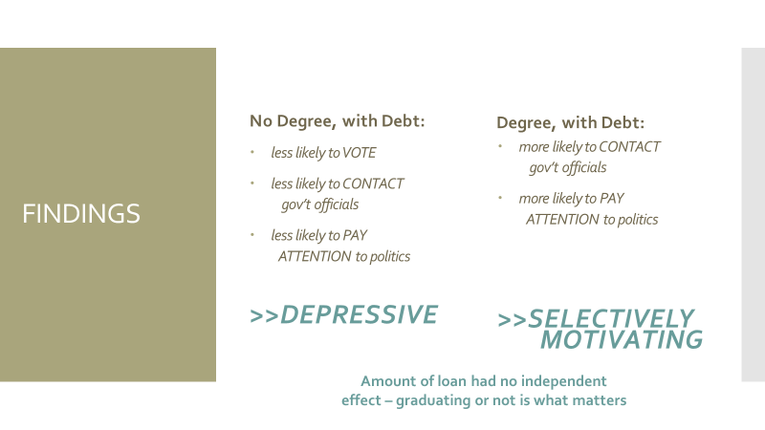

Figure 2. Findings of our study: The amount of the loan is less important than completion of the degree. Those who have not completed are less likely to engage in civic action.

Interestingly, the amount of the loan had no independent effect. That is not what was driving the effects on participation. We found that the most important variable was whether you have the debt and the degree or have the debt and no degree. This is a very common experience in US politics, and we hear less from those who have not finished a degree. They have a distinct policy interest because their loan debt is smaller but much more cumbersome. Their interest is to get student loan forgiveness but not necessarily at $50,000. A smaller amount of loan forgiveness would help them considerably. Thus, Joe Biden’s plan of $10,000 would actually assist most of these borrowers tremendously, and the $10,000 amount is more politically palatable to average Americans. But our findings also show that it is those with the debt and the degree, those who desire larger amounts of loan forgiveness, that government officials hear more from.

We know that this is not the only thing driving participatory inequality in the United States. There are voter access policies and a lot of other things that we can talk about, but student loan debt is an important part of the story. Look at how massive the amount of student loan debt is. One in four adults are carrying it. This is an experience that is driving participatory inequality in the United States, and we know that policymakers are more responsive to those they hear from. They are hearing from the people who finished and have debt, and those are the people pushing for the Sanders policy or the Warren and Schumer plan. Policy makers are less likely to hear from those who did not finish and who usually need smaller levels of debt forgiveness, that is, a more Bidenesque policy.

The key takeaway from this talk is that student loans have unintended negative effects for political engagement and civic participation. We should be funding public and private higher education so that no one needs to take out so many cumbersome loans. In the current political moment, though, since funding higher education is not what is occurring, it is important to know that those people who do not finish their degree but take on debt have unique policy interests directly stemming from their experience with the government and student loans that are less likely to be heard by policy makers.

If these results were widely known, would student loan policy be more generous, or would policymakers double down? Or would they continue to be more responsive to those with, quite frankly, more economic voice? We hope that the discussion of student loans better differentiates between those who finish a degree and those who do not. We hope, too, that higher education policy and funding leave far fewer students indebted and at lower levels. This is good for America, and it is good civic engagement.

NOTES

1. . Michael Stratford, “How Bernie Sanders Would Cancel All Student Loan Debt,” *Politico*, June 24, 2019, <https://www.politico.com/story/2019/06/24/bernie-sanders-2020-student-loan-debt-forgiveness-plan-1296863>.
2. . Senate Democrats, “Schumer, Warren Joint Statement on Student Debt Cancellation,” Senate Democrats, February 17, 2021, <https://www.democrats.senate.gov/newsroom/press-releases/schumer-warren-joint-statement-on-student-debt-cancellation>.
3. . Adam S. Minsky, “Biden: I Support Cancelling $10,000 in Student Debt and ‘Eliminating Interest,’” *Forbes*, February 17, 2021, <https://www.forbes.com/sites/adamminsky/2021/02/17/biden-i-support-cancelling-10000-in-student-debt-and-eliminating-interest/?sh=4c9cbff73902>.
4. . Bill Cassidy. “Sen. Bill Cassidy: Cancel Student Debt? Better Solutions Exist—Here Are Answers Republicans Should Offer,” *Fox* News, February 16, 2021, <https://www.foxnews.com/opinion/cancel-student-debt-republican-solutions-sen-bill-cassidy>.
5. . Zack Friedman, “Student Loan Debt Statistics in 2020: A Record $1.6 Trillion,” *Forbes*, February 3, 2020, <https://www.forbes.com/sites/zackfriedman/2020/02/03/student-loan-debt-statistics/>; Alyssa Fowers and Danielle Douglas-Gabriel, “Who Has Student Loan Debt in America?” *The Washington Post,* May 22, 2022, <https://www.washingtonpost.com/education/2022/05/22/student-loan-borrowers/>.
6. . Melanie Hanson, “Average Student Loan Debt,” Education Data Initiative, last updated July 10, 2021, <https://educationdata.org/average-student-loan-debt>; Melanie Hanson, “Average Student Loan Payment,” Education Data Initiative, last updated March 1, 2022, <https://educationdata.org/average-student-loan-payment>.
7. . Friedman, “Student Loan Debt Statistics in 2020.”
8. . Caitlin Zaloom, *Indebted: How Families Make College Work at Any Cost* (Princeton, NJ: Princeton University Press, 2019); Rebecca Safier, “73% of Parents Plan to Help Their Kids Pay Off Student Loans,” eds. Pearly Huang and Michael Kitchen, *Student Loan Hero*, Lending Tree, updated October 12, 2021, <https://studentloanhero.com/featured/parents-help-student-loans-survey/>.
9. . Student Loan Hero, “A Look at the Shocking Student Loan Debt Statistics for 2022,” *Student Loan Hero,* Lending Tree, updated April 6, 2022, <https://studentloanhero.com/student-loan-debt-statistics/>.
10. . Sara Goldrick-Rab, *Paying the Price: College Costs, Financial Aid, and the Betrayal of the American Dream* (Chicago: University of Chicago Press, 2016), p. 1.
11. . Suzanne Mettler, *Degrees of Inequality: How the Politics of Higher Education Sabotaged the American* Dream (New York: Basic Books, 2014), p. 10.
12. . Emmie Martin, “Here’s How Much More Expensive It Is for You to Go to College Than It Was for Your Parents,” *Make It*, CNBC.com, November 29, 2017, <https://www.cnbc.com/2017/11/29/how-much-college-tuition-has-increased-from-1988-to-2018.html>.
13. . Suzanne Mettler, “How US Higher Education Promotes Inequality—And What Can be Done to Broaden Access and Graduation,” *The Society Pages*, Scholars Strategy Network, January 17, 2017, <https://thesocietypages.org/ssn/2017/01/17/higher-education-promotes-inequality/>.
14. . Lynn O’Shaughnessy, “Where Most Students End up Attending College,” The College Solution, n.d., <https://thecollegesolution.com/where-most-students-end-up-attending-college/>; Michael Mitchell, Michael Leachman, and Matt Saenz, “State Higher Education Funding Cuts Have Pushed Costs to Students, Worsened Inequality,” Center on Budget and Policy Priorities, October 24, 2019, <https://www.cbpp.org/research/state-budget-and-tax/state-higher-education-funding-cuts-have-pushed-costs-to-students>.
15. . Victoria Jackson and Matt Saenz, “States Can Choose Better Path for Higher Education Funding in COVID-19 Recession,” Center on Budget and Policy Priorities, February 17, 2021, <https://www.cbpp.org/research/state-budget-and-tax/states-can-choose-better-path-for-higher-education-funding-in-covid>.
16. . Samantha Fields, “70% of College Students Graduate with Debt. How Did We Get Here?” *Marketplace*, Minnesota Public Radio, September 30, 2019, <https://www.marketplace.org/2019/09/30/70-of-college-students-graduate-with-debt-how-did-we-get-here/>.
17. . Senate Democrats, “Schumer, Warren.”
18. # . "Direct Loan Portfolio by Delinquency Status and Enrollment," *Federal Student Loan Portfolio,* Federal Student Aid: An Office of the US Department of Education, <https://studentaid.gov/data-center/student/portfolio> (accessed February 2019).

   
19. # . Anne Schneider and Helen Ingram, “Social Construction of Target Populations: Implications for Politics and Policy,” *The American Political Science Review* 87 (1993): 334-47.

   
20. . Joe Soss, “Making Clients and Citizens: Welfare Policy as a Source of Status, Belief, and Action,” in Anne L. Schneider and Helen M. Ingram, eds., *Deserving and Entitled: Social Constructions and Public Policy* (Albany, NY: State University of New York Press, 2005), pp. 291-328.
21. . Suzanne Mettler, “Bringing the State Back in to Civic Engagement: Policy Feedback Effects of the GI Bill for WWII Veterans,” *American Political Science Review,* 96 (June 2002): 351-365; Suzanne Mettler, *Soldiers to Citizens: The GI Bill and the Making of the Greatest Generation* (Oxford: Oxford University Press, 2005); and Suzanne Mettler, “’The Only Good Thing Was the GI Bill’: Effects of the Education and Training Provisions on African-American Veterans’ Political Participation,” *Studies in American Political Development* 19 (April 2005): 31-52.
22. . Deondra Rose, *Citizens by Degree: Higher Education Policy and the Changing Gender Dynamics of American Citizenship* (Oxford: Oxford University Press, 2018).