Wellbeing Assessment Report
Juniata College
10 May, 2018
Table of Contents
How to Read this Document 5
Navigating your report 5
Additional Items and Custom Items 5
Reading your report 5
Charts 6
Tables 7
Summary Statistics 8
Your School 8
Aggregate 8
Academic Engagement 9
Academic Outcomes 12
Activity Engagement 15
Activities 15
Outcomes 18
Pathways 21
Belonging 28
Outcomes 28
Pathways 32
Experiences of discrimination 41
Health and substance use 43
Health behaviors 43
Health attitudes 46
Alcohol use 50
Lifelong Service 59
Outcomes 59
Pathways 62
Life Satisfaction 67
Meaning 72
Outcomes 72
Pathways 75
Mood 84
Happiness 84
Anxiety 87
Depression 90
Loneliness 93
Social Anxiety 96
Positive Relationships: Friendship 99
Outcomes for friends-in-general 99
Pathways for friends-in-general 103
Outcome for friends-who-are-different 109
Pathways for friends-who-are-different 110
Positive Relationships: Romantic Relationships 113
Set 1 115
Set 2 120
Positivity 122
Self Esteem 122
Optimism 126
Perseverance 129
Purpose 132
“Have goals” Outcomes 133
“Have goals” Pathways 136
“Defining goals” Outcomes 147
“Defining goals” Pathways 150
Standing up to Discrimination 158
Outcomes 158
Pathways 161
Volunteerism 163
Outcomes 163
Pathways 166
Demographics and background 171
Age, Class 171
Disability 172
Foreign school, Gender, GPA, Housing 174
Major, Military, Parents’ education 178
Paying for college & loans 180
Program participation, RA 183
Race/ethnicity, Sexual orientation, Spirituality, Study abroad 186
Work & money 190
Additional Items 191
Campus Safety 191
Mental Health Care 194
Custom Items 198

How to Read this Document
This document summarizes your school’s data from the Spring 2018 Wake Forest University Wellbeing Assessment.

Navigating your report
The report is broken down according to sections of the Wellbeing Assessment, which are organized in alphabetical order with the following exception: Demographics, Additional Items, and Custom Items. These appear at the end of the report.
The table of contents can be used to navigate from section to section. Simply Ctrl + click on the section heading in the table of contents to move to that section. The footer of each page contains a hyperlink that says “Click here to return to table of contents”. If you open the footer, you can Ctrl + click on that link to navigate back to the table of contents.

Additional Items and Custom Items
Each school had the opportunity to select up to two sets of Additional Items from the following: Campus Safety, Medical Care, Mental Health Care, and Money. Each school also had the opportunity to add up to 3 custom items. If you opted to include Additional Items and/or Custom Items in your survey, they will appear at the end of your report (after the demographics) and will be indicated by section headings Additional Items and Custom Items.

Reading your report
The data is summarized using charts and tables, which provide information on the number and proportion of students who responded in a given way to each item. Some items do not have a chart because the data was best represented in a table or some other form. Below is more information on how to read the charts and tables.

break

Charts
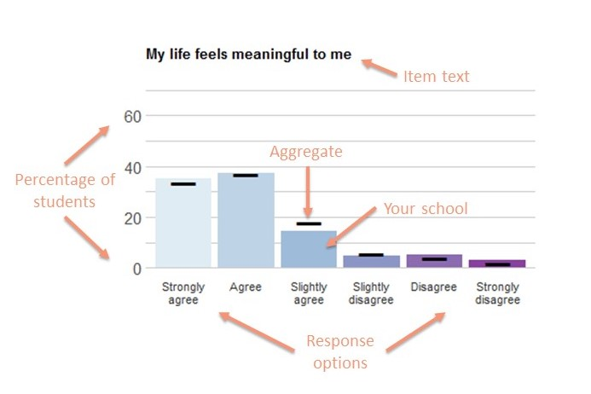
Each bar on the bar chart represents the percentage of students at your school who endorsed a particular response option for the given item. The bold black lines represent the percentage of students in the aggregated sample of all schools who endorsed a particular response. The item text is at the top of the chart and the response options are indicated along the bottom of the chart. Charts for Additional Items and Custom items do not include aggregate data.

break

Tables
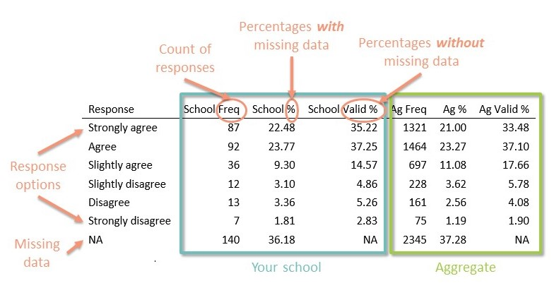
Following the bar chart is frequency table for each item. There are two sets of 3 columns. The left-hand columns labeled School represent students at your school, and the right-hand columns labeled Ag represent students from the aggregate sample of all schools. The Freq column indicates the raw number of students who endorsed each response option. The % column indicates the proportion of students who endorsed each response option, including those who did not provide a response (indicated in the table as NA’s). The Valid % column indicates the proportion of students who endorsed each response option, not including those who did not provide a response. The Valid % provides the most useful interpretation of the data and is identical to the percentage indicated in the bar chart. For items with no chart, the item text is indicated at the top of the table. Tables for Additional and Custom items do not include aggregate data.

Summary Statistics

Your School
- Total N of participants = 387
- Mean age of participants = 20.06
- Gender:
  - Female = 66.41%
  - Male = 32.03%
  - Other = 1.56%
- Class standing:
  - First year or freshman = 24.74%
  - Sophomore = 23.7%
  - Junior = 23.44%
  - Senior = 28.12%

Aggregate
- Total N of participants = 6291
- Mean age of participants = 20.26
- Gender:
  - Female = 68.26%
  - Male = 30.71%
  - Other = 1.03%
- Class standing:
  - First year or freshman = 27.85%
  - Sophomore = 23.94%
  - Junior = 26.41%
  - Senior = 21.81%

Academic Engagement
This set of items asks you about your academic experience.
Please rate how strongly you agree or disagree with the following statements.

ACAENG_1
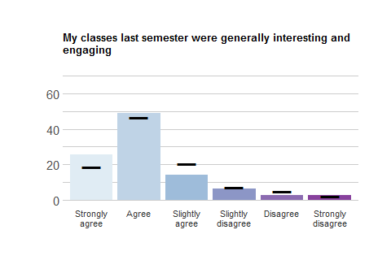
Response | School Freq | School % | School Valid % | Ag Freq | Ag % | Ag Valid %
Strongly agree | 63 | 16.28 | 25.82 | 744 | 11.83 | 18.51
Agree | 120 | 31.01 | 49.18 | 1885 | 29.96 | 46.90
Slightly agree | 34 | 8.79 | 13.93 | 829 | 13.18 | 20.63
Slightly disagree | 15 | 3.88 | 6.15 | 285 | 4.53 | 7.09
Disagree | 6 | 1.55 | 2.46 | 191 | 3.04 | 4.75
Strongly disagree | 6 | 1.55 | 2.46 | 85 | 1.35 | 2.11
NA | 143 | 36.95 | NA | 2272 | 36.12 | NA

ACAENG_2
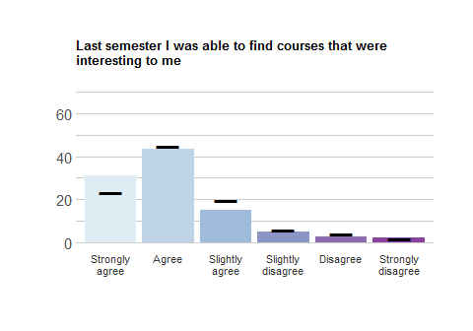
Response | School Freq | School % | School Valid % | Ag Freq | Ag % | Ag Valid %
Strongly agree | 78 | 20.16 | 30.95 | 950 | 15.10 | 23.46
Agree | 110 | 28.42 | 43.65 | 1818 | 28.90 | 44.90
Slightly agree | 38 | 9.82 | 15.08 | 803 | 12.76 | 19.83
Slightly disagree | 13 | 3.36 | 5.16 | 237 | 3.77 | 5.85
Disagree | 7 | 1.81 | 2.78 | 171 | 2.72 | 4.22
Strongly disagree | 6 | 1.55 | 2.38 | 70 | 1.11 | 1.73
NA | 135 | 34.88 | NA | 2242 | 35.64 | NA

ACAENG_3
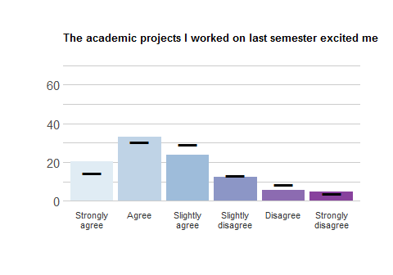
Response | School Freq | School % | School Valid % | Ag Freq | Ag % | Ag Valid %
Strongly agree | 76 | 19.64 | 20.49 | 887 | 14.10 | 14.62
Agree | 123 | 31.78 | 33.15 | 1862 | 29.60 | 30.69
Slightly agree | 88 | 22.74 | 23.72 | 1783 | 28.34 | 29.39
Slightly disagree | 46 | 11.89 | 12.40 | 799 | 12.70 | 13.17
Disagree | 20 | 5.17 | 5.39 | 506 | 8.04 | 8.34
Strongly disagree | 18 | 4.65 | 4.85 | 230 | 3.66 | 3.79
NA | 16 | 4.13 | NA | 224 | 3.56 | NA

Academic Outcomes
This set of items asks about your work and academic plans.
How likely is it that you will do any of the following:

OUTCOMES_1
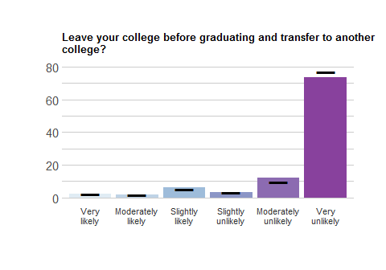
Response | School Freq | School % | School Valid % | Ag Freq | Ag % | Ag Valid %
Very likely | 9 | 2.33 | 2.34 | 147 | 2.34 | 2.37
Moderately likely | 8 | 2.07 | 2.08 | 116 | 1.84 | 1.87
Slightly likely | 25 | 6.46 | 6.51 | 342 | 5.44 | 5.51
Slightly unlikely | 13 | 3.36 | 3.39 | 196 | 3.12 | 3.16
Moderately unlikely | 46 | 11.89 | 11.98 | 619 | 9.84 | 9.97
Very unlikely | 283 | 73.13 | 73.70 | 4788 | 76.11 | 77.13
NA | 3 | 0.78 | NA | 83 | 1.32 | NA

OUTCOMES_2
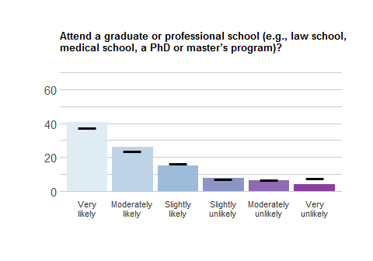
Response | School Freq | School % | School Valid % | Ag Freq | Ag % | Ag Valid %
Very likely | 157 | 40.57 | 40.78 | 2338 | 37.16 | 37.60
Moderately likely | 101 | 26.10 | 26.23 | 1491 | 23.70 | 23.98
Slightly likely | 58 | 14.99 | 15.06 | 1023 | 16.26 | 16.45
Slightly unlikely | 29 | 7.49 | 7.53 | 440 | 6.99 | 7.08
Moderately unlikely | 25 | 6.46 | 6.49 | 436 | 6.93 | 7.01
Very unlikely | 15 | 3.88 | 3.90 | 490 | 7.79 | 7.88
NA | 2 | 0.52 | NA | 73 | 1.16 | NA

OUTCOMES_3
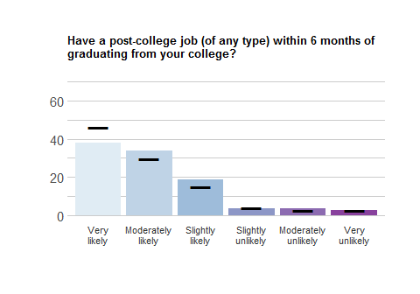
Response | School Freq | School % | School Valid % | Ag Freq | Ag % | Ag Valid %
Very likely | 146 | 37.73 | 38.12 | 2860 | 45.46 | 46.05
Moderately likely | 129 | 33.33 | 33.68 | 1848 | 29.38 | 29.76
Slightly likely | 71 | 18.35 | 18.54 | 922 | 14.66 | 14.85
Slightly unlikely | 13 | 3.36 | 3.39 | 241 | 3.83 | 3.88
Moderately unlikely | 13 | 3.36 | 3.39 | 172 | 2.73 | 2.77
Very unlikely | 11 | 2.84 | 2.87 | 167 | 2.65 | 2.69
NA | 4 | 1.03 | NA | 81 | 1.29 | NA

Activity Engagement
This set of items asks about the activities you are involved in.

Activities
In an average week, do you participate in any of the following?

ACT1_1
Social fraternity or sorority
Response | School Freq | School % | School Valid % | Ag Freq | Ag % | Ag Valid %
Yes | 5 | 1.29 | 1.33 | 1177 | 18.71 | 19.3
No | 370 | 95.61 | 98.67 | 4923 | 78.25 | 80.7
NA | 12 | 3.10 | NA | 191 | 3.04 | NA

ACT1_2:
Academic fraternity or honor society
Response | School Freq | School % | School Valid % | Ag Freq | Ag % | Ag Valid %
Yes | 40 | 10.34 | 10.67 | 782 | 12.43 | 12.88
No | 335 | 86.56 | 89.33 | 5289 | 84.07 | 87.12
NA | 12 | 3.10 | NA | 220 | 3.50 | NA

ACT1_3:
Varsity sport
Response | School Freq | School % | School Valid % | Ag Freq | Ag % | Ag Valid %
Yes | 114 | 29.46 | 30.48 | 615 | 9.78 | 10.14
No | 260 | 67.18 | 69.52 | 5452 | 86.66 | 89.86
NA | 13 | 3.36 | NA | 224 | 3.56 | NA

ACT1_4:
Club/intramural sport
Response | School Freq | School % | School Valid % | Ag Freq | Ag % | Ag Valid %
Yes | 129 | 33.33 | 34.4 | 1602 | 25.46 | 26.49
No | 246 | 63.57 | 65.6 | 4446 | 70.67 | 73.51
NA | 12 | 3.10 | NA | 243 | 3.86 | NA

ACT1_5:
Campus recreation activities (e.g. group fitness classes, outdoor excursions, etc.)
Response | School Freq | School % | School Valid % | Ag Freq | Ag % | Ag Valid %
Yes | 144 | 37.21 | 38.5 | 2220 | 35.29 | 36.65
No | 230 | 59.43 | 61.5 | 3838 | 61.01 | 63.35
NA | 13 | 3.36 | NA | 233 | 3.70 | NA

ACT1_6:
Performing arts group
Response | School Freq | School % | School Valid % | Ag Freq | Ag % | Ag Valid %
Yes | 64 | 16.54 | 17.16 | 784 | 12.46 | 12.93
No | 309 | 79.84 | 82.84 | 5278 | 83.90 | 87.07
NA | 14 | 3.62 | NA | 229 | 3.64 | NA

ACT1_7:
Community service group
Response | School Freq | School % | School Valid % | Ag Freq | Ag % | Ag Valid %
Yes | 86 | 22.22 | 23.12 | 1754 | 27.88 | 28.96
No | 286 | 73.90 | 76.88 | 4303 | 68.40 | 71.04
NA | 15 | 3.88 | NA | 234 | 3.72 | NA

ACT1_8:
Spiritual/faith-based group
Response | School Freq | School % | School Valid % | Ag Freq | Ag % | Ag Valid %
Yes | 47 | 12.14 | 12.67 | 1278 | 20.31 | 21.1
No | 324 | 83.72 | 87.33 | 4779 | 75.97 | 78.9
NA | 16 | 4.13 | NA | 234 | 3.72 | NA

ACT1_9:
Political group
Response | School Freq | School % | School Valid % | Ag Freq | Ag % | Ag Valid %
Yes | 31 | 8.01 | 8.27 | 337 | 5.36 | 5.57
No | 344 | 88.89 | 91.73 | 5717 | 90.88 | 94.43
NA | 12 | 3.10 | NA | 237 | 3.77 | NA

ACT1_10:
Student government
Response | School Freq | School % | School Valid % | Ag Freq | Ag % | Ag Valid %
Yes | 21 | 5.43 | 5.68 | 268 | 4.26 | 4.46
No | 349 | 90.18 | 94.32 | 5745 | 91.32 | 95.54
NA | 17 | 4.39 | NA | 278 | 4.42 | NA

ACT1_11:
Cultural/ethnic organization
Response | School Freq | School % | School Valid % | Ag Freq | Ag % | Ag Valid %
Yes | 58 | 14.99 | 15.55 | 708 | 11.25 | 11.7
No | 315 | 81.40 | 84.45 | 5341 | 84.90 | 88.3
NA | 14 | 3.62 | NA | 242 | 3.85 | NA

ACT1_12:
Media group (e.g. newspaper, radio station, etc.)
Response | School Freq | School % | School Valid % | Ag Freq | Ag % | Ag Valid %
Yes | 23 | 5.94 | 6.17 | 340 | 5.40 | 5.62
No | 350 | 90.44 | 93.83 | 5706 | 90.70 | 94.38
NA | 14 | 3.62 | NA | 245 | 3.89 | NA

ACT1_13:
Other
Response | School Freq | School % | School Valid % | Ag Freq | Ag % | Ag Valid %
Yes | 31 | 8.01 | 11.15 | 569 | 9.04 | 12.85
No | 247 | 63.82 | 88.85 | 3860 | 61.36 | 87.15
NA | 109 | 28.17 | NA | 1862 | 29.60 | NA

Outcomes
Thinking about all the activities you are involved in at your school, please rate how strongly you agree or disagree with the following statements.

ACT2_1
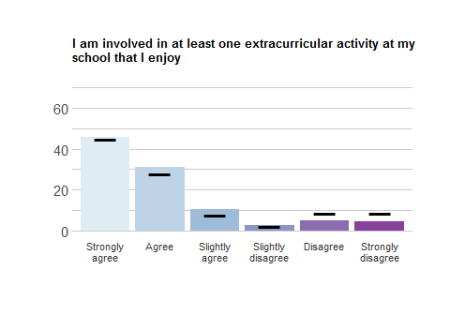
Response | School Freq | School % | School Valid % | Ag Freq | Ag % | Ag Valid %
Strongly agree | 117 | 30.23 | 45.88 | 1815 | 28.85 | 44.76
Agree | 79 | 20.41 | 30.98 | 1127 | 17.91 | 27.79
Slightly agree | 27 | 6.98 | 10.59 | 318 | 5.05 | 7.84
Slightly disagree | 7 | 1.81 | 2.75 | 97 | 1.54 | 2.39
Disagree | 13 | 3.36 | 5.10 | 344 | 5.47 | 8.48
Strongly disagree | 12 | 3.10 | 4.71 | 354 | 5.63 | 8.73
NA | 132 | 34.11 | NA | 2236 | 35.54 | NA

ACT2_2
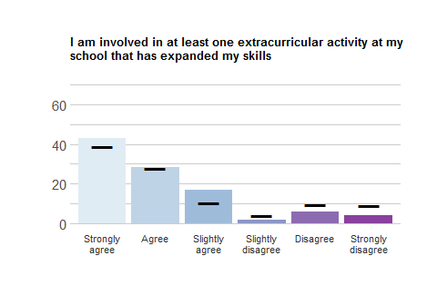
Response | School Freq | School % | School Valid % | Ag Freq | Ag % | Ag Valid %
Strongly agree | 106 | 27.39 | 43.09 | 1557 | 24.75 | 38.73
Agree | 70 | 18.09 | 28.46 | 1118 | 17.77 | 27.81
Slightly agree | 41 | 10.59 | 16.67 | 427 | 6.79 | 10.62
Slightly disagree | 4 | 1.03 | 1.63 | 157 | 2.50 | 3.91
Disagree | 15 | 3.88 | 6.10 | 392 | 6.23 | 9.75
Strongly disagree | 10 | 2.58 | 4.07 | 369 | 5.87 | 9.18
NA | 141 | 36.43 | NA | 2271 | 36.10 | NA

ACT2_3
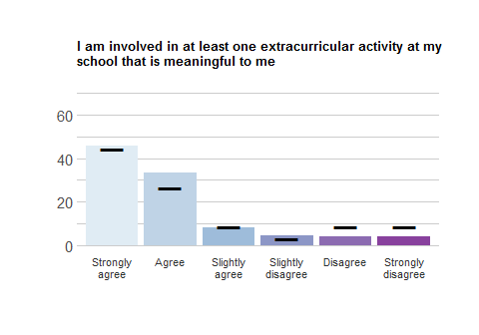
Response | School Freq | School % | School Valid % | Ag Freq | Ag % | Ag Valid %
Strongly agree | 115 | 29.72 | 46.0 | 1811 | 28.79 | 44.45
Agree | 83 | 21.45 | 33.2 | 1078 | 17.14 | 26.46
Slightly agree | 21 | 5.43 | 8.4 | 356 | 5.66 | 8.74
Slightly disagree | 11 | 2.84 | 4.4 | 128 | 2.03 | 3.14
Disagree | 10 | 2.58 | 4.0 | 345 | 5.48 | 8.47
Strongly disagree | 10 | 2.58 | 4.0 | 356 | 5.66 | 8.74
NA | 137 | 35.40 | NA | 2217 | 35.24 | NA

Pathways
Thinking about all the activities you are involved in at your school, please rate how strongly you agree or disagree with the following statements.

ACT2_4
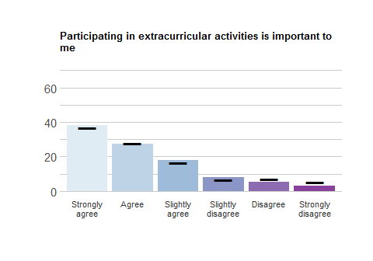
Response | School Freq | School % | School Valid % | Ag Freq | Ag % | Ag Valid %
Strongly agree | 96 | 24.81 | 38.25 | 1504 | 23.91 | 36.94
Agree | 69 | 17.83 | 27.49 | 1127 | 17.91 | 27.68
Slightly agree | 45 | 11.63 | 17.93 | 681 | 10.82 | 16.72
Slightly disagree | 20 | 5.17 | 7.97 | 270 | 4.29 | 6.63
Disagree | 13 | 3.36 | 5.18 | 283 | 4.50 | 6.95
Strongly disagree | 8 | 2.07 | 3.19 | 207 | 3.29 | 5.08
NA | 136 | 35.14 | NA | 2219 | 35.27 | NA

ACT2_5
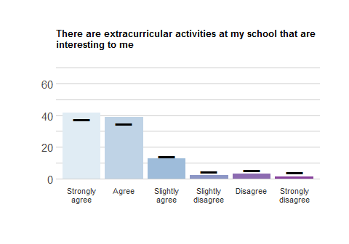
Response | School Freq | School % | School Valid % | Ag Freq | Ag % | Ag Valid %
Strongly agree | 103 | 26.61 | 41.87 | 1509 | 23.99 | 37.52
Agree | 96 | 24.81 | 39.02 | 1392 | 22.13 | 34.61
Slightly agree | 31 | 8.01 | 12.60 | 572 | 9.09 | 14.22
Slightly disagree | 5 | 1.29 | 2.03 | 178 | 2.83 | 4.43
Disagree | 8 | 2.07 | 3.25 | 210 | 3.34 | 5.22
Strongly disagree | 3 | 0.78 | 1.22 | 161 | 2.56 | 4.00
NA | 141 | 36.43 | NA | 2269 | 36.07 | NA

ACT2_6
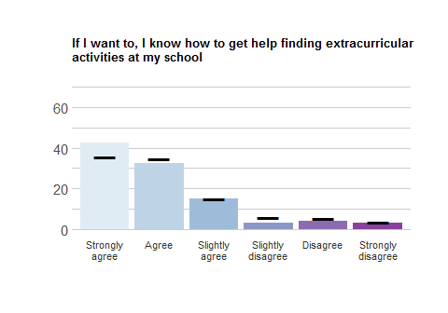
Response | School Freq | School % | School Valid % | Ag Freq | Ag % | Ag Valid %
Strongly agree | 108 | 27.91 | 42.52 | 1435 | 22.81 | 35.48
Agree | 82 | 21.19 | 32.28 | 1407 | 22.37 | 34.79
Slightly agree | 38 | 9.82 | 14.96 | 608 | 9.66 | 15.03
Slightly disagree | 8 | 2.07 | 3.15 | 229 | 3.64 | 5.66
Disagree | 10 | 2.58 | 3.94 | 221 | 3.51 | 5.46
Strongly disagree | 8 | 2.07 | 3.15 | 144 | 2.29 | 3.56
NA | 133 | 34.37 | NA | 2247 | 35.72 | NA

ACT2_7
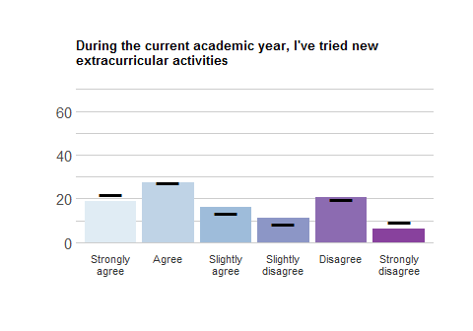
Response | School Freq | School % | School Valid % | Ag Freq | Ag % | Ag Valid %
Strongly agree | 47 | 12.14 | 18.73 | 892 | 14.18 | 21.87
Agree | 69 | 17.83 | 27.49 | 1112 | 17.68 | 27.27
Slightly agree | 40 | 10.34 | 15.94 | 551 | 8.76 | 13.51
Slightly disagree | 28 | 7.24 | 11.16 | 338 | 5.37 | 8.29
Disagree | 52 | 13.44 | 20.72 | 805 | 12.80 | 19.74
Strongly disagree | 15 | 3.88 | 5.98 | 380 | 6.04 | 9.32
NA | 136 | 35.14 | NA | 2213 | 35.18 | NA

ACT2_8
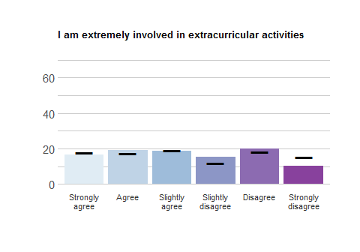
Response | School Freq | School % | School Valid % | Ag Freq | Ag % | Ag Valid %
Strongly agree | 42 | 10.85 | 16.47 | 724 | 11.51 | 17.84
Agree | 49 | 12.66 | 19.22 | 711 | 11.30 | 17.52
Slightly agree | 48 | 12.40 | 18.82 | 768 | 12.21 | 18.93
Slightly disagree | 39 | 10.08 | 15.29 | 481 | 7.65 | 11.85
Disagree | 51 | 13.18 | 20.00 | 746 | 11.86 | 18.38
Strongly disagree | 26 | 6.72 | 10.20 | 628 | 9.98 | 15.48
NA | 132 | 34.11 | NA | 2233 | 35.50 | NA

ACT2_9
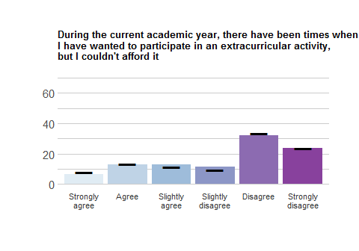
Response | School Freq | School % | School Valid % | Ag Freq | Ag % | Ag Valid %
Strongly agree | 16 | 4.13 | 6.50 | 325 | 5.17 | 8.06
Agree | 32 | 8.27 | 13.01 | 539 | 8.57 | 13.37
Slightly agree | 32 | 8.27 | 13.01 | 469 | 7.46 | 11.63
Slightly disagree | 28 | 7.24 | 11.38 | 389 | 6.18 | 9.65
Disagree | 79 | 20.41 | 32.11 | 1347 | 21.41 | 33.42
Strongly disagree | 59 | 15.25 | 23.98 | 962 | 15.29 | 23.87
NA | 141 | 36.43 | NA | 2260 | 35.92 | NA

ACT2_10
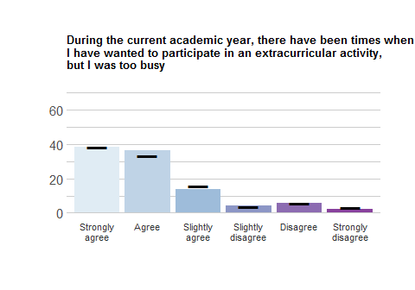
Response | School Freq | School % | School Valid % | Ag Freq | Ag % | Ag Valid %
Strongly agree | 144 | 37.21 | 38.30 | 2316 | 36.81 | 38.10
Agree | 136 | 35.14 | 36.17 | 2025 | 32.19 | 33.31
Slightly agree | 51 | 13.18 | 13.56 | 950 | 15.10 | 15.63
Slightly disagree | 16 | 4.13 | 4.26 | 222 | 3.53 | 3.65
Disagree | 21 | 5.43 | 5.59 | 362 | 5.75 | 5.95
Strongly disagree | 8 | 2.07 | 2.13 | 204 | 3.24 | 3.36
NA | 11 | 2.84 | NA | 212 | 3.37 | NA

ACT3
NOTE: People who agreed with ACT2_10 received the following items.
Thinking more about being too busy to participate in extracurricular activities, which of the following get in the way? (Select all that apply)
Item number | Item text | School freq | School perc | Ag freq | Ag perc
Act3_1 | School work/studying | 318 | 82.17 | 5100 | 81.07
Act3_2 | Working at a job | 148 | 38.24 | 2584 | 41.07
Act3_3 | Family obligations | 48 | 12.40 | 1083 | 17.22
Act3_4 | Relationships | 81 | 20.93 | 1651 | 26.24
Act3_5 | Social obligations | 112 | 28.94 | 1997 | 31.74
Act3_6 | Other extracurricular activities | 163 | 42.12 | 2139 | 34.00
Act3_7 | Other | 15 | 3.88 | 360 | 5.72

Belonging
This set of items asks you about your sense of belonging to your school.

Outcomes
Please rate how strongly you agree or disagree with the following statements.

BELONG_10
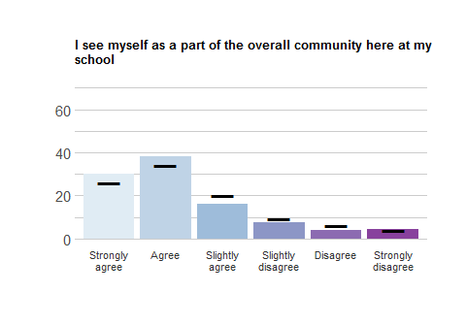
Response | School Freq | School % | School Valid % | Ag Freq | Ag % | Ag Valid %
Strongly agree | 109 | 28.17 | 30.11 | 1522 | 24.19 | 25.84
Agree | 138 | 35.66 | 38.12 | 2018 | 32.08 | 34.26
Slightly agree | 58 | 14.99 | 16.02 | 1186 | 18.85 | 20.14
Slightly disagree | 27 | 6.98 | 7.46 | 557 | 8.85 | 9.46
Disagree | 14 | 3.62 | 3.87 | 367 | 5.83 | 6.23
Strongly disagree | 16 | 4.13 | 4.42 | 240 | 3.81 | 4.07
NA | 25 | 6.46 | NA | 401 | 6.37 | NA

BELONG_11
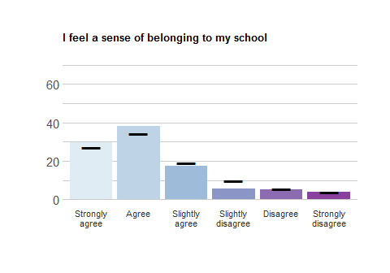
Response | School Freq | School % | School Valid % | Ag Freq | Ag % | Ag Valid %
Strongly agree | 73 | 18.86 | 29.55 | 1074 | 17.07 | 27.31
Agree | 94 | 24.29 | 38.06 | 1348 | 21.43 | 34.28
Slightly agree | 43 | 11.11 | 17.41 | 750 | 11.92 | 19.07
Slightly disagree | 14 | 3.62 | 5.67 | 392 | 6.23 | 9.97
Disagree | 13 | 3.36 | 5.26 | 213 | 3.39 | 5.42
Strongly disagree | 10 | 2.58 | 4.05 | 155 | 2.46 | 3.94
NA | 140 | 36.18 | NA | 2359 | 37.50 | NA

BELONG_12
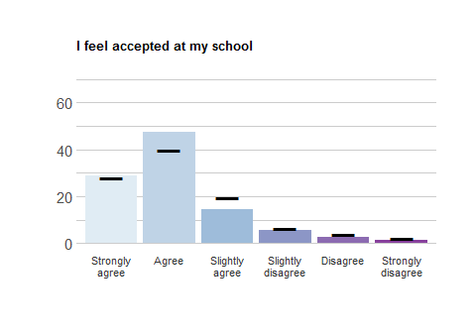
Response | School Freq | School % | School Valid % | Ag Freq | Ag % | Ag Valid %
Strongly agree | 68 | 17.57 | 28.81 | 1098 | 17.45 | 28.21
Agree | 112 | 28.94 | 47.46 | 1550 | 24.64 | 39.83
Slightly agree | 34 | 8.79 | 14.41 | 763 | 12.13 | 19.60
Slightly disagree | 13 | 3.36 | 5.51 | 252 | 4.01 | 6.47
Disagree | 6 | 1.55 | 2.54 | 143 | 2.27 | 3.67
Strongly disagree | 3 | 0.78 | 1.27 | 86 | 1.37 | 2.21
NA | 151 | 39.02 | NA | 2399 | 38.13 | NA

BELONG_13
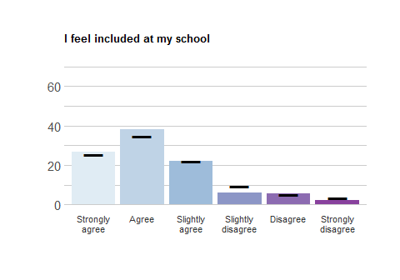
Response | School Freq | School % | School Valid % | Ag Freq | Ag % | Ag Valid %
Strongly agree | 64 | 16.54 | 26.56 | 1006 | 15.99 | 25.54
Agree | 92 | 23.77 | 38.17 | 1367 | 21.73 | 34.70
Slightly agree | 53 | 13.70 | 21.99 | 864 | 13.73 | 21.93
Slightly disagree | 14 | 3.62 | 5.81 | 365 | 5.80 | 9.27
Disagree | 13 | 3.36 | 5.39 | 202 | 3.21 | 5.13
Strongly disagree | 5 | 1.29 | 2.07 | 135 | 2.15 | 3.43
NA | 146 | 37.73 | NA | 2352 | 37.39 | NA

Pathways
Please rate how strongly you agree or disagree with the following statements.

BELONG_1
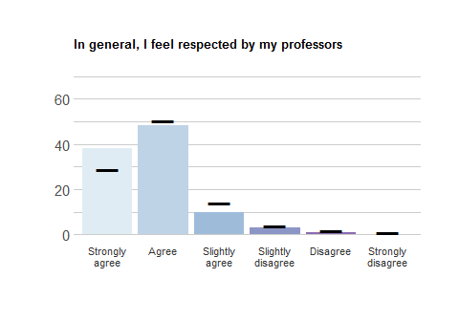
Response | School Freq | School % | School Valid % | Ag Freq | Ag % | Ag Valid %
Strongly agree | 90 | 23.26 | 38.14 | 1130 | 17.96 | 29.00
Agree | 114 | 29.46 | 48.31 | 1972 | 31.35 | 50.60
Slightly agree | 23 | 5.94 | 9.75 | 550 | 8.74 | 14.11
Slightly disagree | 7 | 1.81 | 2.97 | 146 | 2.32 | 3.75
Disagree | 2 | 0.52 | 0.85 | 66 | 1.05 | 1.69
Strongly disagree | 0 | 0.00 | 0.00 | 33 | 0.52 | 0.85
NA | 151 | 39.02 | NA | 2394 | 38.05 | NA

BELONG_2
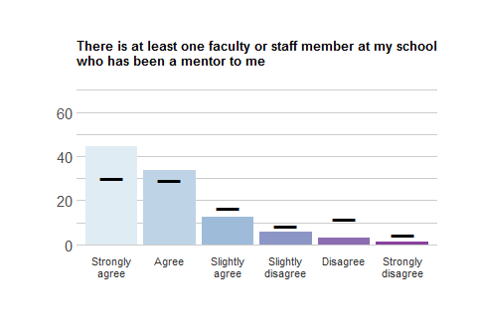
Response | School Freq | School % | School Valid % | Ag Freq | Ag % | Ag Valid %
Strongly agree | 105 | 27.13 | 44.49 | 1170 | 18.60 | 30.05
Agree | 79 | 20.41 | 33.47 | 1129 | 17.95 | 28.99
Slightly agree | 29 | 7.49 | 12.29 | 645 | 10.25 | 16.56
Slightly disagree | 13 | 3.36 | 5.51 | 332 | 5.28 | 8.53
Disagree | 7 | 1.81 | 2.97 | 451 | 7.17 | 11.58
Strongly disagree | 3 | 0.78 | 1.27 | 167 | 2.65 | 4.29
NA | 151 | 39.02 | NA | 2397 | 38.10 | NA

BELONG_3
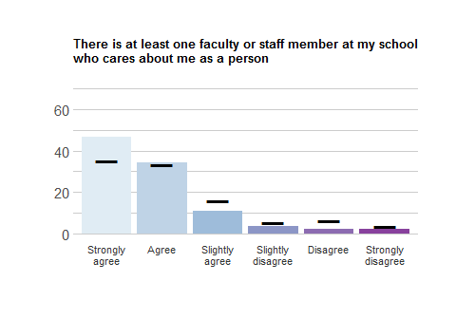
Response | School Freq | School % | School Valid % | Ag Freq | Ag % | Ag Valid %
Strongly agree | 115 | 29.72 | 46.75 | 1378 | 21.90 | 35.05
Agree | 84 | 21.71 | 34.15 | 1315 | 20.90 | 33.45
Slightly agree | 27 | 6.98 | 10.98 | 634 | 10.08 | 16.13
Slightly disagree | 9 | 2.33 | 3.66 | 222 | 3.53 | 5.65
Disagree | 6 | 1.55 | 2.44 | 248 | 3.94 | 6.31
Strongly disagree | 5 | 1.29 | 2.03 | 134 | 2.13 | 3.41
NA | 141 | 36.43 | NA | 2360 | 37.51 | NA

BELONG_4
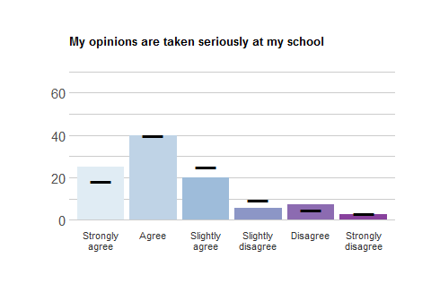
Response | School Freq | School % | School Valid % | Ag Freq | Ag % | Ag Valid %
Strongly agree | 60 | 15.50 | 25.00 | 712 | 11.32 | 18.08
Agree | 96 | 24.81 | 40.00 | 1563 | 24.85 | 39.70
Slightly agree | 48 | 12.40 | 20.00 | 994 | 15.80 | 25.25
Slightly disagree | 13 | 3.36 | 5.42 | 367 | 5.83 | 9.32
Disagree | 17 | 4.39 | 7.08 | 188 | 2.99 | 4.78
Strongly disagree | 6 | 1.55 | 2.50 | 113 | 1.80 | 2.87
NA | 147 | 37.98 | NA | 2354 | 37.42 | NA

BELONG_5
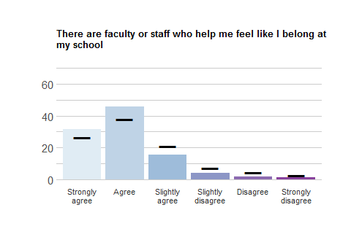
Response | School Freq | School % | School Valid % | Ag Freq | Ag % | Ag Valid %
Strongly agree | 76 | 19.64 | 31.80 | 1045 | 16.61 | 26.56
Agree | 109 | 28.17 | 45.61 | 1495 | 23.76 | 37.99
Slightly agree | 37 | 9.56 | 15.48 | 831 | 13.21 | 21.12
Slightly disagree | 10 | 2.58 | 4.18 | 279 | 4.43 | 7.09
Disagree | 4 | 1.03 | 1.67 | 186 | 2.96 | 4.73
Strongly disagree | 3 | 0.78 | 1.26 | 99 | 1.57 | 2.52
NA | 148 | 38.24 | NA | 2356 | 37.45 | NA

BELONG_6
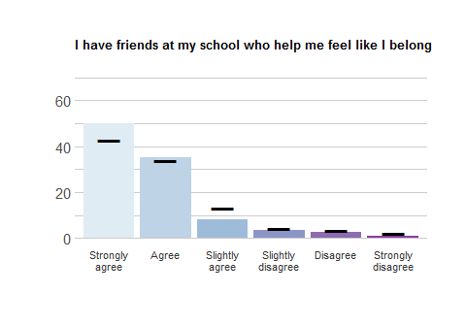
Response | School Freq | School % | School Valid % | Ag Freq | Ag % | Ag Valid %
Strongly agree | 118 | 30.49 | 50.00 | 1672 | 26.58 | 43.02
Agree | 83 | 21.45 | 35.17 | 1319 | 20.97 | 33.93
Slightly agree | 19 | 4.91 | 8.05 | 512 | 8.14 | 13.17
Slightly disagree | 8 | 2.07 | 3.39 | 165 | 2.62 | 4.24
Disagree | 6 | 1.55 | 2.54 | 128 | 2.03 | 3.29
Strongly disagree | 2 | 0.52 | 0.85 | 91 | 1.45 | 2.34
NA | 151 | 39.02 | NA | 2404 | 38.21 | NA

BELONG_7
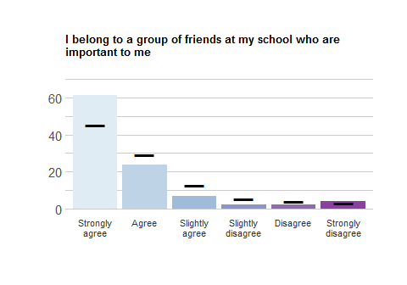
Response | School Freq | School % | School Valid % | Ag Freq | Ag % | Ag Valid %
Strongly agree | 148 | 38.24 | 61.41 | 1785 | 28.37 | 45.28
Agree | 57 | 14.73 | 23.65 | 1159 | 18.42 | 29.40
Slightly agree | 16 | 4.13 | 6.64 | 501 | 7.96 | 12.71
Slightly disagree | 5 | 1.29 | 2.07 | 216 | 3.43 | 5.48
Disagree | 5 | 1.29 | 2.07 | 160 | 2.54 | 4.06
Strongly disagree | 10 | 2.58 | 4.15 | 121 | 1.92 | 3.07
NA | 146 | 37.73 | NA | 2349 | 37.34 | NA

BELONG_8
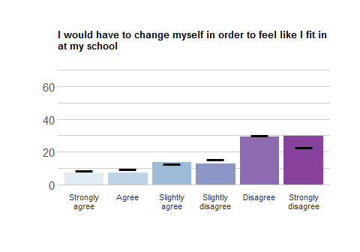
Response | School Freq | School % | School Valid % | Ag Freq | Ag % | Ag Valid %
Strongly agree | 18 | 4.65 | 7.32 | 337 | 5.36 | 8.58
Agree | 18 | 4.65 | 7.32 | 382 | 6.07 | 9.73
Slightly agree | 34 | 8.79 | 13.82 | 493 | 7.84 | 12.56
Slightly disagree | 31 | 8.01 | 12.60 | 614 | 9.76 | 15.64
Disagree | 72 | 18.60 | 29.27 | 1194 | 18.98 | 30.41
Strongly disagree | 73 | 18.86 | 29.67 | 906 | 14.40 | 23.08
NA | 141 | 36.43 | NA | 2365 | 37.59 | NA

BELONG_9
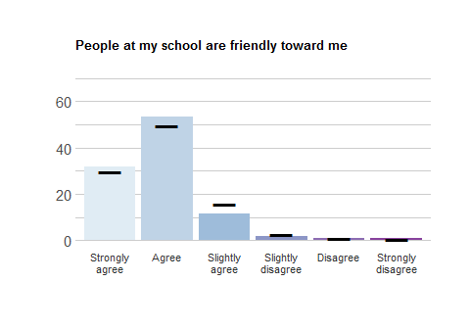
Response | School Freq | School % | School Valid % | Ag Freq | Ag % | Ag Valid %
Strongly agree | 79 | 20.41 | 31.98 | 1172 | 18.63 | 29.81
Agree | 132 | 34.11 | 53.44 | 1958 | 31.12 | 49.80
Slightly agree | 28 | 7.24 | 11.34 | 627 | 9.97 | 15.95
Slightly disagree | 4 | 1.03 | 1.62 | 106 | 1.68 | 2.70
Disagree | 2 | 0.52 | 0.81 | 44 | 0.70 | 1.12
Strongly disagree | 2 | 0.52 | 0.81 | 25 | 0.40 | 0.64
NA | 140 | 36.18 | NA | 2359 | 37.50 | NA

break

Experiences of discrimination
This set of items asks you about your discrimination experiences at your school
During the current academic year, I have experienced discrimination (e.g. being excluded from activities or being the target of disparaging jokes, slurs, or comments) as a result of my:

BDISC_1
Racial/ethnic background
Response | School Freq | School % | School Valid % | Ag Freq | Ag % | Ag Valid %
Yes | 42 | 10.85 | 11.7 | 812 | 12.91 | 13.82
No | 317 | 81.91 | 88.3 | 5063 | 80.48 | 86.18
NA | 28 | 7.24 | NA | 416 | 6.61 | NA

BDISC_2
Gender
Response | School Freq | School % | School Valid % | Ag Freq | Ag % | Ag Valid %
Yes | 67 | 17.31 | 18.61 | 1239 | 19.69 | 21.1
No | 293 | 75.71 | 81.39 | 4632 | 73.63 | 78.9
NA | 27 | 6.98 | NA | 420 | 6.68 | NA

BDISC_3
Religious affiliation
Response | School Freq | School % | School Valid % | Ag Freq | Ag % | Ag Valid %
Yes | 33 | 8.53 | 9.12 | 549 | 8.73 | 9.36
No | 329 | 85.01 | 90.88 | 5315 | 84.49 | 90.64
NA | 25 | 6.46 | NA | 427 | 6.79 | NA

BDISC_4
Socioeconomic status
Response | School Freq | School % | School Valid % | Ag Freq | Ag % | Ag Valid %
Yes | 24 | 6.20 | 6.65 | 506 | 8.04 | 8.63
No | 337 | 87.08 | 93.35 | 5359 | 85.19 | 91.37
NA | 26 | 6.72 | NA | 426 | 6.77 | NA

break

BDISC_5
Political beliefs
Response | School Freq | School % | School Valid % | Ag Freq | Ag % | Ag Valid %
Yes | 68 | 17.57 | 18.84 | 908 | 14.43 | 15.46
No | 293 | 75.71 | 81.16 | 4966 | 78.94 | 84.54
NA | 26 | 6.72 | NA | 417 | 6.63 | NA

BDISC_6
Sexual orientation
Response | School Freq | School % | School Valid % | Ag Freq | Ag % | Ag Valid %
Yes | 23 | 5.94 | 6.37 | 341 | 5.42 | 5.82
No | 338 | 87.34 | 93.63 | 5523 | 87.79 | 94.18
NA | 26 | 6.72 | NA | 427 | 6.79 | NA

BDISC_7
Disability
Response | School Freq | School % | School Valid % | Ag Freq | Ag % | Ag Valid %
Yes | 13 | 3.36 | 3.62 | 203 | 3.23 | 3.48
No | 346 | 89.41 | 96.38 | 5627 | 89.45 | 96.52
NA | 28 | 7.24 | NA | 461 | 7.33 | NA

Health and substance use
This set of items asks you about your health and substance use.

Health behaviors
Please rate how strongly you agree or disagree with the following statements.

HEALTH_1
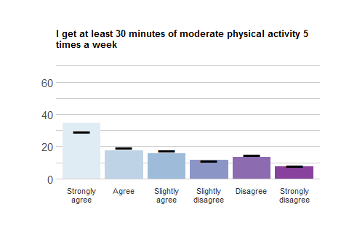
Response | School Freq | School % | School Valid % | Ag Freq | Ag % | Ag Valid %
Strongly agree | 125 | 32.30 | 34.53 | 1714 | 27.25 | 29.27
Agree | 63 | 16.28 | 17.40 | 1135 | 18.04 | 19.39
Slightly agree | 57 | 14.73 | 15.75 | 1023 | 16.26 | 17.47
Slightly disagree | 42 | 10.85 | 11.60 | 649 | 10.32 | 11.08
Disagree | 48 | 12.40 | 13.26 | 857 | 13.62 | 14.64
Strongly disagree | 27 | 6.98 | 7.46 | 477 | 7.58 | 8.15
NA | 25 | 6.46 | NA | 436 | 6.93 | NA

HEALTH_2
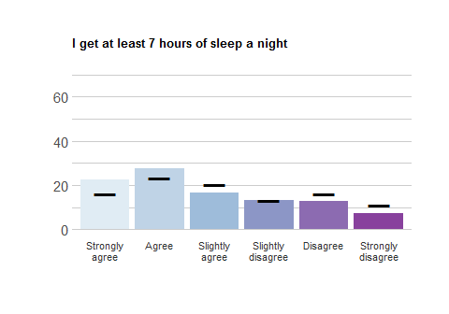
Response | School Freq | School % | School Valid % | Ag Freq | Ag % | Ag Valid %
Strongly agree | 82 | 21.19 | 22.71 | 943 | 14.99 | 16.11
Agree | 99 | 25.58 | 27.42 | 1358 | 21.59 | 23.19
Slightly agree | 60 | 15.50 | 16.62 | 1189 | 18.90 | 20.31
Slightly disagree | 47 | 12.14 | 13.02 | 773 | 12.29 | 13.20
Disagree | 46 | 11.89 | 12.74 | 950 | 15.10 | 16.23
Strongly disagree | 27 | 6.98 | 7.48 | 642 | 10.21 | 10.96
NA | 26 | 6.72 | NA | 436 | 6.93 | NA

HEALTH_3
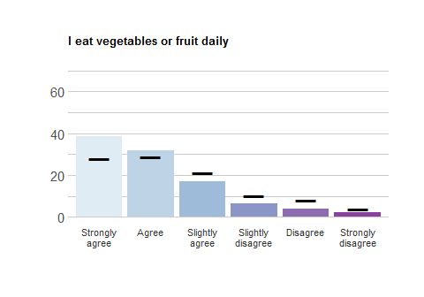
Response | School Freq | School % | School Valid % | Ag Freq | Ag % | Ag Valid %
Strongly agree | 140 | 36.18 | 38.67 | 1633 | 25.96 | 27.90
Agree | 115 | 29.72 | 31.77 | 1677 | 26.66 | 28.66
Slightly agree | 61 | 15.76 | 16.85 | 1238 | 19.68 | 21.16
Slightly disagree | 24 | 6.20 | 6.63 | 592 | 9.41 | 10.12
Disagree | 14 | 3.62 | 3.87 | 478 | 7.60 | 8.17
Strongly disagree | 8 | 2.07 | 2.21 | 234 | 3.72 | 4.00
NA | 25 | 6.46 | NA | 439 | 6.98 | NA

Health attitudes
Please rate how strongly you agree or disagree with the following statements.

HEALTH_4
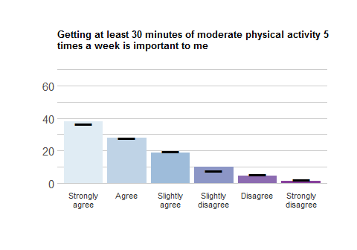
Response | School Freq | School % | School Valid % | Ag Freq | Ag % | Ag Valid %
Strongly agree | 137 | 35.40 | 37.85 | 2155 | 34.26 | 36.78
Agree | 101 | 26.10 | 27.90 | 1646 | 26.16 | 28.09
Slightly agree | 67 | 17.31 | 18.51 | 1158 | 18.41 | 19.76
Slightly disagree | 36 | 9.30 | 9.94 | 462 | 7.34 | 7.89
Disagree | 16 | 4.13 | 4.42 | 316 | 5.02 | 5.39
Strongly disagree | 5 | 1.29 | 1.38 | 122 | 1.94 | 2.08
NA | 25 | 6.46 | NA | 432 | 6.87 | NA

HEALTH_5
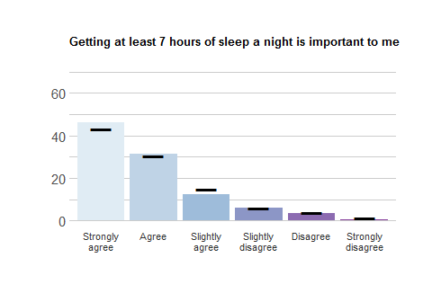
Response | School Freq | School % | School Valid % | Ag Freq | Ag % | Ag Valid %
Strongly agree | 168 | 43.41 | 46.41 | 2529 | 40.20 | 43.17
Agree | 114 | 29.46 | 31.49 | 1795 | 28.53 | 30.64
Slightly agree | 45 | 11.63 | 12.43 | 875 | 13.91 | 14.94
Slightly disagree | 21 | 5.43 | 5.80 | 349 | 5.55 | 5.96
Disagree | 12 | 3.10 | 3.31 | 227 | 3.61 | 3.88
Strongly disagree | 2 | 0.52 | 0.55 | 83 | 1.32 | 1.42
NA | 25 | 6.46 | NA | 433 | 6.88 | NA

HEALTH_6
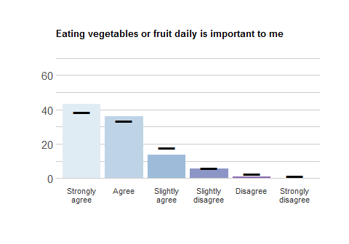
Response | School Freq | School % | School Valid % | Ag Freq | Ag % | Ag Valid %
Strongly agree | 157 | 40.57 | 43.25 | 2261 | 35.94 | 38.64
Agree | 131 | 33.85 | 36.09 | 1962 | 31.19 | 33.53
Slightly agree | 49 | 12.66 | 13.50 | 1051 | 16.71 | 17.96
Slightly disagree | 21 | 5.43 | 5.79 | 349 | 5.55 | 5.96
Disagree | 4 | 1.03 | 1.10 | 155 | 2.46 | 2.65
Strongly disagree | 1 | 0.26 | 0.28 | 74 | 1.18 | 1.26
NA | 24 | 6.20 | NA | 439 | 6.98 | NA

HEALTH_7
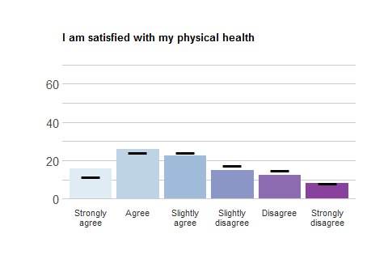
Response | School Freq | School % | School Valid % | Ag Freq | Ag % | Ag Valid %
Strongly agree | 57 | 14.73 | 15.75 | 685 | 10.89 | 11.71
Agree | 94 | 24.29 | 25.97 | 1405 | 22.33 | 24.01
Slightly agree | 82 | 21.19 | 22.65 | 1410 | 22.41 | 24.09
Slightly disagree | 54 | 13.95 | 14.92 | 1009 | 16.04 | 17.24
Disagree | 45 | 11.63 | 12.43 | 874 | 13.89 | 14.94
Strongly disagree | 30 | 7.75 | 8.29 | 469 | 7.46 | 8.01
NA | 25 | 6.46 | NA | 439 | 6.98 | NA

Alcohol use
Please rate how strongly you agree or disagree with the following statements.

SUBST1_1
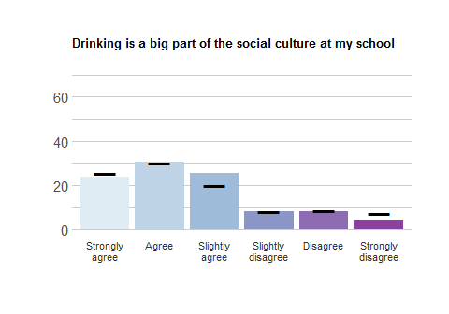
Response | School Freq | School % | School Valid % | Ag Freq | Ag % | Ag Valid %
Strongly agree | 86 | 22.22 | 23.69 | 1486 | 23.62 | 25.38
Agree | 111 | 28.68 | 30.58 | 1771 | 28.15 | 30.25
Slightly agree | 92 | 23.77 | 25.34 | 1175 | 18.68 | 20.07
Slightly disagree | 29 | 7.49 | 7.99 | 484 | 7.69 | 8.27
Disagree | 30 | 7.75 | 8.26 | 510 | 8.11 | 8.71
Strongly disagree | 15 | 3.88 | 4.13 | 429 | 6.82 | 7.33
NA | 24 | 6.20 | NA | 436 | 6.93 | NA

SUBST1_2
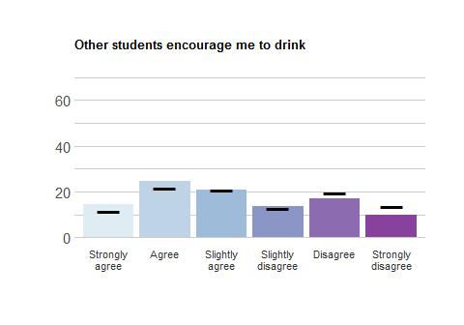
Response | School Freq | School % | School Valid % | Ag Freq | Ag % | Ag Valid %
Strongly agree | 52 | 13.44 | 14.33 | 678 | 10.78 | 11.58
Agree | 89 | 23.00 | 24.52 | 1267 | 20.14 | 21.65
Slightly agree | 75 | 19.38 | 20.66 | 1213 | 19.28 | 20.72
Slightly disagree | 50 | 12.92 | 13.77 | 749 | 11.91 | 12.80
Disagree | 61 | 15.76 | 16.80 | 1150 | 18.28 | 19.65
Strongly disagree | 36 | 9.30 | 9.92 | 796 | 12.65 | 13.60
NA | 24 | 6.20 | NA | 438 | 6.96 | NA

SUBST1_3
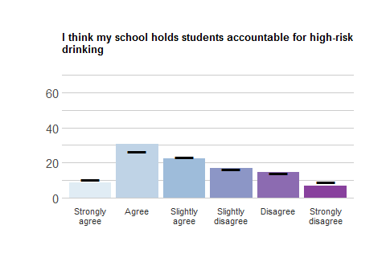
Response | School Freq | School % | School Valid % | Ag Freq | Ag % | Ag Valid %
Strongly agree | 32 | 8.27 | 8.82 | 601 | 9.55 | 10.32
Agree | 111 | 28.68 | 30.58 | 1538 | 24.45 | 26.40
Slightly agree | 82 | 21.19 | 22.59 | 1365 | 21.70 | 23.43
Slightly disagree | 61 | 15.76 | 16.80 | 964 | 15.32 | 16.55
Disagree | 53 | 13.70 | 14.60 | 837 | 13.30 | 14.37
Strongly disagree | 24 | 6.20 | 6.61 | 521 | 8.28 | 8.94
NA | 24 | 6.20 | NA | 465 | 7.39 | NA

SUBST2_1
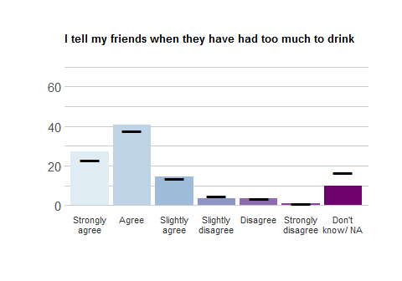
Response | School Freq | School % | School Valid % | Ag Freq | Ag % | Ag Valid %
Strongly agree | 98 | 25.32 | 27.07 | 1331 | 21.16 | 22.73
Agree | 147 | 37.98 | 40.61 | 2217 | 35.24 | 37.87
Slightly agree | 52 | 13.44 | 14.36 | 797 | 12.67 | 13.61
Slightly disagree | 13 | 3.36 | 3.59 | 289 | 4.59 | 4.94
Disagree | 13 | 3.36 | 3.59 | 191 | 3.04 | 3.26
Strongly disagree | 3 | 0.78 | 0.83 | 57 | 0.91 | 0.97
Don’t know/ NA | 36 | 9.30 | 9.94 | 973 | 15.47 | 16.62
NA | 25 | 6.46 | NA | 436 | 6.93 | NA

SUBST2_2
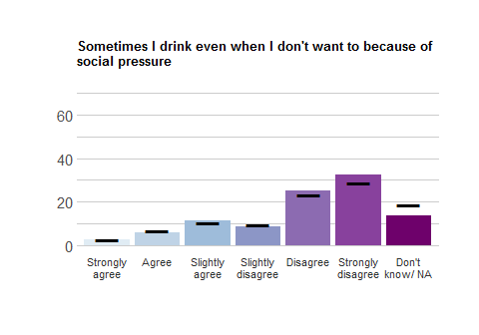
Response | School Freq | School % | School Valid % | Ag Freq | Ag % | Ag Valid %
Strongly agree | 9 | 2.33 | 2.48 | 146 | 2.32 | 2.49
Agree | 21 | 5.43 | 5.79 | 396 | 6.29 | 6.77
Slightly agree | 42 | 10.85 | 11.57 | 616 | 9.79 | 10.52
Slightly disagree | 31 | 8.01 | 8.54 | 546 | 8.68 | 9.33
Disagree | 92 | 23.77 | 25.34 | 1368 | 21.75 | 23.37
Strongly disagree | 118 | 30.49 | 32.51 | 1680 | 26.70 | 28.70
Don’t know/ NA | 50 | 12.92 | 13.77 | 1101 | 17.50 | 18.81
NA | 24 | 6.20 | NA | 438 | 6.96 | NA

SUBST2_3
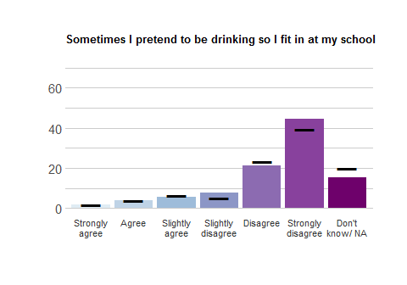
Response | School Freq | School % | School Valid % | Ag Freq | Ag % | Ag Valid %
Strongly agree | 7 | 1.81 | 1.93 | 99 | 1.57 | 1.69
Agree | 14 | 3.62 | 3.86 | 239 | 3.80 | 4.08
Slightly agree | 21 | 5.43 | 5.79 | 386 | 6.14 | 6.60
Slightly disagree | 28 | 7.24 | 7.71 | 298 | 4.74 | 5.09
Disagree | 77 | 19.90 | 21.21 | 1364 | 21.68 | 23.31
Strongly disagree | 161 | 41.60 | 44.35 | 2307 | 36.67 | 39.43
Don’t know/ NA | 55 | 14.21 | 15.15 | 1158 | 18.41 | 19.79
NA | 24 | 6.20 | NA | 440 | 6.99 | NA

SUBST2_4
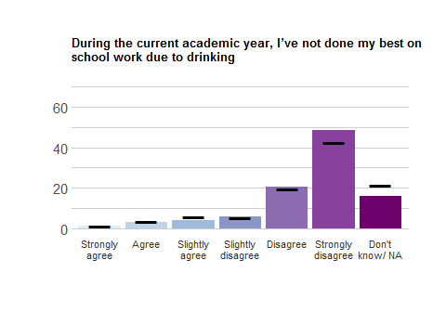
Response | School Freq | School % | School Valid % | Ag Freq | Ag % | Ag Valid %
Strongly agree | 5 | 1.29 | 1.39 | 79 | 1.26 | 1.35
Agree | 12 | 3.10 | 3.32 | 207 | 3.29 | 3.54
Slightly agree | 15 | 3.88 | 4.16 | 342 | 5.44 | 5.86
Slightly disagree | 21 | 5.43 | 5.82 | 312 | 4.96 | 5.34
Disagree | 75 | 19.38 | 20.78 | 1160 | 18.44 | 19.86
Strongly disagree | 176 | 45.48 | 48.75 | 2481 | 39.44 | 42.48
Don’t know/ NA | 57 | 14.73 | 15.79 | 1259 | 20.01 | 21.56
NA | 26 | 6.72 | NA | 451 | 7.17 | NA

SUBST3_1
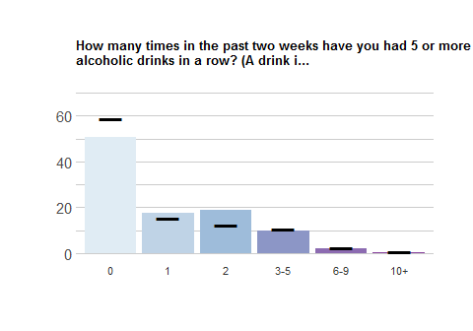
Response | School Freq | School % | School Valid % | Ag Freq | Ag % | Ag Valid %
0 | 184 | 47.55 | 50.69 | 3457 | 54.95 | 58.92
1 | 64 | 16.54 | 17.63 | 895 | 14.23 | 15.25
2 | 69 | 17.83 | 19.01 | 716 | 11.38 | 12.20
3-5 | 36 | 9.30 | 9.92 | 620 | 9.86 | 10.57
6-9 | 8 | 2.07 | 2.20 | 139 | 2.21 | 2.37
10+ | 2 | 0.52 | 0.55 | 40 | 0.64 | 0.68
NA | 24 | 6.20 | NA | 424 | 6.74 | NA

SUBST3_2
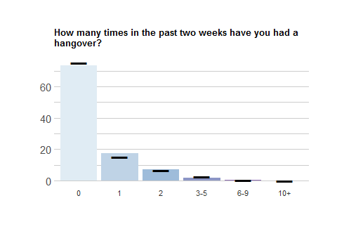
Response | School Freq | School % | School Valid % | Ag Freq | Ag % | Ag Valid %
0 | 267 | 68.99 | 73.55 | 4406 | 70.04 | 75.16
1 | 63 | 16.28 | 17.36 | 878 | 13.96 | 14.98
2 | 25 | 6.46 | 6.89 | 392 | 6.23 | 6.69
3-5 | 7 | 1.81 | 1.93 | 166 | 2.64 | 2.83
6-9 | 1 | 0.26 | 0.28 | 14 | 0.22 | 0.24
10+ | 0 | 0.00 | 0.00 | 6 | 0.10 | 0.10
NA | 24 | 6.20 | NA | 429 | 6.82 | NA

Lifelong Service
This set of items asks you about your attitudes toward helping people.

Outcomes
Please rate how strongly you agree or disagree with the following statements.

LLS_1
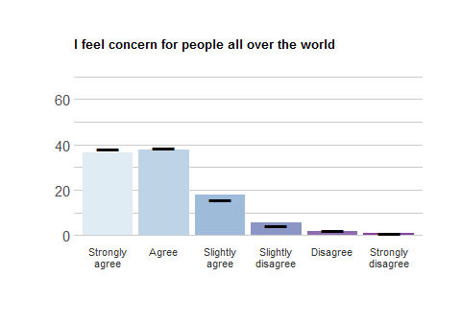
Response | School Freq | School % | School Valid % | Ag Freq | Ag % | Ag Valid %
Strongly agree | 87 | 22.48 | 36.55 | 1499 | 23.83 | 38.37
Agree | 90 | 23.26 | 37.82 | 1501 | 23.86 | 38.42
Slightly agree | 42 | 10.85 | 17.65 | 621 | 9.87 | 15.89
Slightly disagree | 13 | 3.36 | 5.46 | 163 | 2.59 | 4.17
Disagree | 4 | 1.03 | 1.68 | 91 | 1.45 | 2.33
Strongly disagree | 2 | 0.52 | 0.84 | 32 | 0.51 | 0.82
NA | 149 | 38.50 | NA | 2384 | 37.90 | NA

LLS_2
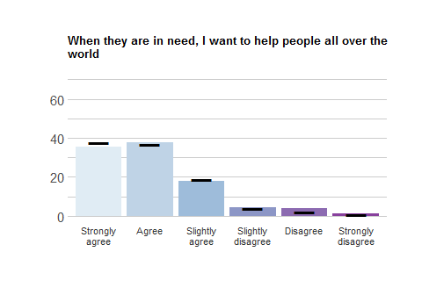
Response | School Freq | School % | School Valid % | Ag Freq | Ag % | Ag Valid %
Strongly agree | 85 | 21.96 | 35.27 | 1482 | 23.56 | 37.58
Agree | 91 | 23.51 | 37.76 | 1454 | 23.11 | 36.87
Slightly agree | 43 | 11.11 | 17.84 | 737 | 11.72 | 18.69
Slightly disagree | 10 | 2.58 | 4.15 | 159 | 2.53 | 4.03
Disagree | 9 | 2.33 | 3.73 | 86 | 1.37 | 2.18
Strongly disagree | 3 | 0.78 | 1.24 | 26 | 0.41 | 0.66
NA | 146 | 37.73 | NA | 2347 | 37.31 | NA

LLS_3
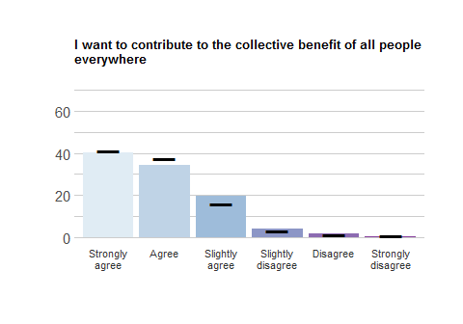
Response | School Freq | School % | School Valid % | Ag Freq | Ag % | Ag Valid %
Strongly agree | 99 | 25.58 | 40.08 | 1611 | 25.61 | 40.98
Agree | 85 | 21.96 | 34.41 | 1484 | 23.59 | 37.75
Slightly agree | 48 | 12.40 | 19.43 | 631 | 10.03 | 16.05
Slightly disagree | 10 | 2.58 | 4.05 | 131 | 2.08 | 3.33
Disagree | 4 | 1.03 | 1.62 | 49 | 0.78 | 1.25
Strongly disagree | 1 | 0.26 | 0.40 | 25 | 0.40 | 0.64
NA | 140 | 36.18 | NA | 2360 | 37.51 | NA

Pathways
Please rate how strongly you agree or disagree with the following statements.

LLS_4
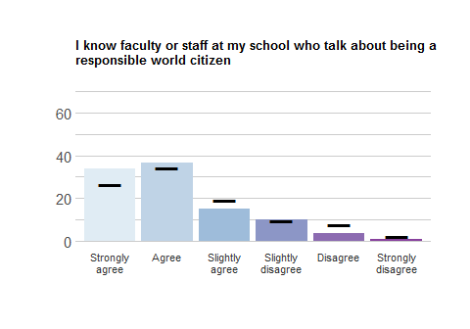
Response | School Freq | School % | School Valid % | Ag Freq | Ag % | Ag Valid %
Strongly agree | 84 | 21.71 | 34.01 | 1050 | 16.69 | 26.71
Agree | 90 | 23.26 | 36.44 | 1349 | 21.44 | 34.32
Slightly agree | 37 | 9.56 | 14.98 | 753 | 11.97 | 19.16
Slightly disagree | 25 | 6.46 | 10.12 | 376 | 5.98 | 9.56
Disagree | 9 | 2.33 | 3.64 | 309 | 4.91 | 7.86
Strongly disagree | 2 | 0.52 | 0.81 | 94 | 1.49 | 2.39
NA | 140 | 36.18 | NA | 2360 | 37.51 | NA

LLS_5
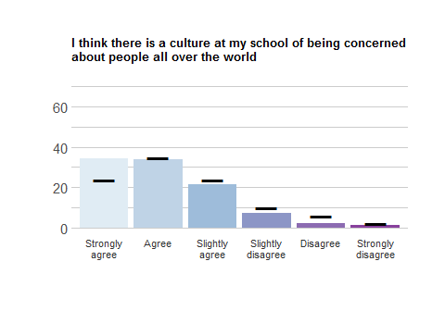
Response | School Freq | School % | School Valid % | Ag Freq | Ag % | Ag Valid %
Strongly agree | 81 | 20.93 | 34.18 | 928 | 14.75 | 23.76
Agree | 80 | 20.67 | 33.76 | 1354 | 21.52 | 34.66
Slightly agree | 51 | 13.18 | 21.52 | 928 | 14.75 | 23.76
Slightly disagree | 17 | 4.39 | 7.17 | 389 | 6.18 | 9.96
Disagree | 5 | 1.29 | 2.11 | 224 | 3.56 | 5.73
Strongly disagree | 3 | 0.78 | 1.27 | 83 | 1.32 | 2.12
NA | 150 | 38.76 | NA | 2385 | 37.91 | NA

LLS_6
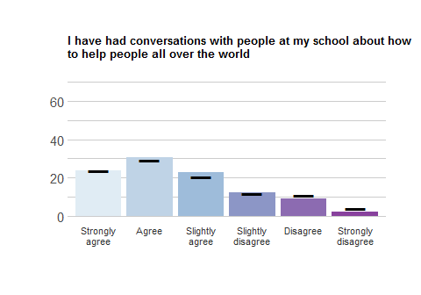
Response | School Freq | School % | School Valid % | Ag Freq | Ag % | Ag Valid %
Strongly agree | 58 | 14.99 | 23.58 | 926 | 14.72 | 23.59
Agree | 75 | 19.38 | 30.49 | 1151 | 18.30 | 29.32
Slightly agree | 56 | 14.47 | 22.76 | 810 | 12.88 | 20.63
Slightly disagree | 30 | 7.75 | 12.20 | 461 | 7.33 | 11.74
Disagree | 22 | 5.68 | 8.94 | 422 | 6.71 | 10.75
Strongly disagree | 5 | 1.29 | 2.03 | 156 | 2.48 | 3.97
NA | 141 | 36.43 | NA | 2365 | 37.59 | NA

LLS_7
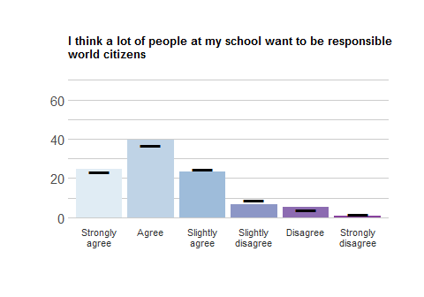
Response | School Freq | School % | School Valid % | Ag Freq | Ag % | Ag Valid %
Strongly agree | 59 | 15.25 | 24.48 | 915 | 14.54 | 23.27
Agree | 95 | 24.55 | 39.42 | 1452 | 23.08 | 36.93
Slightly agree | 56 | 14.47 | 23.24 | 978 | 15.55 | 24.87
Slightly disagree | 16 | 4.13 | 6.64 | 351 | 5.58 | 8.93
Disagree | 13 | 3.36 | 5.39 | 162 | 2.58 | 4.12
Strongly disagree | 2 | 0.52 | 0.83 | 74 | 1.18 | 1.88
NA | 146 | 37.73 | NA | 2359 | 37.50 | NA

LLS_8
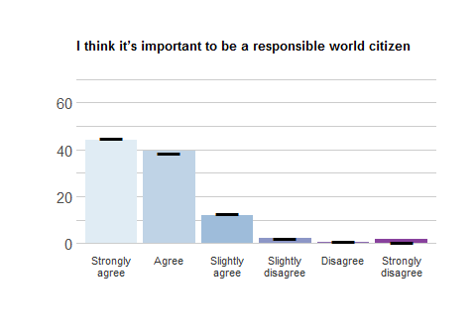
Response | School Freq | School % | School Valid % | Ag Freq | Ag % | Ag Valid %
Strongly agree | 106 | 27.39 | 44.17 | 1767 | 28.09 | 44.93
Agree | 95 | 24.55 | 39.58 | 1522 | 24.19 | 38.70
Slightly agree | 29 | 7.49 | 12.08 | 506 | 8.04 | 12.87
Slightly disagree | 5 | 1.29 | 2.08 | 78 | 1.24 | 1.98
Disagree | 1 | 0.26 | 0.42 | 36 | 0.57 | 0.92
Strongly disagree | 4 | 1.03 | 1.67 | 24 | 0.38 | 0.61
NA | 147 | 37.98 | NA | 2358 | 37.48 | NA

Life Satisfaction
This set of items asks how satisfied you are with several areas in your life.
Please rate how strongly you agree or disagree with the following statements.

LIFESAT_1
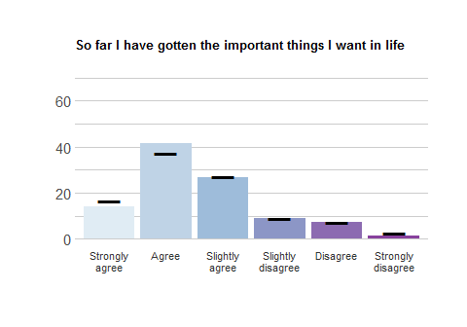
Response | School Freq | School % | School Valid % | Ag Freq | Ag % | Ag Valid %
Strongly agree | 36 | 9.30 | 13.95 | 695 | 11.05 | 16.78
Agree | 107 | 27.65 | 41.47 | 1552 | 24.67 | 37.47
Slightly agree | 69 | 17.83 | 26.74 | 1133 | 18.01 | 27.35
Slightly disagree | 23 | 5.94 | 8.91 | 363 | 5.77 | 8.76
Disagree | 19 | 4.91 | 7.36 | 294 | 4.67 | 7.10
Strongly disagree | 4 | 1.03 | 1.55 | 105 | 1.67 | 2.54
NA | 129 | 33.33 | NA | 2149 | 34.16 | NA

LIFESAT_2
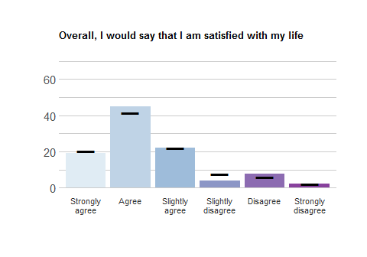
Response | School Freq | School % | School Valid % | Ag Freq | Ag % | Ag Valid %
Strongly agree | 48 | 12.40 | 19.2 | 844 | 13.42 | 20.59
Agree | 112 | 28.94 | 44.8 | 1697 | 26.98 | 41.39
Slightly agree | 55 | 14.21 | 22.0 | 906 | 14.40 | 22.10
Slightly disagree | 10 | 2.58 | 4.0 | 311 | 4.94 | 7.59
Disagree | 19 | 4.91 | 7.6 | 248 | 3.94 | 6.05
Strongly disagree | 6 | 1.55 | 2.4 | 94 | 1.49 | 2.29
NA | 137 | 35.40 | NA | 2191 | 34.83 | NA

LIFESAT_3
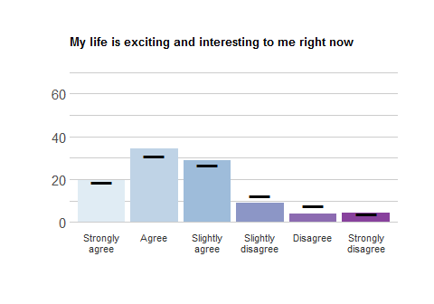
Response | School Freq | School % | School Valid % | Ag Freq | Ag % | Ag Valid %
Strongly agree | 50 | 12.92 | 19.38 | 779 | 12.38 | 18.80
Agree | 89 | 23.00 | 34.50 | 1282 | 20.38 | 30.94
Slightly agree | 75 | 19.38 | 29.07 | 1101 | 17.50 | 26.57
Slightly disagree | 23 | 5.94 | 8.91 | 509 | 8.09 | 12.28
Disagree | 10 | 2.58 | 3.88 | 318 | 5.05 | 7.67
Strongly disagree | 11 | 2.84 | 4.26 | 155 | 2.46 | 3.74
NA | 129 | 33.33 | NA | 2147 | 34.13 | NA

LIFESAT_4
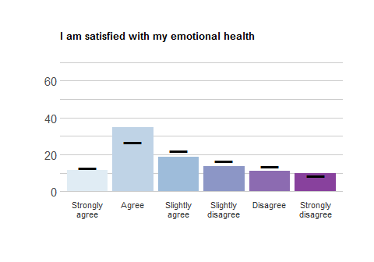
Response | School Freq | School % | School Valid % | Ag Freq | Ag % | Ag Valid %
Strongly agree | 29 | 7.49 | 11.6 | 520 | 8.27 | 12.69
Agree | 87 | 22.48 | 34.8 | 1095 | 17.41 | 26.72
Slightly agree | 47 | 12.14 | 18.8 | 903 | 14.35 | 22.04
Slightly disagree | 34 | 8.79 | 13.6 | 684 | 10.87 | 16.69
Disagree | 28 | 7.24 | 11.2 | 551 | 8.76 | 13.45
Strongly disagree | 25 | 6.46 | 10.0 | 345 | 5.48 | 8.42
NA | 137 | 35.40 | NA | 2193 | 34.86 | NA

LIFESAT_5
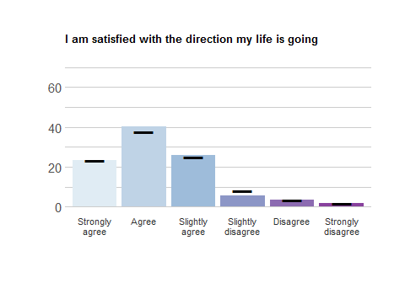
Response | School Freq | School % | School Valid % | Ag Freq | Ag % | Ag Valid %
Strongly agree | 59 | 15.25 | 23.23 | 968 | 15.39 | 23.34
Agree | 102 | 26.36 | 40.16 | 1573 | 25.00 | 37.93
Slightly agree | 66 | 17.05 | 25.98 | 1047 | 16.64 | 25.25
Slightly disagree | 14 | 3.62 | 5.51 | 338 | 5.37 | 8.15
Disagree | 9 | 2.33 | 3.54 | 149 | 2.37 | 3.59
Strongly disagree | 4 | 1.03 | 1.57 | 72 | 1.14 | 1.74
NA | 133 | 34.37 | NA | 2144 | 34.08 | NA

Meaning
This set of items asks about your sense of meaning in life.

Outcomes
Please rate how strongly you agree or disagree with the following statements.

MEANING_1
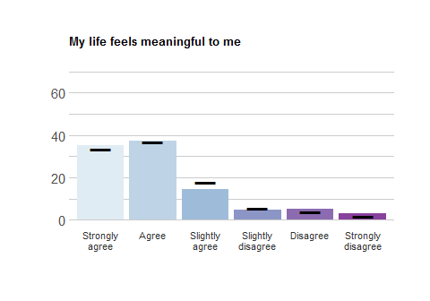
Response | School Freq | School % | School Valid % | Ag Freq | Ag % | Ag Valid %
Strongly agree | 87 | 22.48 | 35.22 | 1321 | 21.00 | 33.48
Agree | 92 | 23.77 | 37.25 | 1464 | 23.27 | 37.10
Slightly agree | 36 | 9.30 | 14.57 | 697 | 11.08 | 17.66
Slightly disagree | 12 | 3.10 | 4.86 | 228 | 3.62 | 5.78
Disagree | 13 | 3.36 | 5.26 | 161 | 2.56 | 4.08
Strongly disagree | 7 | 1.81 | 2.83 | 75 | 1.19 | 1.90
NA | 140 | 36.18 | NA | 2345 | 37.28 | NA

MEANING_2
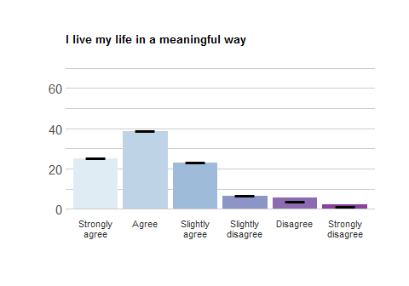
Response | School Freq | School % | School Valid % | Ag Freq | Ag % | Ag Valid %
Strongly agree | 59 | 15.25 | 24.89 | 994 | 15.80 | 25.44
Agree | 91 | 23.51 | 38.40 | 1532 | 24.35 | 39.21
Slightly agree | 54 | 13.95 | 22.78 | 907 | 14.42 | 23.21
Slightly disagree | 15 | 3.88 | 6.33 | 268 | 4.26 | 6.86
Disagree | 13 | 3.36 | 5.49 | 152 | 2.42 | 3.89
Strongly disagree | 5 | 1.29 | 2.11 | 54 | 0.86 | 1.38
NA | 150 | 38.76 | NA | 2384 | 37.90 | NA

MEANING_3
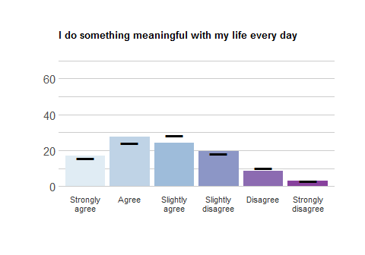
Response | School Freq | School % | School Valid % | Ag Freq | Ag % | Ag Valid %
Strongly agree | 41 | 10.59 | 16.94 | 618 | 9.82 | 15.69
Agree | 67 | 17.31 | 27.69 | 949 | 15.09 | 24.09
Slightly agree | 59 | 15.25 | 24.38 | 1120 | 17.80 | 28.43
Slightly disagree | 47 | 12.14 | 19.42 | 718 | 11.41 | 18.22
Disagree | 21 | 5.43 | 8.68 | 411 | 6.53 | 10.43
Strongly disagree | 7 | 1.81 | 2.89 | 124 | 1.97 | 3.15
NA | 145 | 37.47 | NA | 2351 | 37.37 | NA

Pathways
Please rate how strongly you agree or disagree with the following statements.

MEANING_4
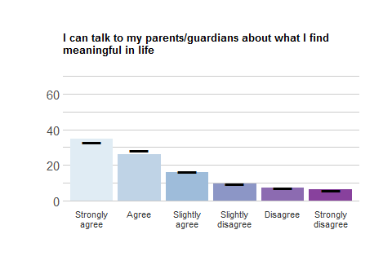
Response | School Freq | School % | School Valid % | Ag Freq | Ag % | Ag Valid %
Strongly agree | 86 | 22.22 | 34.96 | 1303 | 20.71 | 33.11
Agree | 64 | 16.54 | 26.02 | 1110 | 17.64 | 28.21
Slightly agree | 39 | 10.08 | 15.85 | 643 | 10.22 | 16.34
Slightly disagree | 23 | 5.94 | 9.35 | 367 | 5.83 | 9.33
Disagree | 18 | 4.65 | 7.32 | 281 | 4.47 | 7.14
Strongly disagree | 16 | 4.13 | 6.50 | 231 | 3.67 | 5.87
NA | 141 | 36.43 | NA | 2356 | 37.45 | NA

MEANING_5
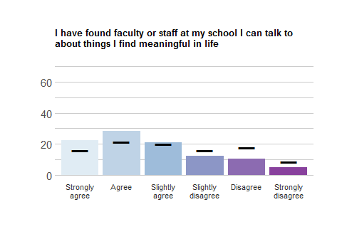
Response | School Freq | School % | School Valid % | Ag Freq | Ag % | Ag Valid %
Strongly agree | 53 | 13.70 | 22.46 | 622 | 9.89 | 15.93
Agree | 67 | 17.31 | 28.39 | 843 | 13.40 | 21.59
Slightly agree | 50 | 12.92 | 21.19 | 786 | 12.49 | 20.13
Slightly disagree | 29 | 7.49 | 12.29 | 620 | 9.86 | 15.88
Disagree | 25 | 6.46 | 10.59 | 696 | 11.06 | 17.83
Strongly disagree | 12 | 3.10 | 5.08 | 337 | 5.36 | 8.63
NA | 151 | 39.02 | NA | 2387 | 37.94 | NA

MEANING_6
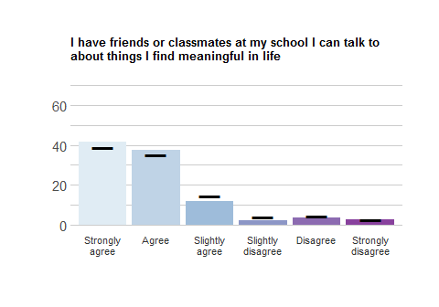
Response | School Freq | School % | School Valid % | Ag Freq | Ag % | Ag Valid %
Strongly agree | 101 | 26.10 | 41.74 | 1544 | 24.54 | 39.11
Agree | 91 | 23.51 | 37.60 | 1392 | 22.13 | 35.26
Slightly agree | 29 | 7.49 | 11.98 | 571 | 9.08 | 14.46
Slightly disagree | 5 | 1.29 | 2.07 | 166 | 2.64 | 4.20
Disagree | 9 | 2.33 | 3.72 | 169 | 2.69 | 4.28
Strongly disagree | 7 | 1.81 | 2.89 | 106 | 1.68 | 2.68
NA | 145 | 37.47 | NA | 2343 | 37.24 | NA

MEANING_7
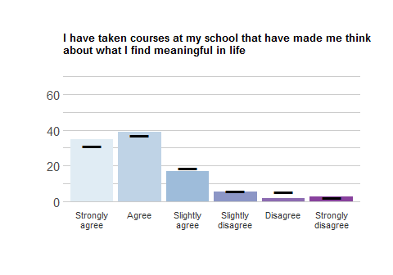
Response | School Freq | School % | School Valid % | Ag Freq | Ag % | Ag Valid %
Strongly agree | 84 | 21.71 | 34.71 | 1221 | 19.41 | 30.93
Agree | 94 | 24.29 | 38.84 | 1457 | 23.16 | 36.91
Slightly agree | 41 | 10.59 | 16.94 | 733 | 11.65 | 18.57
Slightly disagree | 13 | 3.36 | 5.37 | 236 | 3.75 | 5.98
Disagree | 4 | 1.03 | 1.65 | 214 | 3.40 | 5.42
Strongly disagree | 6 | 1.55 | 2.48 | 86 | 1.37 | 2.18
NA | 145 | 37.47 | NA | 2344 | 37.26 | NA

MEANING_8
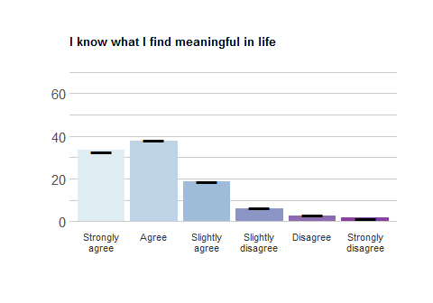
Response | School Freq | School % | School Valid % | Ag Freq | Ag % | Ag Valid %
Strongly agree | 83 | 21.45 | 33.60 | 1285 | 20.43 | 32.61
Agree | 93 | 24.03 | 37.65 | 1504 | 23.91 | 38.16
Slightly agree | 46 | 11.89 | 18.62 | 743 | 11.81 | 18.85
Slightly disagree | 15 | 3.88 | 6.07 | 245 | 3.89 | 6.22
Disagree | 6 | 1.55 | 2.43 | 118 | 1.88 | 2.99
Strongly disagree | 4 | 1.03 | 1.62 | 46 | 0.73 | 1.17
NA | 140 | 36.18 | NA | 2350 | 37.35 | NA

MEANING_9
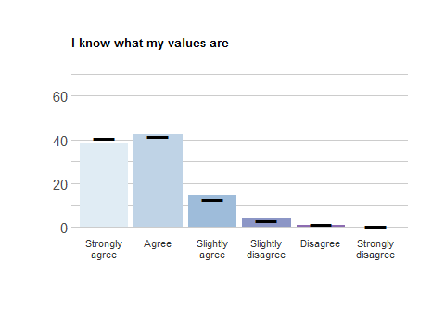
Response | School Freq | School % | School Valid % | Ag Freq | Ag % | Ag Valid %
Strongly agree | 91 | 23.51 | 38.40 | 1585 | 25.19 | 40.54
Agree | 101 | 26.10 | 42.62 | 1627 | 25.86 | 41.61
Slightly agree | 34 | 8.79 | 14.35 | 503 | 8.00 | 12.86
Slightly disagree | 9 | 2.33 | 3.80 | 122 | 1.94 | 3.12
Disagree | 2 | 0.52 | 0.84 | 53 | 0.84 | 1.36
Strongly disagree | 0 | 0.00 | 0.00 | 20 | 0.32 | 0.51
NA | 150 | 38.76 | NA | 2381 | 37.85 | NA

MEANING_10
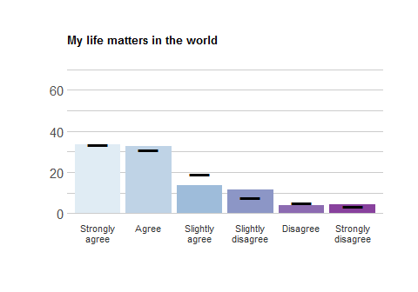
Response | School Freq | School % | School Valid % | Ag Freq | Ag % | Ag Valid %
Strongly agree | 83 | 21.45 | 33.60 | 1314 | 20.89 | 33.38
Agree | 81 | 20.93 | 32.79 | 1219 | 19.38 | 30.96
Slightly agree | 34 | 8.79 | 13.77 | 758 | 12.05 | 19.25
Slightly disagree | 28 | 7.24 | 11.34 | 300 | 4.77 | 7.62
Disagree | 10 | 2.58 | 4.05 | 206 | 3.27 | 5.23
Strongly disagree | 11 | 2.84 | 4.45 | 140 | 2.23 | 3.56
NA | 140 | 36.18 | NA | 2354 | 37.42 | NA

MEANING_11
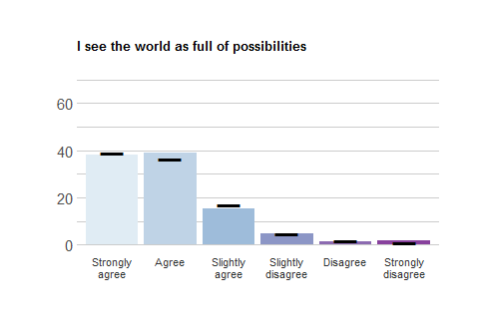
Response | School Freq | School % | School Valid % | Ag Freq | Ag % | Ag Valid %
Strongly agree | 90 | 23.26 | 37.97 | 1532 | 24.35 | 39.23
Agree | 93 | 24.03 | 39.24 | 1420 | 22.57 | 36.36
Slightly agree | 36 | 9.30 | 15.19 | 663 | 10.54 | 16.98
Slightly disagree | 11 | 2.84 | 4.64 | 180 | 2.86 | 4.61
Disagree | 3 | 0.78 | 1.27 | 71 | 1.13 | 1.82
Strongly disagree | 4 | 1.03 | 1.69 | 39 | 0.62 | 1.00
NA | 150 | 38.76 | NA | 2386 | 37.93 | NA

MEANING_12
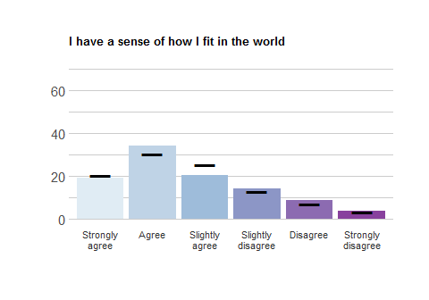
Response | School Freq | School % | School Valid % | Ag Freq | Ag % | Ag Valid %
Strongly agree | 46 | 11.89 | 19.01 | 798 | 12.68 | 20.24
Agree | 83 | 21.45 | 34.30 | 1203 | 19.12 | 30.51
Slightly agree | 49 | 12.66 | 20.25 | 1004 | 15.96 | 25.46
Slightly disagree | 34 | 8.79 | 14.05 | 518 | 8.23 | 13.14
Disagree | 21 | 5.43 | 8.68 | 281 | 4.47 | 7.13
Strongly disagree | 9 | 2.33 | 3.72 | 139 | 2.21 | 3.53
NA | 145 | 37.47 | NA | 2348 | 37.32 | NA

Mood
These items ask you about how you have been feeling lately.

Happiness
Over the past two weeks, how often have you experienced any of the following:

HAPPY_1
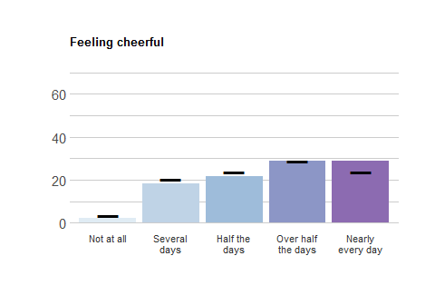
Response | School Freq | School % | School Valid % | Ag Freq | Ag % | Ag Valid %
Not at all | 9 | 2.33 | 2.33 | 218 | 3.47 | 3.47
Several days | 71 | 18.35 | 18.39 | 1280 | 20.35 | 20.40
Half the days | 84 | 21.71 | 21.76 | 1490 | 23.68 | 23.75
Over half the days | 111 | 28.68 | 28.76 | 1805 | 28.69 | 28.77
Nearly every day | 111 | 28.68 | 28.76 | 1481 | 23.54 | 23.61
NA | 1 | 0.26 | NA | 17 | 0.27 | NA

HAPPY_2
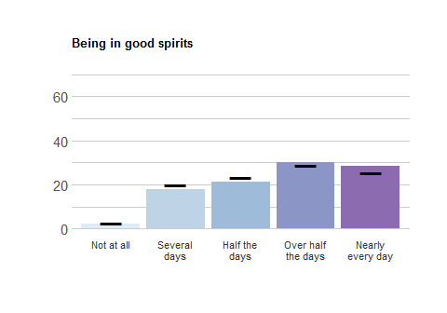
Response | School Freq | School % | School Valid % | Ag Freq | Ag % | Ag Valid %
Not at all | 9 | 2.33 | 2.34 | 163 | 2.59 | 2.60
Several days | 68 | 17.57 | 17.71 | 1239 | 19.69 | 19.79
Half the days | 81 | 20.93 | 21.09 | 1460 | 23.21 | 23.32
Over half the days | 116 | 29.97 | 30.21 | 1811 | 28.79 | 28.93
Nearly every day | 110 | 28.42 | 28.65 | 1587 | 25.23 | 25.35
NA | 3 | 0.78 | NA | 31 | 0.49 | NA

HAPPY_3
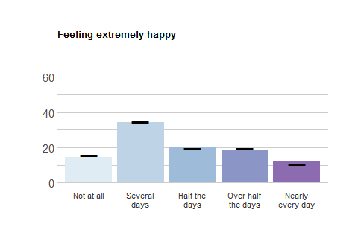
Response | School Freq | School % | School Valid % | Ag Freq | Ag % | Ag Valid %
Not at all | 56 | 14.47 | 14.58 | 973 | 15.47 | 15.58
Several days | 132 | 34.11 | 34.38 | 2165 | 34.41 | 34.66
Half the days | 79 | 20.41 | 20.57 | 1224 | 19.46 | 19.59
Over half the days | 71 | 18.35 | 18.49 | 1210 | 19.23 | 19.37
Nearly every day | 46 | 11.89 | 11.98 | 675 | 10.73 | 10.81
NA | 3 | 0.78 | NA | 44 | 0.70 | NA

Anxiety
Over the past two weeks, how often have you experienced any of the following:

ANX_1
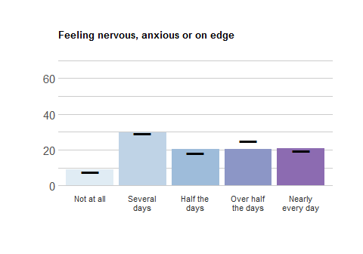
Response | School Freq | School % | School Valid % | Ag Freq | Ag % | Ag Valid %
Not at all | 34 | 8.79 | 8.81 | 493 | 7.84 | 7.86
Several days | 115 | 29.72 | 29.79 | 1840 | 29.25 | 29.34
Half the days | 78 | 20.16 | 20.21 | 1148 | 18.25 | 18.30
Over half the days | 79 | 20.41 | 20.47 | 1567 | 24.91 | 24.98
Nearly every day | 80 | 20.67 | 20.73 | 1224 | 19.46 | 19.52
NA | 1 | 0.26 | NA | 19 | 0.30 | NA

ANX_2
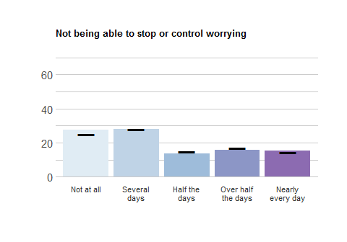
Response | School Freq | School % | School Valid % | Ag Freq | Ag % | Ag Valid %
Not at all | 106 | 27.39 | 27.60 | 1575 | 25.04 | 25.18
Several days | 107 | 27.65 | 27.86 | 1758 | 27.94 | 28.10
Half the days | 52 | 13.44 | 13.54 | 937 | 14.89 | 14.98
Over half the days | 60 | 15.50 | 15.62 | 1071 | 17.02 | 17.12
Nearly every day | 59 | 15.25 | 15.36 | 915 | 14.54 | 14.63
NA | 3 | 0.78 | NA | 35 | 0.56 | NA

ANX_3
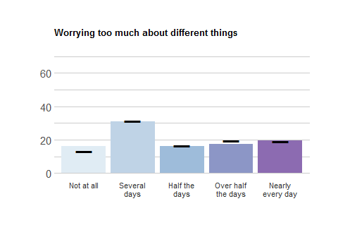
Response | School Freq | School % | School Valid % | Ag Freq | Ag % | Ag Valid %
Not at all | 62 | 16.02 | 16.06 | 827 | 13.15 | 13.22
Several days | 120 | 31.01 | 31.09 | 1970 | 31.31 | 31.49
Half the days | 62 | 16.02 | 16.06 | 1032 | 16.40 | 16.50
Over half the days | 67 | 17.31 | 17.36 | 1228 | 19.52 | 19.63
Nearly every day | 75 | 19.38 | 19.43 | 1198 | 19.04 | 19.15
NA | 1 | 0.26 | NA | 36 | 0.57 | NA

Depression
Over the past two weeks, how often have you experienced any of the following:

DEP_1
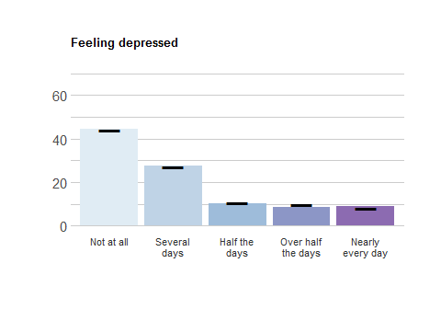
Response | School Freq | School % | School Valid % | Ag Freq | Ag % | Ag Valid %
Not at all | 172 | 44.44 | 44.68 | 2749 | 43.70 | 44.01
Several days | 106 | 27.39 | 27.53 | 1684 | 26.77 | 26.96
Half the days | 40 | 10.34 | 10.39 | 672 | 10.68 | 10.76
Over half the days | 33 | 8.53 | 8.57 | 626 | 9.95 | 10.02
Nearly every day | 34 | 8.79 | 8.83 | 515 | 8.19 | 8.25
NA | 2 | 0.52 | NA | 45 | 0.72 | NA

DEP_2
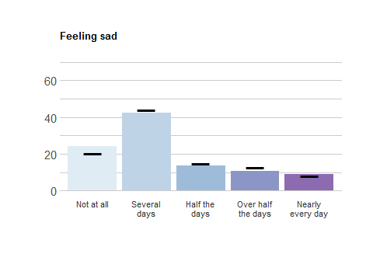
Response | School Freq | School % | School Valid % | Ag Freq | Ag % | Ag Valid %
Not at all | 93 | 24.03 | 24.16 | 1277 | 20.30 | 20.37
Several days | 164 | 42.38 | 42.60 | 2754 | 43.78 | 43.93
Half the days | 53 | 13.70 | 13.77 | 937 | 14.89 | 14.95
Over half the days | 41 | 10.59 | 10.65 | 802 | 12.75 | 12.79
Nearly every day | 34 | 8.79 | 8.83 | 499 | 7.93 | 7.96
NA | 2 | 0.52 | NA | 22 | 0.35 | NA

DEP_3
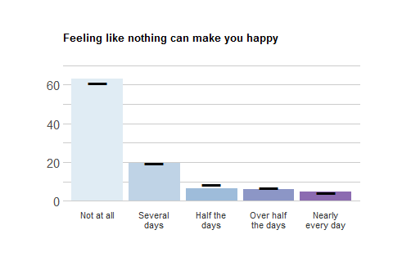
Response | School Freq | School % | School Valid % | Ag Freq | Ag % | Ag Valid %
Not at all | 244 | 63.05 | 63.21 | 3820 | 60.72 | 60.99
Several days | 76 | 19.64 | 19.69 | 1212 | 19.27 | 19.35
Half the days | 24 | 6.20 | 6.22 | 543 | 8.63 | 8.67
Over half the days | 23 | 5.94 | 5.96 | 417 | 6.63 | 6.66
Nearly every day | 19 | 4.91 | 4.92 | 271 | 4.31 | 4.33
NA | 1 | 0.26 | NA | 28 | 0.45 | NA

Loneliness
Over the past two weeks, how often have you experienced any of the following:

LONE_1
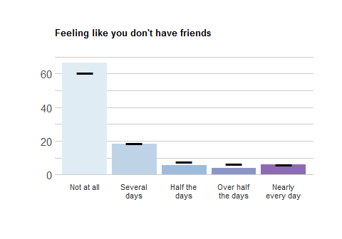
Response | School Freq | School % | School Valid % | Ag Freq | Ag % | Ag Valid %
Not at all | 255 | 65.89 | 66.41 | 3806 | 60.50 | 60.80
Several days | 70 | 18.09 | 18.23 | 1183 | 18.80 | 18.90
Half the days | 21 | 5.43 | 5.47 | 469 | 7.46 | 7.49
Over half the days | 15 | 3.88 | 3.91 | 414 | 6.58 | 6.61
Nearly every day | 23 | 5.94 | 5.99 | 388 | 6.17 | 6.20
NA | 3 | 0.78 | NA | 31 | 0.49 | NA

LONE_2
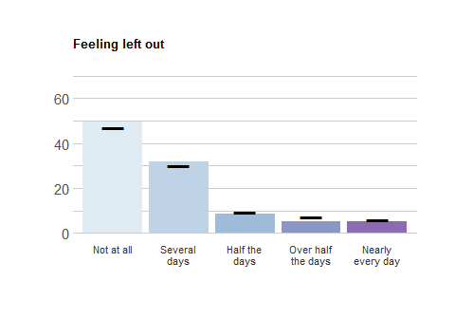
Response | School Freq | School % | School Valid % | Ag Freq | Ag % | Ag Valid %
Not at all | 191 | 49.35 | 49.74 | 2947 | 46.84 | 47.13
Several days | 122 | 31.52 | 31.77 | 1878 | 29.85 | 30.03
Half the days | 32 | 8.27 | 8.33 | 592 | 9.41 | 9.47
Over half the days | 20 | 5.17 | 5.21 | 463 | 7.36 | 7.40
Nearly every day | 19 | 4.91 | 4.95 | 373 | 5.93 | 5.97
NA | 3 | 0.78 | NA | 38 | 0.60 | NA

LONE_3
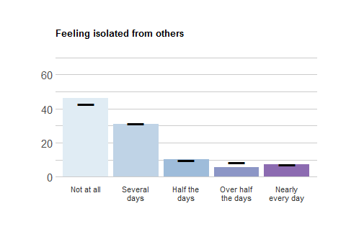
Response | School Freq | School % | School Valid % | Ag Freq | Ag % | Ag Valid %
Not at all | 178 | 45.99 | 46.11 | 2676 | 42.54 | 42.67
Several days | 119 | 30.75 | 30.83 | 1963 | 31.20 | 31.30
Half the days | 39 | 10.08 | 10.10 | 625 | 9.93 | 9.97
Over half the days | 22 | 5.68 | 5.70 | 544 | 8.65 | 8.67
Nearly every day | 28 | 7.24 | 7.25 | 463 | 7.36 | 7.38
NA | 1 | 0.26 | NA | 20 | 0.32 | NA

Social Anxiety
Over the past two weeks, how often have you experienced any of the following:

SOCANX_1
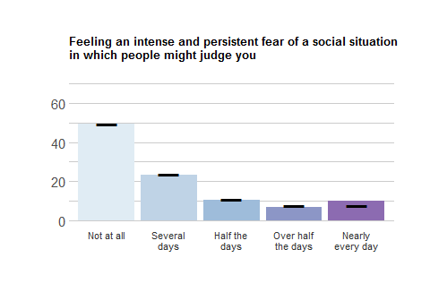
Response | School Freq | School % | School Valid % | Ag Freq | Ag % | Ag Valid %
Not at all | 191 | 49.35 | 49.61 | 3114 | 49.50 | 49.68
Several days | 90 | 23.26 | 23.38 | 1488 | 23.65 | 23.74
Half the days | 40 | 10.34 | 10.39 | 673 | 10.70 | 10.74
Over half the days | 26 | 6.72 | 6.75 | 497 | 7.90 | 7.93
Nearly every day | 38 | 9.82 | 9.87 | 496 | 7.88 | 7.91
NA | 2 | 0.52 | NA | 23 | 0.37 | NA

SOCANX_2
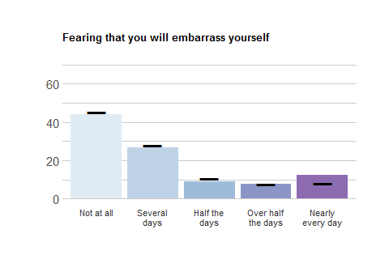
Response | School Freq | School % | School Valid % | Ag Freq | Ag % | Ag Valid %
Not at all | 170 | 43.93 | 44.27 | 2843 | 45.19 | 45.43
Several days | 102 | 26.36 | 26.56 | 1752 | 27.85 | 28.00
Half the days | 35 | 9.04 | 9.11 | 660 | 10.49 | 10.55
Over half the days | 30 | 7.75 | 7.81 | 487 | 7.74 | 7.78
Nearly every day | 47 | 12.14 | 12.24 | 516 | 8.20 | 8.25
NA | 3 | 0.78 | NA | 33 | 0.52 | NA

SOCANX_3
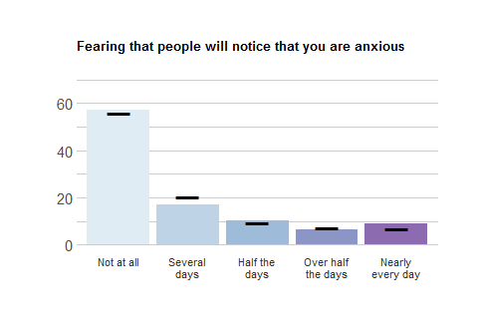
Response | School Freq | School % | School Valid % | Ag Freq | Ag % | Ag Valid %
Not at all | 219 | 56.59 | 57.03 | 3498 | 55.60 | 56.05
Several days | 66 | 17.05 | 17.19 | 1285 | 20.43 | 20.59
Half the days | 40 | 10.34 | 10.42 | 586 | 9.31 | 9.39
Over half the days | 25 | 6.46 | 6.51 | 445 | 7.07 | 7.13
Nearly every day | 34 | 8.79 | 8.85 | 427 | 6.79 | 6.84
NA | 3 | 0.78 | NA | 50 | 0.79 | NA

Positive Relationships: Friendship
This set of items asks you about your friendships

Outcomes for friends-in-general
Please rate how strongly you agree or disagree with the following statements.

FRIENDS_7
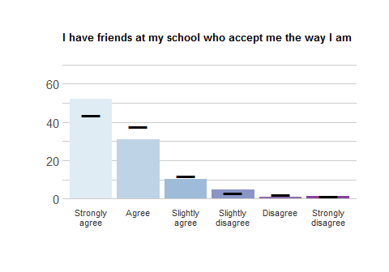
Response | School Freq | School % | School Valid % | Ag Freq | Ag % | Ag Valid %
Strongly agree | 125 | 32.30 | 52.30 | 1728 | 27.47 | 43.77
Agree | 74 | 19.12 | 30.96 | 1488 | 23.65 | 37.69
Slightly agree | 24 | 6.20 | 10.04 | 469 | 7.46 | 11.88
Slightly disagree | 11 | 2.84 | 4.60 | 127 | 2.02 | 3.22
Disagree | 2 | 0.52 | 0.84 | 81 | 1.29 | 2.05
Strongly disagree | 3 | 0.78 | 1.26 | 55 | 0.87 | 1.39
NA | 148 | 38.24 | NA | 2343 | 37.24 | NA

FRIENDS_8
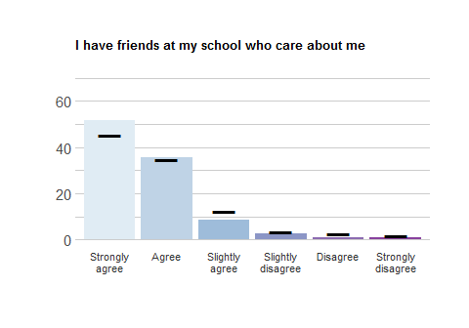
Response | School Freq | School % | School Valid % | Ag Freq | Ag % | Ag Valid %
Strongly agree | 124 | 32.04 | 51.88 | 1775 | 28.21 | 45.47
Agree | 85 | 21.96 | 35.56 | 1352 | 21.49 | 34.63
Slightly agree | 20 | 5.17 | 8.37 | 482 | 7.66 | 12.35
Slightly disagree | 6 | 1.55 | 2.51 | 128 | 2.03 | 3.28
Disagree | 2 | 0.52 | 0.84 | 95 | 1.51 | 2.43
Strongly disagree | 2 | 0.52 | 0.84 | 72 | 1.14 | 1.84
NA | 148 | 38.24 | NA | 2387 | 37.94 | NA

FRIENDS_9
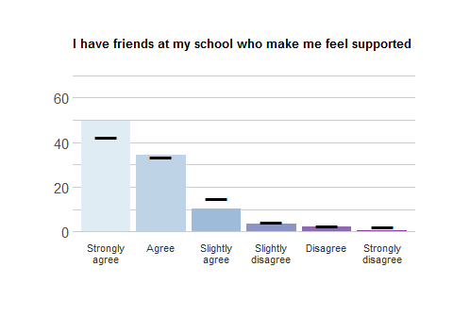
Response | School Freq | School % | School Valid % | Ag Freq | Ag % | Ag Valid %
Strongly agree | 123 | 31.78 | 49.60 | 1675 | 26.63 | 42.53
Agree | 85 | 21.96 | 34.27 | 1328 | 21.11 | 33.72
Slightly agree | 25 | 6.46 | 10.08 | 581 | 9.24 | 14.75
Slightly disagree | 9 | 2.33 | 3.63 | 162 | 2.58 | 4.11
Disagree | 5 | 1.29 | 2.02 | 111 | 1.76 | 2.82
Strongly disagree | 1 | 0.26 | 0.40 | 81 | 1.29 | 2.06
NA | 139 | 35.92 | NA | 2353 | 37.40 | NA

FRIENDS_10
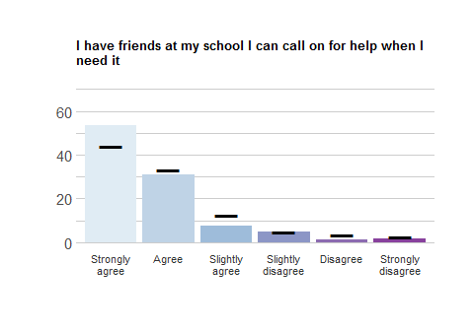
Response | School Freq | School % | School Valid % | Ag Freq | Ag % | Ag Valid %
Strongly agree | 129 | 33.33 | 53.53 | 1737 | 27.61 | 43.97
Agree | 75 | 19.38 | 31.12 | 1310 | 20.82 | 33.16
Slightly agree | 18 | 4.65 | 7.47 | 490 | 7.79 | 12.41
Slightly disagree | 12 | 3.10 | 4.98 | 183 | 2.91 | 4.63
Disagree | 3 | 0.78 | 1.24 | 130 | 2.07 | 3.29
Strongly disagree | 4 | 1.03 | 1.66 | 100 | 1.59 | 2.53
NA | 146 | 37.73 | NA | 2341 | 37.21 | NA

Pathways for friends-in-general
Please rate how strongly you agree or disagree with the following statements.

FRIENDS_1
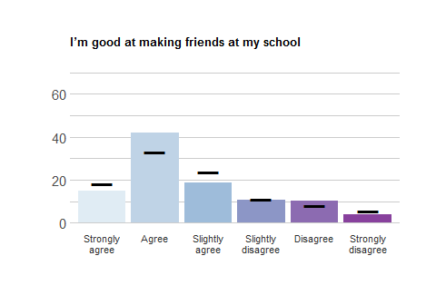
Response | School Freq | School % | School Valid % | Ag Freq | Ag % | Ag Valid %
Strongly agree | 36 | 9.30 | 15.06 | 712 | 11.32 | 18.21
Agree | 100 | 25.84 | 41.84 | 1297 | 20.62 | 33.18
Slightly agree | 45 | 11.63 | 18.83 | 927 | 14.74 | 23.71
Slightly disagree | 25 | 6.46 | 10.46 | 439 | 6.98 | 11.23
Disagree | 24 | 6.20 | 10.04 | 322 | 5.12 | 8.24
Strongly disagree | 9 | 2.33 | 3.77 | 212 | 3.37 | 5.42
NA | 148 | 38.24 | NA | 2382 | 37.86 | NA

FRIENDS_2
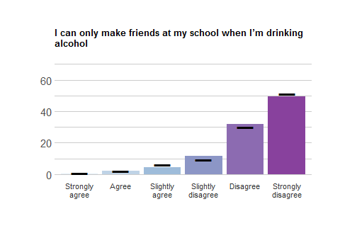
Response | School Freq | School % | School Valid % | Ag Freq | Ag % | Ag Valid %
Strongly agree | 1 | 0.26 | 0.40 | 35 | 0.56 | 0.89
Agree | 5 | 1.29 | 2.02 | 86 | 1.37 | 2.19
Slightly agree | 11 | 2.84 | 4.44 | 242 | 3.85 | 6.15
Slightly disagree | 29 | 7.49 | 11.69 | 373 | 5.93 | 9.48
Disagree | 79 | 20.41 | 31.85 | 1184 | 18.82 | 30.10
Strongly disagree | 123 | 31.78 | 49.60 | 2014 | 32.01 | 51.19
NA | 139 | 35.92 | NA | 2357 | 37.47 | NA

FRIENDS_3
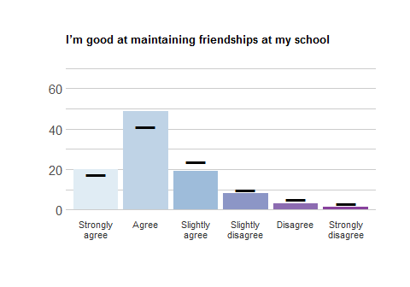
Response | School Freq | School % | School Valid % | Ag Freq | Ag % | Ag Valid %
Strongly agree | 49 | 12.66 | 19.84 | 683 | 10.86 | 17.35
Agree | 120 | 31.01 | 48.58 | 1614 | 25.66 | 41.01
Slightly agree | 47 | 12.14 | 19.03 | 940 | 14.94 | 23.88
Slightly disagree | 20 | 5.17 | 8.10 | 383 | 6.09 | 9.73
Disagree | 8 | 2.07 | 3.24 | 195 | 3.10 | 4.95
Strongly disagree | 3 | 0.78 | 1.21 | 121 | 1.92 | 3.07
NA | 140 | 36.18 | NA | 2355 | 37.43 | NA

FRIENDS_4
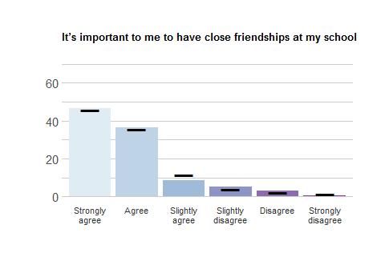
Response | School Freq | School % | School Valid % | Ag Freq | Ag % | Ag Valid %
Strongly agree | 112 | 28.94 | 46.47 | 1806 | 28.71 | 45.70
Agree | 88 | 22.74 | 36.51 | 1409 | 22.40 | 35.65
Slightly agree | 21 | 5.43 | 8.71 | 453 | 7.20 | 11.46
Slightly disagree | 12 | 3.10 | 4.98 | 148 | 2.35 | 3.74
Disagree | 7 | 1.81 | 2.90 | 91 | 1.45 | 2.30
Strongly disagree | 1 | 0.26 | 0.41 | 45 | 0.72 | 1.14
NA | 146 | 37.73 | NA | 2339 | 37.18 | NA

FRIENDS_5
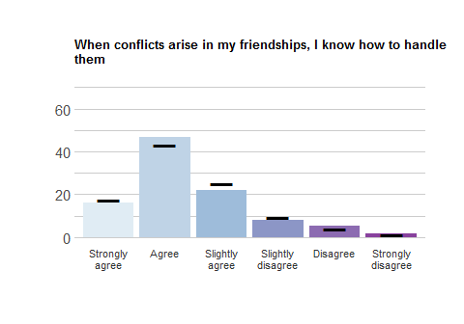
Response | School Freq | School % | School Valid % | Ag Freq | Ag % | Ag Valid %
Strongly agree | 39 | 10.08 | 16.18 | 681 | 10.82 | 17.23
Agree | 113 | 29.20 | 46.89 | 1711 | 27.20 | 43.28
Slightly agree | 53 | 13.70 | 21.99 | 998 | 15.86 | 25.25
Slightly disagree | 19 | 4.91 | 7.88 | 370 | 5.88 | 9.36
Disagree | 13 | 3.36 | 5.39 | 147 | 2.34 | 3.72
Strongly disagree | 4 | 1.03 | 1.66 | 46 | 0.73 | 1.16
NA | 146 | 37.73 | NA | 2338 | 37.16 | NA

FRIENDS_6
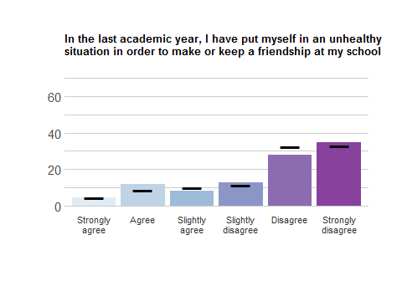
Response | School Freq | School % | School Valid % | Ag Freq | Ag % | Ag Valid %
Strongly agree | 11 | 2.84 | 4.60 | 178 | 2.83 | 4.56
Agree | 28 | 7.24 | 11.72 | 341 | 5.42 | 8.73
Slightly agree | 20 | 5.17 | 8.37 | 397 | 6.31 | 10.17
Slightly disagree | 30 | 7.75 | 12.55 | 444 | 7.06 | 11.37
Disagree | 67 | 17.31 | 28.03 | 1267 | 20.14 | 32.45
Strongly disagree | 83 | 21.45 | 34.73 | 1278 | 20.31 | 32.73
NA | 148 | 38.24 | NA | 2386 | 37.93 | NA

Outcome for friends-who-are-different
Please rate how strongly you agree or disagree with the following statements.

DFRIENDS_4
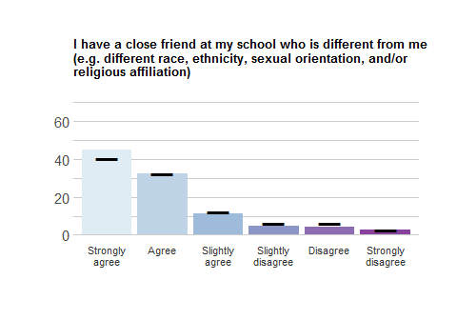
Response | School Freq | School % | School Valid % | Ag Freq | Ag % | Ag Valid %
Strongly agree | 161 | 41.60 | 44.60 | 2356 | 37.45 | 40.11
Agree | 116 | 29.97 | 32.13 | 1899 | 30.19 | 32.33
Slightly agree | 40 | 10.34 | 11.08 | 734 | 11.67 | 12.50
Slightly disagree | 18 | 4.65 | 4.99 | 362 | 5.75 | 6.16
Disagree | 16 | 4.13 | 4.43 | 357 | 5.67 | 6.08
Strongly disagree | 10 | 2.58 | 2.77 | 166 | 2.64 | 2.83
NA | 26 | 6.72 | NA | 417 | 6.63 | NA

Pathways for friends-who-are-different
Please rate how strongly you agree or disagree with the following statements.

DFRIENDS_1
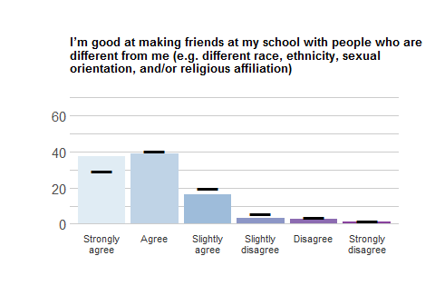
Response | School Freq | School % | School Valid % | Ag Freq | Ag % | Ag Valid %
Strongly agree | 92 | 23.77 | 37.40 | 1160 | 18.44 | 29.49
Agree | 96 | 24.81 | 39.02 | 1576 | 25.05 | 40.07
Slightly agree | 40 | 10.34 | 16.26 | 769 | 12.22 | 19.55
Slightly disagree | 8 | 2.07 | 3.25 | 226 | 3.59 | 5.75
Disagree | 7 | 1.81 | 2.85 | 139 | 2.21 | 3.53
Strongly disagree | 3 | 0.78 | 1.22 | 63 | 1.00 | 1.60
NA | 141 | 36.43 | NA | 2358 | 37.48 | NA

DFRIENDS_2
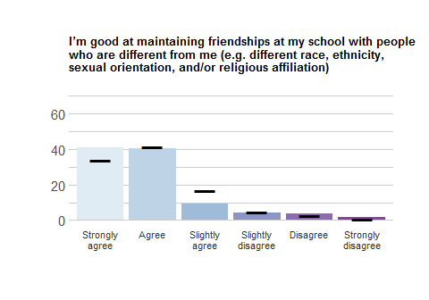
Response | School Freq | School % | School Valid % | Ag Freq | Ag % | Ag Valid %
Strongly agree | 98 | 25.32 | 41.00 | 1321 | 21.00 | 33.61
Agree | 96 | 24.81 | 40.17 | 1632 | 25.94 | 41.53
Slightly agree | 22 | 5.68 | 9.21 | 657 | 10.44 | 16.72
Slightly disagree | 10 | 2.58 | 4.18 | 184 | 2.92 | 4.68
Disagree | 9 | 2.33 | 3.77 | 99 | 1.57 | 2.52
Strongly disagree | 4 | 1.03 | 1.67 | 37 | 0.59 | 0.94
NA | 148 | 38.24 | NA | 2361 | 37.53 | NA

DFRIENDS_3
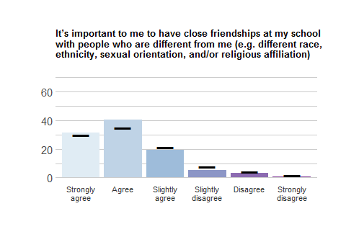
Response | School Freq | School % | School Valid % | Ag Freq | Ag % | Ag Valid %
Strongly agree | 74 | 19.12 | 31.36 | 1165 | 18.52 | 29.90
Agree | 95 | 24.55 | 40.25 | 1363 | 21.67 | 34.98
Slightly agree | 45 | 11.63 | 19.07 | 830 | 13.19 | 21.30
Slightly disagree | 12 | 3.10 | 5.08 | 293 | 4.66 | 7.52
Disagree | 8 | 2.07 | 3.39 | 174 | 2.77 | 4.47
Strongly disagree | 2 | 0.52 | 0.85 | 71 | 1.13 | 1.82
NA | 151 | 39.02 | NA | 2395 | 38.07 | NA

Positive Relationships: Romantic Relationships

ROMAN_1
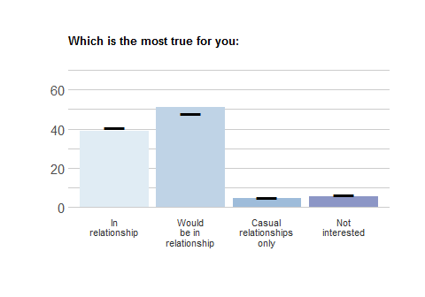
Response | School Freq | School % | School Valid % | Ag Freq | Ag % | Ag Valid %
In relationship | 139 | 35.92 | 38.72 | 2405 | 38.23 | 40.77
Would be in relationship | 184 | 47.55 | 51.25 | 2823 | 44.87 | 47.86
Casual relationships only | 17 | 4.39 | 4.74 | 305 | 4.85 | 5.17
Not interested | 19 | 4.91 | 5.29 | 366 | 5.82 | 6.20
NA | 28 | 7.24 | NA | 392 | 6.23 | NA

ROMAN_2
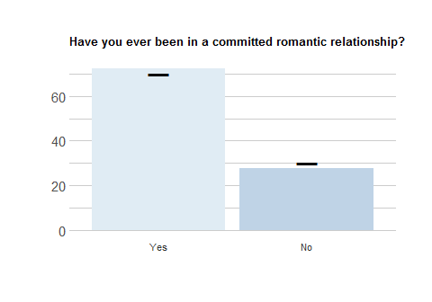
Response | School Freq | School % | School Valid % | Ag Freq | Ag % | Ag Valid %
Yes | 260 | 67.18 | 72.42 | 4111 | 65.35 | 69.74
No | 99 | 25.58 | 27.58 | 1784 | 28.36 | 30.26
NA | 28 | 7.24 | NA | 396 | 6.29 | NA

Set 1
NOTE: People who selected “A” in ROMAN_2 received these items
Please rate how strongly you agree or disagree with the following statements.

ROMAN3_1
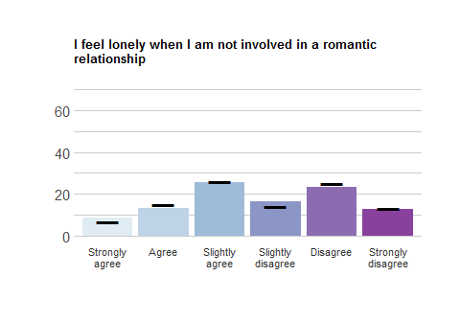
Response | School Freq | School % | School Valid % | Ag Freq | Ag % | Ag Valid %
Strongly agree | 23 | 5.94 | 8.85 | 270 | 4.29 | 6.60
Agree | 34 | 8.79 | 13.08 | 619 | 9.84 | 15.13
Slightly agree | 66 | 17.05 | 25.38 | 1062 | 16.88 | 25.95
Slightly disagree | 43 | 11.11 | 16.54 | 582 | 9.25 | 14.22
Disagree | 61 | 15.76 | 23.46 | 1024 | 16.28 | 25.02
Strongly disagree | 33 | 8.53 | 12.69 | 535 | 8.50 | 13.07
NA | 127 | 32.82 | NA | 2199 | 34.95 | NA

ROMAN3_2
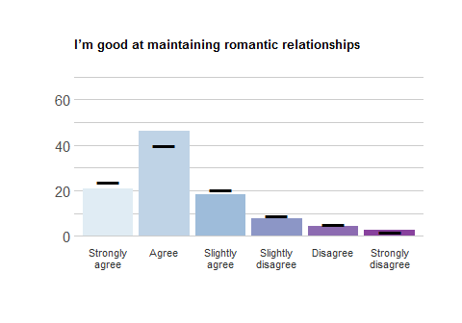
Response | School Freq | School % | School Valid % | Ag Freq | Ag % | Ag Valid %
Strongly agree | 54 | 13.95 | 20.77 | 977 | 15.53 | 23.85
Agree | 120 | 31.01 | 46.15 | 1626 | 25.85 | 39.70
Slightly agree | 48 | 12.40 | 18.46 | 828 | 13.16 | 20.21
Slightly disagree | 20 | 5.17 | 7.69 | 371 | 5.90 | 9.06
Disagree | 11 | 2.84 | 4.23 | 214 | 3.40 | 5.22
Strongly disagree | 7 | 1.81 | 2.69 | 80 | 1.27 | 1.95
NA | 127 | 32.82 | NA | 2195 | 34.89 | NA

ROMAN3_3
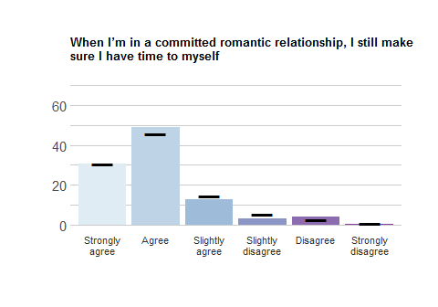
Response | School Freq | School % | School Valid % | Ag Freq | Ag % | Ag Valid %
Strongly agree | 79 | 20.41 | 30.50 | 1257 | 19.98 | 30.74
Agree | 127 | 32.82 | 49.03 | 1874 | 29.79 | 45.83
Slightly agree | 33 | 8.53 | 12.74 | 596 | 9.47 | 14.58
Slightly disagree | 8 | 2.07 | 3.09 | 224 | 3.56 | 5.48
Disagree | 11 | 2.84 | 4.25 | 110 | 1.75 | 2.69
Strongly disagree | 1 | 0.26 | 0.39 | 28 | 0.45 | 0.68
NA | 128 | 33.07 | NA | 2202 | 35.00 | NA

ROMAN3_4
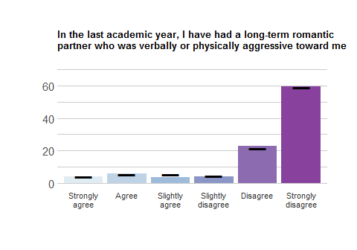
Response | School Freq | School % | School Valid % | Ag Freq | Ag % | Ag Valid %
Strongly agree | 11 | 2.84 | 4.23 | 168 | 2.67 | 4.10
Agree | 15 | 3.88 | 5.77 | 214 | 3.40 | 5.22
Slightly agree | 9 | 2.33 | 3.46 | 226 | 3.59 | 5.52
Slightly disagree | 10 | 2.58 | 3.85 | 189 | 3.00 | 4.61
Disagree | 60 | 15.50 | 23.08 | 881 | 14.00 | 21.51
Strongly disagree | 155 | 40.05 | 59.62 | 2418 | 38.44 | 59.03
NA | 127 | 32.82 | NA | 2195 | 34.89 | NA

ROMAN3_5
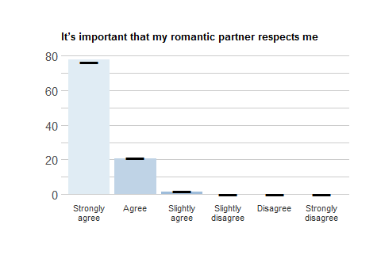
Response | School Freq | School % | School Valid % | Ag Freq | Ag % | Ag Valid %
Strongly agree | 202 | 52.20 | 77.69 | 3127 | 49.71 | 76.36
Agree | 54 | 13.95 | 20.77 | 862 | 13.70 | 21.05
Slightly agree | 4 | 1.03 | 1.54 | 84 | 1.34 | 2.05
Slightly disagree | 0 | 0.00 | 0.00 | 11 | 0.17 | 0.27
Disagree | 0 | 0.00 | 0.00 | 10 | 0.16 | 0.24
Strongly disagree | 0 | 0.00 | 0.00 | 1 | 0.02 | 0.02
NA | 127 | 32.82 | NA | 2196 | 34.91 | NA

Set 2
NOTE: Everyone received these items
Please rate how strongly you agree or disagree with the following statements.

ROMAN4_1
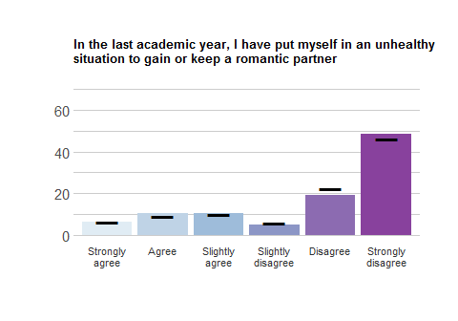
Response | School Freq | School % | School Valid % | Ag Freq | Ag % | Ag Valid %
Strongly agree | 23 | 5.94 | 6.41 | 384 | 6.10 | 6.53
Agree | 37 | 9.56 | 10.31 | 532 | 8.46 | 9.05
Slightly agree | 38 | 9.82 | 10.58 | 577 | 9.17 | 9.81
Slightly disagree | 18 | 4.65 | 5.01 | 348 | 5.53 | 5.92
Disagree | 69 | 17.83 | 19.22 | 1311 | 20.84 | 22.30
Strongly disagree | 174 | 44.96 | 48.47 | 2727 | 43.35 | 46.39
NA | 28 | 7.24 | NA | 412 | 6.55 | NA

ROMAN4_2
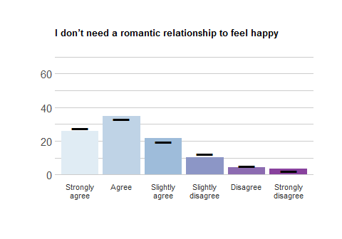
Response | School Freq | School % | School Valid % | Ag Freq | Ag % | Ag Valid %
Strongly agree | 92 | 23.77 | 25.70 | 1632 | 25.94 | 27.76
Agree | 124 | 32.04 | 34.64 | 1951 | 31.01 | 33.18
Slightly agree | 77 | 19.90 | 21.51 | 1139 | 18.11 | 19.37
Slightly disagree | 37 | 9.56 | 10.34 | 732 | 11.64 | 12.45
Disagree | 15 | 3.88 | 4.19 | 298 | 4.74 | 5.07
Strongly disagree | 13 | 3.36 | 3.63 | 128 | 2.03 | 2.18
NA | 29 | 7.49 | NA | 411 | 6.53 | NA

Positivity
This set of items asks about your behaviors and attitudes toward life.

Self Esteem
Please rate how strongly you agree or disagree with the following statements.

SELFEST_1
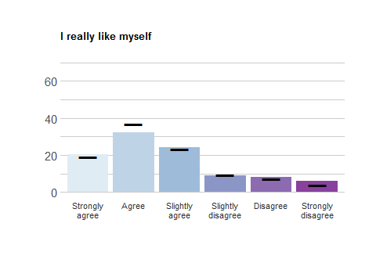
Response | School Freq | School % | School Valid % | Ag Freq | Ag % | Ag Valid %
Strongly agree | 51 | 13.18 | 20.4 | 778 | 12.37 | 19.09
Agree | 81 | 20.93 | 32.4 | 1511 | 24.02 | 37.07
Slightly agree | 61 | 15.76 | 24.4 | 950 | 15.10 | 23.31
Slightly disagree | 22 | 5.68 | 8.8 | 386 | 6.14 | 9.47
Disagree | 20 | 5.17 | 8.0 | 295 | 4.69 | 7.24
Strongly disagree | 15 | 3.88 | 6.0 | 156 | 2.48 | 3.83
NA | 137 | 35.40 | NA | 2215 | 35.21 | NA

SELFEST_2
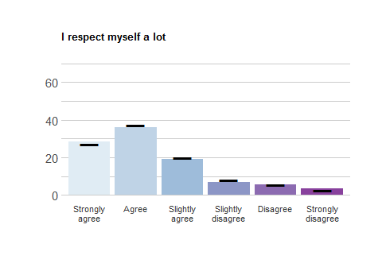
Response | School Freq | School % | School Valid % | Ag Freq | Ag % | Ag Valid %
Strongly agree | 73 | 18.86 | 28.63 | 1123 | 17.85 | 27.20
Agree | 92 | 23.77 | 36.08 | 1536 | 24.42 | 37.20
Slightly agree | 49 | 12.66 | 19.22 | 817 | 12.99 | 19.79
Slightly disagree | 18 | 4.65 | 7.06 | 329 | 5.23 | 7.97
Disagree | 14 | 3.62 | 5.49 | 222 | 3.53 | 5.38
Strongly disagree | 9 | 2.33 | 3.53 | 102 | 1.62 | 2.47
NA | 132 | 34.11 | NA | 2162 | 34.37 | NA

SELFEST_3
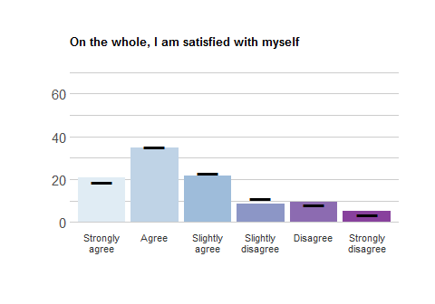
Response | School Freq | School % | School Valid % | Ag Freq | Ag % | Ag Valid %
Strongly agree | 53 | 13.70 | 20.62 | 766 | 12.18 | 18.64
Agree | 89 | 23.00 | 34.63 | 1452 | 23.08 | 35.34
Slightly agree | 56 | 14.47 | 21.79 | 939 | 14.93 | 22.85
Slightly disagree | 22 | 5.68 | 8.56 | 462 | 7.34 | 11.24
Disagree | 24 | 6.20 | 9.34 | 342 | 5.44 | 8.32
Strongly disagree | 13 | 3.36 | 5.06 | 148 | 2.35 | 3.60
NA | 130 | 33.59 | NA | 2182 | 34.68 | NA

SELFEST_4
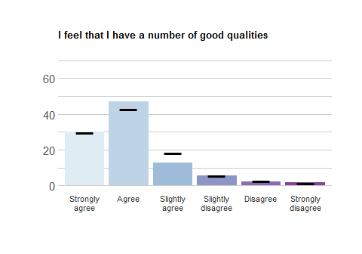
Response | School Freq | School % | School Valid % | Ag Freq | Ag % | Ag Valid %
Strongly agree | 77 | 19.90 | 30.20 | 1225 | 19.47 | 29.68
Agree | 120 | 31.01 | 47.06 | 1765 | 28.06 | 42.77
Slightly agree | 33 | 8.53 | 12.94 | 746 | 11.86 | 18.08
Slightly disagree | 14 | 3.62 | 5.49 | 223 | 3.54 | 5.40
Disagree | 6 | 1.55 | 2.35 | 115 | 1.83 | 2.79
Strongly disagree | 5 | 1.29 | 1.96 | 53 | 0.84 | 1.28
NA | 132 | 34.11 | NA | 2164 | 34.40 | NA

Optimism
Please rate how strongly you agree or disagree with the following statements.

OPT_1
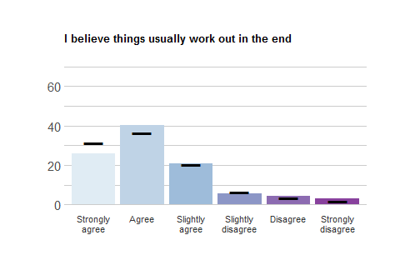
Response | School Freq | School % | School Valid % | Ag Freq | Ag % | Ag Valid %
Strongly agree | 99 | 25.58 | 25.98 | 1929 | 30.66 | 31.29
Agree | 153 | 39.53 | 40.16 | 2254 | 35.83 | 36.57
Slightly agree | 80 | 20.67 | 21.00 | 1257 | 19.98 | 20.39
Slightly disagree | 22 | 5.68 | 5.77 | 409 | 6.50 | 6.64
Disagree | 16 | 4.13 | 4.20 | 209 | 3.32 | 3.39
Strongly disagree | 11 | 2.84 | 2.89 | 106 | 1.68 | 1.72
NA | 6 | 1.55 | NA | 127 | 2.02 | NA

OPT_2
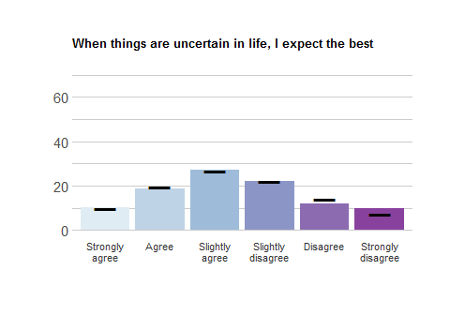
Response | School Freq | School % | School Valid % | Ag Freq | Ag % | Ag Valid %
Strongly agree | 39 | 10.08 | 10.24 | 614 | 9.76 | 9.96
Agree | 71 | 18.35 | 18.64 | 1209 | 19.22 | 19.62
Slightly agree | 103 | 26.61 | 27.03 | 1650 | 26.23 | 26.77
Slightly disagree | 84 | 21.71 | 22.05 | 1366 | 21.71 | 22.16
Disagree | 46 | 11.89 | 12.07 | 872 | 13.86 | 14.15
Strongly disagree | 38 | 9.82 | 9.97 | 452 | 7.18 | 7.33
NA | 6 | 1.55 | NA | 128 | 2.03 | NA

OPT_3
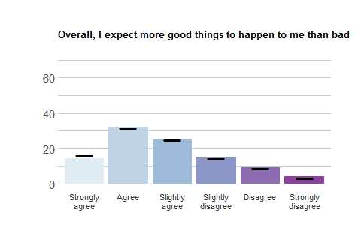
Response | School Freq | School % | School Valid % | Ag Freq | Ag % | Ag Valid %
Strongly agree | 55 | 14.21 | 14.47 | 1008 | 16.02 | 16.35
Agree | 123 | 31.78 | 32.37 | 1949 | 30.98 | 31.61
Slightly agree | 95 | 24.55 | 25.00 | 1533 | 24.37 | 24.87
Slightly disagree | 56 | 14.47 | 14.74 | 896 | 14.24 | 14.53
Disagree | 35 | 9.04 | 9.21 | 553 | 8.79 | 8.97
Strongly disagree | 16 | 4.13 | 4.21 | 226 | 3.59 | 3.67
NA | 7 | 1.81 | NA | 126 | 2.00 | NA

Perseverance
Please rate how strongly you agree or disagree with the following statements.

PERS_1
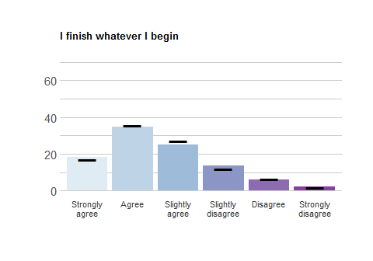
Response | School Freq | School % | School Valid % | Ag Freq | Ag % | Ag Valid %
Strongly agree | 70 | 18.09 | 18.32 | 1054 | 16.75 | 17.10
Agree | 133 | 34.37 | 34.82 | 2209 | 35.11 | 35.84
Slightly agree | 96 | 24.81 | 25.13 | 1672 | 26.58 | 27.13
Slightly disagree | 52 | 13.44 | 13.61 | 738 | 11.73 | 11.97
Disagree | 23 | 5.94 | 6.02 | 385 | 6.12 | 6.25
Strongly disagree | 8 | 2.07 | 2.09 | 106 | 1.68 | 1.72
NA | 5 | 1.29 | NA | 127 | 2.02 | NA

PERS_2
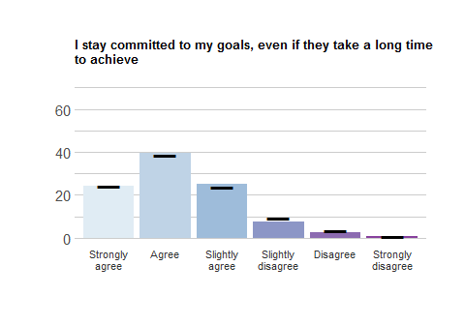
Response | School Freq | School % | School Valid % | Ag Freq | Ag % | Ag Valid %
Strongly agree | 92 | 23.77 | 24.15 | 1503 | 23.89 | 24.38
Agree | 151 | 39.02 | 39.63 | 2374 | 37.74 | 38.51
Slightly agree | 96 | 24.81 | 25.20 | 1451 | 23.06 | 23.54
Slightly disagree | 29 | 7.49 | 7.61 | 563 | 8.95 | 9.13
Disagree | 10 | 2.58 | 2.62 | 219 | 3.48 | 3.55
Strongly disagree | 3 | 0.78 | 0.79 | 55 | 0.87 | 0.89
NA | 6 | 1.55 | NA | 126 | 2.00 | NA

PERS_3
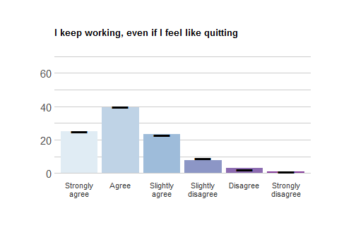
Response | School Freq | School % | School Valid % | Ag Freq | Ag % | Ag Valid %
Strongly agree | 96 | 24.81 | 25.13 | 1540 | 24.48 | 25.00
Agree | 151 | 39.02 | 39.53 | 2448 | 38.91 | 39.73
Slightly agree | 90 | 23.26 | 23.56 | 1418 | 22.54 | 23.02
Slightly disagree | 30 | 7.75 | 7.85 | 540 | 8.58 | 8.76
Disagree | 12 | 3.10 | 3.14 | 146 | 2.32 | 2.37
Strongly disagree | 3 | 0.78 | 0.79 | 69 | 1.10 | 1.12
NA | 5 | 1.29 | NA | 130 | 2.07 | NA

Purpose
This set of items asks about your goals in life.
By “goals”, we mean plans for your life after graduation.

PURP1
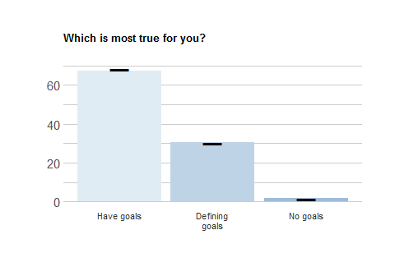
Response | School Freq | School % | School Valid % | Ag Freq | Ag % | Ag Valid %
Have goals | 247 | 63.82 | 67.49 | 4063 | 64.58 | 68.44
Defining goals | 112 | 28.94 | 30.60 | 1786 | 28.39 | 30.08
No goals | 7 | 1.81 | 1.91 | 88 | 1.40 | 1.48
NA | 21 | 5.43 | NA | 354 | 5.63 | NA
NOTE: People who selected “C” in PURP_1 skipped the remaining PURPOSE items

“Have goals” Outcomes
NOTE: People who selected “A” in PURP_1 received these items
Please rate how strongly you agree or disagree with the following statements.

PURP2_1
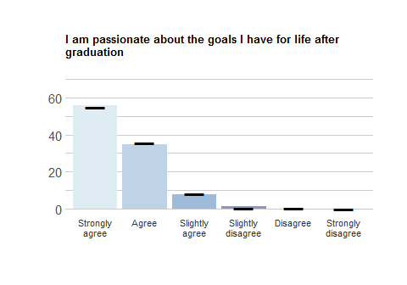
Response | School Freq | School % | School Valid % | Ag Freq | Ag % | Ag Valid %
Strongly agree | 92 | 23.77 | 56.10 | 1465 | 23.29 | 54.95
Agree | 57 | 14.73 | 34.76 | 957 | 15.21 | 35.90
Slightly agree | 13 | 3.36 | 7.93 | 222 | 3.53 | 8.33
Slightly disagree | 2 | 0.52 | 1.22 | 15 | 0.24 | 0.56
Disagree | 0 | 0.00 | 0.00 | 7 | 0.11 | 0.26
Strongly disagree | 0 | 0.00 | 0.00 | 0 | 0.00 | 0.00
NA | 223 | 57.62 | NA | 3625 | 57.62 | NA

PURP2_2
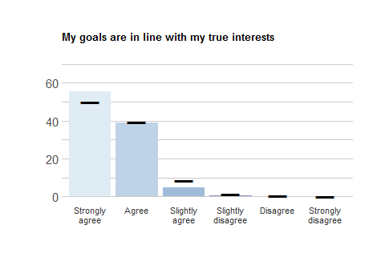
Response | School Freq | School % | School Valid % | Ag Freq | Ag % | Ag Valid %
Strongly agree | 93 | 24.03 | 55.69 | 1368 | 21.75 | 50.09
Agree | 65 | 16.80 | 38.92 | 1078 | 17.14 | 39.47
Slightly agree | 8 | 2.07 | 4.79 | 236 | 3.75 | 8.64
Slightly disagree | 1 | 0.26 | 0.60 | 34 | 0.54 | 1.24
Disagree | 0 | 0.00 | 0.00 | 11 | 0.17 | 0.40
Strongly disagree | 0 | 0.00 | 0.00 | 4 | 0.06 | 0.15
NA | 220 | 56.85 | NA | 3560 | 56.59 | NA

PURP2_3
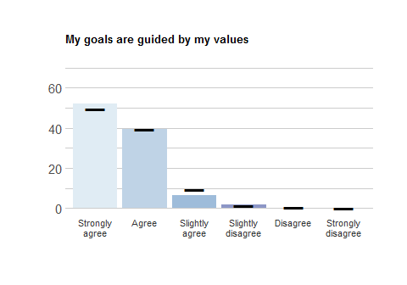
Response | School Freq | School % | School Valid % | Ag Freq | Ag % | Ag Valid %
Strongly agree | 83 | 21.45 | 52.20 | 1317 | 20.93 | 49.53
Agree | 63 | 16.28 | 39.62 | 1047 | 16.64 | 39.38
Slightly agree | 10 | 2.58 | 6.29 | 245 | 3.89 | 9.21
Slightly disagree | 3 | 0.78 | 1.89 | 35 | 0.56 | 1.32
Disagree | 0 | 0.00 | 0.00 | 13 | 0.21 | 0.49
Strongly disagree | 0 | 0.00 | 0.00 | 2 | 0.03 | 0.08
NA | 228 | 58.91 | NA | 3632 | 57.73 | NA

“Have goals” Pathways
NOTE: People who selected “A” in PURP_1 received these items
Please rate how strongly you agree or disagree with the following statements.

PURP2_4
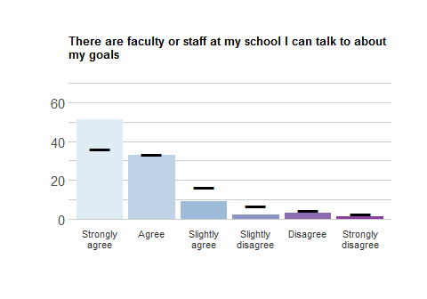
Response | School Freq | School % | School Valid % | Ag Freq | Ag % | Ag Valid %
Strongly agree | 86 | 22.22 | 51.50 | 988 | 15.70 | 36.16
Agree | 55 | 14.21 | 32.93 | 909 | 14.45 | 33.27
Slightly agree | 15 | 3.88 | 8.98 | 455 | 7.23 | 16.65
Slightly disagree | 4 | 1.03 | 2.40 | 184 | 2.92 | 6.73
Disagree | 5 | 1.29 | 2.99 | 121 | 1.92 | 4.43
Strongly disagree | 2 | 0.52 | 1.20 | 75 | 1.19 | 2.75
NA | 220 | 56.85 | NA | 3559 | 56.57 | NA

PURP2_5
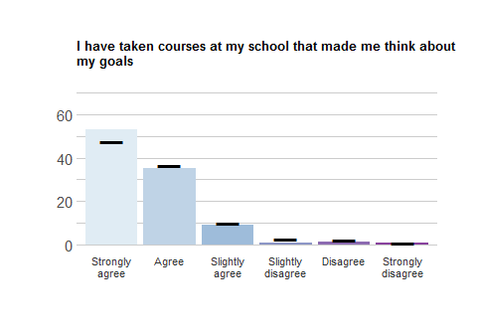
Response | School Freq | School % | School Valid % | Ag Freq | Ag % | Ag Valid %
Strongly agree | 87 | 22.48 | 53.05 | 1270 | 20.19 | 47.69
Agree | 58 | 14.99 | 35.37 | 981 | 15.59 | 36.84
Slightly agree | 15 | 3.88 | 9.15 | 269 | 4.28 | 10.10
Slightly disagree | 1 | 0.26 | 0.61 | 66 | 1.05 | 2.48
Disagree | 2 | 0.52 | 1.22 | 55 | 0.87 | 2.07
Strongly disagree | 1 | 0.26 | 0.61 | 22 | 0.35 | 0.83
NA | 223 | 57.62 | NA | 3628 | 57.67 | NA

PURP2_6
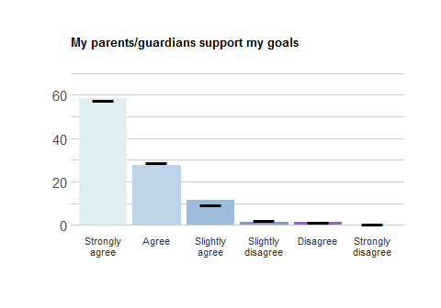
Response | School Freq | School % | School Valid % | Ag Freq | Ag % | Ag Valid %
Strongly agree | 96 | 24.81 | 58.54 | 1529 | 24.30 | 57.50
Agree | 45 | 11.63 | 27.44 | 771 | 12.26 | 29.00
Slightly agree | 19 | 4.91 | 11.59 | 248 | 3.94 | 9.33
Slightly disagree | 2 | 0.52 | 1.22 | 54 | 0.86 | 2.03
Disagree | 2 | 0.52 | 1.22 | 39 | 0.62 | 1.47
Strongly disagree | 0 | 0.00 | 0.00 | 18 | 0.29 | 0.68
NA | 223 | 57.62 | NA | 3632 | 57.73 | NA

PURP2_7
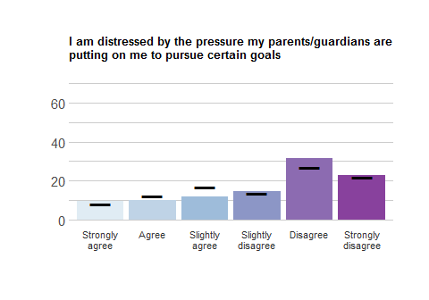
Response | School Freq | School % | School Valid % | Ag Freq | Ag % | Ag Valid %
Strongly agree | 15 | 3.88 | 9.43 | 221 | 3.51 | 8.31
Agree | 16 | 4.13 | 10.06 | 329 | 5.23 | 12.37
Slightly agree | 19 | 4.91 | 11.95 | 446 | 7.09 | 16.77
Slightly disagree | 23 | 5.94 | 14.47 | 366 | 5.82 | 13.76
Disagree | 50 | 12.92 | 31.45 | 719 | 11.43 | 27.03
Strongly disagree | 36 | 9.30 | 22.64 | 579 | 9.20 | 21.77
NA | 228 | 58.91 | NA | 3631 | 57.72 | NA

PURP2_8
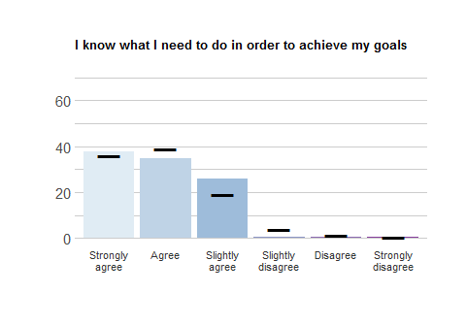
Response | School Freq | School % | School Valid % | Ag Freq | Ag % | Ag Valid %
Strongly agree | 63 | 16.28 | 37.72 | 986 | 15.67 | 36.13
Agree | 58 | 14.99 | 34.73 | 1068 | 16.98 | 39.14
Slightly agree | 43 | 11.11 | 25.75 | 524 | 8.33 | 19.20
Slightly disagree | 1 | 0.26 | 0.60 | 103 | 1.64 | 3.77
Disagree | 1 | 0.26 | 0.60 | 39 | 0.62 | 1.43
Strongly disagree | 1 | 0.26 | 0.60 | 9 | 0.14 | 0.33
NA | 220 | 56.85 | NA | 3562 | 56.62 | NA

PURP2_9
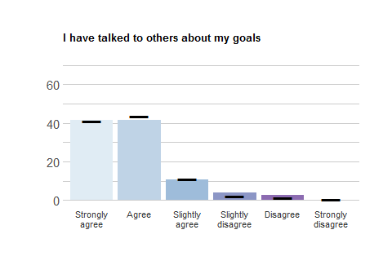
Response | School Freq | School % | School Valid % | Ag Freq | Ag % | Ag Valid %
Strongly agree | 66 | 17.05 | 41.51 | 1096 | 17.42 | 41.27
Agree | 66 | 17.05 | 41.51 | 1158 | 18.41 | 43.60
Slightly agree | 17 | 4.39 | 10.69 | 295 | 4.69 | 11.11
Slightly disagree | 6 | 1.55 | 3.77 | 59 | 0.94 | 2.22
Disagree | 4 | 1.03 | 2.52 | 36 | 0.57 | 1.36
Strongly disagree | 0 | 0.00 | 0.00 | 12 | 0.19 | 0.45
NA | 228 | 58.91 | NA | 3635 | 57.78 | NA

PURP2_10
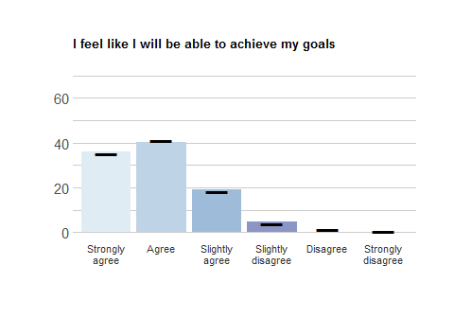
Response | School Freq | School % | School Valid % | Ag Freq | Ag % | Ag Valid %
Strongly agree | 60 | 15.50 | 35.93 | 964 | 15.32 | 35.40
Agree | 67 | 17.31 | 40.12 | 1116 | 17.74 | 40.98
Slightly agree | 32 | 8.27 | 19.16 | 494 | 7.85 | 18.14
Slightly disagree | 8 | 2.07 | 4.79 | 105 | 1.67 | 3.86
Disagree | 0 | 0.00 | 0.00 | 34 | 0.54 | 1.25
Strongly disagree | 0 | 0.00 | 0.00 | 10 | 0.16 | 0.37
NA | 220 | 56.85 | NA | 3568 | 56.72 | NA

PURP2_11
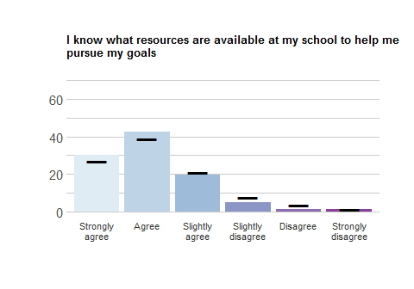
Response | School Freq | School % | School Valid % | Ag Freq | Ag % | Ag Valid %
Strongly agree | 48 | 12.40 | 30.19 | 717 | 11.40 | 27.01
Agree | 68 | 17.57 | 42.77 | 1037 | 16.48 | 39.06
Slightly agree | 31 | 8.01 | 19.50 | 563 | 8.95 | 21.21
Slightly disagree | 8 | 2.07 | 5.03 | 200 | 3.18 | 7.53
Disagree | 2 | 0.52 | 1.26 | 98 | 1.56 | 3.69
Strongly disagree | 2 | 0.52 | 1.26 | 40 | 0.64 | 1.51
NA | 228 | 58.91 | NA | 3636 | 57.80 | NA

PURP2_12
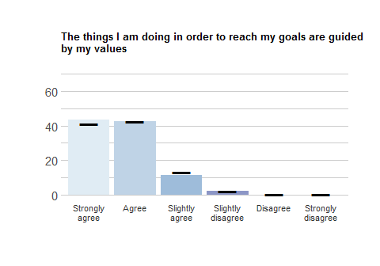
Response | School Freq | School % | School Valid % | Ag Freq | Ag % | Ag Valid %
Strongly agree | 71 | 18.35 | 43.29 | 1096 | 17.42 | 41.19
Agree | 70 | 18.09 | 42.68 | 1139 | 18.11 | 42.80
Slightly agree | 19 | 4.91 | 11.59 | 346 | 5.50 | 13.00
Slightly disagree | 4 | 1.03 | 2.44 | 59 | 0.94 | 2.22
Disagree | 0 | 0.00 | 0.00 | 14 | 0.22 | 0.53
Strongly disagree | 0 | 0.00 | 0.00 | 7 | 0.11 | 0.26
NA | 223 | 57.62 | NA | 3630 | 57.70 | NA

PURP2_13
NOTE: This item was only displayed to students who selected a major in demographic item MAJOR.
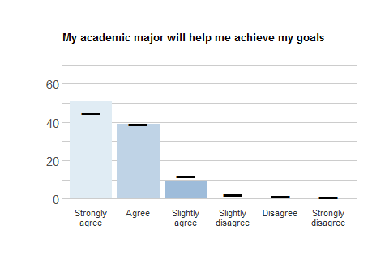
Response | School Freq | School % | School Valid % | Ag Freq | Ag % | Ag Valid %
Strongly agree | 175 | 45.22 | 50.87 | 2494 | 39.64 | 44.99
Agree | 134 | 34.63 | 38.95 | 2164 | 34.40 | 39.03
Slightly agree | 32 | 8.27 | 9.30 | 655 | 10.41 | 11.81
Slightly disagree | 2 | 0.52 | 0.58 | 122 | 1.94 | 2.20
Disagree | 1 | 0.26 | 0.29 | 66 | 1.05 | 1.19
Strongly disagree | 0 | 0.00 | 0.00 | 43 | 0.68 | 0.78
NA | 43 | 11.11 | NA | 747 | 11.87 | NA

PURP2_14
NOTE: This item was only displayed to students who selected “undecided” in demographic item MAJOR.
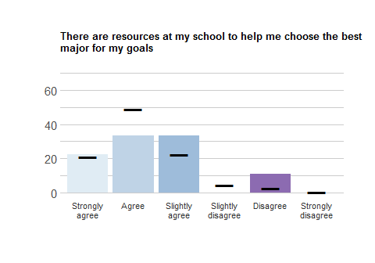
Response | School Freq | School % | School Valid % | Ag Freq | Ag % | Ag Valid %
Strongly agree | 2 | 0.52 | 22.22 | 50 | 0.79 | 20.83
Agree | 3 | 0.78 | 33.33 | 118 | 1.88 | 49.17
Slightly agree | 3 | 0.78 | 33.33 | 54 | 0.86 | 22.50
Slightly disagree | 0 | 0.00 | 0.00 | 11 | 0.17 | 4.58
Disagree | 1 | 0.26 | 11.11 | 6 | 0.10 | 2.50
Strongly disagree | 0 | 0.00 | 0.00 | 1 | 0.02 | 0.42
NA | 378 | 97.67 | NA | 6051 | 96.19 | NA

“Defining goals” Outcomes
NOTE: People who selected “B” in PURP_1 received these items
Please rate how strongly you agree or disagree with the following statements.

PURP3_1
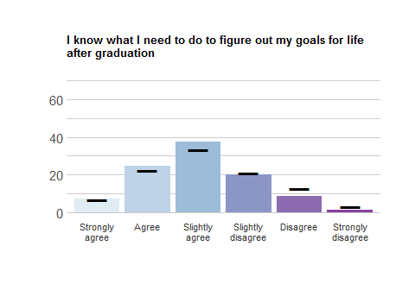
Response | School Freq | School % | School Valid % | Ag Freq | Ag % | Ag Valid %
Strongly agree | 5 | 1.29 | 7.25 | 79 | 1.26 | 6.77
Agree | 17 | 4.39 | 24.64 | 260 | 4.13 | 22.28
Slightly agree | 26 | 6.72 | 37.68 | 390 | 6.20 | 33.42
Slightly disagree | 14 | 3.62 | 20.29 | 248 | 3.94 | 21.25
Disagree | 6 | 1.55 | 8.70 | 151 | 2.40 | 12.94
Strongly disagree | 1 | 0.26 | 1.45 | 39 | 0.62 | 3.34
NA | 318 | 82.17 | NA | 5124 | 81.45 | NA

PURP3_2
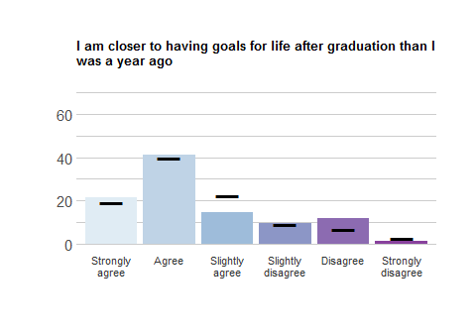
Response | School Freq | School % | School Valid % | Ag Freq | Ag % | Ag Valid %
Strongly agree | 16 | 4.13 | 21.33 | 232 | 3.69 | 19.13
Agree | 31 | 8.01 | 41.33 | 483 | 7.68 | 39.82
Slightly agree | 11 | 2.84 | 14.67 | 272 | 4.32 | 22.42
Slightly disagree | 7 | 1.81 | 9.33 | 109 | 1.73 | 8.99
Disagree | 9 | 2.33 | 12.00 | 85 | 1.35 | 7.01
Strongly disagree | 1 | 0.26 | 1.33 | 32 | 0.51 | 2.64
NA | 312 | 80.62 | NA | 5078 | 80.72 | NA

PURP3_3
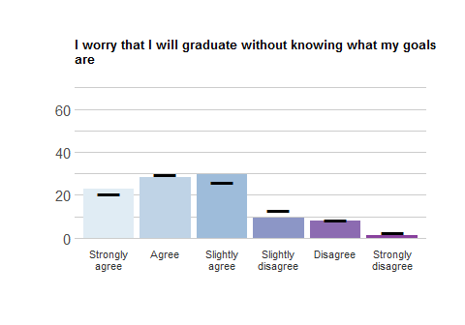
Response | School Freq | School % | School Valid % | Ag Freq | Ag % | Ag Valid %
Strongly agree | 17 | 4.39 | 22.97 | 237 | 3.77 | 20.77
Agree | 21 | 5.43 | 28.38 | 337 | 5.36 | 29.54
Slightly agree | 22 | 5.68 | 29.73 | 296 | 4.71 | 25.94
Slightly disagree | 7 | 1.81 | 9.46 | 148 | 2.35 | 12.97
Disagree | 6 | 1.55 | 8.11 | 95 | 1.51 | 8.33
Strongly disagree | 1 | 0.26 | 1.35 | 28 | 0.45 | 2.45
NA | 313 | 80.88 | NA | 5150 | 81.86 | NA

“Defining goals” Pathways
NOTE: People who selected “B” in PURP_1 received these items
Please rate how strongly you agree or disagree with the following statements.

PURP3_4
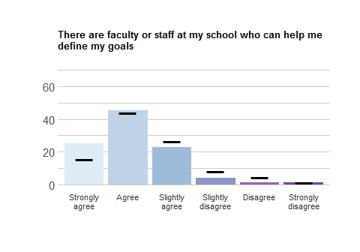
Response | School Freq | School % | School Valid % | Ag Freq | Ag % | Ag Valid %
Strongly agree | 19 | 4.91 | 25.33 | 188 | 2.99 | 15.51
Agree | 34 | 8.79 | 45.33 | 535 | 8.50 | 44.14
Slightly agree | 17 | 4.39 | 22.67 | 319 | 5.07 | 26.32
Slightly disagree | 3 | 0.78 | 4.00 | 100 | 1.59 | 8.25
Disagree | 1 | 0.26 | 1.33 | 52 | 0.83 | 4.29
Strongly disagree | 1 | 0.26 | 1.33 | 18 | 0.29 | 1.49
NA | 312 | 80.62 | NA | 5079 | 80.73 | NA

PURP3_5
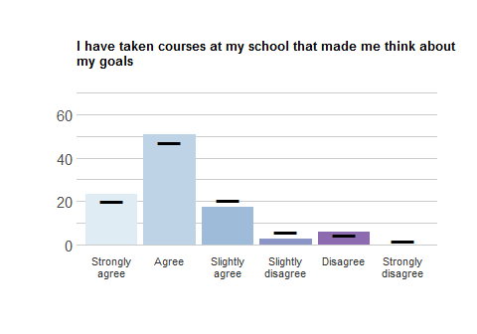
Response | School Freq | School % | School Valid % | Ag Freq | Ag % | Ag Valid %
Strongly agree | 16 | 4.13 | 23.19 | 233 | 3.70 | 20.02
Agree | 35 | 9.04 | 50.72 | 547 | 8.69 | 46.99
Slightly agree | 12 | 3.10 | 17.39 | 240 | 3.81 | 20.62
Slightly disagree | 2 | 0.52 | 2.90 | 71 | 1.13 | 6.10
Disagree | 4 | 1.03 | 5.80 | 54 | 0.86 | 4.64
Strongly disagree | 0 | 0.00 | 0.00 | 19 | 0.30 | 1.63
NA | 318 | 82.17 | NA | 5127 | 81.50 | NA

PURP3_6
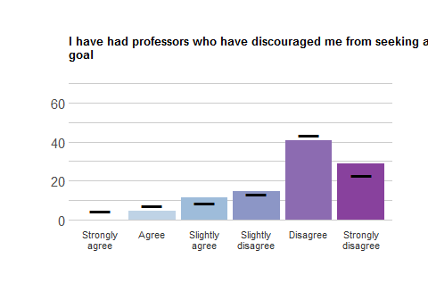
Response | School Freq | School % | School Valid % | Ag Freq | Ag % | Ag Valid %
Strongly agree | 0 | 0.00 | 0.00 | 50 | 0.79 | 4.30
Agree | 3 | 0.78 | 4.35 | 84 | 1.34 | 7.23
Slightly agree | 8 | 2.07 | 11.59 | 102 | 1.62 | 8.78
Slightly disagree | 10 | 2.58 | 14.49 | 154 | 2.45 | 13.25
Disagree | 28 | 7.24 | 40.58 | 505 | 8.03 | 43.46
Strongly disagree | 20 | 5.17 | 28.99 | 267 | 4.24 | 22.98
NA | 318 | 82.17 | NA | 5129 | 81.53 | NA

PURP3_7
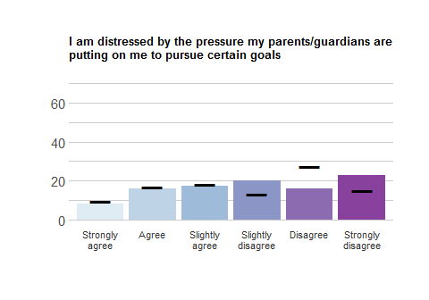
Response | School Freq | School % | School Valid % | Ag Freq | Ag % | Ag Valid %
Strongly agree | 6 | 1.55 | 8.00 | 116 | 1.84 | 9.57
Agree | 12 | 3.10 | 16.00 | 202 | 3.21 | 16.67
Slightly agree | 13 | 3.36 | 17.33 | 219 | 3.48 | 18.07
Slightly disagree | 15 | 3.88 | 20.00 | 163 | 2.59 | 13.45
Disagree | 12 | 3.10 | 16.00 | 331 | 5.26 | 27.31
Strongly disagree | 17 | 4.39 | 22.67 | 181 | 2.88 | 14.93
NA | 312 | 80.62 | NA | 5079 | 80.73 | NA

PURP3_8
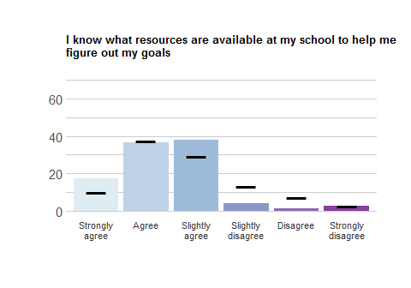
Response | School Freq | School % | School Valid % | Ag Freq | Ag % | Ag Valid %
Strongly agree | 13 | 3.36 | 17.57 | 112 | 1.78 | 9.82
Agree | 27 | 6.98 | 36.49 | 427 | 6.79 | 37.46
Slightly agree | 28 | 7.24 | 37.84 | 335 | 5.33 | 29.39
Slightly disagree | 3 | 0.78 | 4.05 | 153 | 2.43 | 13.42
Disagree | 1 | 0.26 | 1.35 | 85 | 1.35 | 7.46
Strongly disagree | 2 | 0.52 | 2.70 | 28 | 0.45 | 2.46
NA | 313 | 80.88 | NA | 5151 | 81.88 | NA

PURP3_9
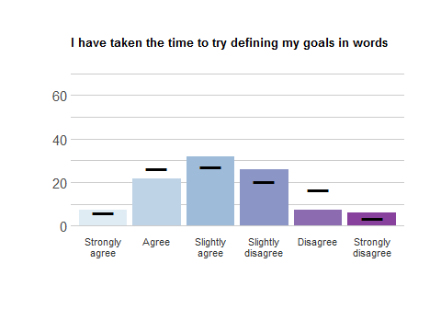
Response | School Freq | School % | School Valid % | Ag Freq | Ag % | Ag Valid %
Strongly agree | 5 | 1.29 | 7.25 | 72 | 1.14 | 6.20
Agree | 15 | 3.88 | 21.74 | 306 | 4.86 | 26.33
Slightly agree | 22 | 5.68 | 31.88 | 315 | 5.01 | 27.11
Slightly disagree | 18 | 4.65 | 26.09 | 238 | 3.78 | 20.48
Disagree | 5 | 1.29 | 7.25 | 191 | 3.04 | 16.44
Strongly disagree | 4 | 1.03 | 5.80 | 40 | 0.64 | 3.44
NA | 318 | 82.17 | NA | 5129 | 81.53 | NA

PURP3_10
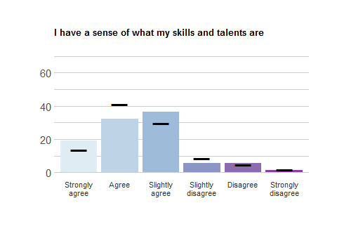
Response | School Freq | School % | School Valid % | Ag Freq | Ag % | Ag Valid %
Strongly agree | 14 | 3.62 | 18.92 | 154 | 2.45 | 13.51
Agree | 24 | 6.20 | 32.43 | 470 | 7.47 | 41.23
Slightly agree | 27 | 6.98 | 36.49 | 341 | 5.42 | 29.91
Slightly disagree | 4 | 1.03 | 5.41 | 99 | 1.57 | 8.68
Disagree | 4 | 1.03 | 5.41 | 56 | 0.89 | 4.91
Strongly disagree | 1 | 0.26 | 1.35 | 20 | 0.32 | 1.75
NA | 313 | 80.88 | NA | 5151 | 81.88 | NA

PURP3_11
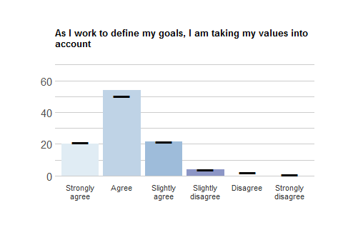
Response | School Freq | School % | School Valid % | Ag Freq | Ag % | Ag Valid %
Strongly agree | 15 | 3.88 | 20.27 | 237 | 3.77 | 20.88
Agree | 40 | 10.34 | 54.05 | 574 | 9.12 | 50.57
Slightly agree | 16 | 4.13 | 21.62 | 245 | 3.89 | 21.59
Slightly disagree | 3 | 0.78 | 4.05 | 46 | 0.73 | 4.05
Disagree | 0 | 0.00 | 0.00 | 26 | 0.41 | 2.29
Strongly disagree | 0 | 0.00 | 0.00 | 7 | 0.11 | 0.62
NA | 313 | 80.88 | NA | 5156 | 81.96 | NA

Standing up to Discrimination

Outcomes
Please rate how strongly you agree or disagree with the following statements.

DISCRIM_1
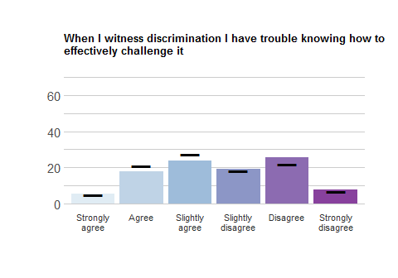
Response | School Freq | School % | School Valid % | Ag Freq | Ag % | Ag Valid %
Strongly agree | 13 | 3.36 | 5.42 | 186 | 2.96 | 4.74
Agree | 43 | 11.11 | 17.92 | 819 | 13.02 | 20.86
Slightly agree | 57 | 14.73 | 23.75 | 1075 | 17.09 | 27.38
Slightly disagree | 46 | 11.89 | 19.17 | 711 | 11.30 | 18.11
Disagree | 62 | 16.02 | 25.83 | 866 | 13.77 | 22.06
Strongly disagree | 19 | 4.91 | 7.92 | 269 | 4.28 | 6.85
NA | 147 | 37.98 | NA | 2365 | 37.59 | NA

DISCRIM_2
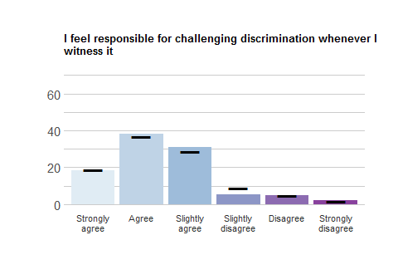
Response | School Freq | School % | School Valid % | Ag Freq | Ag % | Ag Valid %
Strongly agree | 44 | 11.37 | 18.57 | 733 | 11.65 | 18.79
Agree | 91 | 23.51 | 38.40 | 1441 | 22.91 | 36.95
Slightly agree | 73 | 18.86 | 30.80 | 1125 | 17.88 | 28.85
Slightly disagree | 13 | 3.36 | 5.49 | 339 | 5.39 | 8.69
Disagree | 11 | 2.84 | 4.64 | 193 | 3.07 | 4.95
Strongly disagree | 5 | 1.29 | 2.11 | 69 | 1.10 | 1.77
NA | 150 | 38.76 | NA | 2391 | 38.01 | NA

DISCRIM_3
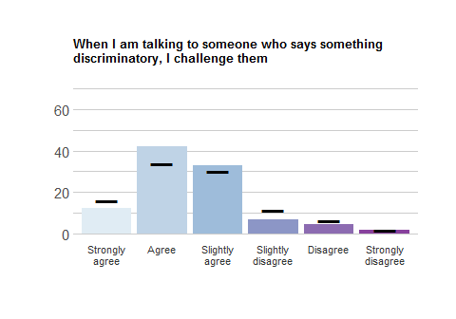
Response | School Freq | School % | School Valid % | Ag Freq | Ag % | Ag Valid %
Strongly agree | 30 | 7.75 | 12.15 | 629 | 10.00 | 16.02
Agree | 104 | 26.87 | 42.11 | 1334 | 21.20 | 33.97
Slightly agree | 81 | 20.93 | 32.79 | 1193 | 18.96 | 30.38
Slightly disagree | 17 | 4.39 | 6.88 | 450 | 7.15 | 11.46
Disagree | 11 | 2.84 | 4.45 | 249 | 3.96 | 6.34
Strongly disagree | 4 | 1.03 | 1.62 | 72 | 1.14 | 1.83
NA | 140 | 36.18 | NA | 2364 | 37.58 | NA

Pathways
Please rate how strongly you agree or disagree with the following statements.

DISCRIM_4
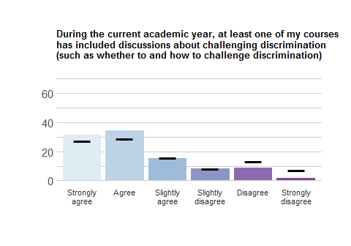
Response | School Freq | School % | School Valid % | Ag Freq | Ag % | Ag Valid %
Strongly agree | 74 | 19.12 | 31.36 | 1056 | 16.79 | 27.08
Agree | 81 | 20.93 | 34.32 | 1121 | 17.82 | 28.75
Slightly agree | 36 | 9.30 | 15.25 | 608 | 9.66 | 15.59
Slightly disagree | 20 | 5.17 | 8.47 | 324 | 5.15 | 8.31
Disagree | 21 | 5.43 | 8.90 | 512 | 8.14 | 13.13
Strongly disagree | 4 | 1.03 | 1.69 | 278 | 4.42 | 7.13
NA | 151 | 39.02 | NA | 2392 | 38.02 | NA

DISCRIM_5
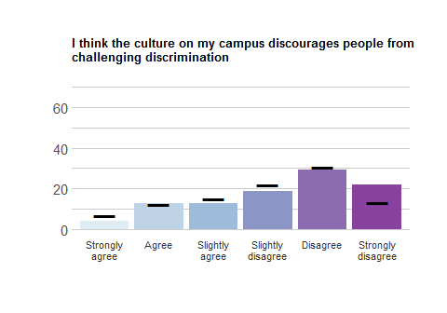
Response | School Freq | School % | School Valid % | Ag Freq | Ag % | Ag Valid %
Strongly agree | 10 | 2.58 | 4.17 | 266 | 4.23 | 6.79
Agree | 31 | 8.01 | 12.92 | 490 | 7.79 | 12.51
Slightly agree | 31 | 8.01 | 12.92 | 598 | 9.51 | 15.27
Slightly disagree | 45 | 11.63 | 18.75 | 856 | 13.61 | 21.85
Disagree | 70 | 18.09 | 29.17 | 1196 | 19.01 | 30.53
Strongly disagree | 53 | 13.70 | 22.08 | 511 | 8.12 | 13.05
NA | 147 | 37.98 | NA | 2374 | 37.74 | NA

Volunteerism
This set of items asks you about your attitudes and behaviors toward volunteering.

Outcomes
Please rate how strongly you agree or disagree with the following statements.

VOLUNT_1
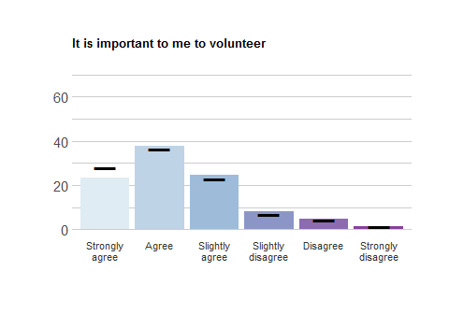
Response | School Freq | School % | School Valid % | Ag Freq | Ag % | Ag Valid %
Strongly agree | 57 | 14.73 | 23.55 | 1100 | 17.49 | 27.83
Agree | 91 | 23.51 | 37.60 | 1441 | 22.91 | 36.46
Slightly agree | 60 | 15.50 | 24.79 | 910 | 14.47 | 23.03
Slightly disagree | 20 | 5.17 | 8.26 | 278 | 4.42 | 7.03
Disagree | 11 | 2.84 | 4.55 | 163 | 2.59 | 4.12
Strongly disagree | 3 | 0.78 | 1.24 | 60 | 0.95 | 1.52
NA | 145 | 37.47 | NA | 2339 | 37.18 | NA

VOLUNT_2
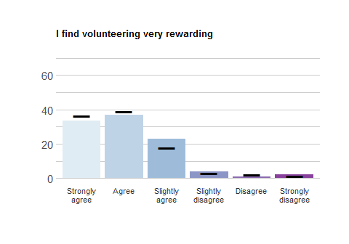
Response | School Freq | School % | School Valid % | Ag Freq | Ag % | Ag Valid %
Strongly agree | 82 | 21.19 | 33.47 | 1440 | 22.89 | 36.52
Agree | 90 | 23.26 | 36.73 | 1533 | 24.37 | 38.88
Slightly agree | 56 | 14.47 | 22.86 | 707 | 11.24 | 17.93
Slightly disagree | 10 | 2.58 | 4.08 | 116 | 1.84 | 2.94
Disagree | 2 | 0.52 | 0.82 | 92 | 1.46 | 2.33
Strongly disagree | 5 | 1.29 | 2.04 | 55 | 0.87 | 1.39
NA | 142 | 36.69 | NA | 2348 | 37.32 | NA

VOLUNT_3
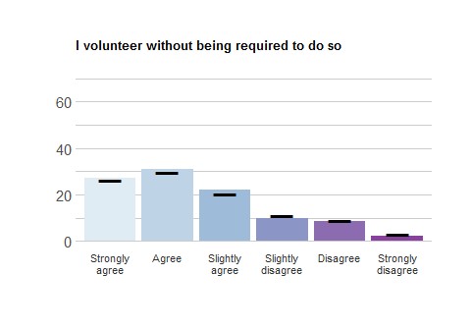
Response | School Freq | School % | School Valid % | Ag Freq | Ag % | Ag Valid %
Strongly agree | 64 | 16.54 | 27.00 | 1027 | 16.32 | 26.31
Agree | 73 | 18.86 | 30.80 | 1165 | 18.52 | 29.85
Slightly agree | 52 | 13.44 | 21.94 | 804 | 12.78 | 20.60
Slightly disagree | 23 | 5.94 | 9.70 | 440 | 6.99 | 11.27
Disagree | 20 | 5.17 | 8.44 | 351 | 5.58 | 8.99
Strongly disagree | 5 | 1.29 | 2.11 | 116 | 1.84 | 2.97
NA | 150 | 38.76 | NA | 2388 | 37.96 | NA

Pathways
Please rate how strongly you agree or disagree with the following statements.

VOLUNT_4
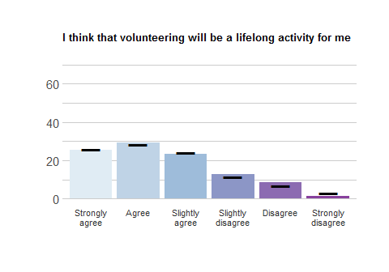
Response | School Freq | School % | School Valid % | Ag Freq | Ag % | Ag Valid %
Strongly agree | 60 | 15.50 | 25.32 | 1015 | 16.13 | 26.00
Agree | 69 | 17.83 | 29.11 | 1104 | 17.55 | 28.28
Slightly agree | 55 | 14.21 | 23.21 | 951 | 15.12 | 24.36
Slightly disagree | 30 | 7.75 | 12.66 | 447 | 7.11 | 11.45
Disagree | 20 | 5.17 | 8.44 | 271 | 4.31 | 6.94
Strongly disagree | 3 | 0.78 | 1.27 | 116 | 1.84 | 2.97
NA | 150 | 38.76 | NA | 2387 | 37.94 | NA

VOLUNT_5
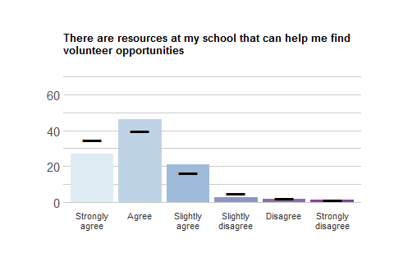
Response | School Freq | School % | School Valid % | Ag Freq | Ag % | Ag Valid %
Strongly agree | 66 | 17.05 | 27.16 | 1365 | 21.70 | 34.71
Agree | 112 | 28.94 | 46.09 | 1568 | 24.92 | 39.87
Slightly agree | 51 | 13.18 | 20.99 | 642 | 10.21 | 16.32
Slightly disagree | 7 | 1.81 | 2.88 | 204 | 3.24 | 5.19
Disagree | 4 | 1.03 | 1.65 | 95 | 1.51 | 2.42
Strongly disagree | 3 | 0.78 | 1.23 | 59 | 0.94 | 1.50
NA | 144 | 37.21 | NA | 2358 | 37.48 | NA

VOLUNT_6
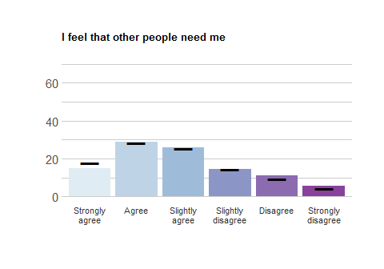
Response | School Freq | School % | School Valid % | Ag Freq | Ag % | Ag Valid %
Strongly agree | 35 | 9.04 | 14.77 | 705 | 11.21 | 18.05
Agree | 68 | 17.57 | 28.69 | 1110 | 17.64 | 28.43
Slightly agree | 61 | 15.76 | 25.74 | 995 | 15.82 | 25.48
Slightly disagree | 34 | 8.79 | 14.35 | 557 | 8.85 | 14.26
Disagree | 26 | 6.72 | 10.97 | 362 | 5.75 | 9.27
Strongly disagree | 13 | 3.36 | 5.49 | 176 | 2.80 | 4.51
NA | 150 | 38.76 | NA | 2386 | 37.93 | NA

VOLUNT_7
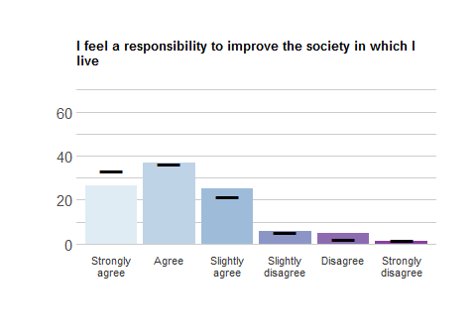
Response | School Freq | School % | School Valid % | Ag Freq | Ag % | Ag Valid %
Strongly agree | 65 | 16.80 | 26.53 | 1305 | 20.74 | 33.16
Agree | 90 | 23.26 | 36.73 | 1433 | 22.78 | 36.41
Slightly agree | 61 | 15.76 | 24.90 | 843 | 13.40 | 21.42
Slightly disagree | 14 | 3.62 | 5.71 | 207 | 3.29 | 5.26
Disagree | 12 | 3.10 | 4.90 | 89 | 1.41 | 2.26
Strongly disagree | 3 | 0.78 | 1.22 | 59 | 0.94 | 1.50
NA | 142 | 36.69 | NA | 2355 | 37.43 | NA

VOLUNT_8
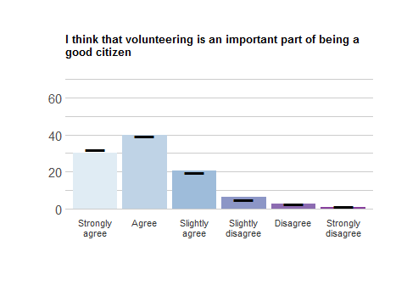
Response | School Freq | School % | School Valid % | Ag Freq | Ag % | Ag Valid %
Strongly agree | 73 | 18.86 | 30.17 | 1273 | 20.24 | 32.24
Agree | 96 | 24.81 | 39.67 | 1563 | 24.85 | 39.59
Slightly agree | 50 | 12.92 | 20.66 | 773 | 12.29 | 19.58
Slightly disagree | 15 | 3.88 | 6.20 | 194 | 3.08 | 4.91
Disagree | 6 | 1.55 | 2.48 | 98 | 1.56 | 2.48
Strongly disagree | 2 | 0.52 | 0.83 | 47 | 0.75 | 1.19
NA | 145 | 37.47 | NA | 2343 | 37.24 | NA

Demographics and background

Age, Class

AGE
- Mean (School) = 20.06
- Mean (Aggregate) = 20.26

CLASS
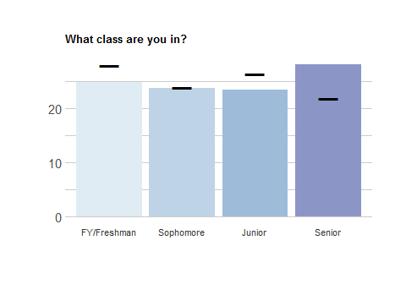
Response | School Freq | School % | School Valid % | Ag Freq | Ag % | Ag Valid %
FY/freshman | 95 | 24.55 | 24.74 | 1739 | 27.64 | 27.85
Sophomore | 91 | 23.51 | 23.70 | 1495 | 23.76 | 23.94
Junior | 90 | 23.26 | 23.44 | 1649 | 26.21 | 26.41
Senior | 108 | 27.91 | 28.12 | 1362 | 21.65 | 21.81
NA | 3 | 0.78 | NA | 46 | 0.73 | NA

break

Disability
Do you have any of the following disabilities or medical conditions? (answer each item)

DISABL_1
Learning disability (dyslexia, etc.)
Response | School Freq | School % | School Valid % | Ag Freq | Ag % | Ag Valid %
Yes | 33 | 8.53 | 8.89 | 294 | 4.67 | 4.83
No | 338 | 87.34 | 91.11 | 5794 | 92.10 | 95.17
NA | 16 | 4.13 | NA | 203 | 3.23 | NA

DISABL_2
Attention-deficit/hyperactivity disorder (ADHD)
Response | School Freq | School % | School Valid % | Ag Freq | Ag % | Ag Valid %
Yes | 35 | 9.04 | 9.51 | 573 | 9.11 | 9.43
No | 333 | 86.05 | 90.49 | 5505 | 87.51 | 90.57
NA | 19 | 4.91 | NA | 213 | 3.39 | NA

DISABL_3
Physical disability (speech, sight, mobility, hearing, etc.)
Response | School Freq | School % | School Valid % | Ag Freq | Ag % | Ag Valid %
Yes | 26 | 6.72 | 7.05 | 288 | 4.58 | 4.74
No | 343 | 88.63 | 92.95 | 5784 | 91.94 | 95.26
NA | 18 | 4.65 | NA | 219 | 3.48 | NA

DISABL_4
Chronic illness (cancer, diabetes, autoimmune disorders, etc.)
Response | School Freq | School % | School Valid % | Ag Freq | Ag % | Ag Valid %
Yes | 22 | 5.68 | 6.01 | 330 | 5.25 | 5.44
No | 344 | 88.89 | 93.99 | 5736 | 91.18 | 94.56
NA | 21 | 5.43 | NA | 225 | 3.58 | NA

break

DISABL_5
Psychological disorder (depression, etc.)
Response | School Freq | School % | School Valid % | Ag Freq | Ag % | Ag Valid %
Yes | 104 | 26.87 | 27.73 | 1445 | 22.97 | 23.6
No | 271 | 70.03 | 72.27 | 4677 | 74.34 | 76.4
NA | 12 | 3.10 | NA | 169 | 2.69 | NA

DISABL_6
Other
Response | School Freq | School % | School Valid % | Ag Freq | Ag % | Ag Valid %
Yes | 10 | 2.58 | 3.73 | 171 | 2.72 | 4.08
No | 258 | 66.67 | 96.27 | 4022 | 63.93 | 95.92
NA | 119 | 30.75 | NA | 2098 | 33.35 | NA

break

Foreign school, Gender, GPA, Housing

FRNSCHL
How many years of schooling before college have you received outside of the United States?
Years | School freq | School perc | Ag freq | Ag perc
0 | 312 | 80.62 | 4922 | 78.24
1 | 10 | 2.58 | 88 | 1.40
2 | 1 | 0.26 | 47 | 0.75
3 | 1 | 0.26 | 42 | 0.67
4 | 1 | 0.26 | 40 | 0.64
5 | 0 | 0.00 | 27 | 0.43
6 | 1 | 0.26 | 20 | 0.32
7 | 2 | 0.52 | 15 | 0.24
8 | 0 | 0.00 | 22 | 0.35
9 | 1 | 0.26 | 14 | 0.22
10 | 2 | 0.52 | 34 | 0.54
11 | 0 | 0.00 | 30 | 0.48
12 | 17 | 4.39 | 416 | 6.61
13 | 13 | 3.36 | 219 | 3.48
14 | 11 | 2.84 | 107 | 1.70
15 | 2 | 0.52 | 57 | 0.91
16 | 4 | 1.03 | 26 | 0.41
17 | 0 | 0.00 | 12 | 0.19
18 | 0 | 0.00 | 17 | 0.27
19 | 0 | 0.00 | 5 | 0.08
20 | 0 | 0.00 | 4 | 0.06
NA | 9 | 2.33 | 127 | 2.02

break

GENDER
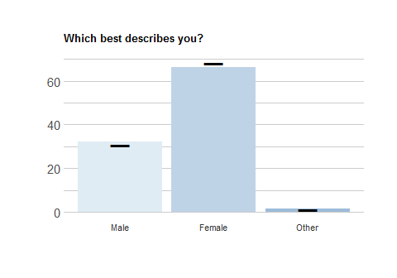
Response | School Freq | School % | School Valid % | Ag Freq | Ag % | Ag Valid %
Male | 123 | 31.78 | 32.03 | 1917 | 30.47 | 30.71
Female | 255 | 65.89 | 66.41 | 4261 | 67.73 | 68.26
Other | 6 | 1.55 | 1.56 | 64 | 1.02 | 1.03
NA | 3 | 0.78 | NA | 49 | 0.78 | NA

TRANS
Are you transgender?
Response | School Freq | School % | School Valid % | Ag Freq | Ag % | Ag Valid %
Yes | 7 | 1.81 | 1.83 | 70 | 1.11 | 1.12
No | 376 | 97.16 | 98.17 | 6165 | 98.00 | 98.88
NA | 4 | 1.03 | NA | 56 | 0.89 | NA

GPA
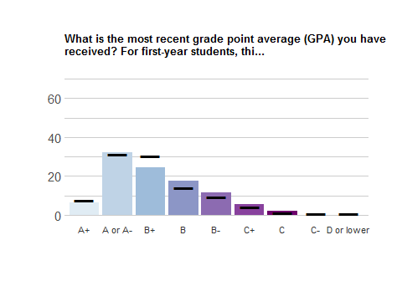
Response | School Freq | School % | School Valid % | Ag Freq | Ag % | Ag Valid %
A+ | 22 | 5.68 | 6.18 | 453 | 7.20 | 7.83
A or A- | 115 | 29.72 | 32.30 | 1811 | 28.79 | 31.31
B+ | 87 | 22.48 | 24.44 | 1766 | 28.07 | 30.53
B | 63 | 16.28 | 17.70 | 822 | 13.07 | 14.21
B- | 41 | 10.59 | 11.52 | 532 | 8.46 | 9.20
C+ | 20 | 5.17 | 5.62 | 243 | 3.86 | 4.20
C | 7 | 1.81 | 1.97 | 76 | 1.21 | 1.31
C- | 1 | 0.26 | 0.28 | 47 | 0.75 | 0.81
D or lower | 0 | 0.00 | 0.00 | 34 | 0.54 | 0.59
NA | 31 | 8.01 | NA | 507 | 8.06 | NA

break

Housing
Response | School Freq | School % | School Valid % | Ag Freq | Ag % | Ag Valid %
First-year student | 37 | 9.56 | 10.34 | 744 | 11.83 | 12.86
Culture-specific | 10 | 2.58 | 2.79 | 27 | 0.43 | 0.47
Special academic | 6 | 1.55 | 1.68 | 137 | 2.18 | 2.37
Other special interest | 4 | 1.03 | 1.12 | 71 | 1.13 | 1.23
Residence hall | 211 | 54.52 | 58.94 | 2042 | 32.46 | 35.30
Apartment | 24 | 6.20 | 6.70 | 603 | 9.59 | 10.42
Fraternity or sorority | 0 | 0.00 | 0.00 | 179 | 2.85 | 3.09
Other residential | 11 | 2.84 | 3.07 | 66 | 1.05 | 1.14
At home with family | 17 | 4.39 | 4.75 | 456 | 7.25 | 7.88
Off-campus fraternity or sorority | 1 | 0.26 | 0.28 | 46 | 0.73 | 0.80
Rented apartment or house | 29 | 7.49 | 8.10 | 1291 | 20.52 | 22.32
Other | 8 | 2.07 | 2.23 | 123 | 1.96 | 2.13
NA | 29 | 7.49 | NA | 506 | 8.04 | NA

break

Major, Military, Parents’ education

MAJOR
Which of these fields best describes your major? (Select up to 2)
Item number | Item text | School freq | School perc | Ag freq | Ag perc
MAJOR_1 | Not yet selected a major | 9 | 2.33 | 271 | 4.31
MAJOR_2 | Agriculture | 1 | 0.26 | 22 | 0.35
MAJOR_3 | Biological/life sciences | 128 | 33.07 | 951 | 15.12
MAJOR_4 | Business | 52 | 13.44 | 797 | 12.67
MAJOR_5 | Communication | 19 | 4.91 | 321 | 5.10
MAJOR_6 | Computer & information sciences | 18 | 4.65 | 401 | 6.37
MAJOR_7 | Education | 35 | 9.04 | 421 | 6.69
MAJOR_8 | Engineering | 5 | 1.29 | 698 | 11.10
MAJOR_9 | Ethnic, cultural, and area studies | 1 | 0.26 | 40 | 0.64
MAJOR_10 | Foreign languages & literature | 28 | 7.24 | 187 | 2.97
MAJOR_11 | Health-related fields | 19 | 4.91 | 527 | 8.38
MAJOR_12 | History | 15 | 3.88 | 135 | 2.15
MAJOR_13 | Humanities | 19 | 4.91 | 254 | 4.04
MAJOR_14 | Liberal/general studies | 0 | 0.00 | 20 | 0.32
MAJOR_15 | Mathematics | 4 | 1.03 | 182 | 2.89
MAJOR_16 | Multi/interdisciplinary studies | 13 | 3.36 | 129 | 2.05
MAJOR_17 | Parks, recreation, leisure, sports | 1 | 0.26 | 25 | 0.40
MAJOR_18 | Physical sciences | 25 | 6.46 | 234 | 3.72
MAJOR_19 | Pre-professional | 29 | 7.49 | 395 | 6.28
MAJOR_20 | Public administration | 0 | 0.00 | 68 | 1.08
MAJOR_21 | Social sciences | 64 | 16.54 | 1085 | 17.25
MAJOR_22 | Visual and performing arts | 19 | 4.91 | 382 | 6.07
MAJOR_23 | Other | 28 | 7.24 | 475 | 7.55

break

MILITARY
Which best describes your military status: (select one)
Response | School Freq | School % | School Valid % | Ag Freq | Ag % | Ag Valid %
None | 380 | 98.19 | 99.48 | 6103 | 97.01 | 98.37
ROTC, cadet, midshipman at service academy | 0 | 0.00 | 0.00 | 54 | 0.86 | 0.87
Reserve or National Guard | 2 | 0.52 | 0.52 | 23 | 0.37 | 0.37
Active Duty | 0 | 0.00 | 0.00 | 1 | 0.02 | 0.02
Discharched vet | 0 | 0.00 | 0.00 | 23 | 0.37 | 0.37
NA | 5 | 1.29 | NA | 87 | 1.38 | NA

PAREDU
Response | School Freq | School % | School Valid % | Ag Freq | Ag % | Ag Valid %
Yes | 324 | 83.72 | 84.82 | 5421 | 86.17 | 87.08
No | 55 | 14.21 | 14.40 | 731 | 11.62 | 11.74
Don’t know | 3 | 0.78 | 0.79 | 73 | 1.16 | 1.17
NA | 5 | 1.29 | NA | 66 | 1.05 | NA

break

Paying for college & loans
How have you paid for your college costs?

PAY_1
Resources from your family (e.g., parent or relative savings, etc.)
Response | School Freq | School % | School Valid % | Ag Freq | Ag % | Ag Valid %
Yes | 308 | 79.59 | 88 | 4706 | 74.81 | 83.28
No | 42 | 10.85 | 12 | 945 | 15.02 | 16.72
NA | 37 | 9.56 | NA | 640 | 10.17 | NA

PAY_2:
Your own personal resources (e.g., your savings, income from a job, etc.)
Response | School Freq | School % | School Valid % | Ag Freq | Ag % | Ag Valid %
Yes | 227 | 58.66 | 65.61 | 3298 | 52.42 | 59.74
No | 119 | 30.75 | 34.39 | 2223 | 35.34 | 40.26
NA | 41 | 10.59 | NA | 770 | 12.24 | NA

PAY_3:
Financial aid that does not need to be repaid (e.g., scholarship or grant money)
Response | School Freq | School % | School Valid % | Ag Freq | Ag % | Ag Valid %
Yes | 327 | 84.50 | 93.43 | 4024 | 63.96 | 71.77
No | 23 | 5.94 | 6.57 | 1583 | 25.16 | 28.23
NA | 37 | 9.56 | NA | 684 | 10.87 | NA

PAY_4:
Financial aid that does need to be repaid by you (student loans)
Response | School Freq | School % | School Valid % | Ag Freq | Ag % | Ag Valid %
Yes | 258 | 66.67 | 73.3 | 2948 | 46.86 | 53.34
No | 94 | 24.29 | 26.7 | 2579 | 41.00 | 46.66
NA | 35 | 9.04 | NA | 764 | 12.14 | NA

break

PAY_5:
Loans your parents are taking out (not student loans)
Response | School Freq | School % | School Valid % | Ag Freq | Ag % | Ag Valid %
Yes | 111 | 28.68 | 32.84 | 1122 | 17.84 | 21.05
No | 227 | 58.66 | 67.16 | 4208 | 66.89 | 78.95
NA | 49 | 12.66 | NA | 961 | 15.28 | NA

PAY_6:
Other
Response | School Freq | School % | School Valid % | Ag Freq | Ag % | Ag Valid %
Yes | 4 | 1.03 | 2.65 | 123 | 1.96 | 4.66
No | 147 | 37.98 | 97.35 | 2515 | 39.98 | 95.34
NA | 236 | 60.98 | NA | 3653 | 58.07 | NA

break

LOANS
NOTE: This item was displayed to people who selected YES to PAY_4 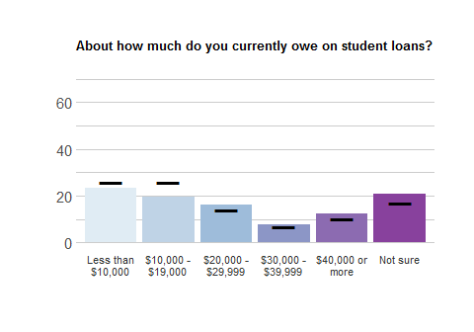
Response | School Freq | School % | School Valid % | Ag Freq | Ag % | Ag Valid %
Less than $10,000 | 60 | 15.50 | 23.26 | 761 | 12.10 | 25.85
$10,000 - $19,000 | 50 | 12.92 | 19.38 | 762 | 12.11 | 25.88
$20,000 - $29,999 | 42 | 10.85 | 16.28 | 417 | 6.63 | 14.16
$30,000 - $39,999 | 20 | 5.17 | 7.75 | 198 | 3.15 | 6.73
$40,000 or more | 32 | 8.27 | 12.40 | 305 | 4.85 | 10.36
Not sure | 54 | 13.95 | 20.93 | 501 | 7.96 | 17.02
NA | 129 | 33.33 | NA | 3347 | 53.20 | NA

break

Program participation, RA

PROGRAMS
During the current academic year, have you attended or participated in any education or prevention programs that discuss the following topics at your school?

PROGRAMS_1
Alcohol and other drugs
Response | School Freq | School % | School Valid % | Ag Freq | Ag % | Ag Valid %
Yes | 186 | 48.06 | 52.10 | 2950 | 46.89 | 51.15
No | 164 | 42.38 | 45.94 | 2602 | 41.36 | 45.12
Not sure | 7 | 1.81 | 1.96 | 215 | 3.42 | 3.73
NA | 30 | 7.75 | NA | 524 | 8.33 | NA

PROGRAMS_2:
Sexual assault
Response | School Freq | School % | School Valid % | Ag Freq | Ag % | Ag Valid %
Yes | 238 | 61.50 | 66.67 | 3311 | 52.63 | 57.44
No | 113 | 29.20 | 31.65 | 2249 | 35.75 | 39.02
Not sure | 6 | 1.55 | 1.68 | 204 | 3.24 | 3.54
NA | 30 | 7.75 | NA | 527 | 8.38 | NA

PROGRAMS_3:
Nutrition
Response | School Freq | School % | School Valid % | Ag Freq | Ag % | Ag Valid %
Yes | 94 | 24.29 | 26.63 | 1729 | 27.48 | 30.13
No | 249 | 64.34 | 70.54 | 3714 | 59.04 | 64.72
Not sure | 10 | 2.58 | 2.83 | 296 | 4.71 | 5.16
NA | 34 | 8.79 | NA | 552 | 8.77 | NA

break

PROGRAMS_4:
Wellbeing
Response | School Freq | School % | School Valid % | Ag Freq | Ag % | Ag Valid %
Yes | 112 | 28.94 | 31.46 | 2243 | 35.65 | 39.05
No | 228 | 58.91 | 64.04 | 3151 | 50.09 | 54.86
Not sure | 16 | 4.13 | 4.49 | 350 | 5.56 | 6.09
NA | 31 | 8.01 | NA | 547 | 8.69 | NA

PROGRAMS_5:
Stress & emotional health
Response | School Freq | School % | School Valid % | Ag Freq | Ag % | Ag Valid %
Yes | 132 | 34.11 | 37.39 | 2471 | 39.28 | 43.0
No | 208 | 53.75 | 58.92 | 2977 | 47.32 | 51.8
Not sure | 13 | 3.36 | 3.68 | 299 | 4.75 | 5.2
NA | 34 | 8.79 | NA | 544 | 8.65 | NA

PROGRAMS_6:
Diversity
Response | School Freq | School % | School Valid % | Ag Freq | Ag % | Ag Valid %
Yes | 234 | 60.47 | 65.36 | 2649 | 42.11 | 45.97
No | 109 | 28.17 | 30.45 | 2799 | 44.49 | 48.58
Not sure | 15 | 3.88 | 4.19 | 314 | 4.99 | 5.45
NA | 29 | 7.49 | NA | 529 | 8.41 | NA

PROGRAMS_7
Other
Response | School Freq | School % | School Valid % | Ag Freq | Ag % | Ag Valid %
Yes | 9 | 2.33 | 5.62 | 102 | 1.62 | 3.81
No | 128 | 33.07 | 80.00 | 2111 | 33.56 | 78.77
Not sure | 23 | 5.94 | 14.37 | 467 | 7.42 | 17.43
NA | 227 | 58.66 | NA | 3611 | 57.40 | NA

break

RA
Response | School Freq | School % | School Valid % | Ag Freq | Ag % | Ag Valid %
Yes | 14 | 3.62 | 3.91 | 170 | 2.70 | 2.94
No | 5 | 1.29 | 1.40 | 113 | 1.80 | 1.95
No, never | 339 | 87.60 | 94.69 | 5500 | 87.43 | 95.11
NA | 29 | 7.49 | NA | 508 | 8.08 | NA

break

Race/ethnicity, Sexual orientation, Spirituality, Study abroad

Race/ethnicity (RACETHN)
NOTE: The RACETHN variable was calculated from the ETHNICITY and RACE variables to reflect federal reporting requirements as of 2007.
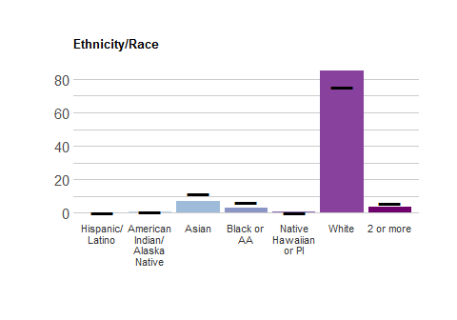
Response | School Freq | School % | School Valid % | Ag Freq | Ag % | Ag Valid %
Hispanic/ Latino | 0 | 0.00 | 0.00 | 0 | 0.00 | 0.00
American Indian/ Alaska Native | 2 | 0.52 | 0.53 | 38 | 0.60 | 0.62
Asian | 26 | 6.72 | 6.93 | 702 | 11.16 | 11.44
Black or AA | 12 | 3.10 | 3.20 | 395 | 6.28 | 6.44
Native Hawaiian or PI | 2 | 0.52 | 0.53 | 11 | 0.17 | 0.18
White | 319 | 82.43 | 85.07 | 4638 | 73.72 | 75.59
2 or more | 14 | 3.62 | 3.73 | 352 | 5.60 | 5.74
NA | 12 | 3.10 | NA | 155 | 2.46 | NA

Sexual orientation (SEX_ORIENT)
How do you describe your sexual orientation? (select one) 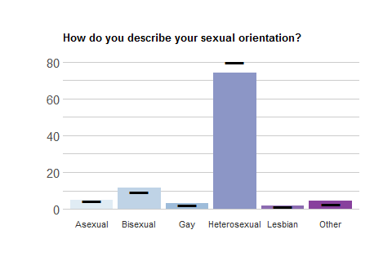
Response | School Freq | School % | School Valid % | Ag Freq | Ag % | Ag Valid %
Asexual | 19 | 4.91 | 4.95 | 275 | 4.37 | 4.41
Bisexual | 44 | 11.37 | 11.46 | 594 | 9.44 | 9.53
Gay | 12 | 3.10 | 3.12 | 137 | 2.18 | 2.20
Heterosexual | 285 | 73.64 | 74.22 | 4981 | 79.18 | 79.95
Lesbian | 7 | 1.81 | 1.82 | 81 | 1.29 | 1.30
Other | 17 | 4.39 | 4.43 | 162 | 2.58 | 2.60
NA | 3 | 0.78 | NA | 61 | 0.97 | NA

break

Spirituality (SPIRIT)
Response | School Freq | School % | School Valid % | Ag Freq | Ag % | Ag Valid %
Buddhist | 5 | 1.29 | 1.30 | 69 | 1.10 | 1.11
Catholic | 52 | 13.44 | 13.54 | 1301 | 20.68 | 20.90
Protestant | 54 | 13.95 | 14.06 | 1136 | 18.06 | 18.25
Christian Other | 78 | 20.16 | 20.31 | 1034 | 16.44 | 16.61
Hindu | 3 | 0.78 | 0.78 | 102 | 1.62 | 1.64
Jewish | 6 | 1.55 | 1.56 | 140 | 2.23 | 2.25
Muslim | 1 | 0.26 | 0.26 | 83 | 1.32 | 1.33
Other | 10 | 2.58 | 2.60 | 106 | 1.68 | 1.70
Multiple | 6 | 1.55 | 1.56 | 56 | 0.89 | 0.90
None | 146 | 37.73 | 38.02 | 1917 | 30.47 | 30.79
Unknown | 23 | 5.94 | 5.99 | 257 | 4.09 | 4.13
NA | 3 | 0.78 | NA | 65 | 1.03 | NA

break

Study abroad (ABROAD)
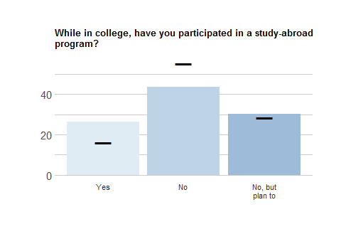
Response | School Freq | School % | School Valid % | Ag Freq | Ag % | Ag Valid %
Yes | 94 | 24.29 | 26.26 | 938 | 14.91 | 16.25
No | 156 | 40.31 | 43.58 | 3196 | 50.80 | 55.38
No, but plan to | 108 | 27.91 | 30.17 | 1637 | 26.02 | 28.37
NA | 29 | 7.49 | NA | 520 | 8.27 | NA

break

Work & money

WORK
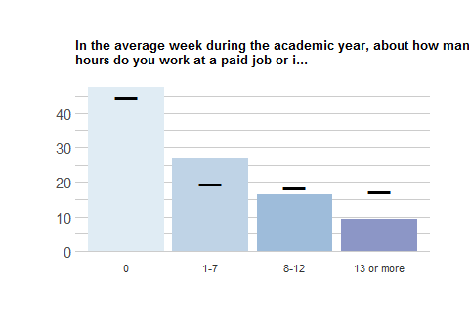
Response | School Freq | School % | School Valid % | Ag Freq | Ag % | Ag Valid %
0 | 170 | 43.93 | 47.49 | 2586 | 41.11 | 44.72
1-7 | 96 | 24.81 | 26.82 | 1137 | 18.07 | 19.66
8-12 | 59 | 15.25 | 16.48 | 1065 | 16.93 | 18.42
13 or more | 33 | 8.53 | 9.22 | 995 | 15.82 | 17.21
NA | 29 | 7.49 | NA | 508 | 8.08 | NA

MONEY
What do you use that money for? (select all that apply)
Item number | Item text | School freq | School perc | Ag freq | Ag perc
MONEY_1 | School expenses | 132 | 34.11 | 2053 | 32.63
MONEY_2 | Spending money | 142 | 36.69 | 2467 | 39.21
MONEY_3 | Sending money home | 14 | 3.62 | 271 | 4.31
MONEY_4 | Savings | 112 | 28.94 | 1999 | 31.78
MONEY_5 | Other | 10 | 2.58 | 373 | 5.93

Additional Items

Campus Safety
Prompt: Please rate how strongly you agree or disagree with the following statements.

Camp_Safe_Camp_Safe_1
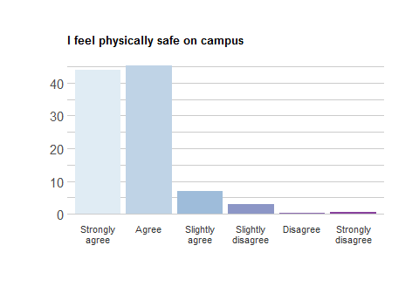
Response | School Freq | School % | School Valid %
Strongly agree | 157 | 40.57 | 43.85
Agree | 162 | 41.86 | 45.25
Slightly agree | 25 | 6.46 | 6.98
Slightly disagree | 11 | 2.84 | 3.07
Disagree | 1 | 0.26 | 0.28
Strongly disagree | 2 | 0.52 | 0.56
NA | 29 | 7.49 | NA

Camp_Safe_Camp_Safe_2
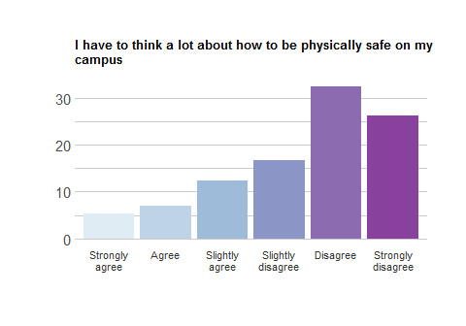
Response | School Freq | School % | School Valid %
Strongly agree | 19 | 4.91 | 5.31
Agree | 25 | 6.46 | 6.98
Slightly agree | 44 | 11.37 | 12.29
Slightly disagree | 60 | 15.50 | 16.76
Disagree | 116 | 29.97 | 32.40
Strongly disagree | 94 | 24.29 | 26.26
NA | 29 | 7.49 | NA

Camp_Safe_Camp_Safe_3
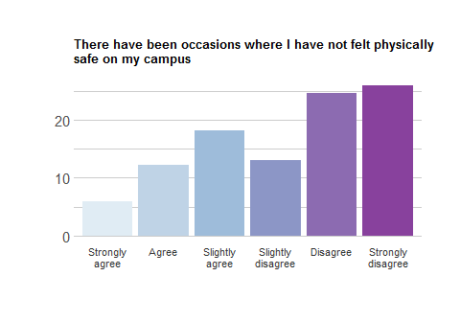
Response | School Freq | School % | School Valid %
Strongly agree | 21 | 5.43 | 5.87
Agree | 44 | 11.37 | 12.29
Slightly agree | 65 | 16.80 | 18.16
Slightly disagree | 47 | 12.14 | 13.13
Disagree | 88 | 22.74 | 24.58
Strongly disagree | 93 | 24.03 | 25.98
NA | 29 | 7.49 | NA
```

Mental Health Care

Mental_Health_Mental_Health_1
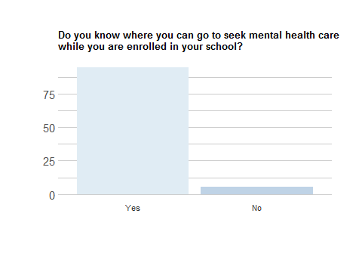
Response | School Freq | School % | School Valid %
Yes | 338 | 87.34 | 94.41
No | 20 | 5.17 | 5.59
NA | 29 | 7.49 | NA

Mental_Health_Mental_Health_2
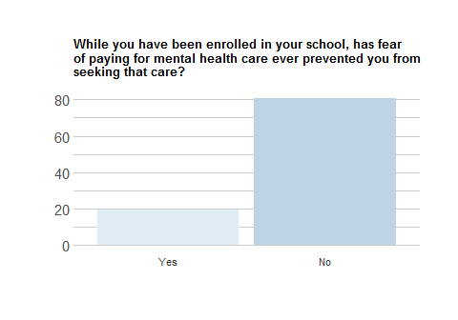
Response | School Freq | School % | School Valid %
Yes | 69 | 17.83 | 19.38
No | 287 | 74.16 | 80.62
NA | 31 | 8.01 | NA

Mental_Health_Mental_Health_3
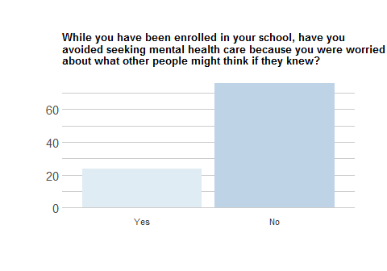
Response | School Freq | School % | School Valid %
Yes | 86 | 22.22 | 24.09
No | 271 | 70.03 | 75.91
NA | 30 | 7.75 | NA

Mental_Health_Mental_Health_4
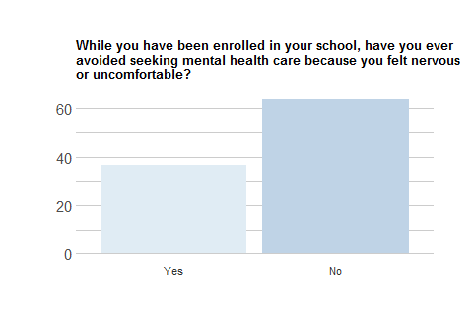
Response | School Freq | School % | School Valid %
Yes | 129 | 33.33 | 36.13
No | 228 | 58.91 | 63.87
NA | 30 | 7.75 | NA

Custom Items

JuniataSp18_Custom_1
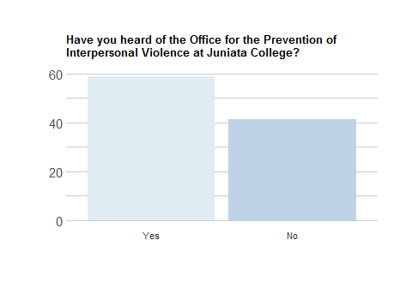
Response | School Freq | School % | School Valid %
Yes | 210 | 54.26 | 58.66
No | 148 | 38.24 | 41.34
NA | 29 | 7.49 | NA

JuniataSp18_Custom_2
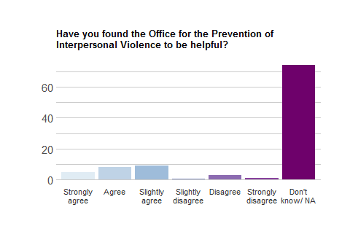
Response | School Freq | School % | School Valid %
Strongly agree | 17 | 4.39 | 4.78
Agree | 28 | 7.24 | 7.87
Slightly agree | 32 | 8.27 | 8.99
Slightly disagree | 2 | 0.52 | 0.56
Disagree | 9 | 2.33 | 2.53
Strongly disagree | 3 | 0.78 | 0.84
Don’t know/ NA | 265 | 68.48 | 74.44
NA | 31 | 8.01 | NA

JuniataSp18_Custom_3
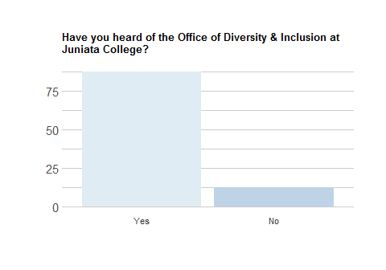
Response | School Freq | School % | School Valid %
Yes | 313 | 80.88 | 87.43
No | 45 | 11.63 | 12.57
NA | 29 | 7.49 | NA

