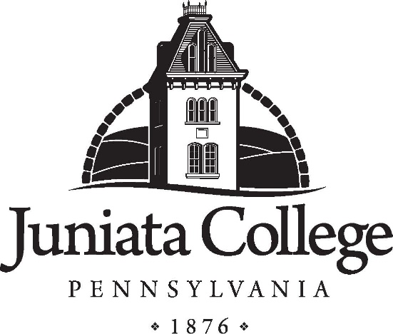

|  |
| --- |
| **JUNIATA COLLEGE QUICK FACTS** |
| **2017-2018** |

|  |
| --- |
| Founded in 1876, Juniata is an independent, co-educational college of liberal arts and sciences. Located in the scenic mountains of central Pennsylvania, the beautiful 110-acre main campus is supplemented by the 315-acre Baker-Henry Nature Preserve and Baker Peace Chapel. In addition, a 365-acre Environmental Studies Field Station on nearby Raystown Lake provides one of the most distinctive opportunities in environmental science in the nation. |
| The College has a strong reputation for excellent academics, personal attention, and state-of-the-art technological resources. Juniata students enjoy small classes, a challenging, flexible curriculum, collaborative student-faculty relationships, countless chances to learn by doing, and a lively campus offering lots to do and great new friends. |

Locations: Huntingdon, PA (small town)

Founded: 1876

Status: Independent, private, four-year residential

Historical Heritage: Church of the Brethren

Motto: "Veritas Liberat" - Truth Sets Free

Team Name: Eagles

School colors: Blue & Gold

President: Dr. James A. Troha

Enrollment: Fall 2017: 1495 total; 1442.2 FTE; 1433.4 UG FTE

Characteristics: 55% Women; 94% Full-time; 9% International; 14% Domestic Minority

Geographic Origin: 36 States and 35 Foreign Countries; 63% from Pennsylvania

Admissions: # Applicants - 2,378; Accepted – 1,664 (70%); Enrolled - 366 (22%)

Freshmen: # First-time Freshmen - 341. Average SAT (Math and Verbal): 1205; Average HS GPA: 3.72; SAT ranges (middle 50%): Verbal: 540 - 650; Math: 540 – 640; 31% graduated in top 10% of high school class

Retention: 80.7% of Freshmen entering fall 2016 returned fall 2017; 83% of cohort entering 2011 graduated within 6 years; 94% of students graduating in 2017 did so within 4 years or less

Popular POEs: Biology- 17.4%; Accounting/Business- 12.5%; Environmental Science/Studies-10.8%; Education-7.2%; Chemistry-6.0%; Psychology-4.3%

Student/Faculty Ratio: 12:1

Employees: Total Employees (including faculty) as of 09/17: 470

Resident Halls: 21 Residence Halls; Capacity - 1277

Tuition: 2017-18 Tuition: $43,050; Room: $6,410; Board: $5,630; Fees: $825. TOTAL - $55,915

Endowment: FY17: $106,785,783 Million